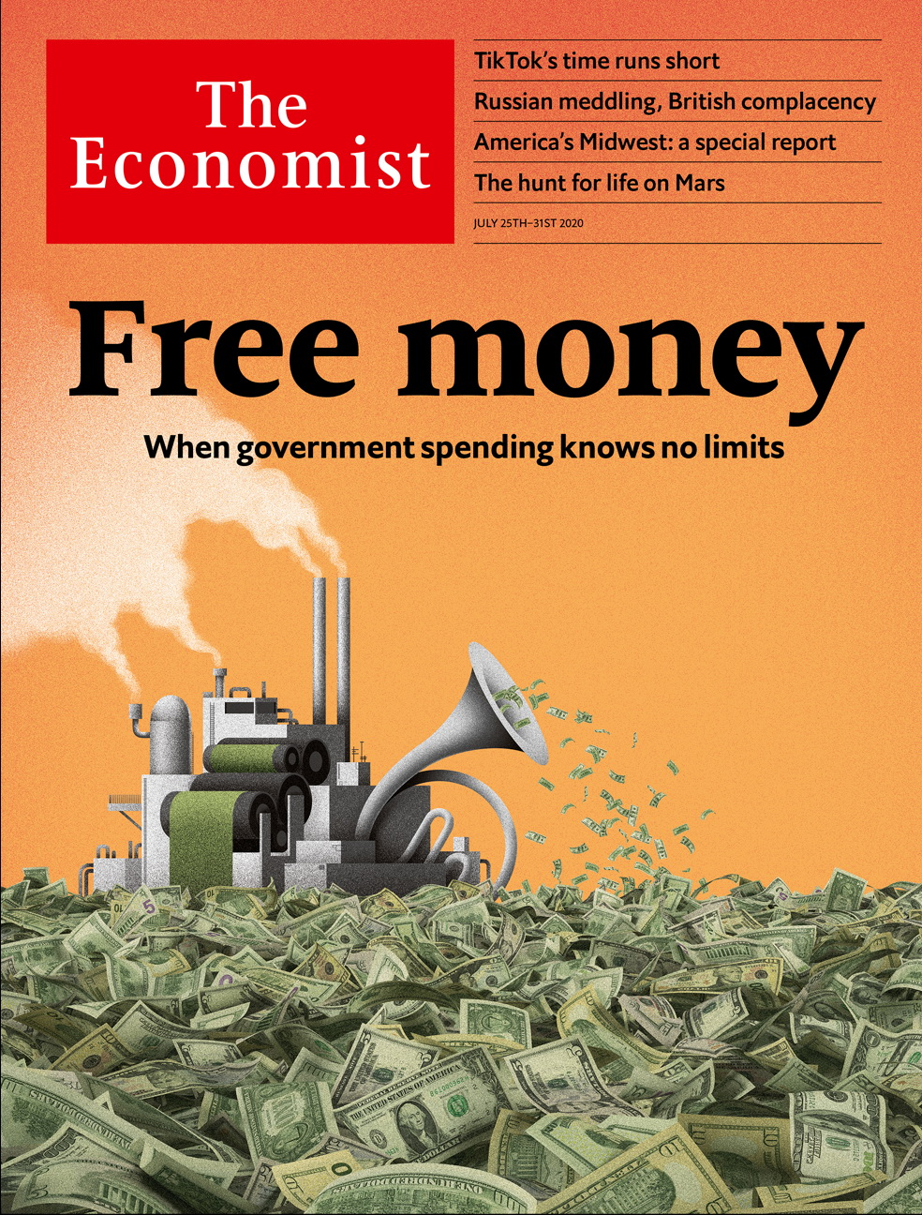

# Table of Contents

The world this week

Politics this week

Business this week

KAL’s cartoon

Leaders

Macroeconomics: Free money

Collective debt: Europe pulls together

Regional development: Revive, then thrive

Tanzania: You say bullish, I say...

Space exploration: Tread softly

Letters

Letters to the editor: On Hong Kong, short-sellers, the Supreme Court, horse jumping, “The Prisoner”, medical terms, breadmaking

Briefing

A new era of economics: Starting over again

Asia

Caste in India: No escape

The Philippine economy: A milder infection

Covid-19 in Central Asia: Dust-busters

Shipping in Japan: Sailing without sailors

Banyan: South China scene

China

Miscarriages of justice: Righting wrongs

Wild mushrooms: The champignon champions

Chaguan: Lessons from a summer hit

United States

Congress and covid-19: Spot trades

Work and incentives: One-handed economics

Easing lockdowns and covid-19: The geometry of the pandemic

Police reform: Now for the hard part

Lexington: Trouble in Trumplandia

The Americas

Migration and Mexico: Youth departs

The Caribbean: Welcome Zoomers

Bello: The Inca trail leads to populism

Middle East & Africa

Tanzania: A Potemkin economy?

Uganda’s coming elections: Power unmasked

Israel and covid-19: Mission unaccomplished

Illegal migration: No passport required

Racism in the Middle East: Maids for sale

Europe

Europe’s economy: A big fiscal deal

The Franco-German relationship: Back on the tandem

Covid-19 in slaughterhouses: Germany’s wurst jobs

Bulgarian protests: Bullies on a beach

Greek ruins: Attic views

Spain’s monarchy: A tarnished crown

Charlemagne: Chekhov’s treaty

Britain

Russian interference in politics: See no evil

Labour’s new management: Man overboard!

Demography: Turning Japanese

Travelling people: Gypsy lives matter

Life on furlough: Hold on

Housing market: A fragile boom

Brexit and fish: On the menu

International

Care homes: No place like home

Special report

The Midwest: An outsized punch

Cities: The urban prairie

Race and the city: Separate, downtrodden

Industry: America’s Mittelstand

Universities: From rustbelt to brainbelt

Politics: America’s divided middle

Nature’s metropolis: Don’t be the next Cahokia

Business

TikTok: Sixty seconds of fame

Information technology: In need of a software update

Bartleby: Pandemic veterans

Corporate profits: Seeing is disbelieving

Vaping: Puff piece

Mergers and acquisitions: Wakey, wakey

Schumpeter: The wannabe Alibaba

Finance & economics

Shadow banking: Putting the capital into capitalism

Metals: Shining brightly

Much Ant-icipated: Ant Group goes to market

Digital currencies: Bips and bytes

Buttonwood: Snake in the grass

Free exchange: Real-time danger

Science & technology

Astrobiology: Life on Mars: the search continues

Covid-19: The bat signal

Books & arts

Inside Tibet: Fear and loathing on the plateau

Bullfighting: The cape and the masks

Rock’n’roll fiction: The band played on

Home Entertainment: There’s always a catch

Johnson: The shadowland

Economic & financial indicators

Economic data, commodities and markets

Graphic detail

Covid-19 and football: Home comforts

Obituary

John Lewis: A country’s conscience



### Friday, July 24, 2020

|  |  |
| --- | --- |
| The world this week | 3 |
| Leaders | 5 |
| Letters | 1 |
| Briefing | 1 |
| Asia | 5 |
| China | 3 |
| United States | 5 |
| The Americas | 3 |
| Middle East & Africa | 5 |
| Europe | 7 |
| Britain | 7 |
| International | 1 |
| Special report | 7 |
| Business | 7 |
| Finance & economics | 6 |
| Science & technology | 2 |
| Books & arts | 5 |
| Economic & financial indicators | 1 |
| Graphic detail | 1 |
| Obituary | 1 |

|  |  |  |
| --- | --- | --- |
|  | Sections | Leaders |

The world this week

Politics this week

.

Business this week

.

KAL’s cartoon

.

|  |  |  |
| --- | --- | --- |
|  | Sections | Leaders |

|  |  |  |  |
| --- | --- | --- | --- |
|  | Articles | Sections | Next |

# Politics this week

Jul 23rd 2020 |

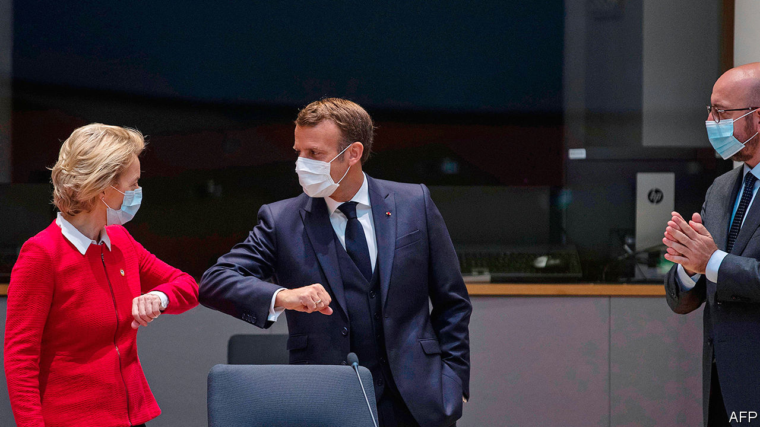

After intense wrangling, the heads of government in the European Union agreed to a €750bn ($869bn) stimulus package. The negotiations were even more tricky than usual, though the outcome was hailed as a breakthrough. It is the first time the EU as a bloc will issue bonds on a huge scale to back stimulus, spreading the fiscal risk among all member countries. See [here](https://www.economist.com/node/21790050) and here.

A long-delayed report into Russian interference in British political life was published by Parliament’s intelligence and security committee. The report stated that the threat from Russia was more embedded, and has been a problem for longer, than previously thought. Russian interference is seen as the “new normal”. It said the government is playing catch-up, especially in cyber-espionage, in which Russia is a “highly capable” adversary. See [article](https://www.economist.com/britain/2020/07/25/russian-interference-highlights-britains-political-failings).

Iran’s president, Hassan Rouhani, said that as many as 25m Iranians, nearly a third of the population, have been infected with covid-19 since the beginning of the outbreak, and that the situation is getting worse. Restrictions have been reimposed in many cities.

Israel banned indoor gatherings of ten or more people and shut some businesses. The country appeared to have contained the coronavirus earlier this year. Thousands of Israelis protested against the government’s handling of the outbreak and alleged corruption by Binyamin Netanyahu, the prime minister. See [article](https://www.economist.com/middle-east-and-africa/2020/07/25/binyamin-netanyahu-boasted-too-soon-of-defeating-the-coronavirus).

The United Arab Emirates successfully launched the Arab world’s first mission to Mars. Its Al Amal probe is expected to reach the red planet by next February and then orbit it for 687 days (a Martian year), gathering data about its atmosphere. It is the first of three international missions to Mars this summer.

Police in Zimbabwe arrested Hopewell Chin’ono, a journalist known for exposing corruption, after he published a report alleging that members of the government were involved in corrupt deals for supplies to fight the coronavirus.

Mass protests continued into their second month in Mali after opposition activists rejected attempts at mediation. Demonstrators are demanding the resignation of Ibrahim Boubacar Keita as president and the dissolution of parliament. Mali has been rocked by a brutal jihadist insurgency since 2012.

Violent incidents involving jihadist groups in Africa jumped by 31% in the 12 months to June 30th, according to the Africa Centre for Strategic Studies, which is part of America’s defence department.

Brazil’s government swore in its fourth education minister, Milton Ribeiro, an evangelical pastor. Days later he and another minister tested positive for covid-19.

The Inter-American Commission on Human Rights, a branch of the Organisation of American States, asked Brazil’s government to take steps to protect indigenous groups from the pandemic. More than 15,500 indigenous Brazilians have been diagnosed with covid-19 and more than 500 have died. The virus has reached even remote tribes in the Amazon rainforest, brought in by health workers and illegal miners.

Matiullah Jan, a journalist in Pakistan, was briefly abducted in an attack that appeared to involve police vehicles. Mr Jan had poked holes in the Supreme Court’s verdict against one of its own justices, an unusually fierce critic of the powerful armed forces.

New Zealand’s main opposition, the National Party, elected Judith “Crusher” Collins as its new leader. Her predecessor, Todd Muller, lasted two months in the job. An election is due on September 19th.

Xu Zhangrun, a Chinese law professor who was recently detained by police for a few days, was formally notified of his dismissal by Tsinghua University. Mr Xu is an outspoken critic of China’s leader, Xi Jinping.

America ordered the closure of China’s consulate in Houston, citing a need to “protect American intellectual property”. China called it an “unprecedented escalation”. America also added 11 more Chinese companies to its blacklist of those allegedly involved in human-rights violations in China’s western region of Xinjiang.

Donald Trump ordered the deployment of quasi-military federal officers to more American cities to tackle a recent increase in shootings and homicides in areas that he has described as being run by the “radical left”, such as Chicago. The deployment of federal officers to Portland, however, has failed to quell protests there, and brought more demonstrators onto the streets.

Congress considered measures to remove the names of Confederate generals from army bases, which Mr Trump has said he would veto. Earlier the Pentagon in effect banned the display of Confederate flags at military installations by issuing a list of official standards that can be flown.

Mr Trump denied a report that he asked America’s ambassador in London to press the British government to get the British Open staged at the Trump Turnberry golf course in Scotland, which would have been lucrative publicity.

## Coronavirus briefs

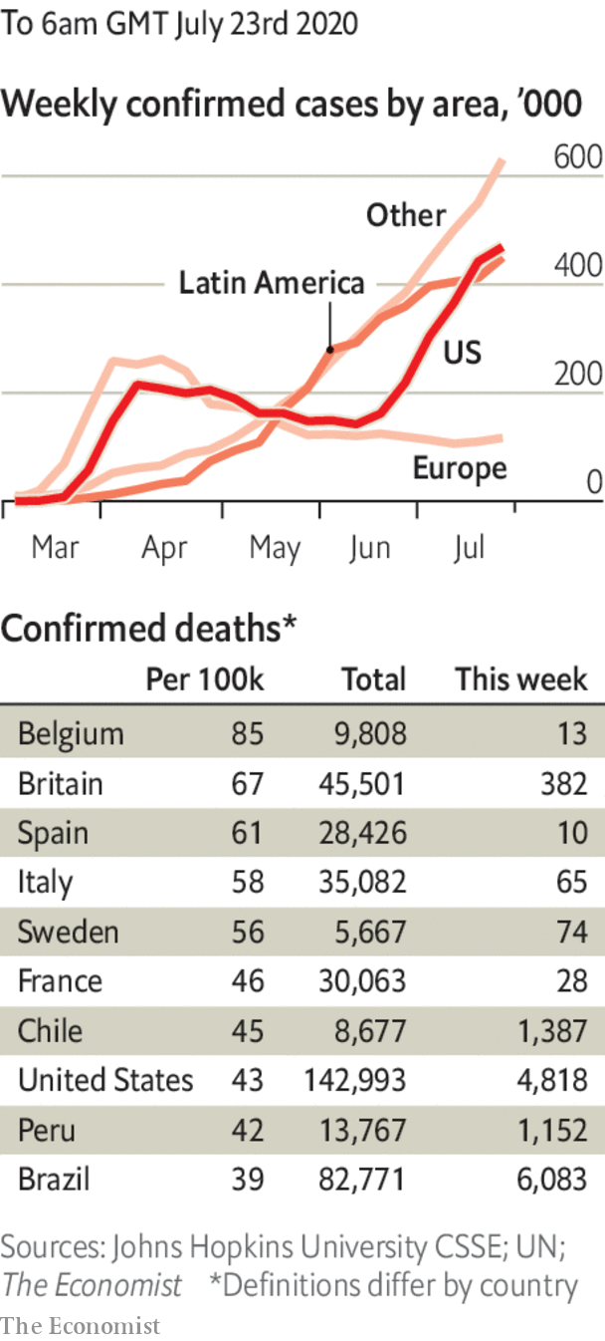

The World Health Organisation reported new record daily increases for global infections and deaths.

The spread of covid-19 accelerated in Australia; the number of cases detected on July 22nd, eclipsed the previous record.

A quarter of Delhi’s population has had the virus, according to a government study.

Argentina began easing restrictions it imposed in March at the start of its lockdown, one of the longest in Latin America.

The Bahamas banned most tourists from entering the islands either by air or sea. Visitors who test negative from Britain, Canada and the EU will still be allowed in, though Americans are by far the biggest group of visitors.

With infections soaring in the United States, Donald Trump urged Americans to wear face masks, calling it “patriotic”. See [article](https://www.economist.com/united-states/2020/07/25/the-geometry-of-the-pandemic-in-america).

This article was downloaded by calibre from <https://www.economist.com/the-world-this-week/2020/07/23/politics-this-week>

|  |  |  |  |
| --- | --- | --- | --- |
|  | Articles | Sections | Next |

|  |  |  |  |
| --- | --- | --- | --- |
| Previous | Articles | Sections | Next |

# Business this week

Jul 23rd 2020 |



Chevron said it would acquire Noble Energy in a deal worth $13bn, the first big takeover in the oil industry since the coronavirus crisis rocked the market in March. Noble is an independent producer with substantial assets in the Permian basin, where Chevron is investing heavily in shale. More consolidation is expected among oil companies as they navigate an uncertain outlook of decreased energy demand.

Meanwhile, oil prices hit their highest level since early March, in a broader market rally that was in part a response to the EU’s stimulus agreement. Brent crude climbed towards $45 a barrel.

United Airlines described the latest quarter as the most financially difficult in its 94-year history. Revenues plunged by 87% from April to June compared with the same three months last year, pushing United to a net loss of $1.6bn. The carrier burnt through an average of $40m in cash a day, though it expects that to ease this quarter. See [article](https://www.economist.com/business/2020/07/25/america-inc-braces-for-an-earnings-bloodbath).

United joined Lufthansa, American Airlines and British Airways in calling for co-ordination in testing transatlantic passengers for covid-19. The airlines sent a letter to the White House and European Commission arguing that co-ordinated testing would remove impediments to travel, such as quarantine.

Intesa Sanpaolo, Italy’s second-biggest bank, improved its takeover proposal for UBI Banca, the fifth biggest. It is trying to entice UBI’s shareholders by increasing the cash element of its deal; its website is running a countdown to the offer’s expiration on July 28th. Intesa thinks a merger will help the banks cope better with “new complex scenarios” resulting from the pandemic.

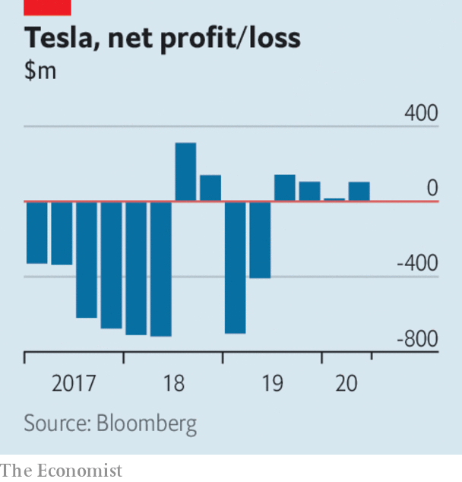

Tesla’s sales stayed steady in the second quarter, bucking the trend of plunging revenues among carmakers, possibly helped by its controversial defiance of the lockdown to restart production. The company reported net income of $104m, marking the first time it has made a profit in four consecutive quarters. It also announced that its second car factory in America will be based near Austin, Texas.

Lockdowns took a toll on Coca-Cola’s sales, which plunged by 28% in the second quarter compared with the same three months last year, thought to be the steepest decline for the company in at least 25 years. The maker of soft drinks gets half its revenue from sales at cinemas, stadiums and other venues. It noted that it had performed better in places with less restrictive lockdown measures.

## Fair exchange

Adevinta, a Norwegian operator of digital marketplaces in 15 countries, agreed to buy eBay’s classified-ads business in a $9.2bn transaction. EBay Classifieds was a force on the web 25 years ago. It now counts Gumtree among its brands, but brings in just a tenth of eBay’s sales. Adevinta says that the combined entity will get 3bn monthly visits to its various websites.

Congress started hashing out another stimulus package. There is resistance from some Republicans towards extending the extra $600 a week in unemployment benefits that has been paid during the crisis. The higher level of benefit irks those who think it is a disincentive to work; Democrats argue that many families will fall into hardship without it. This is the last week that the additional $600 will be doled out to the jobless. See article.

The Senate Banking Committee approved the nomination of Judy Shelton to the Fed (the full Senate must still vote). Donald Trump’s choice of Ms Shelton is controversial. She has argued against the existence of central banks, backed a return to the gold standard, and has been a serial switcher on interest rates.

The Federal Reserve extended its “Main Street” lending-support programme for small and medium-sized businesses to organisations that work for no profit, such as hospitals, colleges and charities.

Financial regulators in China took control of nine insurance companies, trust firms and stockbrokers, in a crackdown on alleged corporate wrongdoing and concern about risky bets amid a rally in China’s stockmarkets. Several of those seized, including Huaxia, a life insurer, are linked to Xiao Jianhua, a Chinese billionaire who was abducted from Hong Kong in 2017. It is thought he is awaiting trial in China.

## A giant cover up

Walmart’s nationwide policy requiring customers to wear face masks came into force. Most abided by the rules, though there were reports of a few differences of opinion being aired among patrons in some stores. Many of America’s retailers now insist on face coverings. Shoppers in England also debated the merits of masks, which are mandatory in shops from July 24th.

This article was downloaded by calibre from <https://www.economist.com/the-world-this-week/2020/07/23/business-this-week>

|  |  |  |  |
| --- | --- | --- | --- |
| Previous | Articles | Sections | Next |

|  |  |  |  |
| --- | --- | --- | --- |
| Previous | Articles | Sections | Next |

# KAL’s cartoon

Jul 23rd 2020 |

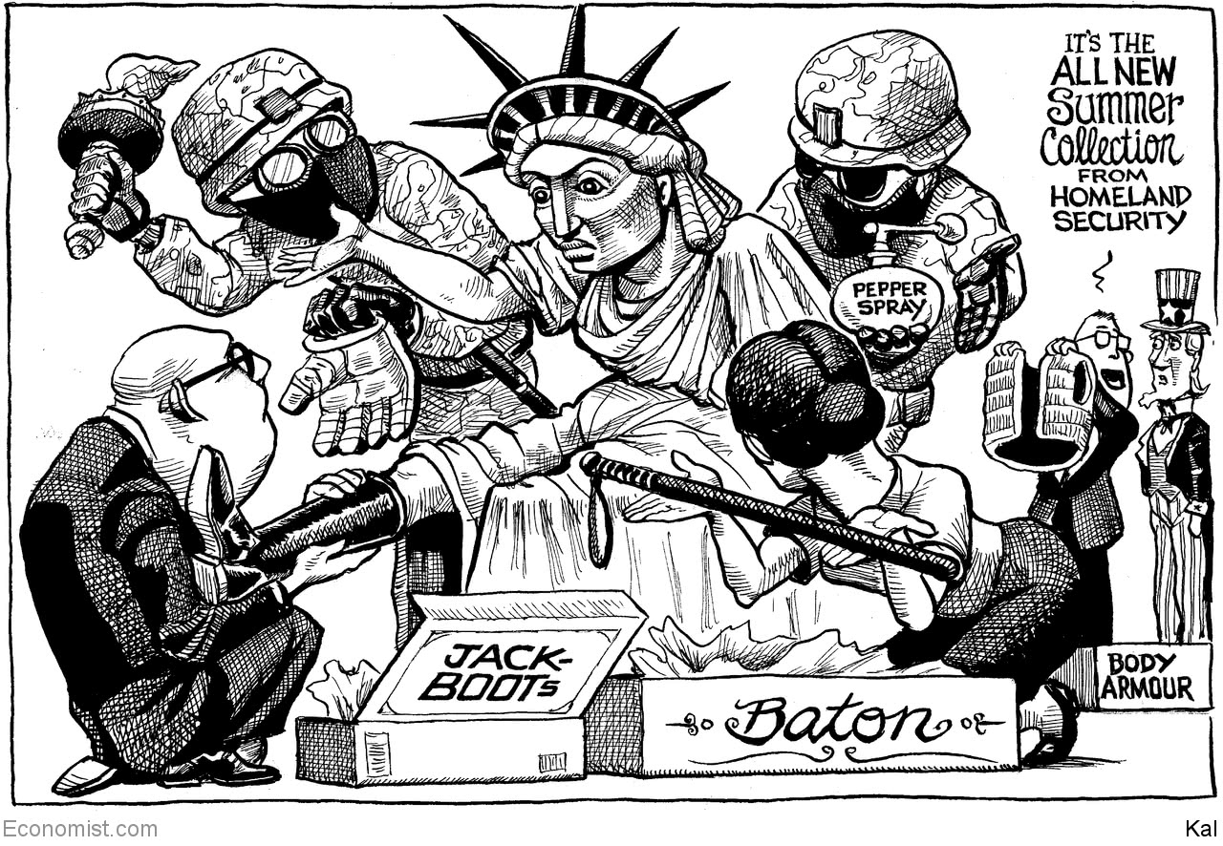

This article was downloaded by calibre from <https://www.economist.com/the-world-this-week/2020/07/23/kals-cartoon>

|  |  |  |  |
| --- | --- | --- | --- |
| Previous | Articles | Sections | Next |

|  |  |  |
| --- | --- | --- |
| The world this week | Sections | Letters |

Leaders

Macroeconomics: Free money

.

Collective debt: Europe pulls together

.

Regional development: Revive, then thrive

.

Tanzania: You say bullish, I say...

.

Space exploration: Tread softly

.

|  |  |  |
| --- | --- | --- |
| The world this week | Sections | Letters |

|  |  |  |  |
| --- | --- | --- | --- |
|  | Articles | Sections | Next |

#### Macroeconomics

# Governments must beware the lure of free money

Budget constraints have gone missing. That presents both danger and opportunity

Jul 23rd 2020 |

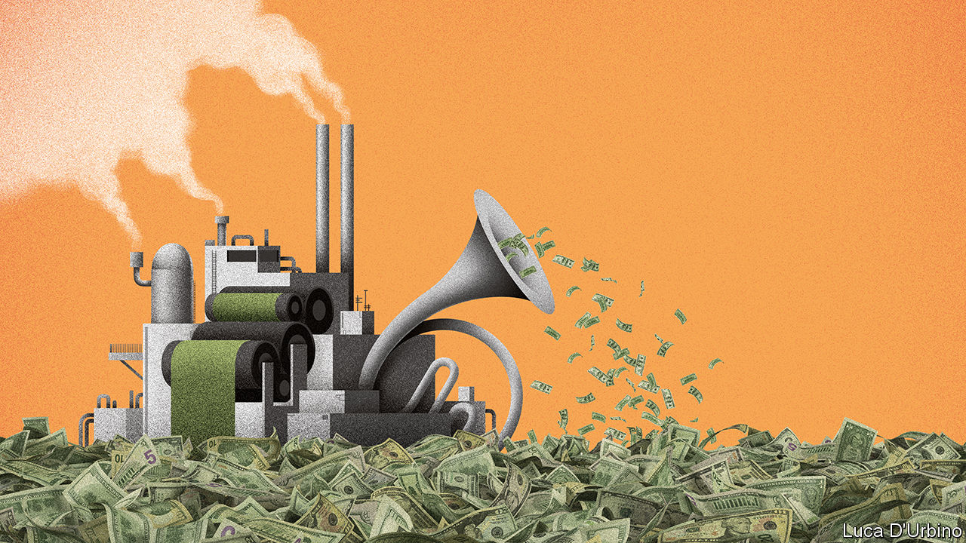

IT IS SOMETIMES said that governments wasted the global financial crisis of 2007-09 by failing to rethink economic policy after the dust settled. Nobody will say the same about the covid-19 pandemic. It has led to a desperate scramble to enact policies that only a few months ago were either unimaginable or heretical. A profound shift is now taking place in economics as a result, of the sort that happens only once in a generation. Much as in the 1970s when clubby Keynesianism gave way to Milton Friedman’s austere monetarism, and in the 1990s when central banks were given their independence, so the pandemic marks the start of a new era. Its overriding preoccupation will be exploiting the opportunities and containing the enormous risks that stem from a supersized level of state intervention in the economy and financial markets.

This new epoch has four defining features. The first is the jaw-dropping scale of today’s government borrowing, and the seemingly limitless potential for yet more. The IMF predicts that rich countries will borrow 17% of their combined GDP this year to fund $4.2trn in spending and tax cuts designed to keep the economy going. They are not done. In America Congress is debating another spending package (see article). The European Union has just agreed on a new stimulus funded by common borrowing, crossing a political Rubicon (see Leader).

The second feature is the whirring of the printing presses. In America, Britain, the euro zone and Japan central banks have created new reserves of money worth some $3.7trn in 2020. Much of this has been used to buy government debt, meaning that central banks are tacitly financing the stimulus. The result is that long-term interest rates stay low even while public-debt issuance soars.

The state’s growing role as capital-allocator-in-chief is the third aspect of the new age. To see off a credit crunch, the Federal Reserve, acting with the Treasury, has waded into financial markets, buying up the bonds of AT&T, Apple and even Coca-Cola, and lending directly to everyone from bond dealers to non-profit hospitals. Together the Fed and Treasury are now backstopping 11% of America’s entire stock of business debt. Across the rich world, governments and central banks are following suit.

The final feature is the most important: low inflation. The absence of upward pressure on prices means there is no immediate need to slow the growth of central-bank balance-sheets or to raise short-term interest rates from their floor around zero. Low inflation is therefore the fundamental reason not to worry about public debt, which, thanks to accommodative monetary policy, now costs so little to service that it looks like free money.

Don’t fool yourself that the role of the state will magically return to normal once the pandemic passes and unemployment falls. Yes, governments and central banks may dial down their spending and bail-outs. But the new era of economics reflects the culmination of long-term trends. Even before the pandemic, inflation and interest rates were subdued despite a jobs boom. Today the bond market still shows no sign of worrying about long-term inflation. If it is right, deficits and money-printing may well become the standard tools of policymaking for decades. The central banks’ growing role in financial markets, meanwhile, reflects the stagnation of banks as intermediaries and the prominence of innovative and risk-hungry shadow banks and capital markets (see article). In the old days, when commercial banks ruled the roost, central banks acted as lenders of last resort to them. Now central banks increasingly have to get their hands dirty on Wall Street and elsewhere by acting as mammoth “marketmakers of last resort”.

A state with a permanently broader and deeper reach across the economy creates some opportunities. Low rates make it cheaper for the government to borrow to build new infrastructure, from research labs to electricity grids, that will boost growth and tackle threats such as pandemics and climate change. As societies age, rising spending on health and pensions is inevitable—if the resulting deficits help provide a necessary stimulus to the economy, all the more reason to embrace them.

Yet the new era also presents grave risks. If inflation jumps unexpectedly the entire edifice of debt will shake, as central banks have to raise their policy rates and in turn pay out vast sums of interest on the new reserves that they have created to buy bonds. And even if inflation stays low, the new machinery is vulnerable to capture by lobbyists, unions and cronies.

One of monetarism’s key insights was that sprawling macroeconomic management leads to infinite opportunities for politicians to play favourites. Already they are deciding which firms get tax breaks and which workers should be paid by the state to wait for their old jobs to reappear. Soon some loans to the private sector will turn sour, leaving governments to choose which firms fail. When money is free, why not rescue companies, protect obsolete jobs and save investors?

However, though that would provide a brief stimulus, it is a recipe for distorted markets, moral hazard and low growth. Fear of politicians’ myopia was why many countries delegated power to independent central banks, which wielded a single, simple tool—interest rates—to manage the economic cycle. Yet today interest rates, so close to zero, seem impotent and the monarchs who run the world’s central banks are becoming rather like servants working as the government’s debt-management arm.

## Free markets and free lunches

Each new era of economics confronts a new challenge. After the 1930s the task was to prevent depressions. In the 1970s and early 1980s the holy grail was to end stagflation. Today the task for policymakers is to create a framework that allows the business cycle to be managed and financial crises to be fought without a politicised takeover of the economy. As our briefing this week explains, this may involve delegating fiscal firepower to technocrats, or reforming the financial system to enable central banks to take interest rates deeply negative, exploiting the revolutionary shift among consumers away from old-style banking to fintech and digital payments. The stakes are high. Failure will mean the age of free money eventually comes at a staggering price.■

This article was downloaded by calibre from <https://www.economist.com/leaders/2020/07/23/governments-must-beware-the-lure-of-free-money>

|  |  |  |  |
| --- | --- | --- | --- |
|  | Articles | Sections | Next |

|  |  |  |  |
| --- | --- | --- | --- |
| Previous | Articles | Sections | Next |

#### Pulling together

# Europe’s €750bn rescue package sets a welcome precedent

Even if the details are fraught

Jul 25th 2020 |

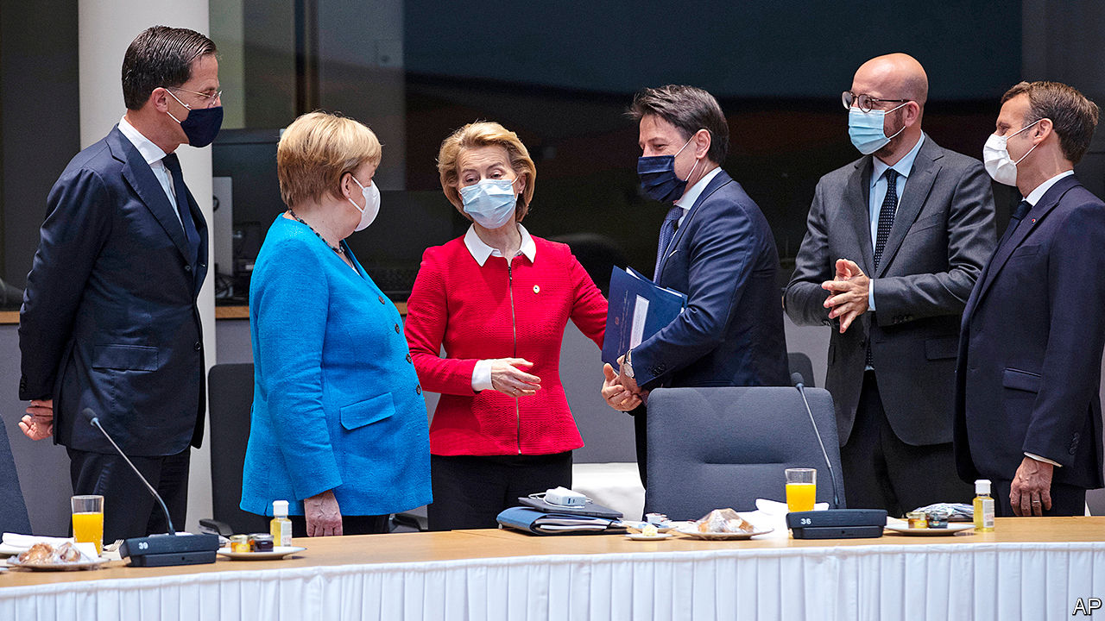

WHEN THE leaders of the European Union agreed this week on a €750bn ($869bn) package to help members’ economies recover from covid-19, they answered a looming question: whether Europe was too divided to handle the pandemic. As in earlier crises, the virus’s economic ravages split the EU’s members. Rich countries with low government debt and fewer infections (such as Germany and the Netherlands) can cope on their own. Some of the heavily indebted and infected countries (such as Italy and Spain) cannot. Without fiscal aid, they face recessions deep enough to drag down the whole of the EU.

The programme agreed to in Brussels does not just avert that danger. It does more to strengthen the union than anyone would have imagined a few months ago (see article). The total is equivalent to nearly 5% of the EU’s annual GDP, to be spent over several years, much of it in grants rather than loans. More important is how the money will be raised: through bonds issued by the European Commission. For the first time, the EU will collectively borrow large sums, piggybacking on the creditworthiness of stronger members to help weak ones. By raising total spending by the EU itself (as opposed to member states), from nearly €1.1trn to €1.8trn over seven years, it gives the club a potent fiscal weapon against recession to complement the monetary tools of the European Central Bank. This is especially important when near-zero interest rates are forcing a shift in emphasis from monetary to fiscal policy. To pay the debts back, and avoid direct responsibility, EU countries may be tempted to grant the European Commission more taxing authority.

All these moves to strengthen the EU are welcome. Yet it is an exaggeration to say that the summit was a “Hamiltonian moment”, analogous to the creation of a centralised borrowing capacity for the United States’ new federal government in 1790. The recovery fund does not pool countries’ existing debts, nor does it create new institutions like those set up during the euro crisis. On the one hand it sets a precedent for collective borrowing during an emergency that will probably be repeated. On the other, whereas a sovereign government borrows automatically when revenues do not meet expenditures, the EU will have to endure gruelling negotiations each time it wants to do so.

In part this is no bad thing. The summit showed that Europe is not ready for a Hamiltonian moment. It reflected splits between members over what policies are desirable and what sort of club the EU is. A group of wealthy, net-contributor countries nicknamed the “frugals” (led by the Netherlands, along with Austria, Denmark, Sweden and Finland), which had misgivings about proposals for collective debt, cut the grant portion from €500bn to €390bn. Mark Rutte, the Dutch prime minister, was lambasted as a skinflint by southern Europeans. Meanwhile Viktor Orban, Hungary’s autocratic leader, infuriated people who care about good governance by demanding that rule-of-law conditions for disbursements be diluted—not a great invitation to a fiscal union.

Given such mistrust, the EU’s leaps forward tend to require a lot of grubby horse-trading. The frugals were bought off with bigger rebates on their budget contributions. Enforcement of the rule of law was watered down sufficiently to appease Mr Orban. Yet the deal gives satisfaction at long last to the EU’s hard-pressed south. And the heroes are the EU’s two driving partners, France and Germany, which looked past narrow national interests and strived for a European solution. In April Angela Merkel, Germany’s chancellor, was still on the frugals’ side in opposing collective debt. It was her decision to join Emmanuel Macron, the French president, in backing this sort of debt that shifted the centre of gravity. Such unity among the big members makes smaller ones nervous: what Mr Macron sees as a hard-won precedent looks to Mr Rutte like a slippery slope. But it is Mr Macron and Mrs Merkel who are building the EU’s future.■

This article was downloaded by calibre from <https://www.economist.com/leaders/2020/07/25/europes-eu750bn-rescue-package-sets-a-welcome-precedent>

|  |  |  |  |
| --- | --- | --- | --- |
| Previous | Articles | Sections | Next |

|  |  |  |  |
| --- | --- | --- | --- |
| Previous | Articles | Sections | Next |

#### Regional development

# The best-run cities of America’s Midwest offer lessons in recovery

How to revive and thrive

Jul 25th 2020 |

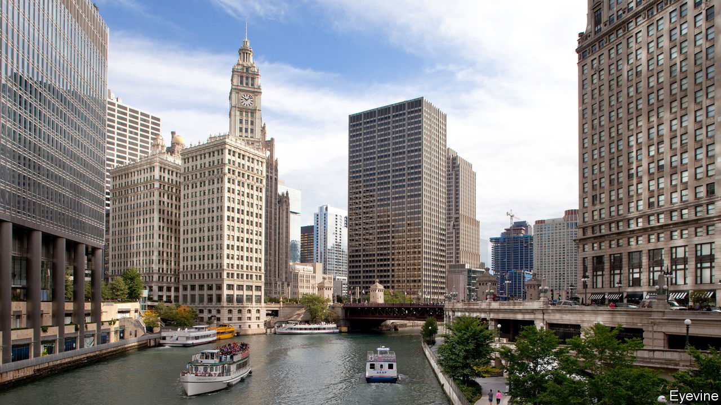

THE DOZEN states of America’s Midwest have a population of 68m, equal to Britain’s. They share an economy worth some $4trn, equivalent to the GDP of Germany, the world’s fourth-biggest. And the region’s swing voters weigh heavily in politics. Donald Trump won the presidency four years ago thanks to narrow victories in Michigan, Pennsylvania and Wisconsin. This year’s contest may yet be decided there, too. At the same time the Midwest’s troubles, after decades of industrial decline, are also outsized. Detroit, despite its recent improvements, is sadly still emblematic of how hard it is for cities to recover. It has shrunk to just one-third of its peak population of 1.8m in the 1950s. What can the region do to prosper again, and what can the rest of the world learn from its experience?

The Midwest as a whole draws in too few migrants, and too many of its brightest decide to leave. Until that is reversed, renewed prosperity is likely only in some urban parts, not everywhere. A sort of triage is under way. Not everywhere can be saved. Sometimes outsiders—state or federal government perhaps—will have to try to make it easier for people to live, work and study elsewhere, for example by cutting housing costs for those who move or helping pay for better education. But even Flint, Michigan, which has become notorious for economic decline and poisoned municipal water, still has some manufacturing jobs and a decent university.

However many places justify greater optimism. Some cities really can learn to flourish again. Parts of the Midwest, especially in the suburbs around Chicago, Minneapolis and Madison, can point to an admirable record in social mobility. Those born poor there have a much better chance of progressing to a middle-class life than people in less upwardly mobile regions, such as the south. That surely has much to do with investments in education. Cities cope best with closing factories or other shocks, such as a pandemic-induced economic slump, when they are home to people with plenty of schooling.

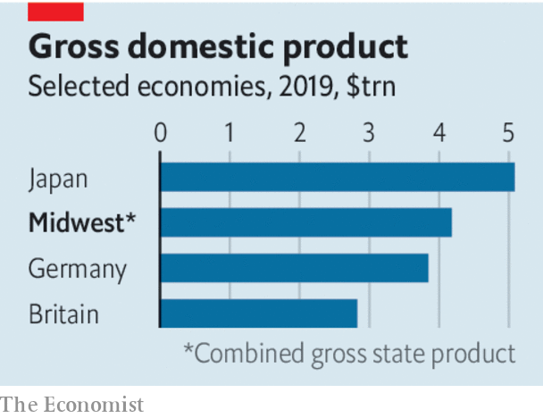

Our special report in this issue highlights some success stories. The population of Columbus, Ohio, is one of the fastest-growing in America. Indianapolis does well getting small businesses to blossom while keeping city finances healthy. And though much of the Midwest is too slow at reducing racial segregation—so evident in Minneapolis, where a policeman killed George Floyd in May—the likes of Cincinnati, which reformed police and promotes African-American businesses, show that progress can come. That is essential, for cutting racial division and boosting the economy go hand in hand.

Each place has its particular story, but the Midwest holds broad lessons for post-industrial areas elsewhere, whether they are in Europe or Asia. One is that recovery tends to grow from the inside out. If a town centre is an attractive place to live, work and play—with renovated bike paths, lots of parks, restaurants and nightlife—that draws young graduates, the newly retired and more. As a whole, Chicago’s population may have stalled but its downtown is an example of how to expand: its population, of around 110,000, is over six times bigger than it was four decades ago. People come both because such places are more fun than they used to be and because they remain less cripplingly expensive than coastal conurbations.

Cities also do well when they tap their own resources, or local social capital, instead of hoping for federal help or for a one-off giant investor who, with enough subsidies, will come in as a saviour. Pittsburgh rebounded after its steel mills shut by shifting spending from police, buying land from bankrupt mills, then letting various new businesses in high technology flourish there. In Grand Rapids, Michigan-based philanthropists, firms and officials persuaded local manufacturers to stay and then attracted others, for example from Germany.

Another lesson is that the most successful places bet on “eds and meds”. Cities with a decent university or an expansive hospital system (often the two go together) reliably outperform others. The Midwest has many of both. Pittsburgh did especially well by co-operating with Carnegie-Mellon University to get new firms in tech, artificial intelligence and robotics to expand. Some now call the city Roboburgh. Chicago plans an ambitious scheme to encourage universities and tech entrepreneurs to work together in a similar way. Minneapolis and others have had success with big health-care companies. The benefits are fewer when universities remain in bubbles, but the most successful ones now strive to engage with local residents.

This matters, last, because cities with the deepest pools of talented workers tend to be long-term winners. Rahm Emanuel, a former mayor of Chicago, boasts that his city produces or lures 140,000 new graduates each year. That’s a big reason why many companies choose to put their headquarters there. Columbus and its flourishing midsized firms also manage to keep hold of bright graduates and are learning to do vocational training that produces high skills for non-academic types. That makes the city appealing to investors of all sorts. Investing in its people is, ultimately, the Midwest’s greatest strength—and it is a recipe for other places, too. ■

Dig deeper:  
Sign up and listen to Checks and Balance, our [weekly newsletter](https://www.economist.com/checksandbalance/) and [podcast](https://www.economist.com/podcasts/2020/07/17/checks-and-balance-our-weekly-podcast-on-american-politics) on American politics, and explore our [presidential election forecast](https://projects.economist.com/us-2020-forecast/president)

This article was downloaded by calibre from <https://www.economist.com/leaders/2020/07/25/the-best-run-cities-of-americas-midwest-offer-lessons-in-recovery>

|  |  |  |  |
| --- | --- | --- | --- |
| Previous | Articles | Sections | Next |

|  |  |  |  |
| --- | --- | --- | --- |
| Previous | Articles | Sections | Next |

#### You say bullish, I say...

# Tanzania’s statistics smell wrong

And the IMF should say so

Jul 23rd 2020 |

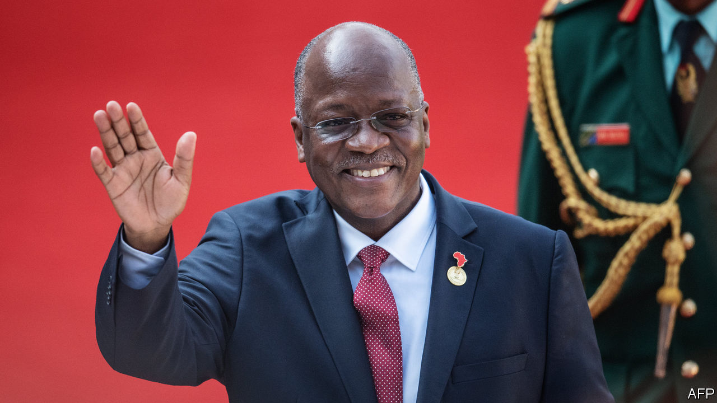

BY OFFICIAL MEASURES Tanzania is doing brilliantly. Covid-19 may be devastating its neighbours, but Tanzania is completely free of the virus—and safe for tourists—says President John Magufuli. Sub-Saharan Africa’s economy will shrink by 3.2% this year, predicts the IMF, but Tanzania forecasts GDP growth of 5.5%, making it one of the world’s star economies. This month the World Bank promoted it from “low income” to “lower-middle income”. That implies that income per person has surpassed $1,036, five years ahead of the government’s schedule.

Were these figures true, Tanzania would have much to celebrate. But the closer you look, the less plausible they seem (see article). For more than a decade from 2000 Tanzania’s economy, east Africa’s second-largest, was indeed among Africa’s best-performing. After ditching one-party rule and “African socialism” in the 1990s, the government opened up the economy and welcomed foreign investors. GDP grew by a cracking 5-8% almost every year. However, when Mr Magufuli came to power in 2015, he turned a hopeful country into a fearful one. Journalists were jailed, opposition MPs have been arrested or shot. The “bulldozer”, as he is known, has scared off investors by ripping up agreements, arresting employees and demanding arbitrary sums from companies. Acacia Mining, the largest foreign investor, was ordered to pay $190bn—more than three years of Tanzania’s GDP—though this absurd figure was later scaled back. Investment has slumped. Tanzania has fallen by ten places in the World Bank’s ease-of-doing-business ranking. Business folk think the economy slipped into recession well before covid-19. But official numbers show it galloping ahead.

IMF staff smelt a fish last year. Official GDP numbers seemed out of step with other gloomier data. The IMF raised concerns about the numbers and noted that the government’s “unpredictable or interventionist policies...could lead to meagre (or even negative) growth.” Its report should have sparked debate. It did not, because Mr Magufuli blocked its release.

If Tanzania’s economy grew by almost 7% in the fiscal year to the end of June 2019, why did tax revenue fall by 1%? And why has bank lending to companies slumped? Private data are bad, too. In 2019 sales at the biggest brewer fell by 5%. Sales of cement by the two biggest producers were almost flat. None of these things is likely if growth is storming ahead. The discrepancies are so large that it is hard to avoid the conclusion that the government is lying. Yet Tanzanians are terrified to suggest anything so scurrilous. Two years ago Mr Magufuli’s government wrote a law (since amended) under which people could be locked up for three years for disputing official statistics. The government has arrested Zitto Kabwe, an opposition MP, for questioning GDP numbers and closed a newspaper for publishing accurate exchange rates.

Lying is bad for democracy: without reliable numbers, it is hard for voters to hold governments to account. Lies are also bad for governance: it is hard to craft good policies without knowing what works. Because accurate numbers matter so much, donors spend almost $700m a year helping poor countries collect them. The World Bank even gave Tanzania a $30m loan to improve its statistics bureau. What was the point, if the IMF buckles to political pressure and professes to believe codswallop?

Some argue that international financial institutions can do more good by staying close to iffy governments and gently nudging them towards reform. If the IMF picks a fight with Mr Magufuli, he may send it packing. But in accepting junk statistics, the fund harms its own credibility, and stores up economic trouble for Tanzania. Mr Magufuli is running for a second term in October, so bad data also undermine the democratic rights of Tanzanians, who should be allowed to vote for politicians based on their actual record, rather than a fictitious one.

Honesty has worked before. In 2013, after it became clear that Argentina was fibbing about inflation, the fund stopped accepting its data. After a change in government, Argentina stopped lying. Tanzanians deserve the truth, too. ■

This article was downloaded by calibre from <https://www.economist.com/leaders/2020/07/23/tanzanias-statistics-smell-wrong>

|  |  |  |  |
| --- | --- | --- | --- |
| Previous | Articles | Sections | Next |

|  |  |  |  |
| --- | --- | --- | --- |
| Previous | Articles | Sections | Next |

#### Protecting other planets

# Mars may be a pristine ecosystem

Earthlings should be careful not to contaminate it

Jul 23rd 2020 |



EARTH ASIDE, Mars is the most-studied planet in the solar system. Satellites zip around it. Rovers trundle over its surface. A helicopter may soon clatter through its skies, for a clutch of new missions are either on their way or planned to launch soon.

The motive behind all this is the hope that Mars, like Earth, may support life—or may have done so in the past (see article). And, as technology spreads and rocketry gets cheaper, more people want to join the search for what would, in effect, be Biosphere 2. At first, Mars was the province of America and the Soviet Union. Japan tried and failed to explore it in 1998. Europe sent its first mission in 2003. India launched its in 2013. The United Arab Emirates joined the fray on July 20th. And China, after a failure in 2011, dispatched another attempt on July 23rd. The time is not far off when even private missions might be feasible.

Behind all this enthusiasm, though, is a worry. If Mars is sterile after all, or if any life which once dwelled there is now extinct, what people do to the planet by way of contamination with Earthly bugs probably does not matter. But if Martians do exist, even if they are but lowly bacteria (or something vaguely equivalent), that would mean Mars is a pristine ecosystem. Those wishing to investigate it should therefore tread lightly, for reasons of both moral and scientific prudence.

Astrobiologists identify two kinds of risk in putative encounters with alien life forms that are not actually toting ray guns. The first, “forward contamination”, is that hardy micro-organisms from Earth might hitch a ride with a space probe and set up shop on landing. The second, “back contamination”, concerns the reverse: that samples returned to Earth might bring alien microbes with them.

The first risk is no longer theoretical. Scientists reckon that the rovers and landers already on Mars each play host to tens of thousands of microscopic Earthlings. Shielded from radiation by the probes themselves, these bacteria are probably dormant—but not dead.

Back contamination would require samples to be returned from Mars. That has not happened yet. But America’s newest rover is designed to stash samples of Martian regolith away, to be returned to Earth by a follow-up mission in 2031.

Back contamination is the less worrying of the two. Lurid suggestions that Martian bugs might infect human beings ignore the fact that their biochemistry would almost certainly be too different from that of terrestrial organisms for this to happen. Sealed laboratories could provide reassurance for sticklers.

Forward contamination is more troubling. Some echo terrestrial worries about conservation, arguing that humans have a moral obligation not to damage other ecosystems. Others fret about the scientific implications. Life on Mars, whether extant or extinct, could be one of the most significant discoveries in the history of biology. Contamination risks disrupting understanding of that scientific bounty.

Countries are already required, by the Outer Space Treaty of 1967, to worry about these risks. But this treaty is light on specifics, leaving individual space agencies to come up with their own rules. This is better than nothing. But as more countries head for Mars, the case grows for a formal, global approach.

Plenty of ideas are worth discussing. Some advocate risk-management, in which the greatest care is taken when exploring those parts of Mars most likely to contain life, though lower standards apply in harsher regions. “Reversible exploration” holds that, if life is discovered, humanity should retrieve the probes that already dot the Martian surface, along with their microbial passengers. And should private individuals be required to follow the same rules as nation-states?

International co-operation is not a popular idea just now. Never mind: it should be tried anyway. Nationalism and protectionism can wane as well as wax, and alien-hunting is the work of decades. Counter-measures need not be expensive—experience suggests they add 10% or less to the cost of a probe. And it is hard to think of a more intrinsically global problem than ensuring that one planet’s life forms do not contaminate another’s. ■

This article was downloaded by calibre from <https://www.economist.com/leaders/2020/07/23/mars-may-be-a-pristine-ecosystem>

|  |  |  |  |
| --- | --- | --- | --- |
| Previous | Articles | Sections | Next |

|  |  |  |
| --- | --- | --- |
| Leaders | Sections | Briefing |

Letters

Letters to the editor: On Hong Kong, short-sellers, the Supreme Court, horse jumping, “The Prisoner”, medical terms, breadmaking

.

|  |  |  |
| --- | --- | --- |
| Leaders | Sections | Briefing |

|  |  |  |  |
| --- | --- | --- | --- |
|  | Articles | Sections | Next |

#### On Hong Kong, short-sellers, the Supreme Court, horse jumping, “The Prisoner”, medical terms, breadmaking

# Letters to the editor

A selection of correspondence

Jul 23rd 2020 |

Letters are welcome via e-mail to letters@economist.com

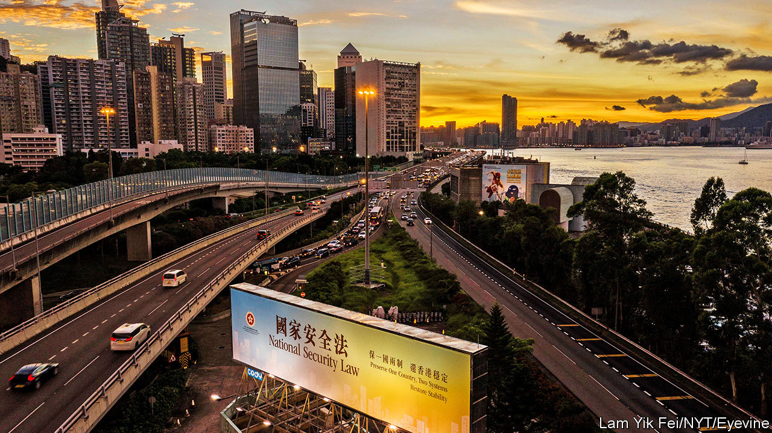

## Stability in Hong Kong

Hong Kong’s new national-security law is hardly “draconian” or “sweeping” (“The evening of its days”, [July 4th](https://www.economist.com/china/2020/07/02/a-new-national-security-bill-to-intimidate-hong-kong), “The party’s grip”, [July 11th](https://www.economist.com/china/2020/07/11/under-a-new-national-security-law-hong-kong-is-already-a-changed-city)). It is relatively mild as far as national-security laws go, focusing on just four well-defined and well-confined activities: secession, subversion of state power, terrorist activities and collusion with foreign or external forces. Nor is it spreading fear among the vast majority of Hong Kongers. After a year of violent protests and traumatising social and business disruption, we are returning to a stable, secure life.

The new law stipulates that the chief executive shall compile a list of judges to hear national-security cases. She may consult Hong Kong’s Committee for Safeguarding National Security and the chief justice of the Court of Final Appeal before doing so. This does not affect judicial independence at all. Hong Kong’s unique “one country, two systems” framework has been successfully implemented since 1997 and will continue to drive its progress.

Moreover, your charge that “censorship is spreading” following the removal of several books from public libraries does not reflect the facts. The books you mentioned are being reviewed to establish whether they violate the national-security legislation’s stipulations (they will be unavailable until that process is complete).

Let me stress that Hong Kong’s fundamental freedoms remain intact under the Basic Law and the applicable provisions of international covenants on human rights. Hong Kong will continue to thrive as a highly autonomous and vibrant international financial and business centre underpinned by the rule of law and an independent judiciary. Between June 30th, when the law was passed, and its opening on July 9th the Hang Seng index rose by 7%. Cash equity market turnover on July 6th, 7th and 9th surpassed HK$200bn ($26bn), the highest daily trading levels in more than two years. In short, Hong Kong looks forward to a peaceful and prosperous future.

MATTHEW CHEUNG KIN-CHUNG  
Chief secretary for administration  
Hong Kong Special Administrative Region Government

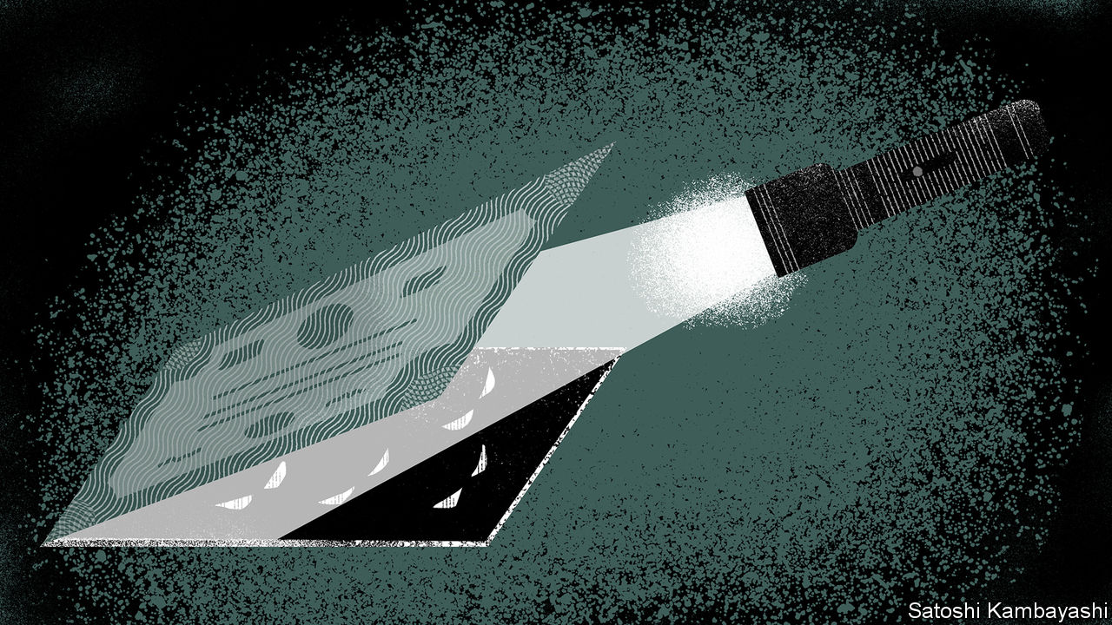

## Market disrupters

You lauded short-sellers because they occasionally correct the price of falsely or overvalued shares (“In praise of short-sellers”, [June 27th](https://www.economist.com/leaders/2020/06/24/wirecards-scandal-shows-the-benefits-of-short-sellers)). Yet on a routine basis small- and mid-cap companies that are known to require additional funds find that their market capitalisation declines alarmingly. Short-traders benefit from highly discounted dilutive rights issues, or defaults. The short interests have deep pockets and routinely work like a pack without actual collaboration through comments on social media and bulletin boards. This is destructive and makes markets such as AIM a dangerous place for a company known to need investment, and for the unwary to invest.

ALISTAIR HINDLE  
Edinburgh

## More united than divided

“The world this week” in the [July 11th](https://www.economist.com/the-world-this-week/2020/07/11/politics-this-week) issue referred to a 9-0 decision at America’s Supreme Court as a “rare instance of unanimity”. In fact, unanimous rulings (9-0 votes and 8-0 when a justice was recused) accounted for almost a third of the court’s judgments in its latest session. The sharply divided 5-4 and 5-3 votes may have got all the press, but made up just a fifth of its decisions.

MARK NELSON  
Denver



## Leaping horses

The list of odd and now defunct Olympic events you proffered in “Citius, Altius, Fortnite” ([June 27th](https://www.economist.com/leaders/2020/06/27/why-the-next-olympics-should-include-fortnite)) overlooked the equestrian long jump at the games in 1900. Constant van Langhendonck, a Belgian horse-rider, won gold with an unimpressive leap of 6.1 metres, one metre below the winning long jump in the athletics competition. Admittedly the athlete in that event did not have to carry a jockey.

RAF MOONS  
Mortsel, Belgium



## I am not a number

To a devoted fan of “The Prisoner” ([June 20th](https://www.economist.com/books-and-arts/2020/06/20/the-prisoner-a-classic-tv-series-is-apt-lockdown-viewing)), your essay was particularly welcome reading. It remains arguably the most original and thought-provoking series ever aired on network television. The themes it explored—man versus the state, the use and abuse of technology, individuality struggling against conformity—are even more real and pressing today than when the series was first broadcast in what seems a lifetime ago.

At its heart is Patrick McGoohan’s performance as Number 6, a former spy who refuses, despite all manner of deception, to reveal why he resigned. Was he, as some speculate, John Drake from McGoohan’s earlier series “Danger Man”? Or was he the symbol of an everyman? What was the meaning of the final episode? Who is Number 1? A quote from the series says it best: “Questions are a burden to others; answers a prison for oneself”.

MICHAEL KACZOROWSKI  
Ottawa, Canada

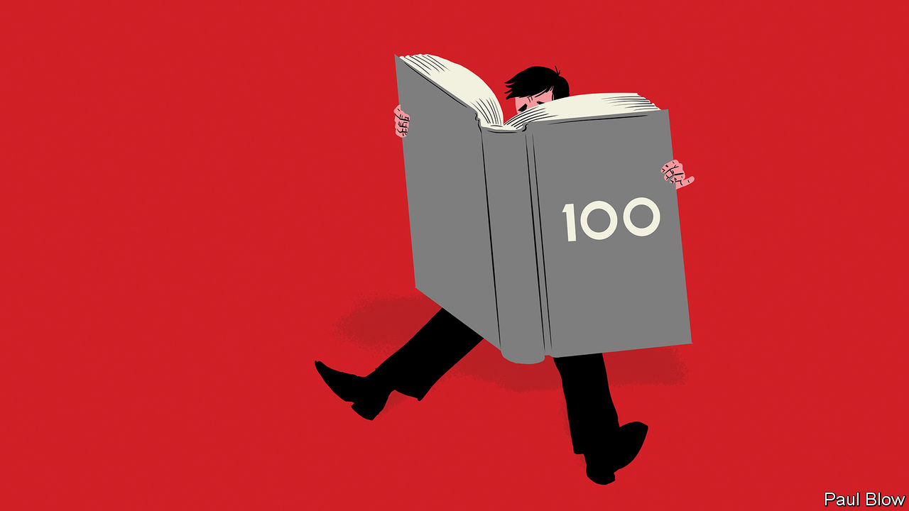

## Emergency words

Bartleby’s musings on pointless esoteric acronyms really resonated with me ([June 13th](https://www.economist.com/business/2020/06/11/lessons-from-100-columns)). Although technical abbreviations are still regularly used in hospitals, CBT (Chronic Burger Toxicity), UDI (Unidentified Drinking Injury) and OFIG (One Foot In the Grave), have for some reason fallen out of favour.

Adam Fox, who has researched the use of medical slang, once recalled the story of a doctor who had scribbled TTFO (polite translation: patient told to leave) on a patient’s notes. When asked in court what this meant, the doctor replied shrewdly that he had advised the patient “to take fluids orally” before sending him on his way.

DR JOSHUA RABINOWITZ  
London



## Rising to the challenge

The global flour-milling industry has been surprised by the surge of interest in home baking during lockdown (“The need to knead”, [July 11th](https://www.economist.com/leaders/2020/07/11/sourdough-economics-no-need-to-knead)). As you observe, people have more of that most valuable baking ingredient, their time. As well as an interest in food, home baking is a leisure activity that people do for many reasons, including educating their children. Baking is for sharing. How do you value that time? Surely it is priceless.

GEORGE MARRIAGE  
Director  
Marriage’s Millers  
Chelmsford, Essex

I’m as big a fan of Ricardian economic theory as the next Economist reader, but your article on sourdough economics failed to persuade this attorney (and newly minted amateur breadbaker) to hang up his apron. Should those less musically adept than Jimi Hendrix or Jimmy Page also hang up their guitars? Those less deft at painting than Vincent van Gogh discard their brushes? Creative endeavours have value above that captured by economic measures. May the trend in dabbling, like our loaves, continue to rise.

COLIN MCDONELL  
Tampa

Thanks for sensibly dissuading amateur breadmaking. I also encourage my friends to leave gambling, football and lovemaking to the professionals. Much more efficient.

SEB FARQUAR  
Oxford

This article was downloaded by calibre from <https://www.economist.com/letters/2020/07/23/letters-to-the-editor>

|  |  |  |  |
| --- | --- | --- | --- |
|  | Articles | Sections | Next |

|  |  |  |
| --- | --- | --- |
| Letters | Sections | Asia |

Briefing

A new era of economics: Starting over again

.

|  |  |  |
| --- | --- | --- |
| Letters | Sections | Asia |

|  |  |  |  |
| --- | --- | --- | --- |
|  | Articles | Sections | Next |

#### Starting over again

# The covid-19 pandemic is forcing a rethink in macroeconomics

It is not yet clear where it will lead

Jul 25th 2020 |

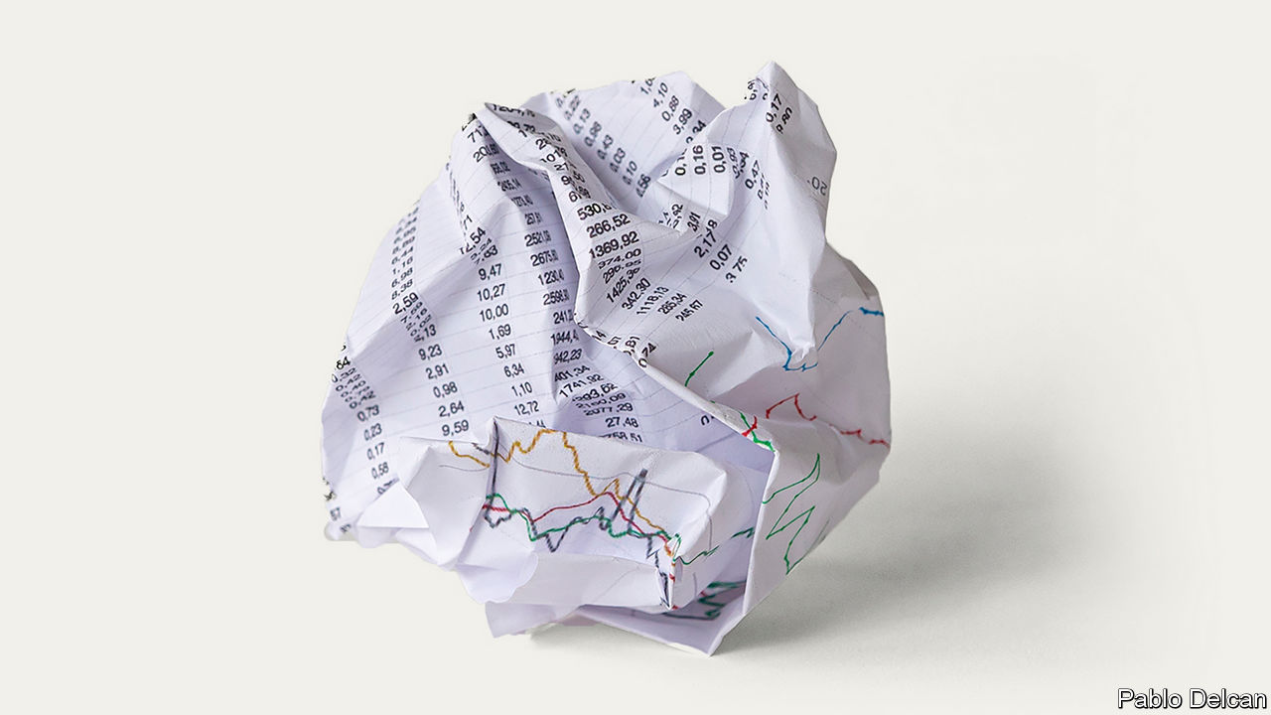

Editor’s note: Some of our covid-19 coverage is free for readers of The Economist Today, our daily [newsletter](https://my.economist.com/user#newsletter). For more stories and our pandemic tracker, see our [hub](https://www.economist.com/news/2020/03/11/the-economists-coverage-of-the-coronavirus)

IN THE FORM it is known today, macroeconomics began in 1936 with the publication of John Maynard Keynes’s “The General Theory of Employment, Interest and Money”. Its subsequent history can be divided into three eras. The era of policy which was guided by Keynes’s ideas began in the 1940s. By the 1970s it had encountered problems that it could not solve and so, in the 1980s, the monetarist era, most commonly associated with the work of Milton Friedman, began. In the 1990s and 2000s economists combined insights from both approaches. But now, in the wreckage left behind by the coronavirus pandemic, a new era is beginning. What does it hold?

The central idea of Keynes’s economics is the management of the business cycle—how to fight recessions and ensure that as many people who want work can get it. By extension, this key idea became the ultimate goal of economic policy. Unlike other forms of economic theory in the early 20th century, Keynesianism envisaged a large role for the state in achieving that end. The experience of the Great Depression had convinced proto-Keynesians that the economy was not a naturally correcting organism. Governments were supposed to run large deficits (ie, spending more than they took in taxes) during downturns to prop up the economy, with the expectation that they would pay down the accumulated debt during the good times.

The Keynesian paradigm collapsed in the 1970s. The persistently high inflation and high unemployment of that decade (“stagflation”) baffled mainstream economists, who thought that the two variables almost always moved in opposite directions. This in turn convinced policymakers that it was no longer possible to “spend your way out of a recession”, as James Callaghan, then Britain’s prime minister, conceded in 1976. A central insight of Friedman’s critique of Keynesianism was that if policymakers tried to stimulate without tackling underlying structural deficiencies then they would raise inflation without bringing unemployment down. And high inflation could then persist, just because it was what people came to expect.

Policymakers looked for something new. The monetarist ideas of the 1980s inspired Paul Volcker, then chairman of the Federal Reserve, to crush inflation by constraining the money supply, even though doing so also produced a recession that sent unemployment soaring. The fact that Volcker had known that this would probably happen revealed that something else had changed. Many monetarists argued that policymakers before them had focused too much on equality of incomes and wealth to the detriment of economic efficiency. They needed instead to focus on the basics—such as low and stable inflation—which would, over the long run, create the conditions in which living standards would rise.

## It sounds like a whisper

In the 1990s and 2000s a synthesis of Keynesianism and Friedmanism emerged. It eventually recommended a policy regime loosely known as “flexible inflation targeting”. The central objective of the policy was to achieve low and stable inflation—though there was some room, during downturns, to put employment first even if inflation was uncomfortably high. The primary tool of economic management was the raising and lowering of short-term interest rates, which, it had turned out, were more reliable determinants of consumption and investment than the money supply. Central banks’ independence from governments ensured that they would not fall into the inflationary traps of which Friedman warned. Fiscal policy, as a way to manage the business cycle, was sidelined, in part because it was seen to be too subject to political influence. The job of fiscal policy was to keep public debts low, and to redistribute income to the degree and in the way that politicians saw fit.

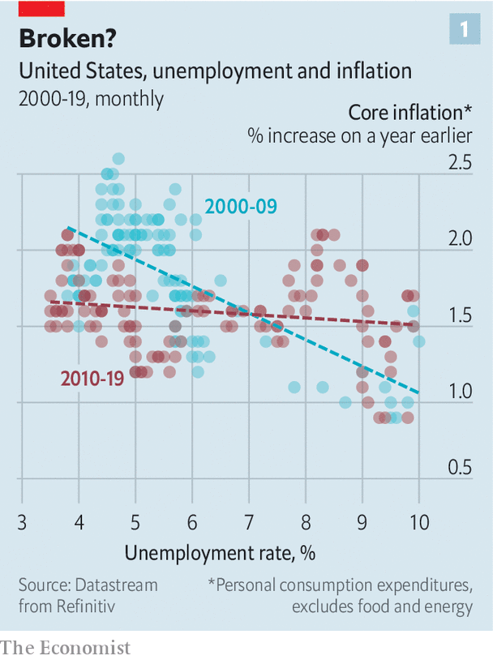

Now it seems that this dominant economic paradigm has reached its limit. It first began to wobble after the global financial crisis of 2007-09, as policymakers were confronted by two big problems. The first was that the level of demand in the economy—broadly, the aggregate desire to spend relative to the aggregate desire to save—seemed to have been permanently reduced by the crisis. To fight the downturn central banks slashed interest rates and launched quantitative easing (QE, or printing money to buy bonds). But even with extraordinary monetary policy, the recovery from the crisis was slow and long. GDP growth was weak. Eventually, labour markets boomed, but inflation remained muted (see chart 1). The late 2010s were simultaneously the new 1970s and the anti-1970s: inflation and unemployment were once again not behaving as expected, though this time they were both surprisingly low.

This threw into question the received wisdom about how to manage the economy. Central bankers faced a situation where the interest rate needed to generate enough demand was below zero. That was a point they could not easily reach, since if banks tried to charge negative interest rates, their customers might simply withdraw their cash and stuff it under the mattress. QE was an alternative policy instrument, but its efficacy was debated. Such disputes prompted a rethink. According to a working paper published in July by Michael Woodford and Yinxi Xie of Columbia University the “events of the period since the financial crisis of 2008 have required a significant reappraisal of the previous conventional wisdom, according to which interest-rate policy alone...should suffice to maintain macroeconomic stability.”

The second post-financial-crisis problem related to distribution. While concerns about the costs of globalisation and automation helped boost populist politics, economists asked in whose interests capitalism had lately been working. An apparent surge in American inequality after 1980 became central to much economic research. Some worried that big firms had become too powerful; others, that a globalised society was too sharp-edged or that social mobility was declining.

Some argued that structurally weak economic growth and the maldistribution of the spoils of economic activity were related. The rich have a higher tendency to save rather than spend, so if their share of income rises then overall saving goes up. Meanwhile in the press central banks faced accusations that low interest rates and QE were driving up inequality by boosting the prices of housing and equities.

Yet it was also becoming clear just how much economic stimulus could benefit the poor, if it caused unemployment to drop sufficiently for wages for low-income folk to rise. Just before the pandemic a growing share of GDP across the rich world was accruing to workers in the form of wages and salaries. The benefits were greatest for low-paid workers. “We are hearing loud and clear that this long recovery is now benefiting low- and moderate-income communities to a greater extent than has been felt for decades,” said Jerome Powell, the Fed’s chair, in July 2019. The growing belief in the redistributive power of a booming economy added to the importance of finding new tools to replace interest rates to manage the business cycle.

## Tables starting to turn

Then coronavirus hit. Supply chains and production have been disrupted, which all else being equal should have caused prices to surge as raw materials and finished goods were harder to come by. But the bigger impact of the pandemic has been on the demand side, causing expectations for future inflation and interest rates to fall even further. The desire to invest has plunged, while people across the rich world are now saving much of their income.

The pandemic has also exposed and accentuated inequities in the economic system. Those in white-collar jobs can work from home, but “essential” workers—the delivery drivers, the rubbish cleaners—must continue to work, and are therefore at greater risk of contracting covid-19, all the while for poor pay. Those in industries such as hospitality (disproportionately young, female and with black or brown skin) have borne the brunt of job losses.

Even before covid-19, policymakers were starting to focus once again on the greater effect of the bust and boom of the business cycle on the poor. But since the economy has been hit with a crisis that hurts the poorest hardest, a new sense of urgency has emerged. That is behind the shift in macroeconomics. Devising new ways of getting back to full employment is once again the top priority for economists.

But how to go about it? Some argue that covid-19 has proved wrong fears that policymakers cannot fight downturns. So far this year rich countries have announced fiscal stimulus worth some $4.2trn, enough to take their deficits to nearly 17% of GDP, while central-bank balance-sheets have grown by 10% of GDP. This enormous stimulus has calmed markets, stopped businesses from collapsing and protected household incomes. Recent policy action “provides a textbook rebuke of the idea that policymakers can run out of ammunition,” argues Erik Nielsen of Unicredit, a bank.

Yet while nobody doubts that policymakers have found plenty of levers, there remains disagreement over which should continue to be pulled, who should do the pulling, and what the effects will be. Economists and policymakers can be divided into three schools of thought, from least to most radical: one which calls merely for greater courage; one which looks to fiscal policy; and one which says the solution is negative interest rates.

Take the first school. Its proponents say that so long as central banks are able to print money to buy assets they will be able to boost economic growth and inflation. Some economists argue that central banks must do this to the extent necessary to restore growth and hit their inflation targets. If they fail it is not because they are out of ammunition but because they are not trying hard enough.

Not long ago central bankers followed this creed, insisting that they still had the tools to do their job. In 2013 Japan, which has more experience than any other country with low-growth, ultra-low-inflation conditions, appointed a “whatever-it-takes” central banker, Kuroda Haruhiko, to lead the Bank of Japan (BoJ). He succeeded in stoking a jobs boom, but boosted inflation by less than was promised. Right before the pandemic Ben Bernanke, a former chairman of the Fed, argued in a speech to the American Economic Association that the potential for asset purchases meant that monetary policy alone would probably be sufficient to fight a recession.

But in recent years most central bankers have gravitated towards exhorting governments to use their budgets to boost growth. Christine Lagarde opened her tenure as president of the European Central Bank with a call for fiscal stimulus. Mr Powell recently warned Congress against prematurely withdrawing its fiscal response to the pandemic. In May Philip Lowe, the governor of the Reserve Bank of Australia (RBA), told the Australian parliament that “fiscal policy will have to play a more significant role in managing the economic cycle than it has in the past”.

## Standing in the welfare lines

That puts most central bankers in the second school of thought, which relies on fiscal policy. Adherents doubt that central-bank asset purchases can deliver unlimited stimulus, or see such purchases as dangerous or unfair—perhaps, for example, because buying corporate debt keeps companies alive that should be allowed to fail. Better for the government to boost spending or cut taxes, with budget deficits soaking up the glut of savings created by the private sector. It may mean running large deficits for a prolonged period, something that Larry Summers of Harvard University has suggested.

This view does not eliminate the role of central banks, but it does relegate them. They become enablers of fiscal stimulus whose main job is to keep even longer-term public borrowing cheap as budget deficits soar. They can do so either by buying bonds up directly, or by pegging longer-term interest rates near zero, as the BoJ and the RBA currently do. As a result of covid-19 “the fine line between monetary policy and government-debt management has become blurred”, according to a report by the Bank for International Settlements (BIS), a club of central banks.

Not everyone is happy about this. In June Paul Tucker, formerly deputy governor of the Bank of England, said that, in response to the bank’s vast purchases of government bonds, the question was whether the bank “has now reverted to being the operational arm of the Treasury”. But those influenced by the Keynesian school, such as Adair Turner, a former British financial regulator, want the monetary financing of fiscal stimulus to become a stated policy—an idea known as “helicopter money”.

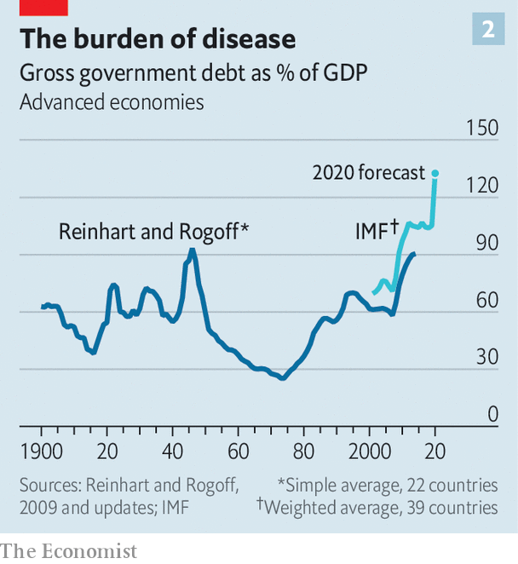

Huge fiscal-stimulus programmes mean that public-debt-to-GDP ratios are rising (see chart 2). Yet these no longer reliably alarm economists. That is because today’s low interest rates enable governments to service much higher public debts (see chart 3). If interest rates remain lower than nominal economic growth—ie, before adjusting for inflation—then an economy can grow its way out of debt without ever needing to run a budget surplus, a point emphasised by Olivier Blanchard of the Peterson Institute for International Economics, a think-tank. Another way of making the argument is to say that central banks can continue to finance governments so long as inflation remains low, because it is ultimately the prospect of inflation that forces policymakers to raise rates to levels which make debt costly.

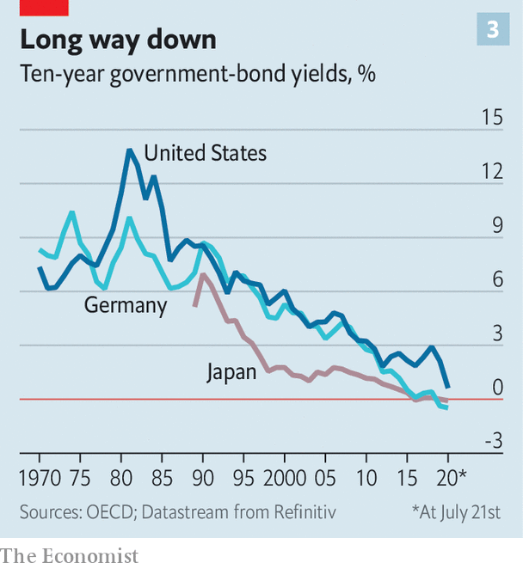

To some, the idea of turning the fiscal tap to full blast, and co-opting the central bank to that end, resembles “modern monetary theory” (MMT). This is a heterodox economics which calls for countries that can print their own currency (such as America and Britain) to ignore debt-to-GDP ratios, rely on the central bank to backstop public debt, and continue to run deficit spending unless and until unemployment and inflation return to normal.

And there is indeed a resemblance between this school of thought and MMT. When interest rates are zero, there is no distinction between issuing debt, which would otherwise incur interest costs, and printing money, which text books assume does not incur interest costs. At a zero interest rate it “doesn’t matter whether you finance by money or finance by debt,” said Mr Blanchard in a recent webinar.

But the comparison ends there. While those who advocate MMT want the central bank to peg interest rates at zero permanently, other mainstream economists advocate expansionary fiscal policy precisely because they want interest rates to rise. This, in turn, allows monetary policy to regain traction.

The third school of thought, which focuses on negative interest rates, is the most radical. It worries about how interest rates will remain below rates of economic growth, as Mr Blanchard stipulated. Its proponents view fiscal stimulus, whether financed by debt or by central-bank money creation, with some suspicion, as both leave bills for the future.

A side-effect of QE is that it leaves the central bank unable to raise interest rates without paying interest on the enormous quantity of electronic money that banks have parked with it. The more money it prints to buy government bonds, the more cash will be deposited with it. If short-term rates rise, so will the central bank’s “interest on reserves” bill. In other words, a central bank creating money to finance stimulus is, in economic terms, doing something surprisingly similar to a government issuing floating-rate debt. And central banks are, ultimately, part of the government.

So there are no free lunches. “The higher the outstanding QE as a share of total government debt, the more the government is exposed to fluctuations in short-term interest rates,” explained Gertjan Vlieghe of the Bank of England in a recent speech. A further concern is that in the coming decades governments will face still more pressure on their budgets from the pension and health-care spending associated with an ageing population, investments to fight climate change, and any further catastrophes in the mould of covid-19. The best way to stimulate economies on an ongoing basis is not, therefore, to create endless bills to be paid when rates rise again. It is to take interest rates negative.

## Waiting for a promotion

Some interest rates are already marginally negative. The Swiss National Bank’s policy rate is -0.75%, while some rates in the euro zone, Japan and Sweden are also in the red. But the likes of Kenneth Rogoff of Harvard University and Willem Buiter, the former chief economist of Citigroup, a bank, envision interest rates of -3% or lower—a much more radical proposition. To stimulate spending and borrowing these rates would have to spread throughout the economy: to financial markets, to the interest charges on bank loans, and also to deposits in banks, which would need to shrink over time. This would discourage saving—in a depressed economy, after all, too much saving is the fundamental problem—though it is easy to imagine negative interest rates stirring a populist backlash.

Many people would also want to take their money out of banks and stuff it under the mattress. Making these proposals effective, therefore, would require sweeping reform. Various ideas for how to do this exist, but the brute-force method is to abolish at least high-denomination banknotes, making holding large quantities of physical cash expensive and impractical. Mr Rogoff suggests that eventually cash might exist only as “weighty coins”.

Negative rates also pose problems for banks and the financial system. In a paper in 2018 Markus Brunnermeier and Yann Koby of Princeton University argue that there is a “reversal interest rate” beneath which interest-rate cuts actually deter bank lending—harming the economy rather than boosting it. Below a certain interest rate, which experience suggests must be negative, banks might be unwilling to pass on interest-rate cuts to their depositors, for fear of prompting peeved customers to move their deposits to a rival bank. Deeply negative interest rates could squash banks’ profits, even in a cashless economy.

## Take what’s theirs

Several factors might yet make the economy more hospitable to negative rates, however. Cash is in decline—another trend the pandemic has accelerated. Banks are becoming less important to finance, with ever more intermediation happening in capital markets (see article). Capital markets, notes Mr Buiter, are unaffected by the “reversal rate” argument. Central bankers, meanwhile, are toying with the idea of creating their own digital currencies which could act like deposit accounts for the public, allowing the central bank to pay or charge interest on deposits directly, rather than via the banking system. Joe Biden’s campaign for the White House includes similar ideas, which would allow the Fed to directly serve those who do not have a private bank account.

Policymakers now have to weigh up the risks to choose from in the post-covid world: widespread central-bank intervention in asset markets, ongoing increases in public debt or a shake-up of the financial system. Yet increasing numbers of economists fear that even these radical changes are not enough. They argue that deeper problems exist which can only be solved by structural reform.



A new paper by Atif Mian of Princeton University, Ludwig Straub of Harvard University and Amir Sufi of the University of Chicago expands on the idea that inequality saps demand from the economy. Just as inequality creates a need for stimulus, they argue, stimulus eventually creates more inequality. This is because it leaves economies more indebted, either because low interest rates encourage households or firms to borrow, or because the government has run deficits. Both public and private indebtedness transfer income to rich investors who own the debt, thereby depressing demand and interest rates still further.

The secular trends of recent decades, of higher inequality, higher debt-to-GDP ratios and lower interest rates, thus reinforce one another. The authors argue that escaping the trap “requires consideration of less standard macroeconomic policies, such as those focused on redistribution or those reducing the structural sources of high inequality.” One of these “structural sources of high inequality” might be a lack of competitiveness. Big businesses with captive markets need not invest as much as they would if they faced more competition.

A new working paper by Anna Stansbury, also of Harvard University, and Mr Summers, rejects that view and instead blames workers’ declining bargaining power in the labour market. According to the authors, this can explain all manner of American economic trends: the decline (until the mid-2010s) in workers’ share of income, reduced unemployment and inflation, and high corporate profitability. Business owners may be more likely to save than workers, they suggest, so as corporate income rises, aggregate savings increase.

Ms Stansbury and Mr Summers favour policies such as strengthening labour unions or promoting “corporate-governance arrangements that increase worker power”. They argue that such policies “would need to be carefully considered in light of the possible risks of increasing unemployment.” Ideas for increasing the power of workers as individuals may be more promising. One is to strengthen the safety-net, which would increase workers’ bargaining power and ability to walk away from unattractive working arrangements.

In a recent book Martin Sandbu, a columnist at the Financial Times, suggests replacing tax-free earnings allowances with small universal basic incomes. Another idea is to strengthen the enforcement of existing employment law, currently weak in many rich countries. Tighter regulation of mergers and acquisitions, to prevent new monopolies forming, would also help.

All these new ideas will now compete for space in a political environment in which change suddenly seems much more possible. Who could have imagined, just six months ago, that tens of millions of workers across Europe would have their wages paid for by government-funded furlough schemes, or that seven in ten American job-losers in the recession would earn more from unemployment-insurance payments than they had done on the job? Owing to mass bail-outs, “the role of the state in the economy will probably loom considerably larger,” says the BIS.

## Talking about a revolution

Many economists want precisely this state intervention, but it presents clear risks. Governments which already carry heavy debts could decide that worrying about deficits is for wimps and that central-bank independence does not matter. That could at last unleash high inflation and provide a painful reminder of the benefits of the old regime. Financial-sector reforms could backfire. Greater redistribution might snap the economy out of a funk in the manner that Mr Sufi, Ms Stansbury and their respective colleagues describe—but heavy taxes could equally discourage employment, enterprise and innovation.

The rethink of economics is an opportunity. There now exists a growing consensus that tight labour markets could give workers more bargaining power without the need for a big expansion of redistribution. A level-headed reassessment of public debt could lead to the green public investment necessary to fight climate change. And governments could unleash a new era of finance, involving more innovation, cheaper financial intermediation and, perhaps, a monetary policy that is not constrained by the presence of physical cash. What is clear is that the old economic paradigm is looking tired. One way or another, change is coming. ■

Editor’s note: Some of our covid-19 coverage is free for readers of The Economist Today, our daily [newsletter](https://my.economist.com/user#newsletter). For more stories and our pandemic tracker, see our [hub](https://www.economist.com/news/2020/03/11/the-economists-coverage-of-the-coronavirus)

This article was downloaded by calibre from <https://www.economist.com/briefing/2020/07/25/the-covid-19-pandemic-is-forcing-a-rethink-in-macroeconomics>

|  |  |  |  |
| --- | --- | --- | --- |
|  | Articles | Sections | Next |

|  |  |  |
| --- | --- | --- |
| Briefing | Sections | China |

Asia

Caste in India: No escape

.

The Philippine economy: A milder infection

.

Covid-19 in Central Asia: Dust-busters

.

Shipping in Japan: Sailing without sailors

.

Banyan: South China scene

.

|  |  |  |
| --- | --- | --- |
| Briefing | Sections | China |

|  |  |  |  |
| --- | --- | --- | --- |
|  | Articles | Sections | Next |

#### No escape

# Even as India urbanises, caste discrimination remains rife

Cities are segregated, and inter-caste marriages are vanishingly rare

Jul 23rd 2020 | DELHI

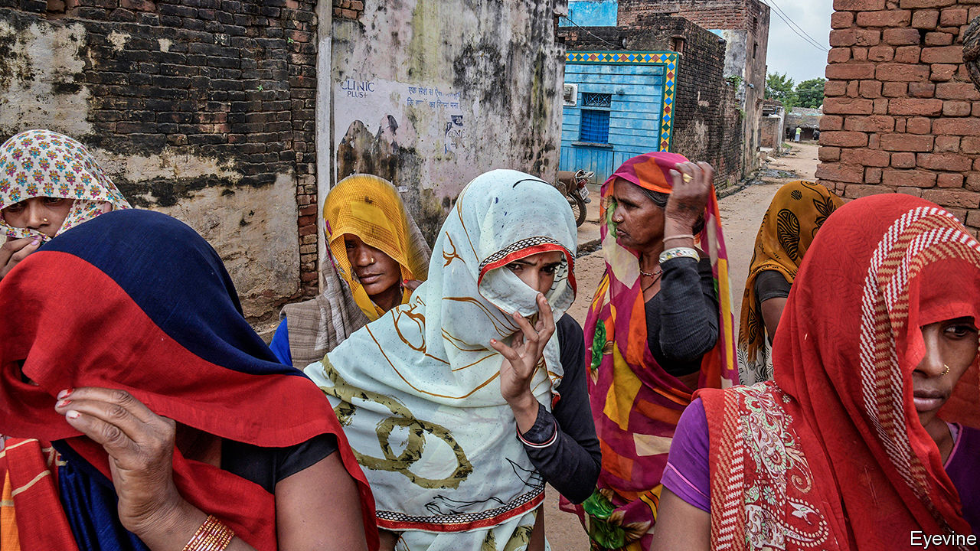

ANKIT PAL and Tushar Singh have a few things in common. They are 19 and 18 years old respectively and live within a couple of hours’ drive of Delhi, albeit in opposite directions. They both happen to be Dalits, from the bottom ranks of India’s voluminous caste register. And they have also both been in the news lately, though for very different reasons.

In mid-July the smiling, bespectacled Mr Singh won brief fame by scoring a flawless 100 out of 100 in each of five subjects in school-leaving exams—the best marks in the country. He wants to study history, he told interviewers, and enter the Indian Administrative Service, the top echelon of the bureaucracy. Mr Pal, in contrast, appeared wearing a pink shirt and grey trousers in a viral video last year in which two young men from the landowning Jat caste force him to pull down his trousers and then beat him with a heavy stick. His tormentors were angry because Mr Pal, having found a job in a factory making smartphone screens, refused to work their land or look after their cows, as Dalits in the Jat-dominated village have done for generations.

Seventy years ago, India’s constitution, largely written by B.R. Ambedkar, a Dalit intellectual, declared all citizens equal before the law. It abolished untouchability, making the Hindu practice a punishable offence, and enjoined the state to improve the lot of the “weaker sections” of society.

Dalits’ circumstances have indeed improved. The rigid, ritual shunning of them has largely faded. Three generations of quotas in legislative bodies, in state schools and in government service have created a lower-caste bourgeoisie, such that mid-ranked castes began lobbying for, and eventually won their own “reservations”. Caste-based parties have sprung up to agitate for more government help, and won power in many states.

Given all this, the stellar success of Mr Singh ought to be unremarkable, just as the casual violence and ritual humiliation inflicted on Mr Pal ought to be unthinkable. Yet Mr Singh’s caste, revealed by the proud portrait of Ambedkar in the young scholar’s living room, was widely remarked upon. Mr Singh is also unusual in that he attended a top private school. His parents are college teachers.

Mr Pal’s luck is of a different kind. It is lucky that he, like many Dalits who have found ways to escape the only jobs previously open to them, such as share-cropping, waste removal and tanning, no longer needs higher-caste patrons. He is also lucky to be alive. Few Hindus any longer observe strict ritual purity or consider Dalits literally “untouchable”. Even so, with dismal regularity news stories tell of higher-caste people maiming, raping or murdering Dalits for such slights as daring to sport a moustache, ride a horse or, worst of all, woo someone above their station.

The persistence of discrimination is not limited to Hindus. An estimated 65% of India’s 20m Catholics are former Dalits whose forebears converted in part to escape caste oppression. Yet according to the Indian church’s most recent published record, out of 27,000 priests only 5% were of Dalit origin, and not a single one of its six cardinals and 30 archbishops. Among India’s 14% Muslim minority a similar unspoken distinction persists, separating families that converted in the distant past, or were associated with ruling Muslim dynasties, from the larger mass imputed to have converted as a way of erasing their previous, presumably lowly, caste status.

And although reservations have secured plum posts for some, lower-caste uplift has been limited. Accelerated economic growth from 1990 to 2010 pulled tens of millions out of poverty, including many of lower caste, but overall inequality between rich and poor, including within caste groups, has grown. Moreover, in the government as in the private sector, the highest positions remain a near-monopoly for the three top tiers or varnas of the broader caste pyramid: the brahmins or priestly class, the kshatriyas or warrior class and the vaishyas or merchant class, who between them account for perhaps 20% of India’s 1.3bn people. It is not just the 220m Dalits, or the 190m Muslims, or the 110m from “scheduled tribes” who are under-represented, but also the 40-50% of Hindus who come from the widest tier of the pyramid, the shudras or labouring castes, known as Other Backwards Classes (OBCs).

Out of the 89 highest-ranked civil servants in the central government, according to a recent survey, just four are not upper-caste Hindus, and not one is an OBC. Two-thirds of the Supreme Court’s 31 judges and more than half of all state governors are high-caste Hindus. When the home ministry recently formed a panel to revise the criminal code, its five experts were all men, all from north India and all from upper castes. The trend is just as stark outside of government. A study published last year of the mainstream Hindi and English press revealed that out of 121 people in senior jobs, such as editors, all but 15 were upper caste. Not a single one was a Dalit.

Just as positive discrimination was supposed to equalise workplaces, it was hoped that demographic change, such as migration from villages to cities, would break down caste rigidities. Optimists pointed to greater mixing as people of multiple castes were often obliged by circumstance to share the same city wards. Stubbornly, however, statistics have shown that intermarriage between castes remains rare: just 6% of all couples at the most recent count.

An analysis of housing by a team led by Naveen Bharathi of Harvard University has revealed a striking persistence and, in some cases, an intensification of caste segregation. Using census data for 147 cities at the level of blocks rather than wards, and accounting not just for broad caste categories but for jati, which is to say the 5,000-odd subcaste “communities” that tend to marry among themselves, Mr Bharathi’s team found that segregation by caste in Indian cities is comparable to that by race in American ones. Whereas 60% of blocks in Ahmedabad, the biggest city in Gujarat, housed not a single Dalit, some 80% of Dalits lived in just 10% of the city. Inequality in Ahmedabad as measured by the Gini coefficient was more extreme than in Johannesburg, the most unequal city in South Africa, the world’s most unequal country.

Yet amid seeming stasis, Mr Bharathi also found a great deal of churn. “Barriers are breaking in cities, but it’s not the big barriers between castes,” he says. “It is the subcastes that are dissolving.” As the association of family names with traditional professions, which evoked some memories in villages, makes ever less sense in cities, there is less of a taboo around marrying into adjacent jatis within the same broader caste. At the same time, says Mr Bharathi, class differences are growing stronger. “If you zoom in on a Dalit slum, you will find that poorer Dalits don’t intermix with Dalits of slightly higher status living right next door.” Ambedkar, who assumed that the positive discrimination he prescribed in the constitution would end millennia of caste oppression, would be perplexed. ■

This article was downloaded by calibre from <https://www.economist.com/asia/2020/07/23/even-as-india-urbanises-caste-discrimination-remains-rife>

|  |  |  |  |
| --- | --- | --- | --- |
|  | Articles | Sections | Next |

|  |  |  |  |
| --- | --- | --- | --- |
| Previous | Articles | Sections | Next |

#### A milder infection

# The Philippine peso is the champion of emerging-market currencies

Relatively low external debts, high reserves and resilient remittances have kept it buoyant

Jul 23rd 2020 |

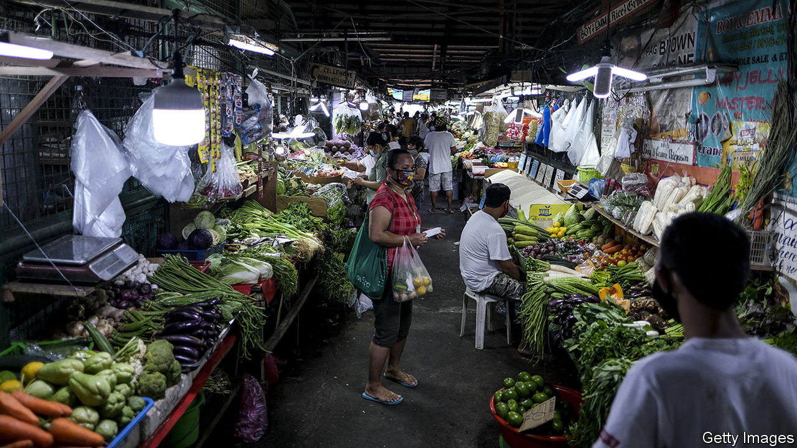

IN MARCH PROSPECTS for the Philippine economy were darkening. The country’s combustible president, Rodrigo Duterte, had announced an immediate quarantine for the main island of Luzon and its 55m people. Bangko Sentral ng Pilipinas (BSP), the central bank, warned that the outlook was the worst since the Asian financial crisis of 1997-98. The currencies of other countries in the region were sinking as the world economy listed. But the peso barely budged (see chart). It is one of a handful of emerging-market currencies to have strengthened against the dollar this year. Its steadfastness says a lot about the resilience of the Philippine economy.

It helped that the oil price was plunging (and consumption within the country was falling), dramatically cutting the Philippines’ import bill. The BSP did cut interest rates to keep credit flowing, which in normal times might have caused the peso to weaken. But Nicholas Mapa of ING, a bank, thinks foreign investors held on to Philippine assets because interest rates remain higher than in rich countries, yet the Philippines is seen as a safer bet than most other emerging markets.

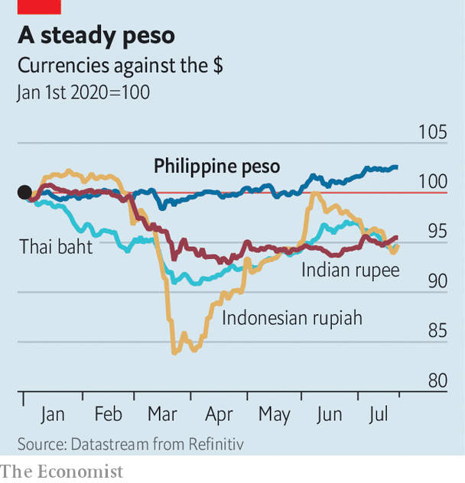

In part that is because remittances, which keep the economy afloat, have held up quite well so far. They fell by only 3% in the first four months of 2020. Inflows can even increase during periods of domestic economic weakness, as the diaspora responds to distress calls from home. Gareth Leather of Capital Economics, a consultancy, points out that lots of Filipino expatriates work in health care, and so are likely to retain their jobs even as migrants working in construction, say, lose theirs.

The public finances have also been prudently managed in recent years. Fairly thrifty budgets combined with rapid economic growth have brought down the ratio of public debt to GDP from more than 70% in the mid-2000s to less than 40% in 2019. Relative to the size of the economy, foreign debts are lower than in Malaysia, Indonesia or Thailand. The BSP has built up $93bn of foreign-exchange reserves—a record stash.

But the Philippines’ relative economic stability, and the buoyancy it has bestowed on the peso, are not unalloyed benefits. The peso’s strength makes Philippine exports more expensive and remittances less valuable. And if the world economy is heading down the tubes, it is scant comfort that other emerging markets are descending faster.

This article was downloaded by calibre from <https://www.economist.com/asia/2020/07/23/the-philippine-peso-is-the-champion-of-emerging-market-currencies>

|  |  |  |  |
| --- | --- | --- | --- |
| Previous | Articles | Sections | Next |

|  |  |  |  |
| --- | --- | --- | --- |
| Previous | Articles | Sections | Next |

#### Dust-busters

# Central Asian governments admit they have a problem with covid-19

Or, in Turkmenistan’s case, with dust

Jul 23rd 2020 | ALMATY



Editor’s note: Some of our covid-19 coverage is free for readers of The Economist Today, our daily [newsletter](https://my.economist.com/user#newsletter). For more stories and our pandemic tracker, see our [hub](https://www.economist.com/news/2020/03/11/the-economists-coverage-of-the-coronavirus)

WHEN TURKMENISTAN’S president did a spot of fishing recently, he brought a snazzy accessory with him: a camouflage face mask. The isolationist Central Asian state is one of the last countries still claiming to be coronavirus-free, along with North Korea and some remote Pacific islands. But something has changed in Turkmenistan, which is suddenly adopting a plethora of precautions. Out are the patriotic festivals, football matches and horse races that stood out as the rest of the world shut down earlier this year. Suddenly, the government wants citizens to wear face masks—to protect against dust, rather than germs, it insists. (No, it has not been an especially dusty summer.) The authorities even admitted a team from the World Health Organisation, which tactfully advised them to behave “as if covid-19 were already circulating”, neatly sidestepping the government’s dismissal of reports that a covid-like ailment was indeed circulating in Turkmenistan as “fake news”.

Elsewhere in Central Asia, the disease is well into a second wave and restrictions are being reimposed. In Kazakhstan officially diagnosed cases have rocketed by around 1,400% since the easing of a stringent lockdown in May. Rules requiring people to keep their distance and wear masks have been flouted. The authorities are now trying to enforce them, painting carefully spaced circles in parks popular with picnickers and plastering cities with posters promoting masks. In early July shopping malls and gyms were closed, though bars and restaurants may still serve customers outdoors. Groups of more than three people are banned, but Kazakhstan, like other countries in Central Asia, has struggled to discourage toi¸ gatherings of the extended family that are an ingrained custom but that have helped spread the pandemic.

The government has admitted that a spike in pneumonia probably reflects undiagnosed cases of covid-19. Given that 163,000 more pneumonia cases were registered in recent months than in the same period last year, the official tally of around 80,000 covid-19 infections is clearly a wild understatement. The health-care system is creaking under the strain, with hospitals in big cities running short of beds. Public anger at the government’s handling of the pandemic is running high, exacerbated by a thunderous but tone-deaf fireworks display in Nur-Sultan, the capital, to celebrate a public holiday that fell on the 80th birthday of Nursultan Nazarbayev, the ex-president in whose honour the city is named. Mr Nazarbayev, who stepped down last year but is still feted as the father of the nation, has recently recovered from the coronavirus himself.

Kyrgyzstan recently adjusted its statistics to include probable covid-19 cases previously classified as pneumonia, causing the number of infections to double overnight and fatalities to jump almost fivefold. Uzbekistan has reimposed a lockdown it began easing in May, although its government is still attempting to lure tourists with a promise to pay them $3,000 should they catch the coronavirus during their visit. Many in the region are anxious enough to resort to spurious folk remedies, from ginger and horseradish to horse milk and dog fat. A cartoon circulating in Uzbekistan captures the grim mood: angry viral blobs have a doctor on the ropes in a boxing ring, while an official looks away.

Gurbanguly Berdymukhamedov, Turkmenistan’s president, could not be accused of being uncaring, however. After his fishing trip, he magnanimously donated his catch to an orphanage. The children duly trooped out on state television to express their awe and gratitude, all safely protected from dust by spotless face masks. ■

Editor’s note: Some of our covid-19 coverage is free for readers of The Economist Today, our daily [newsletter](https://my.economist.com/user#newsletter). For more stories and our pandemic tracker, see our [hub](https://www.economist.com/news/2020/03/11/the-economists-coverage-of-the-coronavirus)

This article was downloaded by calibre from <https://www.economist.com/asia/2020/07/23/central-asian-governments-admit-they-have-a-problem-with-covid-19>

|  |  |  |  |
| --- | --- | --- | --- |
| Previous | Articles | Sections | Next |

|  |  |  |  |
| --- | --- | --- | --- |
| Previous | Articles | Sections | Next |

#### Sailing without sailors

# As crews grow old, Japanese shipping firms try to do without them

But robots have a lot to learn about the ways of the sea

Jul 23rd 2020 | TOKYO

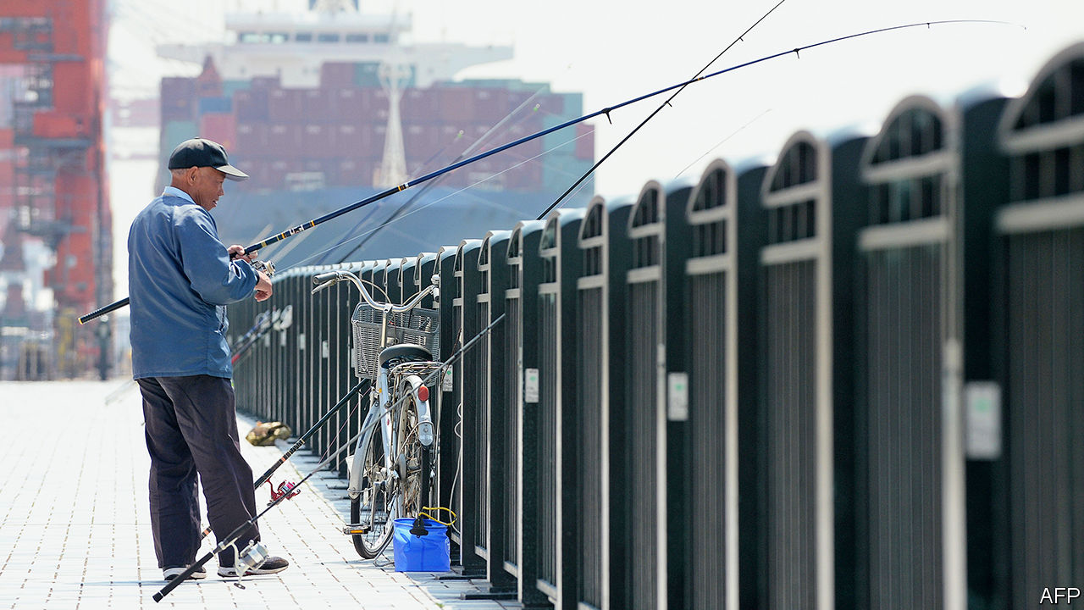

CAPTAIN KUWAHARA SATORU’S tanker is manoeuvring through Yokohama harbour. Dolphins leap in the distance; a cruise ship slides under a glittering bridge. He issues an instruction via the radio, and suddenly the ship is navigating congested waters off Singapore. Offered a turn at the helm, your correspondent accidentally sets the tanker on a collision course. Mr Kuwahara quickly steers away from danger. Then he flips a switch and all the windows go dark. He walks out of the simulator into the 24th-floor offices of Japan Marine Science (JMS), a shipping consultancy.

JMS is using the simulator to develop algorithms to help ships steer themselves. It is one of the many Japanese firms that is experimenting with the maritime equivalent of self-driving cars. The Nippon Foundation, a philanthropic group, has put ¥3.4bn ($31m) into a consortium trying to develop the necessary technology. Giant Japanese shipping firms like Mitsui OSK Lines (MOL) and Nippon Yusen Kaisha (NYK) have been working on autonomous ships since 2016. (Similar efforts are under way in China, South Korea and Europe.)

For Japan, demography and geography make automation essential. The country has more than 400 inhabited islands, many inaccessible by road, and “fewer and fewer transport options to reach them”, says Unno Mitsuyuki of the Nippon Foundation. More than half of the 21,000 mariners in the coastal shipping industry are over 50; more than a quarter are over 60. Their work is physically demanding and often requires spending long stretches away from home. “Plus there’s no internet at sea,” notes Nishimura Haruka, a 33-year-old captain and researcher at JMS. For many of her peers, that makes seafaring a non-starter, although Ms Nishimura herself makes do with “the beauty of the horizon”.

The technology is still in its infancy. Some firms have set their sites on partial automation to reduce the crew needed for long-haul voyages; others want to do away with crew altogether, or to have them steer ships from offices thousands of miles away from the vessel in question. The Nippon Foundation reckons half the coastal fleet could be autonomous by 2040.

Rolls-Royce, a British engineering firm, demonstrated an autonomous ferry off the coast of Finland in 2018. Last year NYK, which is the parent company of JMS, successfully tested an autonomous navigation system on a container ship with 71,000 tons of cargo during a four-day voyage from China to Japan. Earlier this year it deployed a remotely-navigated tugboat in Tokyo Bay. Aboard some of MOL’s ships the helmsmen gaze at horizons with augmented reality overlays that show the depths of the surrounding seas and the position of ships imperceptible to the naked eye. Algorithms flag potential collisions. As well as relieving labour shortages, the industry sees self-steering ships as a way to reduce accidents at sea, some 70% of which are caused by human error. “A computer doesn’t become tired and make mistakes,” says Koyama Tomoyuki of NYK.

Driverless ships, however, pose particular challenges. As Mr Koyama puts it, “We don’t have roads at sea. You can go any direction.” The oceans are filled with ships of varying sizes, from one-man sailboats to hulking tankers. The elements can discombobulate. During its containership trial, NYK found that its computer programme was too sensitive to the fluctuations of rough seas. Oceans also come with unexpected obstacles far more troublesome than a pothole. “Whales, for example,” says Kawagoe Yoshikazu of MOL.

Communications and security present further difficulties. The speed of data transfer to and from ships lags about 15 years behind those on land, reckons Mr Kawagoe. Fully crewless ships would also present opportunities for cyber-pirates (and the ordinary sort, too, presumably). NYK believes it will be cheaper to keep some crew members aboard than to build up ships’ digital defences. Human psychology may also be a barrier to fully autonomous vessels: if driverless cars seem spooky, Mr Kuwahara notes, imagine being at sea aboard a captain-less cruise ship. ■

This article was downloaded by calibre from <https://www.economist.com/asia/2020/07/23/as-crews-grow-old-japanese-shipping-firms-try-to-do-without-them>

|  |  |  |  |
| --- | --- | --- | --- |
| Previous | Articles | Sections | Next |

|  |  |  |  |
| --- | --- | --- | --- |
| Previous | Articles | Sections | Next |

#### Banyan

# In the South China Sea, America is churning waters claimed by China

It is decrying Chinese expansionism in the South China Sea much more emphatically

Jul 23rd 2020 |



CHINA HAS been trying to turn the South China Sea, which is bigger than the Mediterranean, into a Chinese lake for the better part of a decade. In the Spratly archipelago, which is claimed wholly or in part by Brunei, China, Malaysia, the Philippines, Taiwan and Vietnam, it has built 13 square kilometres of artificial islands atop specks of reef and rock. The constructions bristle with missiles and bomber-sized bunkers. Coastguard vessels and even a “maritime militia” of fishing boats also help project power far from China’s shores.

Their business is intimidation, asserting the right to fisheries and oil- and gasfields within waters claimed by other countries. Since late last year, their activities have multiplied. Chinese boats protected by the coastguard have been fishing in Indonesian waters. Chinese vessels have rammed and sunk Philippine and Vietnamese fishing boats and harassed a rig drilling in Malaysian waters. In April China further formalised its territorial claims by establishing two administrative districts to govern them.

Earlier this month America pushed back in a new way. Its secretary of state, Mike Pompeo, declared that China’s claims to offshore resources in the South China Sea were “completely unlawful, as is its campaign of bullying.” Much like the abrupt demand this week that China immediately close its consulate in Houston, the statement constituted a new salvo in America’s ever-expanding hostilities with China.

Mr Pompeo’s harangue came on the fourth anniversary of a ruling by an international tribunal at The Hague in a case brought against China by the Philippines. That ruling demolished China’s claims to maritime resources within the sea as going far beyond rights granted by the UN Convention on the Law of the Sea (UNCLOS). China is a signatory of UNCLOS (America is not), but it angrily dismissed the ruling as “a piece of paper”. Yet the Philippines also set it aside: President Rodrigo Duterte had just come to power and was eager for Chinese investment.

America has always rejected China’s expansive claims in the sea, but Mr Pompeo is far more emphatic than the administration of Barack Obama was at the time of the ruling. Not one of the specks China occupies in the Spratlys, he reiterated, counts as a proper island, which would come with a 200-nautical-mile (370km) “exclusive economic zone”. Nor does China have rights around Scarborough Shoal, where its activity, the tribunal ruled, infringed on Philippine rights. Mr Pompeo dismissed China’s claims around Vanguard Bank off Vietnam, Luconia Shoals off Borneo and Natuna Besar, which is part of Indonesia. And he rubbished its claim to James Shoal, off the Malaysian coast. China cites it as its “southernmost territory”—though over 1,500km from China proper and 20m below the surface.

Until now, America’s priority in the South China Sea has been to ensure free passage for shipping. The Trump administration has sharply increased “freedom of navigation” operations, in which American warships sail close to Chinese outposts without asking for permission. It recently deployed two aircraft carriers to the sea at the same time. Now it is backing other claimants resisting what its assistant secretary of state for the region, David Stilwell, calls China’s “gangster tactics”.

The other claimants welcome the American move, which has bipartisan support in Washington. Mr Duterte’s love-in with China appears over, and hawks alarmed at Chinese behaviour are running Philippine foreign policy again. Vietnam may take its own case against China to The Hague. As for a promised code of conduct in the South China Sea between China and the Association of South-East Asian Nations (ASEAN), of which the other claimants bar Taiwan are all members, agreeing on a text looks daunting, say Hoang Thi Ha and Ian Storey of the ISEAS-Yusof Ishak Institute in Singapore. China will never accept a code that affirms UNCLOS provisions, as ASEAN members want; nor will ASEAN members give in to China’s demands, in effect, to be able to veto military exercises with outside parties.

But having America at your back is a mixed blessing. It could help establish what Bill Hayton of Chatham House, a think-tank in London, calls a “picket line” emboldening ASEAN members to work together to uphold UNCLOS. Yet, Ms Ha and Mr Storey point out, China is more likely to double down than retreat. And the last place the minnows want to be is in the middle of a clash between the South China Sea’s two big fish.

This article was downloaded by calibre from <https://www.economist.com/asia/2020/07/23/in-the-south-china-sea-america-is-churning-waters-claimed-by-china>

|  |  |  |  |
| --- | --- | --- | --- |
| Previous | Articles | Sections | Next |

|  |  |  |
| --- | --- | --- |
| Asia | Sections | United States |

China

Miscarriages of justice: Righting wrongs

.

Wild mushrooms: The champignon champions

.

Chaguan: Lessons from a summer hit

.

|  |  |  |
| --- | --- | --- |
| Asia | Sections | United States |

|  |  |  |  |
| --- | --- | --- | --- |
|  | Articles | Sections | Next |

#### Righting wrongs

# China is growing more willing to review dodgy convictions

But not for political dissidents

Jul 23rd 2020 | BEIJING



ON A NOVEMBER morning in 2004, Wang Zhansheng’s three- and six-year-old sons fell suddenly and violently ill. The older boy recovered. His little brother died the same day. Police in their home province of Henan, in central China, concluded that the toddler had been murdered. Soon they said they had caught the culprit: Wu Chunhong, a 34-year-old neighbour with three children of his own. Under interrogation, Mr Wu told police that he had quarrelled with the boy’s father over a small debt. He said that he had taken revenge by sneaking into the family’s kitchen and sprinkling rat poison into cooking ingredients.

In April this year Mr Wu was freed from prison, his conviction quashed during a brief hearing that was held online as a result of the covid-19 pandemic. For 16 years Mr Wu had maintained that his confession was false and had been obtained through torture. He said that he had been shackled and beaten, and that his resistance had broken when police threatened to subject his wife to the same treatment. His case is the most recent of more than 60 big miscarriages of justice that have been made public since Xi Jinping took power in 2012, researchers at New York University (NYU) calculate. The overturning of these verdicts is proof, officials say, that China’s criminal justice system is working better.

Many wrongful convictions have come to light after re-examination of cases related to China’s occasional nationwide “strike hard” campaigns against serious offences. Big ones in 1996 and 2000-01 aimed to curb a rise in crime that followed the dismantling of the old state-run economy, and the easing of strict social controls that went with it. Short-staffed police bureaus were given high targets for the number of people to be rounded up. This led to many arbitrary arrests, a problem compounded by the incompetence and bias of judges and prosecutors, who often lacked legal training. Many had simply been assigned to the jobs after military service.

Anti-crime campaigns on such a scale are rarer these days, but much about China’s criminal system remains woeful. Only 30% of criminal defendants are represented by lawyers, guesses Ira Belkin of NYU. Verdicts are almost always agreed before trials begin, during private meetings of judges, police and prosecutors. These officials are easily intimidated by higher-ups seeking the swift closure of cases, or by families of victims who threaten to protest should suspects not be punished. Once defendants reach a courtroom, the conviction rate is above 99.9%.

A common cause of wrongful conviction is the convention in serious cases that suspects must confess. Police often use force to make sure this happens. In 2018 academics in Hong Kong and Macau analysed 141 exonerations that had taken place on the mainland since 1982. They found that false admissions of guilt had been a factor in nearly 90% of them. In America, by contrast, false confessions are thought to contribute to about a quarter of wrongful convictions. A more common cause there is mistaken or deceitful testimony by witnesses (a scourge in China, too).

Questioning all this was once taboo. That changed swiftly during the 2000s, in part because of two cases involving egregious errors by the police. One of them was exposed in 2005 when a woman in Hubei, another central province, turned up alive 11 years after her husband told police that he had killed her (she had left her home to begin a new life). The other came to light in 2010 when a villager returned to his home in Henan, more than a decade after his neighbour had admitted to murdering him during an argument. In both cases police had misidentified decomposed bodies. The publicity given to these wrongful convictions was a hint of officials’ concern about the impact such cases were having on public confidence in the justice system and in the Communist Party’s competence.

After taking power, Xi Jinping put new emphasis on a campaign, begun by his predecessors, to stop such embarrassments. Encouraged by this, some lawyers and law professors launched co-ordinated efforts to get shaky-looking cases reopened, using tactics learned from similar grassroots campaigns in America.

Officials have shown no eagerness to re-examine cases involving dissidents—indeed, under Mr Xi’s rule the party’s critics have been subject to harsher repression. Lawyers who have tried to defend ordinary people against the power of the state have been harassed and jailed. But over the past eight years, there has been a string of directives aimed at curbing other miscarriages of justice. Two revisions to the criminal-procedure law, the most recent in 2018, have sought to make it easier for defendants to challenge evidence obtained under duress. In January the government ordered that people accused of major crimes, as well as their lawyers, be interviewed at the end of investigations to ascertain whether torture was used. It has also been trying to make trials less of a mere ritual: for example, by giving courts more power to compel witnesses to appear in person. In 2017 the government said it wanted all defendants in criminal cases to have access to a lawyer, though it gave no deadline.

There have been other encouraging trends. He Jiahong of Renmin University in Beijing says the increasing availability of electronic evidence, such as from mobile phones, cashless payments and security cameras, is likely to reduce the value of obtaining confessions. And he spots a change in attitudes, whereby people who work in the justice system are increasingly inclined to agree that it is better to let the guilty go free than to punish innocents.

But it is difficult to judge how much this is helping to make justice fairer. Information that might be helpful, such as changes in the proportion of cases being concluded without a confession, is hard to come by. Proving trends in abuses committed by police is “almost impossible”, says NYU’s Mr Belkin. The party’s secrecy may also be directly obstructing change. Tobias Smith of the University of California, Berkeley, says the government has neglected its promise to ensure that defence lawyers take part in reviews of death-penalty cases because it does not want them to work out how many people are executed, which is a state secret.

Criminal justice in China is increasingly splitting along two tracks. People accused of crimes that are unrelated to politics are gradually receiving better protection. Those accused of political crimes or official corruption are being treated more harshly, says Joshua Rosenzweig of Amnesty International. The idea is to have a legal system that looks fairer to many citizens but still just as threatening to people whom the party fears might oppose or undermine it. That could be called progress, but few would call it justice. ■

This article was downloaded by calibre from <https://www.economist.com/china/2020/07/23/china-is-growing-more-willing-to-review-dodgy-convictions>

|  |  |  |  |
| --- | --- | --- | --- |
|  | Articles | Sections | Next |

|  |  |  |  |
| --- | --- | --- | --- |
| Previous | Articles | Sections | Next |

#### Champignon champions

# In south-western China’s Yunnan province, mushrooms mean money

Or death if you pick the wrong ones

Jul 23rd 2020 | NANHUA

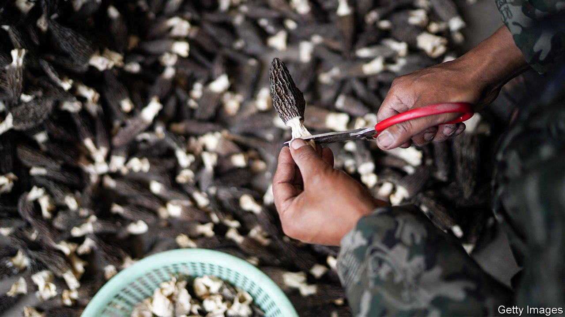

IN MAY, WHEN the first monsoon rains sweep across the mountainous province of Yunnan, foragers throng to damp forests to hunt for wild mushrooms. Grandmothers strap wicker baskets to their backs, wielding sticks with which to rake the forest floor and hook from it a “black beef liver” (known elsewhere as a bronze bolete) or a crimson “green pinch” (named for the bruises that fingerprints leave on its velvety gills). Joining them at first light are local chefs, village children and their parents, some of them migrant workers who have returned from far-flung coastal factories especially for the hunt.

Thousands of Yunnanese families earn much of their living from the wild-fungi season, which runs until October. The 160,000 tonnes they collect annually in the poor south-western province generate income of about 10bn yuan ($1.4bn). The most valuable end up on posh dinner plates abroad, from porcini—beloved of Europeans—to meaty matsutake, prized by South Koreans and Japanese. Trains are commandeered to get the mushrooms from basket to banquet in under 30 hours. A rail service launched last year has been dubbed the “high-speed matsutake express”. Whatever is not sold fresh is air-dried, frozen or made into a relish.

In the summer, Wu Huahai, a young father from Wujia village, makes 4,000 yuan a month from scouring the hills—roughly what he makes as a driver near the coast. In protected forests, where collecting is limited to local families, and so competition is less fierce, a hunter’s monthly take can reach 10,000 yuan. Among the most coveted types are “goat belly” mushrooms (morels), which can fetch up to 1,000 yuan per kilo when they appear later in the season. But this year demand for Yunnan’s mushrooms has been dented by covid-19. Prices have fallen by as much as half.

At the market where Mr Wu and his wife hawk the morning’s finds, 170 tonnes of wild fungi are sold every day in season. It is located in Nanhua, Yunnan’s best-endowed county mycologically. A vast array of mushrooms grow across the province. Yunnan accounts for just 4% of China’s land area yet is home to more than 800 of the country’s 1,000 known edible varieties, and about one third of the world’s. Dozens more are discovered in Yunnan every year, says Yang Zhuliang of the Kunming Institute of Botany.

Some are lethal. A type identified in 2012 is called “little white” because of its resemblance to an innocuous oyster mushroom. Mr Yang’s institute named it as the culprit behind Yunnan Unknown Cause Sudden Death Syndrome, which for decades had haunted villagers during the monsoon. Little whites now feature on billboards at wet markets in the region that show how to discern the delectable from the deadly (and warn against the mind-bending, which are popular).

Another danger lurks. Mycologists fret that harvesting is damaging the mushrooms’ habitat. Some hunters unearth them too young, says Yang Hongying, an old-timer on the hills. She finds only a tenth of what she recalls gathering as a child. But back then there “wasn’t really a market for mushrooms”, says Ms Yang. Now the villagers’ everyday meals—nutty summer truffle shaved raw over eggs, or yellow jizong stir-fried with salted ham—are considered truly to die for. ■

This article was downloaded by calibre from <https://www.economist.com/china/2020/07/23/in-south-western-chinas-yunnan-province-mushrooms-mean-money>

|  |  |  |  |
| --- | --- | --- | --- |
| Previous | Articles | Sections | Next |

|  |  |  |  |
| --- | --- | --- | --- |
| Previous | Articles | Sections | Next |

#### Chaguan

# A hit TV drama in China asks hard questions about right and wrong

Its moral code is messy

Jul 23rd 2020 |

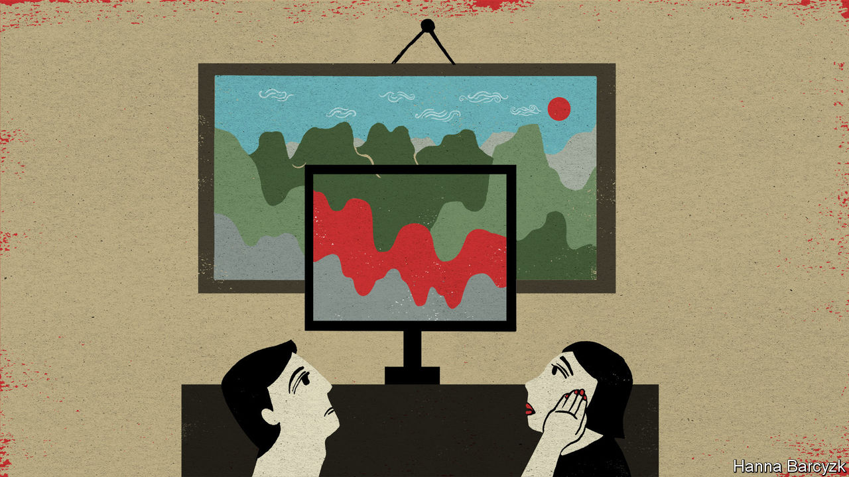

IN THEORY “The Bad Kids”, this summer’s most talked-about Chinese television drama, is a thriller about a teacher turned mass killer, matching wits with three plucky children in a quiet coastal town. In practice, like all really successful horror stories, the 12-part series is also a window onto things that frighten people in their everyday lives. A case can be made that the drama—despite its impressive body-count and inventive murder locations (a seafood buffet will never look the same again)—is really a meditation about how hard it is to be a good parent, or a good person, in a society that is as competitive, stressful and unequal as modern China.

In an era when entertainers are under ever-stricter orders to promote “positive energy” and the joys of Communist Party rule, that is quite a subversive theme. As a result, “The Bad Kids” offers a case-study about how clever film-makers must operate in the China of 2020. A sensitive, complex examination of the human condition, it is sprinkled with upbeat, censor-friendly details, some of them jarringly at odds with the rest of the plot. The trade-offs have worked. Official news outlets have praised the series. The Chinese public, for their part, have also given it an exceptionally high score of 8.9 out of 10 on Douban, a big online rating site.

Censorship-wise, it helps that the drama unfolds over the course of a sweltering summer about 20 years ago, so that scenes showing violent gangsters and loan sharks do not reflect on today’s leaders. Indeed, it is possible to enjoy the show for its nostalgic recreation of a simpler China where childhood friends might spend a hot night climbing rooftops or sharing lurid soft drinks from glass bottles, rather than sitting in lonely silence as many might now, gazing at smartphone screens. Some compromises are easy to spot. Notably, the show depicts small-town policemen as kindly paragons, bringing justice and comfort to the people of Ningzhou, the fictional port where the killer works as a maths teacher. Historians of corruption remember the era differently.

The drama is adapted from a novel by Zijin Chen, a dark study of evil, both adult and juvenile. The screen version, made by iQiyi, a Netflix-like streaming video company, depicts its three young heroes as mostly well-intentioned rebels, one of whom is tempted by evil. The other two speak with a moral clarity that eludes many adults in the show. Repeatedly, the murderous teacher plays on the power of education to change lives in China. He distracts a suspicious policeman with advice about his daughter’s maths grades, and offers free tutoring to the children who have rumbled him. His youngest tormentor, a sweet-natured girl known as Pupu, sternly replies: “Is school where you learned to kill people?”

In the book, the children are angry victims of adult betrayal, ranging from sexual abuse to being disowned by a divorced father. Two youths in the novel are the children of murderers, executed by the state. The television drama offers a nuanced view of parenthood. Viewers see the flaws of a mother whom society might call a model parent, pushing her clever son to study until his bedroom is filled with academic trophies. He will have time for friends once he has a good job, the mother snaps at a teacher concerned by her son’s loneliness. Yet that mother is scared, not wicked. Divorced from a cheating husband, she sees education as a way to armour her son against a harsh world. “Promise you will be safe,” she tells her child. They are the most loving words she utters.

One question comes up time and again: what does it mean to be good? Scenes of supposed hospitality—banquets at which the young are handed cash in red envelopes, or junior family members are bullied to drink alcohol—are exposed as cold and empty. “A man without ambition isn’t a man,” the maths teacher is told at a dinner, as in-laws dissect his career prospects. The drama challenges the idea that respectability and virtue are earned by fulfilling the family, social and professional obligations that cost ordinary Chinese so much time and agony.

## Only connect

Even the law offers little help in defining virtue. “Whether your dad is a good or a bad person is decided by a judge, not by you or me,” a gruff policeman tells Yan Liang, a prisoner’s child. He is proved wrong when Yan Liang’s father, a gangster sent to a mental hospital with drug-induced brain damage, redeems himself with a fleeting, almost miraculous proof of love for his son.

Several characters gain moral authority through such private yet sincere acts of affection. Viewers mostly respect a police captain because they see his sweet, bantering-yet-supportive relationship with his daughter, not because he has stars on his epaulettes. Yan Liang, a ragged teenage runaway, steals a blanket for Pupu and agonises aloud about following his father into criminality. When put to a life-and-death test, though, he does the right thing. “I didn’t become a bad person,” he gasps with relief to the gruff policeman who has become a mentor. It is a moving moment. The censors’ hand can be felt soon afterwards, when Yan Liang abruptly declares an ambition to join the police as an adult.

Devoted fans, including a Chinese-Canadian blogger about television who uses the name AvenueX, suggest that attentive viewers can see alternative endings hidden among the uplifting patriotism. Notably, AvenueX points to clues that several characters die before the drama ends and should now be understood as ghosts, visible only to those who care for them. Her arguments are plausible, though the film-makers have rejected such theories.

Truth is a slippery concept in “The Bad Kids”. Many lies are told, sometimes for selfish reasons, but also for fear of losing something precious. Truth-telling is at its most admirable when offered as an act of love, for instance by a child who cannot bear the loneliness of deceiving a parent for ever. This is a messy moral code, far from the tidy, flag-waving pieties favoured by party chiefs. The show’s popularity is cheering. In a China that rings with the din of patronising, bossy propaganda, viewers crave a bit of messiness.■

This article was downloaded by calibre from <https://www.economist.com/china/2020/07/23/a-hit-tv-drama-in-china-asks-hard-questions-about-right-and-wrong>

|  |  |  |  |
| --- | --- | --- | --- |
| Previous | Articles | Sections | Next |

|  |  |  |
| --- | --- | --- |
| China | Sections | The Americas |

United States

Congress and covid-19: Spot trades

.

Work and incentives: One-handed economics

.

Easing lockdowns and covid-19: The geometry of the pandemic

.

Police reform: Now for the hard part

.

Lexington: Trouble in Trumplandia

.

|  |  |  |
| --- | --- | --- |
| China | Sections | The Americas |

|  |  |  |  |
| --- | --- | --- | --- |
|  | Articles | Sections | Next |

#### Congress and covid-19

# America’s backwards coronavirus strategy

The federal government’s approach is like a hospital that invests in palliative care while abolishing the oncology department

Jul 22nd 2020 | WASHINGTON, DC

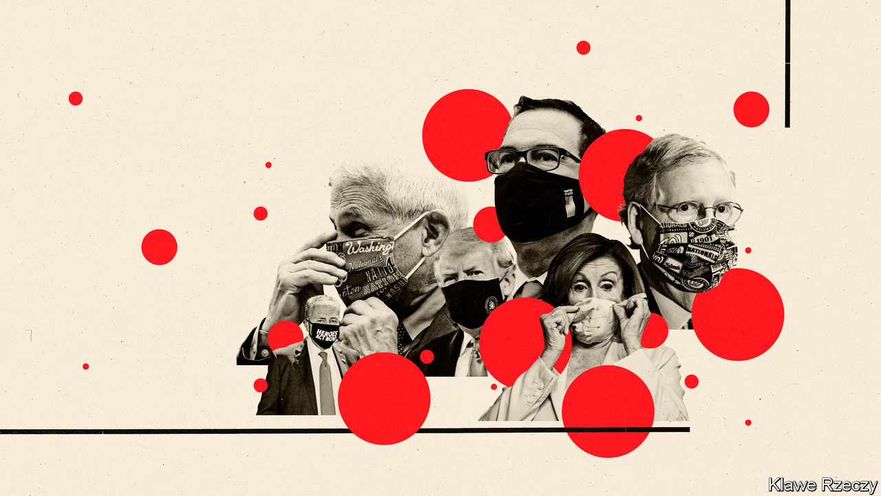

THE SENATE’S status as “the world’s greatest deliberative body”, as President James Buchanan allegedly described it, has been exaggerated for a while. Legislation is accomplished not through considered debate, but rushed, secretive crafting of law by senior party leaders on the eve of some cataclysmic deadline. In the past decade this brinkmanship has led to one struggle over “sequestration”, two debt-ceiling crises and three shutdowns of the federal government, but little in the way of substantive lawmaking. The same dynamic will shape the latest gargantuan stimulus package needed to cushion the fallout from the epidemic of covid-19. But this time, the consequences of brinkmanship and delay could be even more severe.

When Congress passed the CARES Act, a fiscal-stimulus package costing $2.2trn, in March, it included important stabilisers for an economy placed in a medical coma. Among these were much-increased unemployment benefits—boosted from $370 a week on average to $970—and a suspension of evictions and foreclosures in federally backed housing until the end of July. These measures were set to expire after four months, by which time the epidemic was expected to be under control.

That is not the case. New confirmed infections are surpassing their previous peaks in mid-April, sometimes exceeding 70,000 per day. The unemployment rate in June was 11.1%, and the Congressional Budget Office (CBO) expects it to decline only modestly to 8.4% in 2021. The “V-shaped recovery” that America had hoped for seems out of reach. About 18m are still unemployed, compared with 6m before the recession. Surveys from the Census Bureau show that 16% of adults who owe rent or mortgage payments missed them last month, and 11% report that they do not have enough to eat at least some of the time (compared with 8.8% in early March). Eviction notices, many filed by landlords who are also struggling, have begun to pile up.

Hence the need for another stimulus package. Democrats released their proposal, a $3.4trn behemoth called the Heroes Act, two months ago. Republicans have gone from suggesting a “pause” on future stimulus, as Mitch McConnell, the Senate majority leader, said in May, to agreeing that something more is needed. The Republican counterproposal, which is yet to be fully unveiled, will be more modestly priced, perhaps at $1trn or so. Neither side expects the bill to be negotiated by the end of the month, when the provisions on unemployment and evictions in the CARES Act expire. The resulting gap could up-end the lives of millions of American families and set the economy back.

Researchers from Columbia University calculate that without the enhanced safety-net benefits, the poverty rate would have risen by four percentage points, representing 12m people. Instead it has remained flat. Some of the more sophisticated proposals, such as indexing benefits to previous earnings up to a maximum level, are conceptually elegant but might delay cheques for weeks. State unemployment offices, reliant on antiquated computer software and few staff, have struggled to implement something as simple as adding $600 to every cheque. First, though Congress needs to pass a law. A better solution to avoid recurring cliff-edges—automatically tethering unemployment generosity to local unemployment rates, as Michael Bennet, a senator from Colorado, has proposed— would do a lot of good. But because it would limit political leverage in future negotiations, it is unlikely to fly this time.

The negotiations, which began in earnest only this week, must resolve many differences. Democrats would like to extend the generous unemployment benefits until the end of the year. Republicans worry that these are too generous. Indeed, for the majority of eligible workers, the benefits now exceed their former wages (see article). The Democratic proposal would send nearly $1trn to shore up the budgets of states and cities. Republicans worry that this generosity would reward profligacy in pre-pandemic times. Mr McConnell seems to have two priorities: passing a liability shield for businesses from lawsuits over covid-19 exposure and incentivising schools to reopen with cash grants. Both sides at least seem amenable to sending another unconditional cheque to Americans, regardless of employment status.

President Donald Trump is not a direct interlocutor in these negotiations, leaving Steven Mnuchin, his treasury secretary, as the administration’s ambassador. Mr Trump has offered some policy suggestions, but they are not being taken very seriously, even among senators and representatives of his own party. One is that the bill include a holiday for the payroll taxes that employers pay for Social Security and Medicare, the government programmes that provide pensions and health insurance for the elderly. This would do nothing to benefit the currently employed, but it would deplete the trust funds for both schemes. A second, reported in the Washington Post, is that the bill should strip out billions in funding for additional testing for covid-19. Mr Trump has been insisting that the rise in cases is due to the rise in tests. “Many of those cases are young people that would heal in a day,” he told Fox News. “They have the sniffles, and we put it down as a test.”

Step back, and this strategy of repeated enormous stimulus to cushion the blow of an ineffectual national strategy for containment resembles a hospital that invests mightily in palliative care while eliminating the oncology department. America has already spent 13% of GDP on fiscal stimulus, with more on the way. The most important economic policy, in the absence of a vaccine, is to contain the virus’s spread. Leaving it all up to governors no longer seems like a viable White House strategy. Nor does the campaign of attacking the public-health messenger, Anthony Fauci.

Facing flagging confidence in his handling of the crisis (and trailing in polls behind Joe Biden, his Democratic challenger), Mr Trump has resurrected his daily coronavirus briefings. Presidential leadership of this sort might be expected to add coherence and clarity to what has been a helter-skelter national strategy. In Mr Trump’s case, it’s likely to make things worse. ■

This article was downloaded by calibre from <https://www.economist.com/united-states/2020/07/22/americas-backwards-coronavirus-strategy>

|  |  |  |  |
| --- | --- | --- | --- |
|  | Articles | Sections | Next |

|  |  |  |  |
| --- | --- | --- | --- |
| Previous | Articles | Sections | Next |

#### One-handed economics

# Generous unemployment benefits are not keeping Americans from work

Economists usually squabble over everything. On this, they are nearly unanimous

Jul 23rd 2020 |

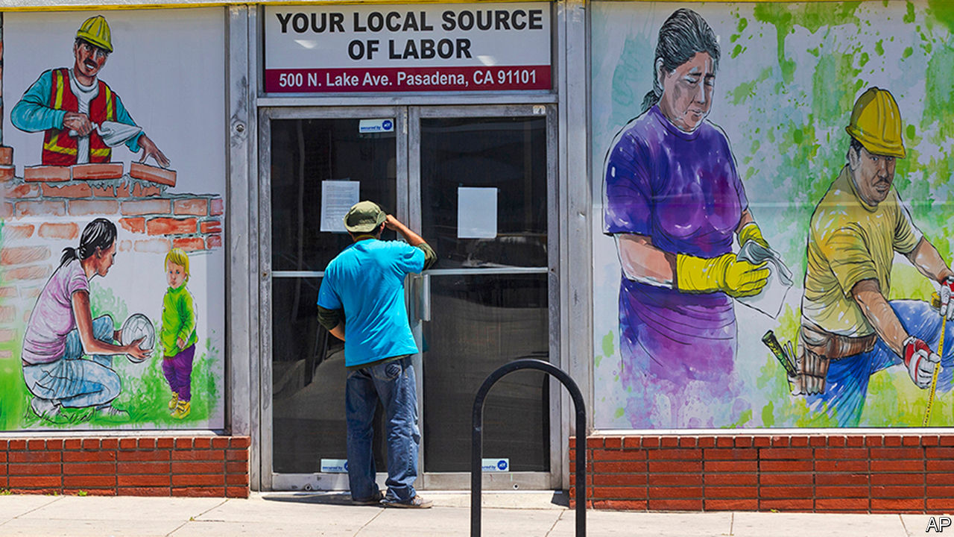

SINCE THE $2trn stimulus package was passed in March, America has temporarily had one of the world’s most generous unemployment-insurance (UI) systems. Some fear this comes at a steep price. With the unemployment rate still in double digits, are munificent state handouts stopping people from looking for new jobs or returning to old ones?

During the recession a decade ago, Robert Barro of Harvard University calculated that nearly a third of unemployment in 2010 was due to prolonged and more generous UI benefits. But if economists thought UI was generous then, they have seen nothing yet. Seven in ten of those on UI now receive benefits greater than their wages, studies suggest. One-fifth of those on benefits are receiving double what they previously made. If people can earn a dignified living from the state, why bother to seek work?

One reason is that for many Americans jobs are tied to health care and retirement programs. It makes no sense to turn down a job with potentially lifetime benefits to cash in a few more UI cheques. Many workers do not even have the option of doing so. Some states oblige employers to report employees who decline to return to work. Those workers’ benefits are stopped if the refusal to work is not due to health concerns.

So far there is little evidence to suggest that the extra $600 a week is slowing down the labour-market recovery. If bosses were struggling to fill positions, you might expect vacancies to be high. In fact the number of job vacancies in April was the lowest since 2014, at only 4.9m openings (though it has recovered somewhat since then). Homebase, a company that provides scheduling tools to businesses, tracks small hospitality and retail firms. Applicants per job doubled in early April, suggesting that laid-off workers were quick to look for something else.

Another signal that employers were struggling to fill positions would be soaring wages. Workers might hold bosses hostage with the threat of settling for benefits instead. Upon first inspection, this seems to be true. Average hourly earnings in the second quarter of 2020 increased by about 7% from a year ago, according to Goldman Sachs. However this is largely because low-paid workers have lost jobs in disproportionate numbers, dragging average wages upwards.

All of this implies that the main factor behind the high unemployment rate is lack of jobs, not an unwillingness to work. Economists normally fight like cats in a bag. But an astonishing 0% of those surveyed by researchers at the University of Chicago disagreed with the idea that “employment growth is currently constrained more by firms’ lack of interest in hiring than people’s willingness to work at prevailing wages.”

This article was downloaded by calibre from <https://www.economist.com/united-states/2020/07/23/generous-unemployment-benefits-are-not-keeping-americans-from-work>

|  |  |  |  |
| --- | --- | --- | --- |
| Previous | Articles | Sections | Next |

|  |  |  |  |
| --- | --- | --- | --- |
| Previous | Articles | Sections | Next |

#### Easing lockdowns and covid-19

# The geometry of the pandemic in America

Even modest changes in behaviour can cause huge rises in coronavirus infections

Jul 23rd 2020 |

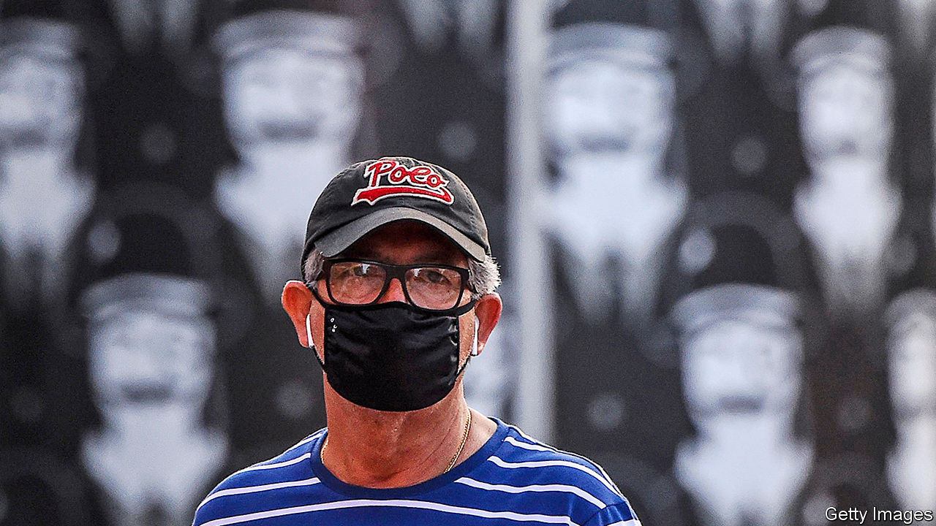

Editor’s note: Some of our covid-19 coverage is free for readers of The Economist Today, our daily [newsletter](https://my.economist.com/user#newsletter). For more stories and our pandemic tracker, see our [hub](https://www.economist.com/news/2020/03/11/the-economists-coverage-of-the-coronavirus)

WHY HAVE covid-19 cases risen so fast? The answer may seem blindingly obvious. But it is not. And the implications of the real answer are even more worrying than those of the obvious one.

The manifest and palpable explanation is that, when lockdowns were eased, people started moving around more, and those who were infected started passing the virus on. This is consistent with the chronology. Most states began to lift restrictions around the end of April or the start of May. Allowing a few weeks for the disease to develop brings you to the start of June when cases began their recent spike.

This is not wrong, but nor is it the whole story, because the pattern of people’s activity does not match the pattern of infection. As the chart shows, new infections fell gradually and gently from 100 cases per million people in mid-April to about 60 in mid-June. America at this point seemed to be following Europe and East Asia down the other side of the mountain of infections. But in mid-June, something extraordinary happened. Infections exploded, increasing fourfold in the next four weeks.

Indices of day-to-day activity, however, show a different pattern. Such data, which are based on mobile-phone tracking, reveal no real change as lockdowns were eased. Unacast, an American-Norwegian firm that provides information to retail businesses, uses anonymised phone data to track how far people are travelling, how often they are making non-essential visits (for example, to cinemas or restaurants) and how often they are meeting others. All three indices show a big fall in activity until mid-April (ie, early in the pandemic), then a wobbly, gradual rise from April to now. As lockdowns ended, most people did not stampede to bars or beaches. SafeGraph, another retail-information company, shows a similar pattern in visits to restaurants, shops and hotels. Human-activity levels have increased linearly and gradually since April, whereas coronavirus cases first fell, then rose exponentially. Does that mean the easing of lockdowns is not to blame, because it has not made a clear difference to people’s behaviour or to the spread of the virus? In a word: no.

The explanation for the pattern of American infections lies in something of central importance to the spread of a virus: geometric progression, such as 1, 2, 4, 8, 16. If one person infects two, two infect four and so on. Unless the rate of infection is driven down by reducing contacts, any geometric increase quickly balloons: 256, 512, 1,024. This is the lesson of the inventor of chess, who in legend asked, as a reward, for one grain of rice on the first square and twice as many on each successive square. There was not enough rice in India to pay his reward. That is one explanation for America’s explosively rising caseload. With almost 4m infections, the country is on square 23.

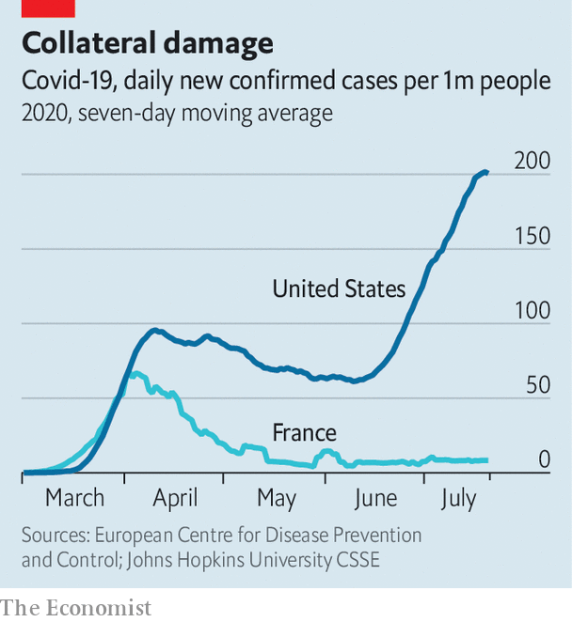

Another explanation is that the starting point matters. If you begin a geometric progression at one, the tenth in the sequence is 512. If you begin at three, the tenth iteration is 1,536. American states began easing lockdowns, as it were, at three: their caseloads were three or more times higher than in Europe, in part, argues Jarbas Barbosa of the Pan-American Health Organisation, because most states never had full lockdowns. Texas had 1,270 new cases on the day its governor said restaurants could re-open: 44 per million. In Georgia, the rate was 95 per million. Disney World reopened the day before Florida announced a record 15,000 new cases in a day. Just as incredibly, in two-thirds of states, infections were rising when governors started to ease lockdowns. By contrast, France, Spain and Italy had 13-17 new cases per million when they began to re-open their economies and numbers were falling fast.

Rajiv Rimal of Johns Hopkins University has modelled the effect on infections of different levels of activity. On April 12th, he reckons, 95% of the population was staying at home (leaving the house only for essential visits), with 5% ignoring lockdown rules. Based on those assumptions, his model predicts that America would have had 559,400 cases on that day—an accurate assessment (it actually had 554,849). On July 14th, Mr Rimal assumed that 80% of the population was staying at home, ie, only a gradual change. On this basis, his model predicts the country would have 3.6m cases, again not far off the actual number and confirming the impact of modest rises in activity. If people really alter their behaviour, the number would rise even further: to 5.6m cases if the stay-at-home share drops to 60% and to 9.5m if it falls to 20%. In that worst case, America’s death toll could top 400,000. Such is the dark logic of geometric growth.

The implication of these figures is that, when the virus is widespread, even small amounts of activity can make infections soar. You do not need vast, mask-less crowds, though America had those, too. So the public-health task is clear: to drive the level of infection down to perhaps a tenth of what it is now (closer to European or Asian levels). That seems to require full lockdowns. At the moment, few politicians seem prepared for such a thing. True, nine states have reversed some restrictions and 13 have paused their reopenings. At his first televised news conference about the virus since late April, President Donald Trump urged people to “get a mask”. But no governor has yet been willing to tell everyone to stay home. Some reopenings continue and Georgia’s governor sued the mayor of Atlanta when she ordered people to wear masks. “We’re having a dozen New Yorks all over the country,” says Peter Hotez, of the Texas Children’s Hospital in Houston. “It’s predominantly in low-income metro areas. Hispanic communities are being devastated. And there’s no leadership dealing with it.” ■

Editor’s note: Some of our covid-19 coverage is free for readers of The Economist Today, our daily [newsletter](https://my.economist.com/user#newsletter). For more stories and our pandemic tracker, see our [hub](https://www.economist.com/news/2020/03/11/the-economists-coverage-of-the-coronavirus)

This article was downloaded by calibre from <https://www.economist.com/united-states/2020/07/23/the-geometry-of-the-pandemic-in-america>

|  |  |  |  |
| --- | --- | --- | --- |
| Previous | Articles | Sections | Next |

|  |  |  |  |
| --- | --- | --- | --- |
| Previous | Articles | Sections | Next |

#### Minnesota vice

# What is a police department for?

Having decided to abolish its police department, Minneapolis does not know how to replace it

Jul 25th 2020 | MINNEAPOLIS

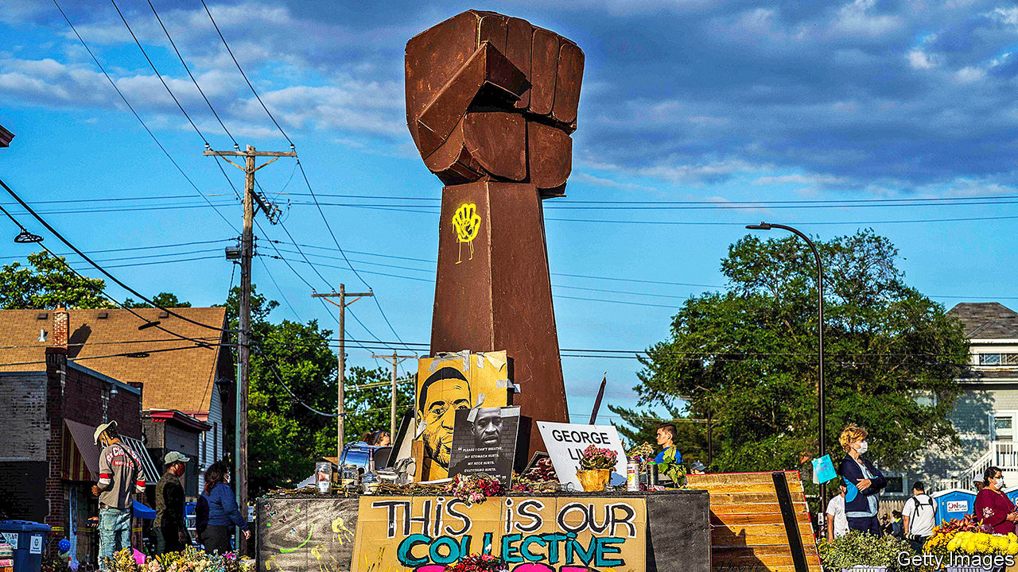

THE INTERSECTION of 38th Street and Chicago Avenue has, since George Floyd was killed there on May 25th, become a shrine, pilgrimage destination and public-art exhibition. A huge raised fist surrounded by flowers stands at the intersection’s centre. “You Changed the World, George,” with sunflowers beneath and clouds above, is painted on the purple side of a squat building across the street. Amid all the expressions of grief and resolve stands an imperative: at the centre of a row of roses pinned to a clothesline, a laminated sheet of paper asks people to “Creatively imagine a world without police.” For two months, many in Minneapolis have been doing just that—and discovering just how wide the gulf between creative imagination and running a city is.

At a rally on June 6th Jacob Frey, Minneapolis’s mayor, was jeered after telling the crowd that he did not support abolishing the police department. At another rally the next afternoon in Powderhorn Park, not far from where Mr Floyd was killed, nine city councillors pledged to do just that. The city council voted unanimously to abolish the department later that month.

They have proposed amending the city’s charter to replace the police department with a “Department of Community Safety and Violence Prevention, which will have responsibility for public safety services prioritising a holistic, public health-oriented approach.” Their proposal also removes the mayor’s “complete power over the establishment, maintenance and command over the police department,” and gives the City Council shared oversight over the new department.

Their proposal is before the city’s Charter Commission (analogous to a constitutional court) for review, and the council wants it on the ballot in November. Even if it passes, state labour law could intrude. Public employers cannot “interfere with the existence of employee organisations,” such as a union. Abolishing the police department would presumably entail abolishing the union, and the union would presumably fight abolition in court.

Whether the plan has the appeal to pass remains unclear, but one thing almost everyone in the city agrees on is that the status quo is not working. Raeisha Williams, an activist and entrepreneur who ran for City Council in 2017, says that “there is a huge disproportion in how [African-Americans] are treated” by the city’s police force. Steven Belton, a lifelong Minnesotan who heads the Urban League Twin Cities, says that “standard operating procedure” among city police officers “assumes that African-Americans generally and black men in particular are hostile, dangerous and require maximum force and must be subdued for the most ordinary and mundane encounters with police.” Before George Floyd, there were Philando Castile, Jamar Clark and Christopher Burns, all black men killed by police in the Minneapolis area. Many black Minnesotans have stories about mistreatment by officers. Police abolitionists believe that systemic bias means that the force is beyond saving, and must be scrapped and reinvented.

Not everyone is so sure. Some object to the amendment’s vagueness about what comes next. Will there still be armed officers to respond to serious emergencies? How many? Not every mental-health crisis or overdose requires a heavily armed response, but what happens when an unarmed mental-health or addiction professional insists on an armed officer as backup? Currently, the police chief has to answer to the mayor. What happens when he has to answer to the mayor and 13 city councillors? Who makes the final decision? Where does the buck stop?

Others object to how replacing the police department was proposed. Nekima Levy Armstrong, a civil-rights lawyer and founder of the Racial Justice Network, an activist group, believes the councillors made their pledge “to pander to the crowd...They didn’t come to the black community to engage us.” She has pushed the city council for years to do something about the police department, to no avail, and they are now just “pretending to take action with regard to police accountability.”

Ms Levy Armstrong also argues that council has undermined Medaria Arradondo, the city’s current and first black police chief, who swiftly fired Derek Chauvin, the officer who killed Mr Floyd, and the three others with him—something few previous chiefs would have done. Unlike many big-city chiefs, who get poached from other departments, Mr Arradondo is a Minneapolis native who came up through the ranks. In 2007, while he was still a lieutenant, he sued the department for racial discrimination (the suit was settled out of court). Ms Williams—who like Ms Levy Armstrong supports reform but opposes the charter amendment—calls Mr Arradondo “our best hope...He treats us with humanity and dignity.”

Others worry about the effects on public safety. Brian Herron, the pastor of Zion Missionary Baptist Church in north Minneapolis, says the city council has “created a climate where people believe that the police have no power...That creates lawlessness.” And indeed Minneapolis has seen a jarring spike in gun violence since the protests began. “We’re not in Shangri-La where every issue is about people not having housing or opportunity,” Mr Herron explains. “We have to come to grips with the fact that people are committed and dedicated to this lifestyle. It’s a very small number, [but] none of the people pushing this will stand in front of the bullets.”■

This article was downloaded by calibre from <https://www.economist.com/united-states/2020/07/25/what-is-a-police-department-for>

|  |  |  |  |
| --- | --- | --- | --- |
| Previous | Articles | Sections | Next |

|  |  |  |  |
| --- | --- | --- | --- |
| Previous | Articles | Sections | Next |

#### Lexington

# Donald Trump’s divisive method culminates in Portland

The president’s growing authoritarianism is a sign of weakness not strength

Jul 23rd 2020 |

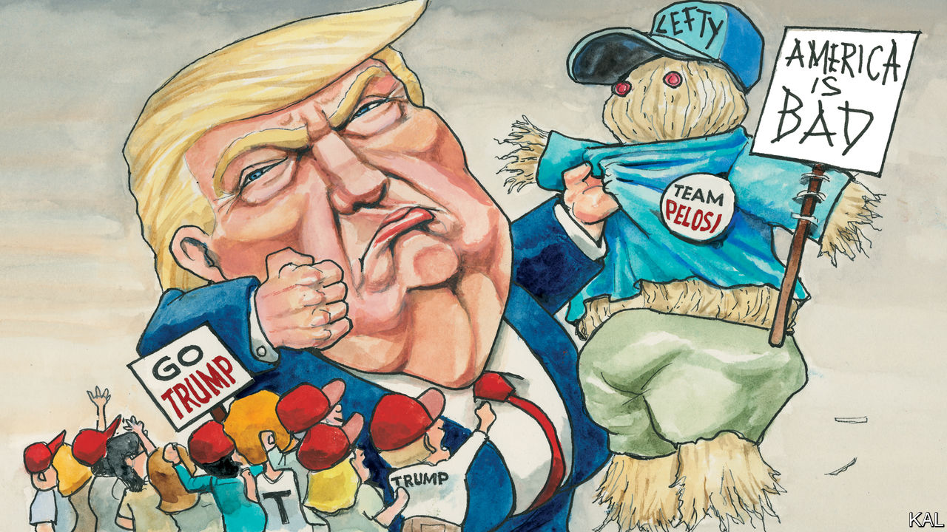

IN “IMAGINED FRONTIERS”, a book about the role of lines on maps in American art and culture, the historian Carl Abbott notes that because “they mark difference, they are also edgy places where change can happen—like the spark that rebalances electrical potential.” This is Donald Trump’s main political insight.

The wall that the president promised to build along the southern border was always more about defining differences—and making sparks fly—than immigration control. It marked who he and his voters were against: explicitly “rapist” migrants, but implicitly diversity, the Republican leaders who took a relaxed view of it, the liberals who celebrated it. This is why hardly any of the president’s fans seem to mind that he has not laid a brick of his promised wall (though he is extending a pre-existing border fence).

Ahead of the 2018 mid-terms, Mr Trump reimagined the same political frontier, this time making an approaching column of Central American asylum-seekers emblematic of it. Now in need of another burst of electoral rebalancing, with Joe Biden far ahead in the polls, he has reconfigured his frontier more audaciously. By deploying immigration law enforcers—trained for shoot-outs with Mexican gangsters on the southern border—against racial justice protesters in Mr Abbott’s hometown of Portland, Oregon, he has moved his dividing line 1,100 miles north of San Diego. This has made explicit what was previously implied: that his and his supporters’ enemies are already within. It is the apogee of Mr Trump’s divisive method and, for rule-of-law implications alone, one of his most reckless moves yet.

The context in Portland is somewhat peculiar. Even so, this should be understood as a rerun of the stunt Mr Trump attempted last month in Lafayette Square, when federal police and troops tear-gassed peaceful protesters to clear a space for him to brandish a Bible outside a nearby church. That gambit failed for two reasons. Executed on hallowed terrain—a park dedicated to the revolution upon which Americans’ freedoms are founded—it was too prominent and egregious for even timorous Republican lawmakers to stomach. And the pushback from the embarrassed Pentagon was even stronger. The country’s foremost military officer, General Mark Milley, apologised for having been involved in the charade, thus condemning it. In the rerun playing out in Portland, where paramilitary-style operatives have been filmed hustling peaceful protesters into unmarked cars even as the president denounces them as “anarchists”, neither safety-check applies.

First, because of the city’s circumstances. Most urban places are liberal citadels with conservative peripheries; Portland, a place of vegan strip-bars with a reactionary hinterland, is an extreme case. This made it a magnet for far-left anarchists and far-right white thugs, often leading to rowdy and occasionally violent confrontations, even before Mr Trump’s election further raised the temperature on its streets. The nationwide race protests that erupted in May, following the police killing of George Floyd, have been predictably angry and sustained in the city. Though still largely peaceful, and confined to a few blocks around its federal courthouse, they have provided images of vandalism and bottle-throwing for conservative media to fume about, yet another no-win situation for the city’s police, and, for those who believe the answer to civil unrest is always cracking heads, a case for action.

Second, in the Department of Homeland Security Mr Trump has found a more malleable agency. Founded in 2002 with a mandate to prevent another 9/11, it had a callow institutional culture even before he got to work on it. The agency has had five secretaries in the past three years, only two of them Senate-confirmed. Almost half its top 27 managers are temporaries. The current acting secretary, Chad Wolf, is a former lobbyist with no qualifying experience. This has made the agency supine before an administration that has used it for its dirtiest work. DHS has separated migrant families, stepped up arrests of long-stay undocumented migrants and now, on the pretext of protecting federal property in Portland, its paramilitaries appear to be intimidating lawful protesters in a bid to score electoral points for the president. That is anyway how it looks to DHS’s founding secretary, Tom Ridge, a former Republican governor of Pennsylvania. Its mission, he said this week, is not “to be the president’s personal militia”.

That is not a warning to take lightly. The risks of a mishap are obvious. The DHS operatives are untrained for civil policing, aggressive and their presence has already made a fraught situation worse. Portland was seeing a hundred or so nightly protesters two weeks ago and is now seeing thousands. Mr Trump is meanwhile raising the prospect of more federal interventions, for example in Albuquerque and Chicago, to support local crime-fighting.

## Moms’ the word

Mr Ridge’s is not the only pushback, however. Mark Esper, the secretary of defence, has expressed concern about the military appearance of the DHS shock troops. Most important, the swollen crowds in Portland are still mostly peaceful—in part thanks to the addition of a throng of self-declared “Moms”, mostly first-time activists, who wear yellow T-shirts and have declared it their mission to protect the protesters. So long as that remains the case, it may prove hard for Mr Trump to escalate the situation even further.

It is also unclear that it would be in his interests to do so. By giving conservative outlets a distraction from the coronavirus, and so ginning up his base, he has achieved his primary objective. And it is not obvious that by stoking more violence in more cities he would expand his support. Most Americans support the protests. Most also consider him largely responsible for the disorderly state of the country—so would logically blame him if it worsens.

This is the fundamental problem with Mr Trump’s dividing line. He has set a minority of Americans against the majority. It does not look like a tenable frontier.■

Dig deeper:  
Sign up and listen to Checks and Balance, our [weekly newsletter](https://www.economist.com/checksandbalance/) and [podcast](https://www.economist.com/podcasts/2020/07/17/checks-and-balance-our-weekly-podcast-on-american-politics) on American politics, and explore our [presidential election forecast](https://projects.economist.com/us-2020-forecast/president)

This article was downloaded by calibre from <https://www.economist.com/united-states/2020/07/23/donald-trumps-divisive-method-culminates-in-portland>

|  |  |  |  |
| --- | --- | --- | --- |
| Previous | Articles | Sections | Next |

|  |  |  |
| --- | --- | --- |
| United States | Sections | Middle East & Africa |

The Americas

Migration and Mexico: Youth departs

.

The Caribbean: Welcome Zoomers

.

Bello: The Inca trail leads to populism

.

|  |  |  |
| --- | --- | --- |
| United States | Sections | Middle East & Africa |

|  |  |  |  |
| --- | --- | --- | --- |
|  | Articles | Sections | Next |

#### Youth departs

# Mexico’s emigrants in America are ageing

That is a challenge for the places they left behind

Jul 23rd 2020 | LOS HARO



TWO KINDS OF EMPTY homes bespeckle the hills and valleys of central Mexico and they could not be more different. The first are the crumbling grey cinder-block houses of people who left long ago and never returned. Then there are the dazzling two-storey mansions built with the dollars of migrants working in the United States, which briefly fill with light and laughter each year when their owners come to visit.

Now another migrant-funded flourish is appearing in the Mexican countryside. Over the past five years in Los Haro, a farming village in the state of Zacatecas, “ridiculous” towering graves have sprouted up in the local cemetery, says Norma Nava, a farmer. The migrants who left half a century ago are starting to die. Just like their fancy houses, their mausoleum-style tombs cast shadows over the humble resting places of neighbours who never left.

Though still the world’s largest international migrant group, the number of Mexicans moving to the United States has been falling for 20 years. The Mexican population there is now shrinking. Mexico’s birth rate has been falling for decades, so there are fewer young adults—the age group most likely to up sticks. And the border has become far harder and riskier to cross, which discourages many from trying. From 2007 to 2018, the median age of a Mexican in the United States rose from 35 to 44.

Covid-19 has caused a flurry of worry about remittances. They seem to be holding up for now. But their long-term future is uncertain. Mexico’s emigrants send back less as they age. Their American-born children are unlikely to pick up the slack after they are gone. That will hit remittance-dependent states. It will also imperil villages that rely on social and economic ties to those who departed while young.

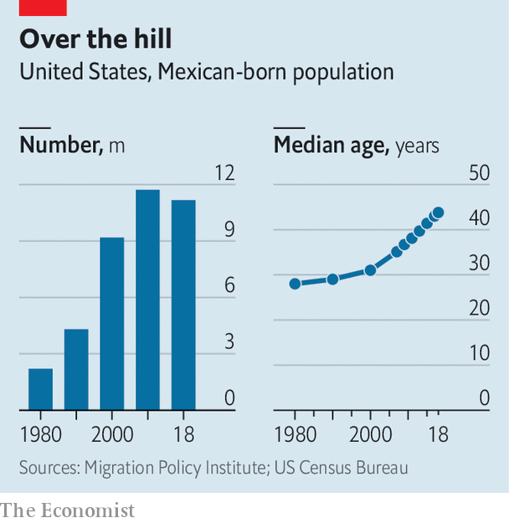

To catch the first glimpse of this future, turn to Zacatecas. The state’s emigrating tradition is among Mexico’s oldest and deepest. From 1955 to 1959 one Zacatecan in 16 headed to the United States. Juan Saldivar Flores, an 80-year-old in Los Haro, recalls how his young son would hear gushing descriptions from uncles over the phone of Napa Valley in California, to which nearly all of Los Haro’s migrants flock. “He reproached me” for staying put, foredooming him to a birth in Mexico, Mr Saldivar says. No matter. A few years later his son had taken off to Napa, where he still lives and works.

A third of those born in Zacatecas live in America. But unlike in other states such as Oaxaca and Veracruz, much of its exodus came before 1982, qualifying migrants for an amnesty Ronald Reagan enacted in 1986. Four-fifths of Zacatecans in the United States have legal status, compared with a minority of Mexicans overall, says José Juan Estrada, the state’s migrants minister.

For all its benefits, migration has imposed a demographic cost on the state, argues Rodolfo García Zamora, an economist at the Autonomous University of Zacatecas. Women outnumber men. Silvia Díaz Vargas, the mayor of an idyllic village named Susticacán, recalls a friend fretting: “I don’t know who my daughters will marry.” And ageing takes a toll. “It is very difficult to sustain a municipality” when all the people aged 20-40 are leaving, says Antonio Aceves, the mayor of Jerez de García Salinas, a Zacatecan town of 50,000 close to Los Haro.

But migration has an uncanny ability to fortify the very places it fractures. Polo Larez was born in El Sauz, a Zacatecan village. As a child he walked barefoot for miles each morning to sell buckets of maize harvested by his parents. When he was 11, in 1979, they paid a “coyote” $600 to smuggle him to California in the back seat of a car with a fake birth certificate. “I had to say my name was Hugo Salas,” he recalls with a smile. For four decades while working as a gardener, Mr Larez sent money to his sister in El Sauz. His first gift to her was a washing machine, saving her a long walk to the nearest river. Mr Larez now has a house in Jerez awaiting him when he retires. It has a jacuzzi.

Zacatecans were also pioneers in the practice of sending collective remittances to improve infrastructure back home. The state, federal and municipal governments would all match what migrants’ clubs in America sent. Some 5,500 public works, worth 3.5bn pesos ($270m), were completed under the “3x1” programme in two decades before President Andrés Manuel López Obrador scrapped it last year. Migrants liked to give money because improvements raise property values, says Efraín Jiménez, of FEDZAC, a migrants’ club.

Returned migrants enrich their hometowns with knowledge as well as money. At a cafe in the centre of Jerez, Erika González Ramírez sells cappuccinos with tiny pieces of ginger floating inside. She picked up this technique to warm the soul while living in chilly Alaska. Rogelio Trujillo, a retired gardener whose bristling moustache reaches his chin and who moved to California in the 1960s, volunteered for the mayor of Jerez during a stint back home, uprooting old trees that had ceased to blossom and planting magnolias in their place.

In Los Haro, Ms Nava’s parents put her to work in the fields after she finished primary school. But her education resumed when she began working in the Napa Valley in her 20s. Back farming in Mexico since 2010, she points with pride to the pipes in the ground as she strolls through her plum tree orchard. She learned about irrigation in Napa while working in a nursery. She has also learned to plant the occasional Santa Rosa plum tree, brought down from California. Their plums are worse than the local Heroda ones but they spread pollen through the rest of the orchard, ensuring a bountiful harvest, she explains. It is hard to learn such tricks without leaving the village.

The problem is that this gainful chapter of Mexican history may be coming to an end. Today a sixth of Zacatecan households receive remittances, more than in any other state. Some $1.1bn, equivalent to 70% of the state’s budget, was sent in 2019. But Zacatecan migrants are much older than the national average of 45 years. Migrants are likeliest to send remittances around the age 40, and send the largest sums in their early 50s, says Jesús Cervantes of the Centre for Latin American Monetary Studies. Much of Mexico is “probably at peak remittances right now”, says Douglas Massey, a sociologist at Princeton.

For a while, retirees returning home may make up for lost remittances, by hiring construction workers and the like. Longer term, parts of the state face a decline. With the border-crossing now so much harder, other places in Mexico are more attractive. Mr Aceves in Jerez describes a cycle in which the town’s residents move to nearby bigger cities, like Zacatecas and Aguascalientes, with the youth from the villages moving to Jerez to replace them. That supply of rural youth is dwindling.

Meanwhile many former residents, and certainly their kin, feel more attached to their American surroundings than to their Mexican homeland. In Palo Alto, a village of 50, Nicolás Galdez Navarro sits alone inside his stone house. He grew up so poor that he had to make his own underwear out of old sugar sacks. Now a flashy flat-screen TV adorns his wall. But so do photographs of grandchildren he has never seen. Of his 13 children, ten live in the United States. “They used to visit every year, but now they say it’s complicated,” he says.

What will the young left in Zacatecas do? Mr Saldivar’s granddaughter, Italia, was raised in Jerez and studies automotive engineering in Zacatecas city, the state capital. The state has no car factories. To use her studies, she says she will need to move. José Luis Ureño, a 22-year-old peach farmer from El Cargadero, ponders the future in his kitchen. His older sister lives in California but without legal status, so she cannot come back for a visit. “The people there work too hard and then sleep. Here you can relax and enjoy nature,” he says.

And yet Mr Ureño covets a slice of such a life. He is studying business administration in Jerez, and wants to go to California when he finishes. He wants a garage for his car and a house like his neighbour’s. “It’s sad” that so many kids want to leave, his mother explains. “But it’s what we do.”

Some communities may just disappear. Back near Los Haro, Ms Nava parks her truck at Los Huertas, the village where her late husband grew up. It has been entirely abandoned since the 1980s. Trees grow where bedrooms once stood. Bees fly about a hive in an old living room. Ms Nava bends down and plucks a fork hidden beneath the weeds. “Stainless steel,” she says. “From the United States.” ■

This article was downloaded by calibre from <https://www.economist.com/the-americas/2020/07/23/mexicos-emigrants-in-america-are-ageing>

|  |  |  |  |
| --- | --- | --- | --- |
|  | Articles | Sections | Next |

|  |  |  |  |
| --- | --- | --- | --- |
| Previous | Articles | Sections | Next |

#### Welcome Zoomers

# Barbados invites you to work from the beach

A new scheme will allow teleworkers to get residency permits

Jul 23rd 2020 |



WORKING FROM a shady veranda overlooking a shimmering sea, with five-star restaurants and golf courses within easy reach: what better place could there be to while away the pandemic than Barbados?

Like most of its Caribbean neighbours, Barbados has been good at keeping covid-19 out. A single new case hits the headlines. But that does not mean the island has been unscathed. Normally tourism brings in more than half of its foreign earnings. Now, many tourists are banned and the economy is reeling. The tourism minister, Kerrie Symmonds, puts unemployment at close to 40%.

Cue the latest proposal of the prime minister, Mia Mottley. She intends to introduce a “Welcome Stamp” for visitors to “work remotely in paradise” for up to a year. The idea is that if holidays are not possible, then maybe the island can attract well-heeled office workers who no longer have to go to the office. A few new telecommuters could spend as much as a boatload of briefly alighting cruise-ship passengers. Other Caribbean islands are considering rival schemes; Bermuda has announced one.

It did not take a pandemic for some digital workers to consider moving to a beach. But before now, it was legally difficult. Getting a work permit or immigrant status meant weeks or months of form-filling. Workers had to pay Barbadian income taxes. The new procedure looks quick and easy by comparison. For a fee of $2,000 for one person, or $3,000 for a family, you can take your Zoom calls from a real pristine white sandy beach, instead of merely selecting it as a virtual background. You continue paying tax according to the rules of whichever country you came from.

There will be some checks on new arrivals. We do not want “the scum of the earth, but decent and upstanding types”, says Mr Symmonds. Applicants must have health insurance, and the main breadwinner must earn at least $50,000. But otherwise the gates are open. “We welcome all. Everyone,” says Ms Mottley. “All must breathe, in this world and in this country.”

This article was downloaded by calibre from <https://www.economist.com/the-americas/2020/07/23/barbados-invites-you-to-work-from-the-beach>

|  |  |  |  |
| --- | --- | --- | --- |
| Previous | Articles | Sections | Next |

|  |  |  |  |
| --- | --- | --- | --- |
| Previous | Articles | Sections | Next |

#### Bello

# Peru is heading towards a dangerous new populism

Unless the government can check the pandemic and revive the economy

Jul 23rd 2020 |



IN MARCH WHEN covid-19 first appeared in Peru, the government’s response seemed exemplary. President Martín Vizcarra imposed a swift lockdown. Taking advantage of Peru’s strong fiscal position, his economic team launched the most ambitious aid package in Latin America, worth 12% of GDP. Four months on, the outcome is disappointing. With more than 350,000 cases and at least 13,000 deaths, Peru has suffered grievously from the pandemic. In April its economy contracted by 40% compared with a year earlier.

What went wrong? Covid-19 exposed weaknesses that strong economic growth in this century had concealed. Even by Latin American standards, Peru’s health system is flimsy. Total spending on health care per person is only two-thirds of the regional average; the system is fragmented between public and private and between national and regional authorities; and there were only 276 intensive-care beds for 33m people in March. Some 70% of the workforce toil in the informal economy, many living in dense shanty towns and travelling on overcrowded buses.

For all these reasons, the government opted for one of the world’s strictest lockdowns. It extended to shutting down most big mines, although many are naturally isolated. All this amounted to an induced coma for the economy. The government did its best to compensate. It has guaranteed Central Bank emergency credits worth 8% of GDP to businesses. The bank auctioned them, which drove down interest rates. María Antonieta Alva, the economy minister, points out that as well as big companies, 156,000 small and micro businesses got credits worth $515m.

The government also gave an emergency payment of $220 to more than 6.5m households. Yet getting the money to people was hard: only 40% of Peruvians have bank accounts. Some of the payments were made via mobile phones but had to be collected from the state bank, which has fewer than 1,000 cash machines.

The lockdown did slow the spread of the disease, and the government has expanded health facilities. But the virus has not been defeated and as Peru opens up again cases are rising. In Arequipa, the second city, patients are dying in tents in the street. Having been too strict, Peru’s health restrictions now look too lax.

Mr Vizcarra is better at the grand gesture than at follow-up, negotiation or delegation. Official information has often been confused. On July 15th he reshuffled his cabinet, sacking the health minister and bringing in Pedro Cateriano, an experienced politician, as prime minister. “We will have better political leadership from this cabinet,” says Carolina Trivelli, a former minister. But she adds that the underlying problem is the frailty of the state and its lack of connections to or even knowledge of citizens.

At least economic recovery may be swifter than elsewhere, thanks partly to the injection of credit. Mines are now operating again, and electricity consumption is on the way back to normal. Ms Alva has allocated an extra 1% of GDP for public works. If all goes well the economy may end the year having contracted by less than 10% and could make up much of that in 2021.

But this depends in part on business confidence, which is being undermined by a legislature bent on populist measures ahead of a general election due in April. In September Mr Vizcarra dissolved the congress elected in 2016, which was dominated by supporters of Keiko Fujimori, the daughter of an autocratic former president. It was obstructive and had many corrupt members. Its replacement is as bad. Many of the new lot on both the right and the left are inspired by a crude anti-capitalism. Congress has suspended tolls in roadbuilding contracts; it has allowed pensioners to withdraw up to 25% of their private pension funds and threatens to refund some workers’ contributions to the state pay-as-you-go system, which would bankrupt it. It wants to impose price controls and freeze loan repayments although banks have already offered grace periods to many debtors.

The crisis has exposed shortcomings in Peru’s economic policies, as well as in its state. There are too many de facto monopolies. But they need intelligent regulation, not persecution. “For the first time in 20 years populism is gaining strength to the point that it could govern the country after the election,” fears Carlos Basombrío, a political consultant. Preventing that will require more effective leadership from Mr Vizcarra.

This article was downloaded by calibre from <https://www.economist.com/the-americas/2020/07/23/peru-is-heading-towards-a-dangerous-new-populism>

|  |  |  |  |
| --- | --- | --- | --- |
| Previous | Articles | Sections | Next |

|  |  |  |
| --- | --- | --- |
| The Americas | Sections | Europe |

Middle East & Africa

Tanzania: A Potemkin economy?

.

Uganda’s coming elections: Power unmasked

.

Israel and covid-19: Mission unaccomplished

.

Illegal migration: No passport required

.

Racism in the Middle East: Maids for sale

.

|  |  |  |
| --- | --- | --- |
| The Americas | Sections | Europe |

|  |  |  |  |
| --- | --- | --- | --- |
|  | Articles | Sections | Next |

#### A Potemkin economy?

# Why Tanzania’s statistics look fishy

A country lauded for its economic growth may not be doing as well as it says

Jul 23rd 2020 |

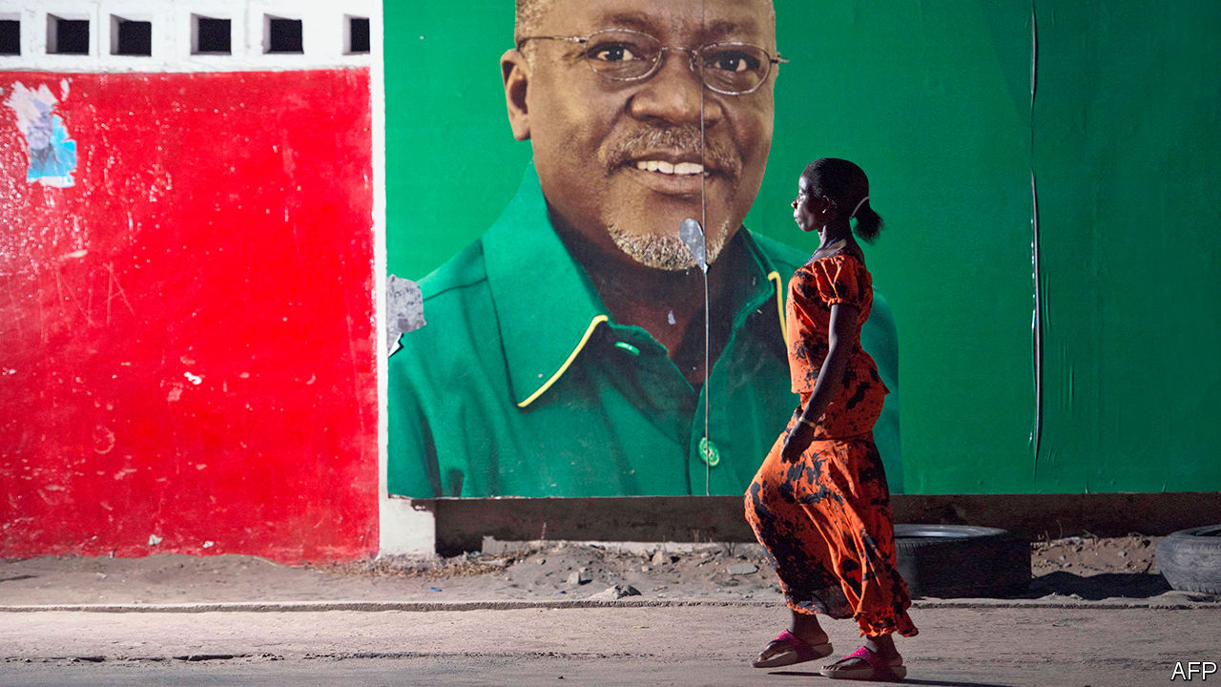

AFTER THE cold war ended, much of Africa democratised and opened up. Few countries better embodied the feverish hope of the 1990s than Tanzania. It had suffered grievously in the 1960s and 1970s under its founding leader, Julius Nyerere. A nascent democracy was throttled by one-party rule. An economy with great potential was wrecked by “African socialism”. Some 11m peasants were forced into collective villages, where they went hungry.

Democracy and economic freedom revived Tanzania. In 1995 the country held its first free elections in 30 years. As state controls were relaxed, investment flowed in. Steady growth more than doubled income per person between 1994 and 2010.

But John Magufuli, who was elected president in 2015, has turned back the clock on democracy by locking up opposition MPs and journalists. He has also meddled capriciously in the economy. His government has shaken down firms for cash, arresting their executives and holding them without bail if they do not pay up. It is “almost ransom”, says Peter Leon of Herbert Smith Freehills, an international law firm. In 2018, when cashew farmers were unhappy with the market price for nuts, Mr Magufuli sent in the army with orders to buy up the crop for 65% more than private traders offered. In the finest socialist traditions he did not pay the farmers for over 18 months. Since then the harvest has slumped by 30%. Farmers are reluctant to plant if they don’t expect to be paid.

Supporters of Mr Magufuli, who is running for re-election in October, argue that he gets things done—hence his nickname, the “bulldozer”. They also point to Tanzania’s startling record of economic growth. This has been running at close to 7% a year for the past decade. Tanzania has just crossed the World Bank’s threshold to become a middle-income country (ie, with an average income of more than $1,036 a year). Mr Magufuli boasts of achieving this goal five years earlier than planned.

Yet the growth numbers do not stack up. From about 2017 several other indicators, from tax revenue to lending to the private sector, have slowed sharply. The IMF raised doubts last year when it said there were “serious weaknesses” in the growth data. It pointed out that public-sector wages, lending to the private sector and imports were all falling while tax revenue was growing only weakly. The authors made it clear that the official 6.8% growth figure for 2017 was not credible. Publication of the report was blocked by the Tanzanian authorities. (The Economist has seen a copy.)

The fund has since backed down. It now reports, without caveat, Tanzania’s growth as 6.8% in 2017, 7% in 2018 and 6.3% in 2019. Jens Reinke, the IMF’s new representative in Tanzania, says that although the fund makes its own forecasts, it relies on official data for historical figures. “We’re not forensic accountants,” he says. Its latest health check in February has also not been published. The press release that usually accompanies these reports is positive.

Nonetheless, the concerns raised by the IMF did not disappear like their report. Analysis by The Economist using the Tanzanian central bank’s own numbers for the most recent full fiscal year available (2018-19) shows that tax revenue has shrunk in real terms. Discrepancies such as these, says Thorsten Beck of Cass Business School, are “red signals” that GDP may have been overestimated.

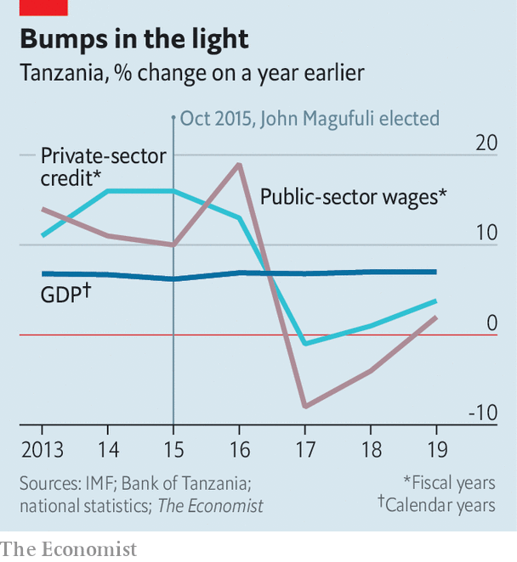

Public-sector wages and lending to the private sector, which had both been growing at well over 10% earlier in the decade, crept up by just 2% and 4% respectively (see chart). The amount of money circulating, normally higher when the economy is booming and people need cash, had grown at 10% for several years earlier in the decade but has edged up by only 2% in 2019.

The World Bank produces its own growth numbers for Tanzania, a reflection of its unease. These are lower than the government’s but still close to 6% in recent years. The Bank says that the gaps between GDP and other indicators such as tax revenue have narrowed of late, which would suggest that actual economic growth may have been recovering.

Yet if one looks beyond the indicators flagged by the IMF last year, the picture is still alarming. Foreign direct investment has almost halved since 2013. Exports and imports both fell between 2012 and 2018. Imports of machinery and construction equipment fell between 2015 and 2018, despite claims of booming construction. “The growth numbers are out of line with almost everything else we are seeing out of Tanzania,” says Justin Sandefur of the Centre for Global Development, a think-tank.

Tanzania’s recent growth ought to be evident in ordinary lives. When incomes rise, people buy more beer; yet revenue for Tanzania’s biggest brewer fell in 2018 and 2019. According to door-to-door surveys done in 2012 and 2018, the share of Tanzanians who are extremely poor, 49%, did not change at all over the period. That is almost unheard of. And because Tanzania’s population is growing, the number of extremely poor people has increased by about 4.5m.

Digging by independent wonks in Tanzania might clear all this up. But challenging the numbers is risky. In 2017 Zitto Kabwe, a prominent opposition MP, was arrested for questioning GDP. In 2018 the government made it a crime to dispute official statistics. After an outcry the law was toned down, but its chilling effect persists.

Mr Magufuli avoids sunlight in other areas, too. Tanzania stopped reporting on covid-19 on May 7th, when it had 509 cases and 21 deaths. In May alone Kenya turned 100 Tanzanians away at the border after finding they were infected with covid-19. Nonetheless, on June 8th Mr Magufuli declared Tanzania “coronavirus free”.

The government says the economy will grow by 5.5% in 2020. That would probably make Tanzania the best-performing economy in the world. The IMF predicts a more modest 1.9%

With an election looming, the government’s economic record is facing fresh scrutiny. Bernard Membe, a former foreign minister who has defected to the opposition, says growth is “exaggerated” and “in fact is less than 3%”. What about Tanzania’s middle-income status? “A very big joke,” says Mr Membe. ■

This article was downloaded by calibre from <https://www.economist.com/middle-east-and-africa/2020/07/23/why-tanzanias-statistics-look-fishy>

|  |  |  |  |
| --- | --- | --- | --- |
|  | Articles | Sections | Next |

|  |  |  |  |
| --- | --- | --- | --- |
| Previous | Articles | Sections | Next |

#### Power unmasked

# Can Uganda have a fair election amid covid-19?

Government guidelines make it hard for the opposition to campaign

Jul 23rd 2020 | KAMPALA

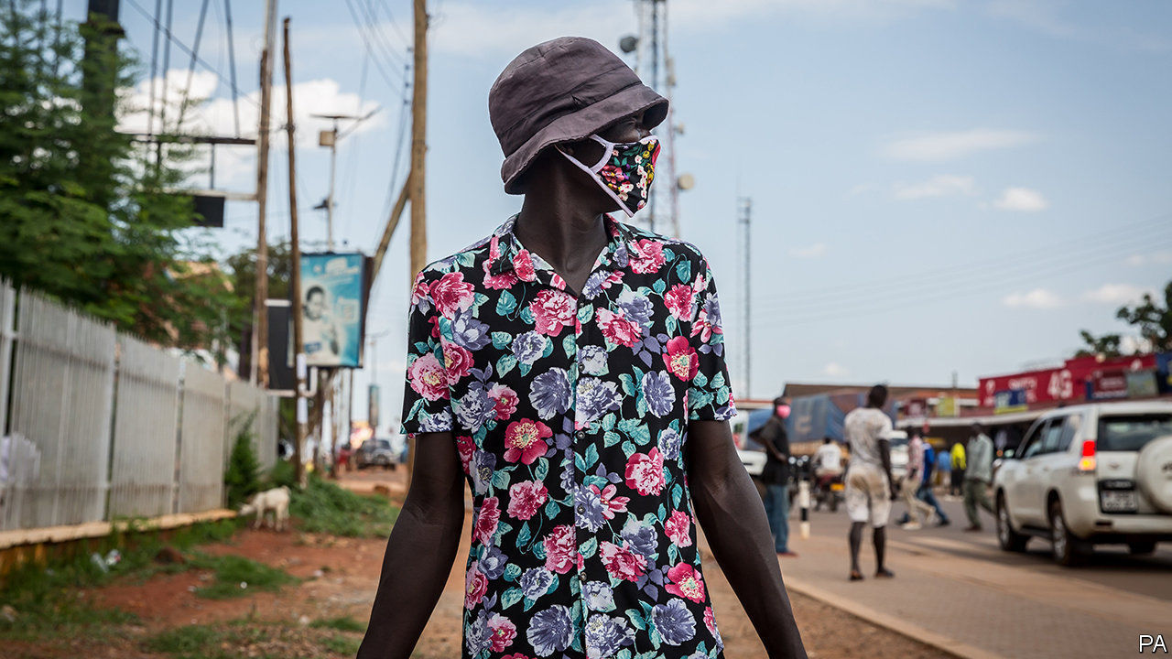

Editor’s note: Some of our covid-19 coverage is free for readers of The Economist Today, our daily [newsletter](https://my.economist.com/user#newsletter). For more stories and our pandemic tracker, see our [hub](https://www.economist.com/news/2020/03/11/the-economists-coverage-of-the-coronavirus)

THE UGANDAN health minister, Jane Ruth Aceng, has won praise for her handling of covid-19, which has yet to cause a single reported death in her country. But recently she was photographed in a crowd, without a mask, in the district where she is seeking election in six months, when Uganda faces presidential, parliamentary and local elections. Ms Aceng’s critics said she was flouting the rules to chase votes, which she denies.

The coming campaigns will take place without the usual mass rallies, according to covid-19 guidelines issued by the electoral commission. That favours Yoweri Museveni, the incumbent president, who has won five contests, by fair means and foul, since fighting his way to power in 1986. Kizza Besigye, the main challenger in the past four elections, has yet to say if he will run again. But there is a new contender: Robert Kyagulanyi, a singer known as Bobi Wine, who is popular with young urbanites and has recently taken over a hitherto obscure party.

The pandemic complicates a longstanding struggle over freedom of speech and assembly. In January Mr Wine and his supporters were arrested in a cloud of teargas as they tried to hold meetings with voters. The police said the singer had fallen foul of the draconian Public Order Management Act, which has been used since 2013 to block gatherings the government does not like. In March the constitutional court struck down a key section of the act, giving civil society a rare victory.

But the country was already entering a covid-19 lockdown, which offered a compelling new reason to clear the streets. With churches, schools and football pitches still closed, it would be a “total disaster” to stage rallies, argues Mike Mukula, a bigwig in the ruling National Resistance Movement (NRM). That has not stopped him holding indoor meetings with scores of NRM activists. Opposition leaders say the state is keener to control people than to protect them. “If you continue provoking Ugandans, Ugandans will rise up against you,” warns Mr Wine.

Without public rallies, candidates will rely on the media to promote their causes. The press in Kampala, the capital, is lively. But most Ugandans get their news from local radio, which has learned to tread carefully. Maria Ledochowska Nnatabi, a 24-year-old parliamentary candidate who backs Mr Wine, says that talk-show moderators steer her away from sensitive topics. “If I go to the communities, I’m going to say what I want to say openly,” she says. On radio “you’re already compromised.”

Many private broadcasters are owned by politicians or business people with links to the NRM, which state-owned stations also support. “Our majority shareholder is the government so we find our hands are somehow tied,” says Dickson Nandinda of Radio West, a regional outlet. “There are things we will not say.” Candidates will have to pay 3m shillings ($813) to appear on an hour-long talk-show, he adds. That is as much as the average Ugandan makes in a year.

Some opposition leaders want Mr Museveni to declare a state of emergency and postpone elections. The old soldier is disinclined to do so. His regime has built a civilian architecture over the hard foundations of military power. Regular elections, however flawed, reinforce his position as “the elected general” who “stands between the army and the population”, argues Angelo Izama, a Ugandan analyst.

The most radical opposition figures, such as Mr Besigye, say that Mr Museveni has such a tight grip that an election alone will never unseat him. Instead, they see the polls as the catalyst for a political crisis, or even a popular uprising. The deployment of armed militia to enforce the covid-19 curfew looks to some like a dress rehearsal for suppressing post-election protests. ■

Editor’s note: Some of our covid-19 coverage is free for readers of The Economist Today, our daily [newsletter](https://my.economist.com/user#newsletter). For more stories and our pandemic tracker, see our [hub](https://www.economist.com/news/2020/03/11/the-economists-coverage-of-the-coronavirus)

This article was downloaded by calibre from <https://www.economist.com/middle-east-and-africa/2020/07/23/can-uganda-have-a-fair-election-amid-covid-19>

|  |  |  |  |
| --- | --- | --- | --- |
| Previous | Articles | Sections | Next |

|  |  |  |  |
| --- | --- | --- | --- |
| Previous | Articles | Sections | Next |

#### Mission unaccomplished

# Binyamin Netanyahu boasted too soon of defeating the coronavirus

With its case count rising, Israel is locking down again

Jul 23rd 2020 | JERUSALEM

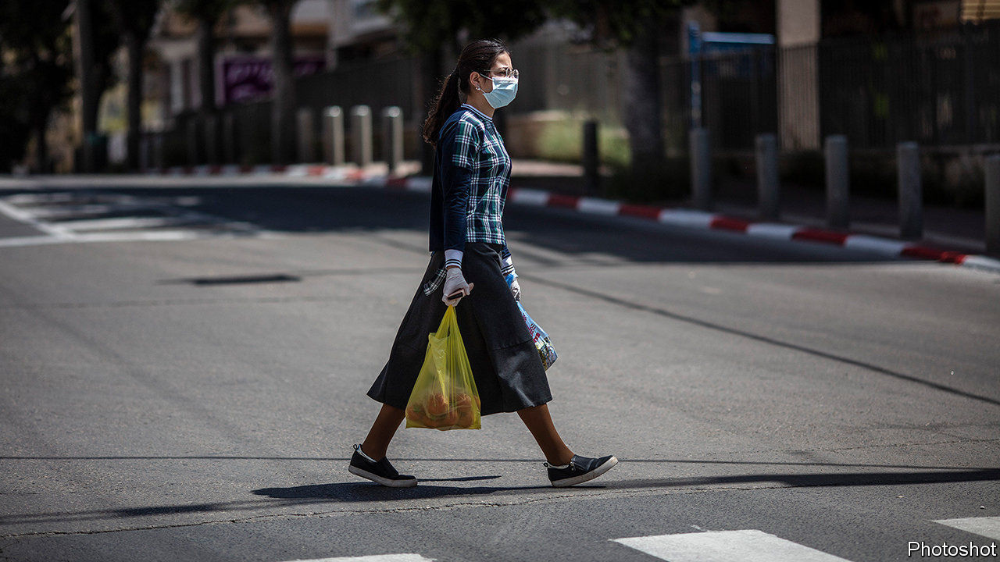

Editor’s note: Some of our covid-19 coverage is free for readers of The Economist Today, our daily [newsletter](https://my.economist.com/user#newsletter). For more stories and our pandemic tracker, see our [hub](https://www.economist.com/news/2020/03/11/the-economists-coverage-of-the-coronavirus)

GO OUT, GET a coffee, have a beer, said Binyamin Netanyahu. “First of all, have fun.” That was two months ago, after nearly eight weeks of lockdown, when Israel’s prime minister thought he had all but beaten covid-19. Mr Netanyahu led the fight, refusing to delegate authority and holding daily briefings full of alarmism and braggadocio. “So far we’ve done it better than nearly any other country in the world and I assess that by the end of this we will be the best in the world,” he said in March. “Other countries are adopting the steps we took.”

They may want to stop. Although Israel pushed new cases of covid-19 down to a handful a day in late May and early June, they are now close to 2,000, higher than the previous peak (see chart). The disease is spreading faster in Israel than in most other developed countries (though not America). So the government is locking down again. On July 17th it shut schools and gyms. Malls and shops were told to close on weekends. All indoor gatherings of ten or more people are banned.

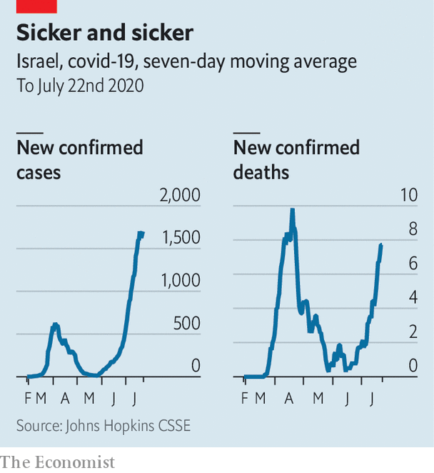

But the new closures look haphazard. For example, restaurants, beaches and pools were closed—then opened again, with some restrictions. Even Mr Netanyahu admits that the actions are “not scientific”. His critics are harsher. “An entire country is trying to understand why decisions are made in the middle of the night without any data,” wrote Yair Lapid, the head of the opposition, on Twitter. Fewer than a third of Israelis are satisfied with the way Mr Netanyahu is handling the crisis, according to recent polls. Thousands of people have taken to the streets in Jerusalem and Tel Aviv to call for his resignation and to demand more aid for people and businesses hurt by the outbreak.

Mr Netanyahu has hinted that another full lockdown could be in the offing if things do not improve. That would clobber the economy, which is already set to contract by 6% this year. Unemployment sits at 21%, compared with 3.4% before the outbreak. The prime minister has tried to help, but Israelis think he is missing the mark. A 6bn shekel ($1.8bn) plan to give $220 to individuals and up to $870 to families was panned for failing to target those in need. “There are more effective ways to help increase demand,” said Amir Yaron, head of the central bank. The cabinet appears to be sidestepping Mr Netanyahu by setting up a committee to decide who gets the cash.

Public-health experts say the government opened things up too fast, while neglecting to take steps to keep the virus under control. Israel is a world leader in testing per person, but its contact-tracing system has been overwhelmed. The health ministry has too few nurses to track people who may have been infected. Some politicians have called on Mr Netanyahu to transfer responsibility to the defence ministry, which has more manpower. But he is loth to let anyone else take credit for fighting the pandemic—and the defence ministry is run by his political rival, Benny Gantz. (Mr Gantz joined the government only after Mr Netanyahu promised to hand him the premiership next year.)

Mr Netanyahu is instead banking on a controversial mobile-phone surveillance program created by Shin Bet, the security service. The program, designed to track terrorists, was used early in the outbreak, then halted. In June the prime minister brought it back over objections from the head of Shin Bet. The program is meant to identify those who have recently been in contact with an infected person. The health ministry then sends them a text message telling them to quarantine. But there has been a high number of false positives, say experts, and the public’s trust in the government is so low that many Israelis leave their mobile phones at home to avoid being tracked and ordered to quarantine.

One silver lining of Israel’s covid-19 crisis is that relatively few people have died. With a population of 9m, Israel has reported over 56,000 cases but just 430 deaths. That is probably because of a young population and good health care. But criticism of Mr Netanyahu is growing for other reasons, too. On July 19th a court said the next stage of his trial on corruption charges, postponed because of the lockdown, would begin in January. The court will convene three times a week, with the prime minister in attendance. Mr Netanyahu is reportedly trying to wriggle out of both his legal troubles and his agreement with Mr Gantz by calling an early election. ■

Editor’s note: Some of our covid-19 coverage is free for readers of The Economist Today, our daily [newsletter](https://my.economist.com/user#newsletter). For more stories and our pandemic tracker, see our [hub](https://www.economist.com/news/2020/03/11/the-economists-coverage-of-the-coronavirus)

This article was downloaded by calibre from <https://www.economist.com/middle-east-and-africa/2020/07/23/binyamin-netanyahu-boasted-too-soon-of-defeating-the-coronavirus>

|  |  |  |  |
| --- | --- | --- | --- |
| Previous | Articles | Sections | Next |

|  |  |  |  |
| --- | --- | --- | --- |
| Previous | Articles | Sections | Next |

#### No passport required

# Vloggers show how to migrate illegally on a jet ski

North African migrants share their adventures on YouTube

Jul 23rd 2020 |



COMPARED WITH the dross of north Africa’s state broadcasters, it makes riveting viewing. The video-blogger cuts his way through rainforests, travels by wooden canoe, flirts with various women and finally reaches Panama, one of ten countries he has entered illegally on his way to the United States. Each instalment, filmed on a mobile phone and posted regularly on YouTube, packs suspense, adventure and tips for would-be illegal migrants. The vlogger, Zouhir Bounou, who calls himself Zizou (pictured), has become a household name back home in Morocco.

North African migrants have long shared advice about how to enter Europe and America illicitly. On social media they offer a romanticised view of life on the other side of the journey. These posts have encouraged hundreds of thousands of north Africans to embark on haraga, or illegal migration. Now vloggers like Zizou are turning their travels into entertainment. And they may be enticing a new generation to pack up and go. “The vlogs have a tremendous pull,” says Amine Ghoulidi, a Moroccan academic.

“I help north Africans break the fear barrier and fulfil their dream of reaching the West,” says Murad Mzouri, who used to peddle cheap clothes in Morocco. Now he is one of its most popular vloggers, with up to a million views a month. Zizou won his audience with tales of raves on beaches and run-ins with the police. Citing the danger, he now tells others not to follow his path.

But the vlogs are full of useful information for would-be migrants, such as the co-ordinates for a route across the Turkish-Greek frontier and the going rates for bribes. Some name lawyers who can help with paperwork or tell of charities that provide the best shelter. Want to know where to conduct a sham marriage or get a fake employment contract? Check the vlogs. How do you avoid deportation? “Claim to be underage, claim to be Libyan and claim to be looking for your father,” suggests a vlogger.

There is often more information in the comments section, such as phone numbers of smugglers. But that’s the old way of doing things. The vloggers caution against paying shady human traffickers. Instead, they suggest buying a ticket to Turkey and hiking into Greece. Jet skis are a popular option for Moroccans heading to Spain. Many of the vloggers are university graduates and have similar viewers. Long considered the desperate pursuit of no-hopers, illegal migration is attracting a growing number of the educated and employed. The vlogs are “making haraga mainstream and middle-class”, says Mr Ghoulidi.

They also make money. Mr Mzouri says he earns $2,000 a month from advertising and product placements. When Zizou landed in jail, his followers crowdfunded his bail. North African vlogs have an advantage over the competition. The authorities in the West know enough standard Arabic—or can use Google translate—to track the information shared on social media by migrants from places like Syria. But the dialects of north Africa are more of a challenge. “The vlogs are beyond the radar of Western officials,” says Matt Herbert, an expert on migration based in Malta. And the vloggers themselves are adept at avoiding the authorities.

This article was downloaded by calibre from <https://www.economist.com/middle-east-and-africa/2020/07/23/vloggers-show-how-to-migrate-illegally-on-a-jet-ski>

|  |  |  |  |
| --- | --- | --- | --- |
| Previous | Articles | Sections | Next |

|  |  |  |  |
| --- | --- | --- | --- |
| Previous | Articles | Sections | Next |

#### Maids for sale

# Bigotry against black people poisons the Arab world, too

Protests in America have shone a new light on an old problem

Jul 23rd 2020 | BEIRUT

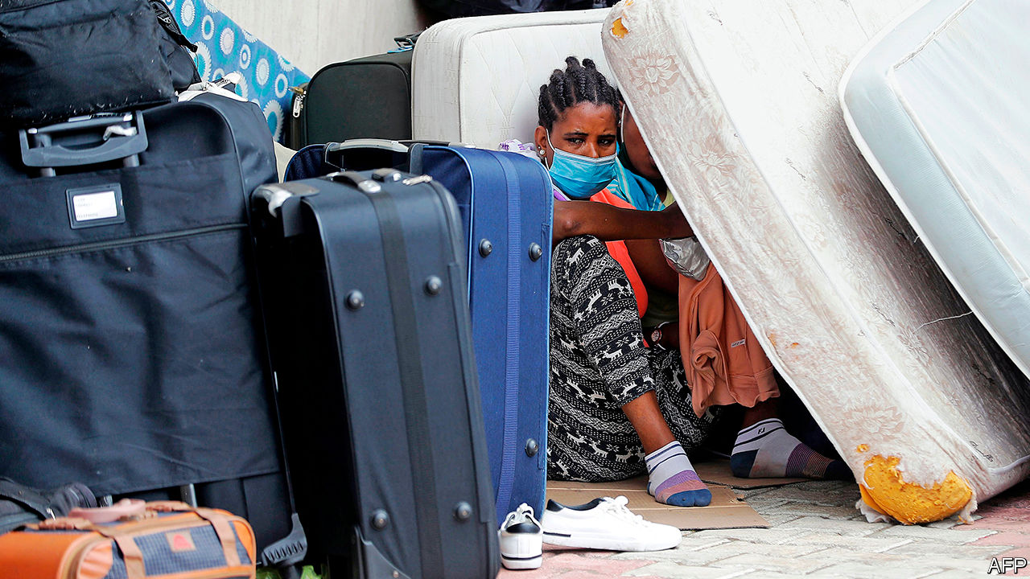

DAY AFTER day, week after week, the cars pulled up outside the Ethiopian embassy in Beirut and ejected their passengers: tired-looking black women, their modest possessions stuffed into cheap suitcases (pictured). With the economy in free fall, many Lebanese families could no longer afford to pay their domestic workers. Nor could they easily send them home. The price of repatriation flights had surged because of covid-19. So their solution was to dump the women outside their embassy. Dozens were left to fend for themselves.

The protests in America over racism and police brutality have drawn much interest in the Middle East. Some people reacted with shock, some with Schadenfreude. For others, though, America’s unrest was an opportunity to discuss the problems with race in their own countries.

Most Arab states have a black minority. Black communities in north Africa trace their roots to antiquity: the Nubians, for example, called Egypt home long before their country acquired its Arab identity. In the Levant and the Gulf many people are the descendants of slaves taken by Islamic empires, or of African Muslims who made pilgrimages east and decided to stay.

All face discrimination. Dark-skinned people are referred to with terms like abd (“slave”). Egypt’s dark-skinned former president, Anwar Sadat, was called his predecessor’s “black poodle”. Blackface is a common sight on Arabic television. In a widely shared video a black Palestinian actress, Maryam Abu Khaled, recounted the casual bigotry she encounters, such as a mother telling her daughter to get out of the sun lest she, too, turn black.

Skin colour can make marriages fraught when families see it as a marker of socioeconomic status or pedigree. Discrimination exists in the workplace, too. Black Iraqis, a community with more than a thousand years of recorded history, struggle to get government jobs and are typically relegated to menial work.

The worst treatment, though, is reserved not for citizens but for migrants. In wealthy Gulf states it manifests in a tacit racial hierarchy. Fancy hotels might employ black migrants as security guards or porters. They are less common in jobs that require interaction with customers, like waiters or hairdressers. Those better-paid roles often go to lighter-skinned workers from Asian or Arab countries.

Egypt is thought to host around 5m African migrants, many of whom fled war and oppression in places like South Sudan and Eritrea. They have faced years of abuse. About two dozen Sudanese were killed in 2005 when police raided a protest camp. In years past some tried to reach Israel, a long journey across Sinai’s desert that left them prey for human traffickers. Those who crossed the border met discrimination and frequent attempts to deport them—regardless of conditions in their home countries.

Some Lebanese advertise their housekeepers on Facebook as if they were property. A post in April offered a Nigerian maid, “very active and clean”, for 1.5m Lebanese pounds ($1,000 at the official exchange rate). Bigotry can trump class: a black diplomat recalled being pursued in malls by security guards who thought her a housekeeper and wanted to know why she was shopping without her madame.

Faustina Tay, a Ghanaian maid in Lebanon, was found dead in March in the car park underneath the home where she worked. Doctors ruled her death the result of a fall. Her case was not unusual. Even before the economic crisis, human-rights groups estimated that around two domestic workers died each week in Lebanon, mostly by suicide. (Not all are African.)

For years activists have urged the government to scrap the kafala system, which prevents foreign workers from leaving an abusive employer without also leaving the country. Economic crisis may make the issue less pressing: fewer Lebanese can afford to employ foreign maids. In June a Ghanaian television channel covered the return of 211 citizens from Lebanon, most of them female domestics. They described long hours, beatings and having to steal food to survive. “No one should make that mistake and go back to Lebanon,” one woman said. “They don’t respect us.” ■

This article was downloaded by calibre from <https://www.economist.com/middle-east-and-africa/2020/07/23/bigotry-against-black-people-poisons-the-arab-world-too>

|  |  |  |  |
| --- | --- | --- | --- |
| Previous | Articles | Sections | Next |

|  |  |  |
| --- | --- | --- |
| Middle East & Africa | Sections | Britain |

Europe

Europe’s economy: A big fiscal deal

.

The Franco-German relationship: Back on the tandem

.

Covid-19 in slaughterhouses: Germany’s wurst jobs

.

Bulgarian protests: Bullies on a beach

.

Greek ruins: Attic views

.

Spain’s monarchy: A tarnished crown

.

Charlemagne: Chekhov’s treaty

.

|  |  |  |
| --- | --- | --- |
| Middle East & Africa | Sections | Britain |

|  |  |  |  |
| --- | --- | --- | --- |
|  | Articles | Sections | Next |

#### A big fiscal deal

# The EU’s leaders have agreed on a €750bn covid-19 recovery package

The union will borrow vast sums collectively for the first time

Jul 21st 2020 | BERLIN



LIKE ALMOST everything else at this week’s European Council, which concluded at 5.30am on July 21st after five days of deliberation, the question of whether it was the longest EU summit in history was hotly contested. Some said it beat the record held by a mammoth discussion in Nice in 2000. Others thought it fell 25 minutes short. Either way, it was a landmark event. Most of the EU’s 27 national leaders emerged into the Brussels dawn claiming to have agreed to something historic. To judge by the soaring euro and plunging spreads, investors concurred.

The deal has two elements: the regular EU budget, or multiannual financial framework (MFF), worth nearly €1.1trn ($1.3tn) over seven years; and a one-off “Next Generation EU” (NGEU) fund of €750bn to help countries recover from the covid-19 recession (both figures in 2018 prices). Rows over the second of these explain the summit’s length: at one point leaders spent over an hour arguing over whether to replace the word “decisively” with “exhaustively” in the communiqué. But in the end each returned home broadly satisfied.

The deal broke two historic taboos, says Silvia Merler, head of research at Algebris Policy Forum, the advisory branch of an asset-management firm. First, Europe’s leaders agreed that the European Commission, acting on behalf of the member states, may incur debt at an unprecedented scale. The NGEU will be funded by borrowing over six years, with bonds issued at maturities extending to 2058. Second, €390bn of the €750bn will be distributed as grants, and hence will not add to governments’ debt loads—breaching what had been a red line over substantial intra-EU fiscal transfers. Both developments would have been unimaginable just six months ago.

Europe has marshalled a fiscal response to the covid crisis equal to or better than America’s. The NGEU is worth some 4.7% of the EU’s annual GDP, albeit spread over several years, and comes on top of national governments’ stimulus efforts. The EU has plugged the budgetary hole left by the departure of Britain. It has answered the European Central Bank’s pleas to balance its monetary activism with a comparable fiscal effort, and will provide investors with a steady stream of safe assets. It may have set a precedent for future crises to be met with collective debt, although that will be ferociously resisted, not least by the self-styled “frugal four”—Austria, Denmark, the Netherlands and Sweden—who were the biggest hurdle to striking a deal.

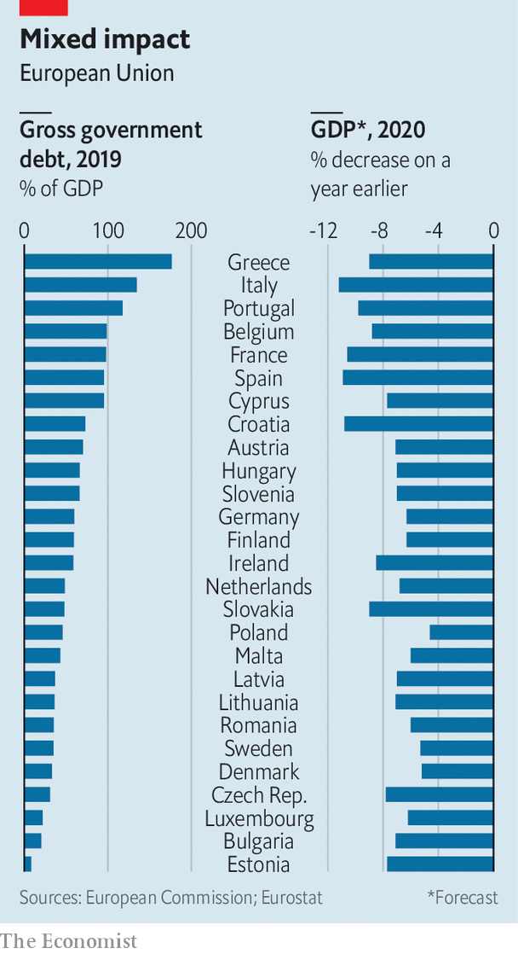

The recovery funds will initially be allocated to countries using criteria like unemployment and income per person. That will benefit the likes of Spain, and Italy, which says it is in line for €209bn in loans and grants. The commission will evaluate governments’ investment plans on the basis of its annual “country-specific recommendations”, usually toothless reform checklists that Ursula von der Leyen, the commission’s president, says will now pack “more punch”. Fully 30% of MFF and NGEU spending should be devoted to climate action, potentially creating a vast green stimulus.

But the commission will not have the only say over spending. Rather like Germany during the euro crisis, the frugals do not trust the commission’s technocrats to police the reforms of southern states. Instead Mark Rutte, the Dutch prime minister, secured an “emergency brake”: any government can object to another’s spending plans, delaying and complicating disbursements. That allows him to tell Dutch voters that they have not signed a blank cheque for feckless southerners. Some southern reformers even hope this rule may help their case (“Thanks Mark Rutte,” wrote a pro-market Spanish politician in El País). But Lucas Guttenberg of the Jacques Delors Centre in Berlin fears the brake could entrench mistrust inside the EU if beneficiary governments believe others are objecting in bad faith.

The deal falls short of the “Hamiltonian moment” some had hoped for, referring to the US national government’s assumption of state debts in 1790. No one has proposed mutualising EU countries’ legacy debts; even the new common debt will not enjoy joint-and-several guarantees. And the question of how to repay it is left for later. Governments have long been unwilling to hand tax-raising powers to Brussels. Yet from 2028 money must be found to repay the new debt: if not from “own resources” (EU revenues, in the jargon) generated by new taxes, then from larger national contributions to the MFF. A levy on plastic will take force in January, and the commission will later propose EU-wide taxes on digital firms and climate-unfriendly imports.

There are two areas of concern. The first is the price demanded by the frugals. To preserve the recovery grants, cuts fell on so-called “future-oriented” areas like research, health care and climate adjustment. These, critics grumble, are precisely the themes the frugals always said should take priority over farming and regional subsidies, which remain intact. And the frugals won big increases to the rebates they get on their EU budget payments (Austria’s more than doubled). Such small-country triumphs do not fatally undercut the deal, but they cost money and will be bitterly contested at the next MFF round.

A second set of worries centred on how to prevent handouts to countries that undermine the rule of law. Wayward governments like Hungary and Poland are big winners from the MFF, and some had hoped that attaching rule-of-law conditions to disbursements might help bring them to heel. In the end the leaders agreed on studiously ambiguous language, shaped by Angela Merkel’s team. It promises “a regime of conditionality to protect the budget” but postpones the decision on how to obtain it. “Lots of people will want this made more precise,” says Katarina Barley, a German social-democratic MEP.

Many of Ms Barley’s colleagues in the European Parliament, which must sign off on the deal, also criticised the deal’s cuts to favoured programmes and their own exclusion from oversight of spending. Yet although the parliament may extract tweaks to the deal, on past form it is unlikely to squash it. A budget must be in place from the start of next year. MEPs will not want to spark a crisis by blocking it. ■

This article was downloaded by calibre from <https://www.economist.com/europe/2020/07/21/the-eus-leaders-have-agreed-on-a-eu750bn-covid-19-recovery-package>

|  |  |  |  |
| --- | --- | --- | --- |
|  | Articles | Sections | Next |

|  |  |  |  |
| --- | --- | --- | --- |
| Previous | Articles | Sections | Next |

#### Keep pedalling the tandem

# The founding partnership behind this week’s EU deal

Macron and Merkel defy those who had written off the Franco-German relationship

Jul 23rd 2020 | PARIS

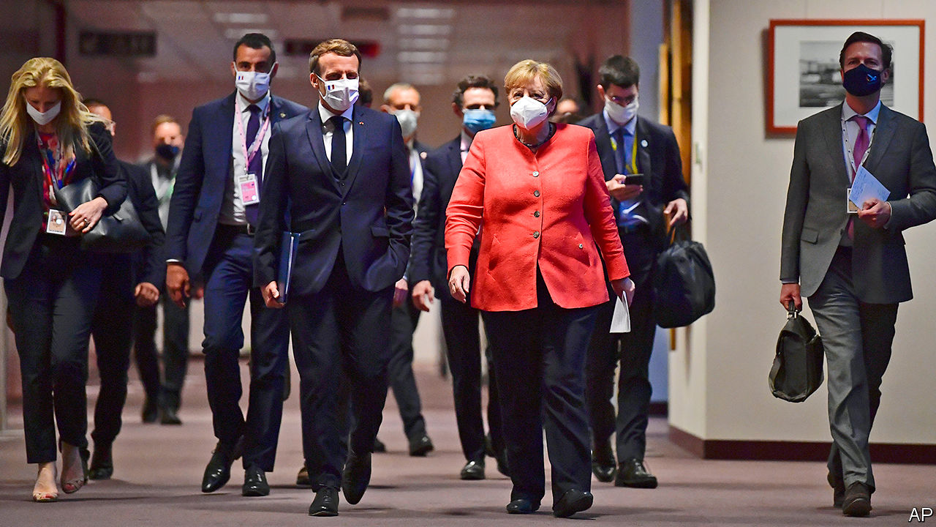

“I’M NOT FRUSTRATED, I’m impatient,” declared an evidently frustrated Emmanuel Macron in Germany earlier this year. The French president had put European integration at the heart of his election campaign in 2017. Yet even as covid-19 struck, European leaders were still unable to agree on much. France and Germany, two founding members that have guided the European Union for over six decades, were condemned, it seemed, to settle for incremental fixes. One commentator wrote of “the end of the Franco-German love-in”. In The Economist last November, Mr Macron said Europe was “on the edge of a precipice”.

In the early hours of July 21st, however, after four long days and nights, the 27 EU leaders agreed to a deal that, for once, deserved the term Mr Macron gave it: “historic”. The agreement was officially shepherded by Charles Michel, president of the European Council, backed by Ursula von der Leyen, head of the European Commission. But ultimately it happened because the leaders of France and Germany managed—in a crisis—to settle their differences beforehand, then bring others along. “Exceptional events”, said Germany’s chancellor, Angela Merkel, “call for exceptional new measures.”

The Franco-German tandem has driven most of Europe’s advances. The Maastricht treaty in 1992, for instance, which led to the euro’s creation, was masterminded by France’s François Mitterrand and Germany’s Helmut Kohl. Over the decades, even when leaders have not got on, strong cross-Rhine administrative links have endured. The point is not that France and Germany agree readily: they approach almost everything—from defence to debt—differently. But if they can agree, goes the theory, fellow Europeans should be able to as well.

This latest deal tested that principle to the limit. The “frugals”—Austria, Denmark, the Netherlands and Sweden, joined by Finland—dug in, insisting on less money for grants and more for their budget rebates. Tempers flared. At one point Mr Macron “banged his fist on the table”, according to an aide, accusing Austria’s Sebastian Kurz of having “a bad attitude” and the Netherlands of behaving as Britain used to. It was exactly the sort of lecturing from France that, when it acts alone, so irks others.

Yet this time, Mr Macron and Mrs Merkel led a double act. They devised a joint plan in May, steered talks à deux, even stormed out of a summit meeting together. After concessions, the frugals agreed to most of what they had rejected just months ago. “Macron held out his hand to Germany for a long time,” says Tara Varma of the European Council on Foreign Relations. “What made the difference is that in the end Merkel took it.”

This article was downloaded by calibre from <https://www.economist.com/europe/2020/07/23/the-founding-partnership-behind-this-weeks-eu-deal>

|  |  |  |  |
| --- | --- | --- | --- |
| Previous | Articles | Sections | Next |

|  |  |  |  |
| --- | --- | --- | --- |
| Previous | Articles | Sections | Next |

#### Germany’s wurst jobs

# After spreading covid-19, a huge European abattoir vows reforms

An outbreak forces German meat wholesaler Tönnies to promise its workers better conditions

Jul 23rd 2020 | BERLIN



Editor’s note: Some of our covid-19 coverage is free for readers of The Economist Today, our daily [newsletter](https://my.economist.com/user#newsletter). For more stories and our pandemic tracker, see our [hub](https://www.economist.com/news/2020/03/11/the-economists-coverage-of-the-coronavirus)

CLEMENS TÖNNIES used to be a local hero in eastern Westphalia. One of six children of a butcher from the town of Rheda-Wiedenbrück, he grew Tönnies, the family meat-wholesaling business which he took over after his brother Bernd’s death in 1994, into one of the biggest meat-processing companies in the world, with annual sales of €7bn ($8bn). For almost two decades the bratwurst billionaire was chairman of Schalke 04, a beloved local football team. He built the Tönnies arena, a 3,600-seat stadium for a women’s football club, next to his company’s headquarters. He donates to the local shooting club, and owns hotels, a gym, a real-estate agency and even a kindergarten in Rheda.

Mr Tönnies’s image suffered last year when he made comments belittling Africans, and was forced to step down as Schalke’s chairman. It took a much bigger hit last month after the plant in Rheda, the largest of his 29 plants in Europe, triggered Germany’s biggest single outbreak of covid-19. More than 1,400 people, mainly contract workers from south-eastern Europe, tested positive. Authorities closed the plant, quarantined some 7,000 workers and their families, and imposed a lockdown for 640,000 people in the area.

As the extent of the outbreak grew clear, Robert Tönnies, Bernd’s 42-year-old son who owns 50% of the company, asked his uncle and the entire top management to resign. Uncle and nephew have been at loggerheads for years over how to manage the firm. (Robert wants his uncle to spend less on football and more on animal and worker welfare.) In a letter leaked to the press, Robert lambasts the company’s use of subcontractors, which he has wanted to ban since 2017. More than 9,000 of Tönnies’s 18,700 workers are supplied by 24 subcontractors who recruit them mainly in Poland, Romania and Bulgaria. They live in cramped, infection-prone quarters.

“Workers are exploited,” says Sonja von Zons, a Green Party candidate for mayor of Rheda-Wiedenbrück. Tönnies does not have a digital time sheet, making it hard to track work: a typical shift is 12 hours of blood-soaked labour at temperatures near freezing, but contractors often pay only for eight. Sixty-hour weeks are the norm. Workers get the minimum wage (€9.35 an hour), but subcontractors charge them for knives, boots and other equipment. They also make them pay for board (in a squalid room shared with half a dozen others) and transport from their home countries. Locals do not mingle with the migrants. “It is a parallel society,” says Ms von Zons.

Mr Tönnies did not resign. Instead, he vowed to right the ship. He promises to scrap subcontractors and employ all workers directly by the start of next year. He also paid for food sent to quarantined workers, and for thousands of coronavirus tests in Rheda and surroundings. In an interview on July 18th with Westfalenblatt, a local paper, he explained that Martin Exner, a hygiene expert at the University of Bonn, found that the outbreak was caused by poor ventilation. In Mr Tönnies’ view, that meant it was not his firm’s problem, but one for the entire industry. On July 17th the Rheda plant restarted slaughtering, albeit at a reduced pace: 8,000 pigs a day, compared with up to 25,000 in normal times.

Hubertus Heil, the German labour minister, will not let Mr Tönnies get off the hook easily. He demands Tönnies pay damages for having forced the region’s quarantining. And he is due to present a draft law on July 29th banning the use of subcontractors in slaughterhouses.

Tönnies reacted by creating 15 subsidiary companies that will employ the formerly subcontracted workers. Critics think this is a ploy to prevent unionisation by dividing workers by job type, and perhaps by nationality: the vast majority of them will still be eastern Europeans. “We cannot find Germans to work for us,” explains André Vielstädte, a spokesman for Tönnies, adding that it is not “pleasant work”. Ending subcontracting will alleviate some hardships for migrant workers, but real change will come only if the industry leader shows the way. So far, Mr Tönnies has improved conditions at his plants mainly when he had no other choice.■

Editor’s note: Some of our covid-19 coverage is free for readers of The Economist Today, our daily [newsletter](https://my.economist.com/user#newsletter). For more stories and our pandemic tracker, see our [hub](https://www.economist.com/news/2020/03/11/the-economists-coverage-of-the-coronavirus)

This article was downloaded by calibre from <https://www.economist.com/europe/2020/07/23/after-spreading-covid-19-a-huge-european-abattoir-vows-reforms>

|  |  |  |  |
| --- | --- | --- | --- |
| Previous | Articles | Sections | Next |

|  |  |  |  |
| --- | --- | --- | --- |
| Previous | Articles | Sections | Next |

#### Bullies on a beach

# A seaside-villa scandal sparks huge protests in Bulgaria

Bodyguards who shoved an opposition politician could cost Boyko Borisov, the prime minister, his job

Jul 23rd 2020 | SOFIA



ON JULY 7TH a small boat motored up to a villa near the Black Sea resort town of Burgas. On board (and livestreaming) was Hristo Ivanov, a former justice minister who leads “Yes Bulgaria”, an anti-corruption party. He wanted to show that the villa’s main resident, Ahmed Dogan, founder of a party representing the country’s ethnic Turkish minority, was illegally treating the beach as his own. (In Bulgaria, coastal beaches are public property.) Mr Ivanov alighted and planted a Bulgarian flag, to the consternation of several muscular men in sunglasses who, unmoved by the ex-minister’s protestations of his constitutional rights, pushed him into the water.

A few weeks on, it is Bulgaria’s government that risks being pushed over. Mr Dogan is seen as an ally of the prime minister, Boyko Borisov, a former bodyguard who dominates the political scene with a mix of populism and patronage. But multiple scandals have led to daily protests in Sofia by thousands of demonstrators. On July 23rd Mr Borisov announced he was sacking four of his ministers, hoping to fend off demands that he resign.

The government’s troubles started in June, when an anonymous source began leaking recordings of someone who sounded like Mr Borisov ridiculing EU officials and boasting of harassing a local business. The next week, photos surfaced of a man resembling the prime minister asleep on a bed, with a handgun on the nightstand and an open drawer full of €500 bills and gold ingots. Mr Borisov said the recordings and photos were manipulated, but acknowledged it was his bedroom.

Then came Mr Ivanov’s visit to Mr Dogan’s beach, which led to questions about the mysterious men who shoved him. On July 8th Rumen Radev, Bulgaria’s president, who was nominated by the opposition Socialists, revealed that they were officers of the state agency that protects senior officeholders. It was providing security for Mr Dogan and another member of his party: Delyan Peevski, a media oligarch. It was not clear why they deserved taxpayer-supplied beach bouncers, and Mr Radev called for the protection to be withdrawn.

The response was swift. On the morning of July 9th police raided the president’s office and detained two aides on charges of influence-peddling and disclosing state secrets. That afternoon demonstrators took to the streets, accusing the chief prosecutor of ordering the raid. By July 11th Mr Radev was saying Mr Borisov ran a “mafia government” and urging him to step down.

Mr Borisov’s term ends next spring, but he may not last that long. Axing his finance, economy, interior and culture ministers was meant to deflect blame, but it hardly suggests strength. Dimitar Bechev, a political scientist at the University of North Carolina, thinks he has lost control of the agenda: voters suspect he is beholden to Mr Dogan and Mr Peevski. But early elections would bring little relief. Apart from Mr Borisov’s conservative GERB party, only the Socialists are strong enough potentially to form a government. They are seen as little better than GERB on corruption, and are friendly towards Russia.

All this has made for a rough summer. Bulgaria handled the first stage of the covid-19 epidemic well, with a tough lockdown. Early this month the European Commission accepted its entry into the “waiting room” for adopting the euro. But covid-19 cases have begun to rise, and the scandals are a reminder of how little progress has been made against corruption. “The state of democracy, the state of the institutions and the quality of life have been going backwards rather than forwards,” says Ruzha Smilova, a political scientist at Sofia University. At least the weather at Mr Dogan’s villa has been marvellous. ■

This article was downloaded by calibre from <https://www.economist.com/europe/2020/07/23/a-seaside-villa-scandal-sparks-huge-protests-in-bulgaria>

|  |  |  |  |
| --- | --- | --- | --- |
| Previous | Articles | Sections | Next |

|  |  |  |  |
| --- | --- | --- | --- |
| Previous | Articles | Sections | Next |

#### Attic views

# A hotel developer in Athens obstructs the Acropolis

Locals are protesting, and the government has taken their side

Jul 23rd 2020 | ATHENS

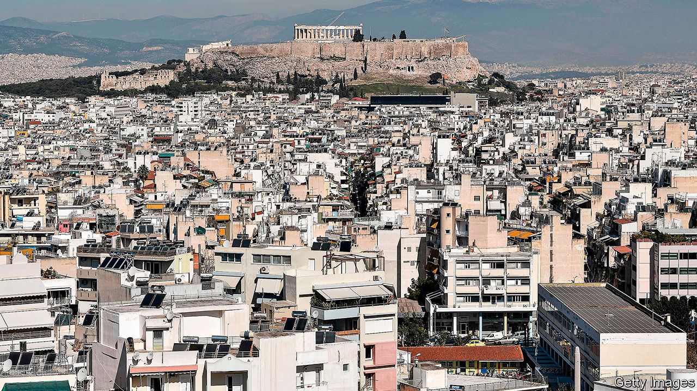

WITHOUT HE Acropolis, the rocky hilltop crowned by the gleaming pillars of the 2,500-year-old Parthenon, Athens would be just another down-at-heel city in southern Europe. This summer, because of covid-19, fewer tourists than usual have shown up to admire its painstakingly restored marble temples, built to celebrate the ancient Greeks’ victories over invading Persians and revered as symbols of western civilisation. But the absence of crowds has made it easier to spot an emerging threat to the distinctive Acropolis skyline.

A few hundred metres south of the hill, in a neighbourhood called Makriyanni, an illegally constructed ten-storey hotel looms over scores of four- and five-storey apartment blocks. From some angles the hotel shuts out the view of the Parthenon, and is distinctly less attractive. Coco-Mat, a hotel company controlled by Libra, a Greek-American shipping group, built it in 2018 under a law passed during Greece’s financial crisis that lets buildings exceed height codes if they include a “green” roof. But in place of the luxuriant Mediterranean garden the company promised, it built a rooftop swimming pool and restaurant.

Angry Makriyanni residents sued the company. An online petition attracted nearly 50,000 signatures. In April the powerful Central Archaeological Council (KAS), which advises the culture ministry, ruled that two floors should be lopped off the hotel, cutting its height from 37m to 24m. The culture minister backed KAS; now Athens’ city authority must approve the two floors’ demolition. The Council of State, Greece’s highest legal body, weighed in, too, setting a height limit of 21m (six floors) for new buildings in Makriyanni. A presidential decree confirming the ruling is expected in September.

But more needs to be done to protect the Acropolis from greedy property developers, says Irini Frezadou, a Swiss-trained architect and local activist. Half a dozen companies have applied for planning permission to build hotels in Makriyanni. Even if the height limit is respected, new hotels could spread horizontally. One project that has got permission includes several underground parking lots, which opponents say would create congestion and annoy pedestrians.

Dimitris Pandermalis, an archaeologist who runs the nearby Acropolis museum, home to sculptures from the temples and other treasures, notes that the ancient Athenians used a simple formula to prevent overbuilding. Less than a century after the Parthenon was completed, a decree was passed making it illegal for a private building to stand higher than a public one. Perhaps today’s rules would be better respected if developers had to worry about being presented with a cup of hemlock. ■

This article was downloaded by calibre from <https://www.economist.com/europe/2020/07/23/a-hotel-developer-in-athens-obstructs-the-acropolis>

|  |  |  |  |
| --- | --- | --- | --- |
| Previous | Articles | Sections | Next |

|  |  |  |  |
| --- | --- | --- | --- |
| Previous | Articles | Sections | Next |

#### A tarnished crown

# Spain’s King Felipe is distancing himself from his father

Headlines about ex-king Juan Carlos’s finances and lovers embarrass the monarchy

Jul 23rd 2020 | MADRID

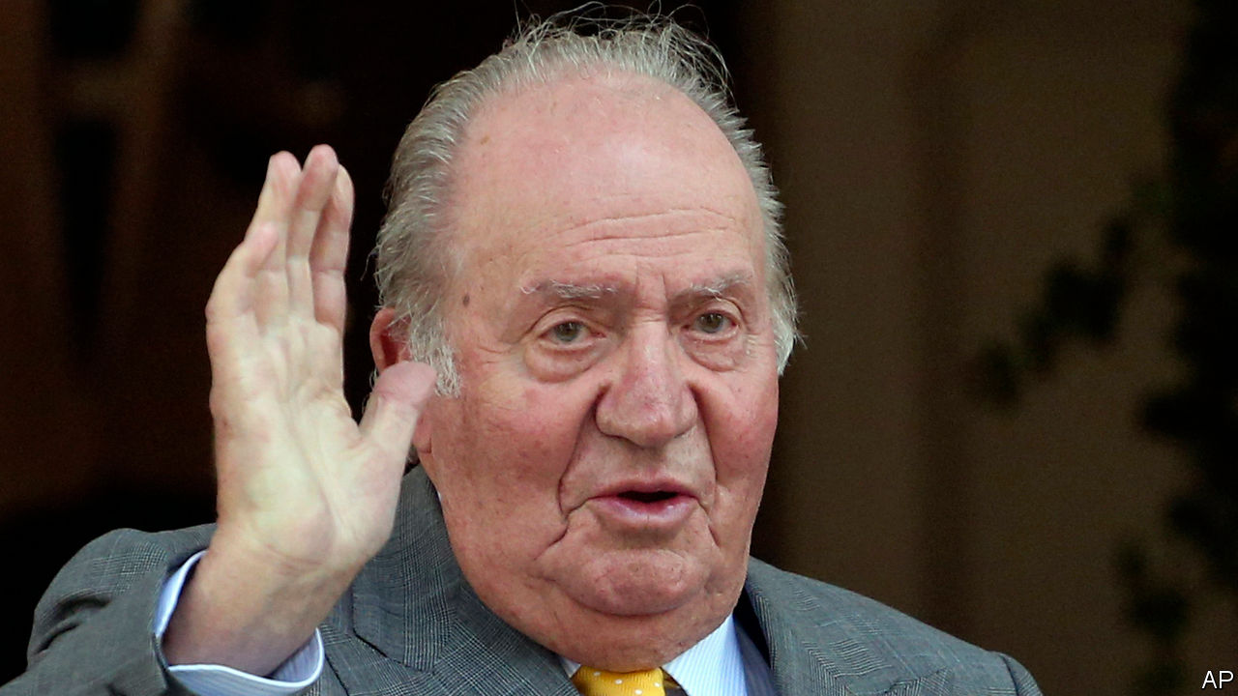

BACK IN MARCH, as Spain was distracted by pandemic and lockdown, the royal household quietly announced that King Felipe had renounced his inheritance and cancelled the salary of €194,232 ($225,173) he was paying his father, Juan Carlos, who abdicated in 2014. The move was prompted by revelations that Felipe was a beneficiary of two foundations linked to Juan Carlos, both registered in tax havens. The Swiss bank account of one is alleged to have received a $100m payment from Saudi Arabia, of which €65m was transferred in 2012 to Corinna Larsen, Juan Carlos’s Danish ex-lover. (She claims this was “not to hide the money” but because he “hoped to win me back”.) Prosecutors in Switzerland and Spain are investigating. The Spanish press continues to publish leaked letters from Ms Larsen’s lawyers suggesting that she tried (and failed) to get Felipe involved.

Installed as monarch on the death of the dictator Francisco Franco, Juan Carlos was long respected for safeguarding Spain’s transition to democracy. He played a crucial role in quashing a coup in 1981. His clubbable manner concealed insecurities. Franco’s choice of him as king prompted a breach with his own, exiled, father. In his childhood “money was a matter of constant problems,” he told a friend. King Felipe grew up watching his father “collect lovers as if they were state gifts”, according to Lucía Méndez of El Mundo, a newspaper.

Juan Carlos’s fall from grace began in 2012, when he broke his hip while elephant-hunting with Ms Larsen in Botswana, revealing their relationship to the public. His level-headed successor, Felipe, has largely lived up to his promise of a “renovated monarchy for a new era”. He now faces the prospect of his father being charged, though as king emeritus Juan Carlos can be tried only in the Supreme Court, and the statute of limitations may save him. The left-wing coalition government has publicly nudged Felipe to chastise his father further, perhaps by evicting him from the Zarzuela Palace.

Ousted three times between 1808 and 1975, the Spanish Bourbons are still on probation. Republican sentiment is growing. “The monarchy isn’t doomed,” says Charles Powell of the Elcano Royal Institute, a think-tank. “But Juan Carlos is toxic and Felipe will struggle to win back the respect and confidence he had won. There’s very little sympathy for the institution now.”■

This article was downloaded by calibre from <https://www.economist.com/europe/2020/07/23/spains-king-felipe-is-distancing-himself-from-his-father>

|  |  |  |  |
| --- | --- | --- | --- |
| Previous | Articles | Sections | Next |

|  |  |  |  |
| --- | --- | --- | --- |
| Previous | Articles | Sections | Next |

#### Charlemagne

# Why the EU is becoming more like a Chekhov play

Legal guns that once gathered dust may soon be fired

Jul 23rd 2020 |



“IF IN THE first act you have hung a pistol on the wall, then in the following one it should be fired.” Anton Chekhov’s rule on writing is a good one. The Russian author would have despaired at the Treaty on the Functioning of the European Union. At 154 pages in its consolidated version, it is a bit long. The prose lacks punch. More importantly, it is littered with unused firearms. Powerful weapons gather dust in the EU’s legal gun-cabinet. Article 222 obliges all EU states to pile in and help if a desperate national capital triggers it, which no one ever has. National capitals can sue each other in the European Court of Justice, although no one has tried it properly. Even the outlines of an EU army are there, if the members want it, which so far they do not.

Now, however, European officials are eyeing up the armoury. Hitherto unused, overlooked or reinterpreted rules provide the legal bedrock for renewed attempts to integrate the bloc in ways unimaginable a few months ago. Such rules were used to allow the EU to issue €750bn of collective debt and then hand it over to member states, with over half of that sum—€390bn—in the form of grants which will not be paid back. At first glance, this plan grinds against the clear principle that the EU is not liable for the debts of its national governments. Instead officials pointed to a vaguer article declaring that the EU has the right to “provide itself with the means necessary to attain its objectives and carry through its policies”. It is a small foothold for the creation of a de facto federal deficit, which is probably the EU’s biggest constitutional leap since the creation of the euro.

Similar ingenuity is afoot when it comes to the powers of EU states to veto legislation they dislike. At the moment, any national government can block an EU tax policy. Now the European Commission is pondering a scheme which would bypass individual objections, if a country’s tax policy distorts the single market—a so far unused part of the treaty. The threat is clear: if a country’s tax scheme is so generous that it bends the single market out of shape, the EU has the right to come and nix it. It is the same story when it comes to foreign and environmental policy, where one or two member states dragging their feet can scupper ambitious plans. In both areas, officials are examining ways of ensuring that a qualified majority of governments can push through proposals, even if a minority objects. “It would be better to adopt a strong and substantial position by a majority rather than unanimously adopting a weak position with little substance,” argued Josep Borrell, the EU’s foreign-policy chief, in a recent interview.

Backdoor integration is in vogue. The thought of the wholesale overhaul of the EU’s treaties makes diplomats nauseous. Changing the union’s legal order would require a wave of referendums across Europe, which have tended not to end well from the EU’s perspective. For a union that rewrote its constitutional rule book every few years during the 1990s and 2000s, this is a problem, particularly as the current one—the Lisbon Treaty—is showing its age. Since it came into force in 2009, a euro crisis has been and gone, a migration crisis flared and a member state has left the union. Rather than rip it up and start again, EU officials are following Chekhov’s advice and using the legal weapons already lying about.

The strategy has been successful elsewhere. America provides the closest analogy. Throughout the 19th and 20th centuries, the federal government’s right to regulate commerce “with foreign Nations, and among the several States, and with the Indian Tribes” was used to suck power up to the national level. It settled law for everything from the humdrum (regulating waterways) to the transformational (civil rights). In the EU the single market plays a similar role to the “commerce clause” of the American constitution, giving EU institutions the right to muscle into almost any area they please under the guise of protecting the union’s trading rules. The single market drags EU members closer together, whether they appreciate it or not.

## Sneaky treaty

Yet integration by stealth has its drawbacks. It can disconcert citizens. During the euro-zone crisis, German and Dutch voters—and others across northern Europe—were perplexed and irked when the clauses in the EU’s treaties that supposedly banned bail-outs turned out to do no such thing. The €750bn covid-19 scheme is justified as an extraordinary, temporary measure. Yet temporary schemes can become permanent fixtures, as anyone who has visited the Eiffel Tower can see. Nor are such tactics guaranteed to succeed legally. Whereas the European Court of Justice has been an engine of integration, it has few qualms about slapping down the commission if it shows too much legal ingenuity. Attempts by the commission to use state-aid rules—which ban unfair subsidies to local business—to crack down on the light-touch tax regimes of countries such as Ireland and the Netherlands, have been thrown out. Guns sometimes backfire.

Limiting the right of member states to veto sweeping plans may speed up integration. Efficiency, however, comes at a cost. Unanimity is an ugly process, as those who sat through the EU’s mammoth five-day meeting on its recovery fund can attest, but it builds consent. Although everyone from mighty Germany to tiny Malta must make sacrifices, none is forced to capitulate entirely. Increased use of qualified majorities leads to a more coercive EU, argues Hans Kundnani of Chatham House, a think-tank: countries that vehemently oppose a policy are compelled to follow it. During the migration crisis, the EU pushed through refugee quotas on a qualified majority vote. Though well within the rules, it further soured an already difficult discussion. Using similar means for topics such as foreign policy or taxation could lead to a backlash. Firing the gun may make for a better plot, and perhaps even a more effective EU, but not necessarily a happier one. When wielding a gun, you should be careful where you point it.■

This article was downloaded by calibre from <https://www.economist.com/europe/2020/07/23/why-the-eu-is-becoming-more-like-a-chekhov-play>

|  |  |  |  |
| --- | --- | --- | --- |
| Previous | Articles | Sections | Next |

|  |  |  |
| --- | --- | --- |
| Europe | Sections | International |

Britain

Russian interference in politics: See no evil

.

Labour’s new management: Man overboard!

.

Demography: Turning Japanese

.

Travelling people: Gypsy lives matter

.

Life on furlough: Hold on

.

Housing market: A fragile boom

.

Brexit and fish: On the menu

.

|  |  |  |
| --- | --- | --- |
| Europe | Sections | International |

|  |  |  |  |
| --- | --- | --- | --- |
|  | Articles | Sections | Next |

#### Putin’s fingerprints

# Russian interference highlights Britain’s political failings

Complacency, greed and self-interest have left the country’s institutions vulnerable

Jul 23rd 2020 |

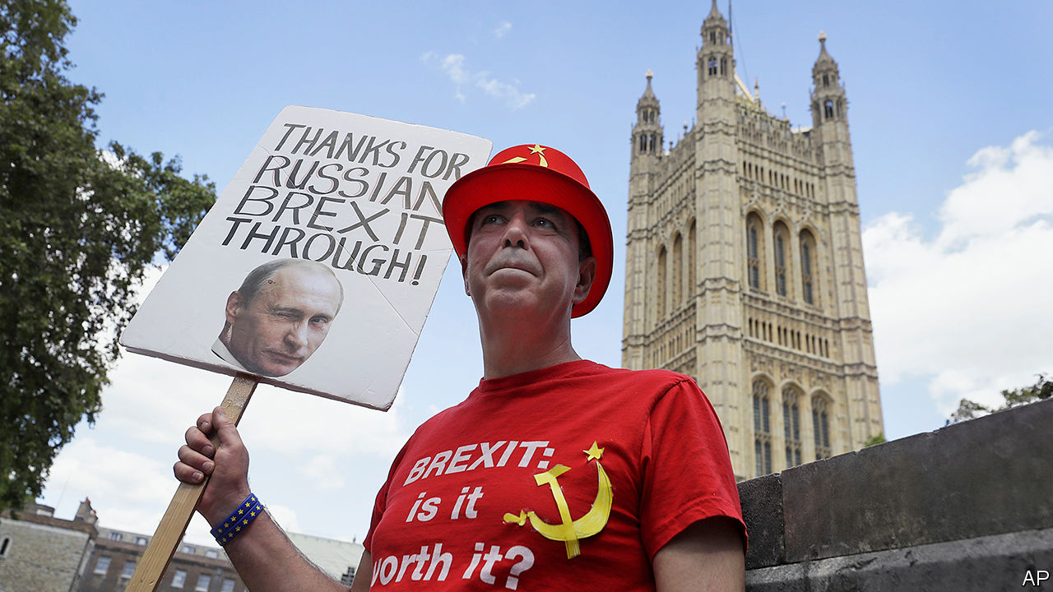

“THE OUTRAGE isn’t that there was interference,” says Kevan Jones. “The outrage is that no one wanted to know if there was interference.” Mr Jones, a member of the House of Commons Intelligence and Security Committee (ISC), whose report into Russian interference in British politics was published on July 21st, encapsulates the government’s alarming attitude to the question of whether Russia meddled in the result of the Brexit referendum.

Russia sows discord and undermines institutions in many Western countries, but Britain is a particular target. The presence of émigrés such as Alexander Litvinenko, who was murdered by the Kremlin, and Sergei Skripal, who nearly suffered the same fate, infuriates Russia’s leadership. It regards Britain as hypocritical and duplicitous for making money from Russians through the “London laundromat” for cleaning money and reputations while offering sanctuary to its opponents. Britain’s special relationship with America also makes it a convenient proxy for Russian attacks on its bigger rival.

The extent of Russian interference in politics has been a subject of much speculation. Many of those who voted to remain in the EU, unwilling to believe that a majority of their countrymen really opted to leave, were inclined to suspect that Russia must have had a hand in it, and indeed funders of a pro-Brexit campaign have admitted meeting Russian diplomats. Russian fingerprints are visible elsewhere. Oligarchs hobnob with ministers at Conservative Party fundraisers. Jeremy Corbyn, a former Labour leader and lifelong critic of America, was endorsed by Russia’s ambassador. Alex Salmond, a former Scottish first minister, hosts a show on Russian state television, which routinely cheers his separatist movement. But hard evidence of interference is thin on the ground.

Many looked to the ISC’s report for a verdict on the matter. Boris Johnson blocked its publication before the December 2019 general election, which heightened expectations. But it is Britain, not Russia, that comes badly out of the report.

MI5, Britain’s domestic intelligence agency, initially provided only a six-line analysis of Russia’s involvement in the Brexit referendum, born, in the committee’s view, of “extreme caution” in dealing with political matters. But a lack of focus on Russia may also have contributed. Two-thirds of MI5’s work is directed towards Islamist terrorism, and a fifth towards Northern Irish terrorism, leaving 13% focused on monitoring hostile state activity. MI6, the foreign intelligence agency, finds Russia a “particularly hard” operating environment. New technology, like biometric controls, makes sending spies into Russia difficult, and grooming sources is a slow business. Though British spies do engage in virtual and physical skulduggery against Russia, fear of escalation and lingering hopes of coaxing Russia into a more emollient stance limit this activity.

Some observers think the report too critical of the security services. “Putin comes out of it really well—a really competent villain—whereas Whitehall comes out looking very Dads’ Armyish, which is a little unfair,” says Mark Galeotti of the Institute of International Relations in Prague. “They are doing things which are much more strung together than most European countries, let alone the US.” Sir David Omand, a former direct of GCHQ, the British signals-intelligence agency, told the BBC that “the intelligence and security agencies follow the priorities of their customers.”

Ultimately, the blame lies with the politicians. Clues that Russia had interfered in Scotland’s independence referendum were ignored, and it was only when Russia hacked America’s Democratic National Committee that the government realised the risk to Britain. Yet the government, held back by fear of a revolt in the Conservative Party, failed to order an inquiry.

Complacency and greed, as well as political self-interest, are to blame. Ministers have “badly underestimated” the Russian threat and adopted a “laissez faire policy approach” says the committee, pointing to an appetite for Russian cash as one explanation. Whatever the reasons, Britain’s political institutions have been left vulnerable. Spies are hobbled by the legal framework in which they operate. Britain’s national-security laws, unlike America’s, do not make it illegal to be a foreign agent. “There are things that compellingly we must investigate…where there isn’t actually an obvious criminal offence,” Sir Andrew Parker, MI5’s chief when the committee was gathering evidence, told the ISC.

Anti-money laundering rules are tougher for businesses than for political parties, which the Electoral Commission says increases the risk of foreign funding. The current fine of £20,000 for breaches risks becoming “a cost of doing business”. Several members of the House of Lords have business dealings with Russian companies, but the current code of conduct does not oblige them to declare income in the way MPs must. Since 2018 the National Crime Agency has had the power to seize money and property from foreign politicians and officials suspected of looting their countries’ coffers, but its head told the committee that its budget for lawyers cannot match the oligarchs’.

Then there is the committee itself. In Britain as in America, lawmakers’ inquisitorial powers are part of the country’s protections against foreign subversion. But the ISC is weak. The security services can refuse to give evidence on live operations, which the committee said had frustrated the inquiry. At their request, the Russia report has been liberally redacted. The report was published after Mr Johnson tried and failed to engineer the appointment as chair of an ally so unpopular that the committee’s members revolted and elected a less pliant candidate. Sometimes Russian efforts to sow distrust in Britain’s political institutions seem unnecessary.

Although the way it has come out is embarrassing to the government, the report provides support for the new, more hawkish line that it is taking on Russia. In its response, the government said that Russia was a top national-security priority; most of the foreign officials on the blacklist that Dominic Raab, the foreign secretary, announced on July 5th were Russians. This new approach will give the Kremlin even more reason to interfere in Britain than it has had in the past. The government had better put some work into bolstering the country’s defences. ■

This article was downloaded by calibre from <https://www.economist.com/britain/2020/07/23/russian-interference-highlights-britains-political-failings>

|  |  |  |  |
| --- | --- | --- | --- |
|  | Articles | Sections | Next |

|  |  |  |  |
| --- | --- | --- | --- |
| Previous | Articles | Sections | Next |

#### Labour Party

# Starmer’s tough stance on Russia and anti-semitism

Tipping Corbyn overboard

Jul 23rd 2020 |

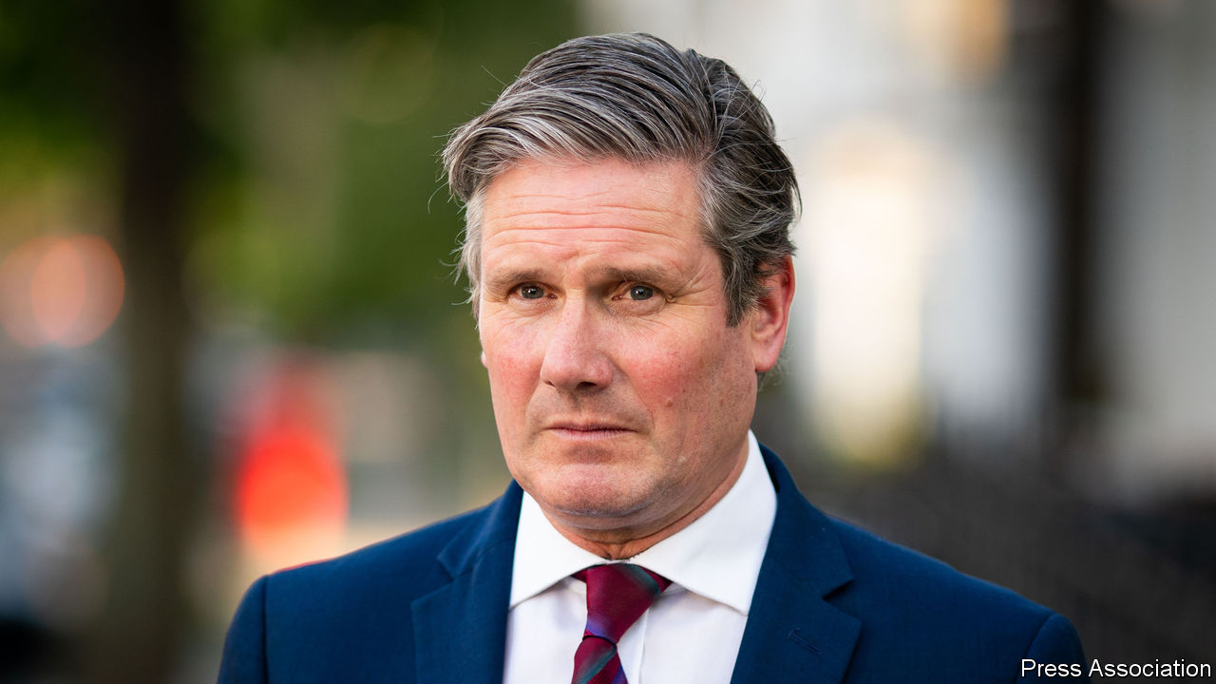

“IN CASE THE prime minister has not noticed, the Labour Party is under new management,” Sir Keir Starmer, the party’s leader, declared in the House of Commons. Showing that a party has changed is a tricky but essential task of opposition politics. It requires jettisoning stances that are prominent and unpopular with voters, but without declaring war on the party’s most loyal supporters. That Jeremy Corbyn, the previous leader, became best known for tolerating anti-semitism in the party ranks and for defending Vladimir Putin is to the Labour Party’s discredit, but it has made Sir Keir’s task of differentiating his regime from the previous one unusually easy. In a few hours before lunchtime on July 22nd, he demonstrated the vigour with which he is pursuing this end.

Just after ten o’clock, lawyers conveyed an apology from the Labour Party to John Ware, a BBC journalist, and seven former staff members, who will also receive “substantial” damages. A year ago, Mr Ware had presented a documentary entitled “Is Labour Anti-Semitic?” in which the staffers claimed that Mr Corbyn’s team had meddled in the complaints process. Rather than show contrition, the Corbynites shot back that Mr Ware was a dishonest journalist and claimed the whistleblowers were anti-Corbyn plotters, which the party now accepts was untrue and defamatory. Sir Keir says he will implement in full the findings of the Equality and Human Rights Commission, an anti-racism watchdog, whose report into the Labour Party will be published later this year, and says he is determined to win back the trust of Jewish voters. Mr Corbyn seems less bothered about their views, and said the settlement was “disappointing”. As a result, Mr Ware is now suing him too.

Shortly after the lawyers had done their bit, at Prime Minister’s Questions, Sir Keir charged that the government was slow to respond to the threat of subversion posed by Russia, and condemned its attempted assassination of Sergei Skripal, a turncoat spy. He announced Labour would support new national-security legislation. None of this would be striking for an aspiring prime minister, except for the fact that Mr Corbyn’s office had refused to blame the Kremlin for the attack and said the allegation Russia had used a nerve weapon was reminiscent of the false claims during the war against Iraq that the country was hiding weapons of mass destruction. Mr Corbyn was a regular guest on Russia Today, a state propaganda channel. Sir Keir called for its broadcasting licence to be reviewed.

Sir Keir won members’ support by promising to clean up Labour’s image while retaining Mr Corbyn’s platform of nationalising utilities and ending austerity. He has not broken that compact. But nor has he fleshed out Labour’s economic agenda, beyond saying that the coronavirus crisis demands radicalism. His campaign promise to “put human rights at the heart of foreign policy” sounded like an adoption of Corbynista hostility towards Western militarism, but has translated into kicking Russia and China. The speed and ruthlessness with which he has cleared out Mr Corbyn’s allies and their grubbier beliefs has surprised those who thought he’d put “vanilla unity” above the pursuit of power. Some Labour MPs miss Mr Corbyn. Mr Johnson misses him more. ■

This article was downloaded by calibre from <https://www.economist.com/britain/2020/07/23/starmers-tough-stance-on-russia-and-anti-semitism>

|  |  |  |  |
| --- | --- | --- | --- |
| Previous | Articles | Sections | Next |

|  |  |  |  |
| --- | --- | --- | --- |
| Previous | Articles | Sections | Next |

#### Demography

# Britain’s baby bust

England and Wales join the low-fertility club

Jul 23rd 2020 |



IN 1945 A sociologist, J. G. Ferraby, tried to explain why women were having so few babies. He mulled various possibilities, such as cramped housing, women’s fear of childbirth and the cost of educating children. In the end, though, Ferraby blamed the baby bust on a lack of “zest” and confidence in the future. “It is possible”, he wrote, “that the majority of people in England—and perhaps all over the Western world—are now just drifting.”

They didn’t drift for long. As soon as the war was over, a two-decade-long baby boom began. But on July 22nd the Office for National Statistics revealed that just 640,000 babies were born in England and Wales in 2019—even fewer than when Ferraby fretted. The fertility rate, which measures births per woman, stands at 1.65. English and Welsh women are now notably less fecund than French women and are approaching the German level (see chart).

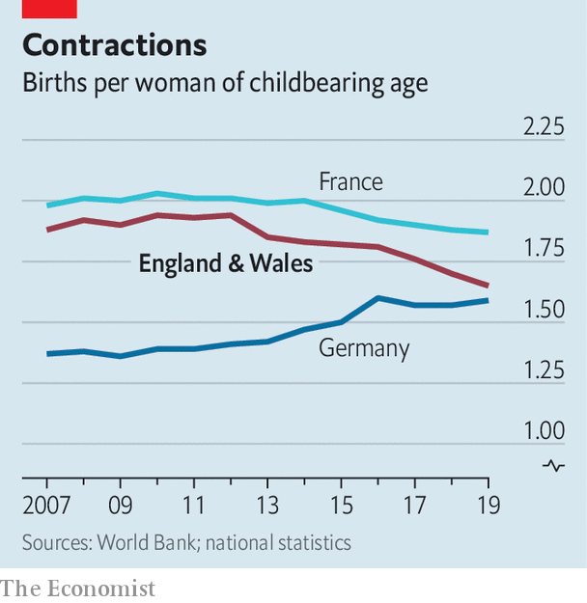

A fall in the fertility rate does not always mean children are going out of fashion. If women postpone pregnancy, the fertility rate will fall and then rise, even though women end up having the same number of children in the end. That happened in the early 2000s. English and Welsh mothers continue to grow older—the mean age of childbirth is now almost 31. Birte Harlev-Lam of the Royal College of Midwives says that is the main reason why, over the past ten years, the proportion of births that begin with an induction or a caesarian section has risen from 31% to 50%.

But it increasingly seems that families are becoming smaller, not just more stretched-out. If women were merely postponing babies, you would expect to see a sharp decline in births to women in their 20s and a slight rise among women in their 30s. Instead, for the past four years the birth rate among women aged 30-39 has fallen. A few more babies are being born to women 40 and over, but these are still rare, accounting for less than 5% of births. Before covid-19 hit, unemployment in Britain was low; online dating has made it easier to find a partner. Why the reticence?

A lack of what Ferraby called “zest” could be part of it. Although the minimum wage rose by 6% in April, it may be that working-class couples in particular have lost a little confidence in the future because jobs have become less stable. Last year two poor regions, north-east England and Wales, had lower fertility rates than anywhere else. Tomas Sobotka of the Vienna Institute of Demography says that in several rich countries, birth rates have fallen sharply among women who do not go to university—who normally have children earlier in life.

You could also blame immigrants, who supplied 29% of the new babies in England and Wales last year. As a rule, immigrants have higher birth rates than natives. But the gap is closing: since 2004 the immigrant fertility rate in England and Wales has fallen from 2.46 to 1.97. Germany’s fertility rate has held up partly because the country has taken in lots of people from Syria, where big families are normal. Britain has seen big increases in migration from low-fertility countries like Italy, Lithuania and Romania.

Few places have changed as much as the East End of London. In the early 2000s, immigrant-heavy boroughs like Hackney and Tower Hamlets were Britain’s nurseries, with fertility rates above the national average. Both boroughs now have below-average fertility, and the proportion of births to immigrant mothers is falling. What starts in the East End tends to spread.■

This article was downloaded by calibre from <https://www.economist.com/britain/2020/07/23/britains-baby-bust>

|  |  |  |  |
| --- | --- | --- | --- |
| Previous | Articles | Sections | Next |

|  |  |  |  |
| --- | --- | --- | --- |
| Previous | Articles | Sections | Next |

#### Gypsy lives matter too

# Britain’s Gypsies and travellers demand justice

They have long been on the wrong end of the law

Jul 23rd 2020 | NEWBRIDGE, SOMERSET



“WE ARE THE white blacks,” declares Joseph Jones, a Romany gypsy who is vice-chair of the Gypsy Council, a civil-rights group, and has been campaigning for the rights of gypsies and travellers since the 1970s. The recent success of the Black Lives Matter (BLM) movement has influenced the way the council is approaching new threats of government action.

Outsiders are common targets for populists, and nomadic people are the ultimate outsiders. The Tory manifesto promised to make it a criminal offence to set up an illegal campsite and give the police greater powers to seize travellers’ vehicles. The announcement in July by Priti Patel, the home secretary, that the government would take new measures in the autumn was therefore not a surprise.

Britain has around 60,000 gypsies and travellers, most of whom settle for periods, then move on again. Around 10,000 will be on the road in England at any one time. Councils are required to provide permanent stopping sites for them, but these are not always to travellers’ liking. “They always build them deep in the woods,” says Patrick McDonagh, an Irish traveller living with his family on a Park and Ride car park in Newbridge, on the outskirts of Bath. “It’s like they think we are murderers.” As sports fields went quiet and car parks emptied, covid-19 provided opportunities for travellers to occupy new spaces—hence the exclusion of trespassers from a Ministry of Justice directive to delay evictions.

Travellers and gypsies argue that, since the law recognises them as an ethnic group, the proposed new measures are racist. Their ethnicity is complex. Travellers tend to be people originally from Ireland who have been travelling since the middle ages or itinerant labourers who came over after the famine, while British gypsies include Roma, descended from nomadic Indians who migrated to Europe. Recent inflows from eastern Europe have swelled numbers, and intermarriage has blurred the lines between these groups.

Drawing parallels with black history, gypsies say that from the 17th to the 19th centuries their forebears were often abducted and sold as slaves in the Caribbean. They are planning protests in Westminster similar to those of BLM, and hope to secure a place for gypsy history on the school curriculum. “London was built around gypsies and travellers,” says Mr Jones. “The barrow boys were gypsies and travellers, they contributed in commerce.”

Some have drawn comparisons between George Floyd, whose murder by police sparked global protests, and Johnny Delaney, a 15-year-old traveller who was kicked to death on a playing field in 2003. The prosecution claimed that the youths made a racist remark before the attack, but the judge rejected racism as a motivation. Campaigners have also taken to filming confrontations, are suing several pubs for discrimination and have emulated BLM’s use of celebrities to make an impact. Tyson Fury, a boxer from a traveller family who dubs himself the Gypsy King, has been promoting the anti-racism campaign.

Campaigners point to the flying of the Romany flag by Kent police last month as a success, but they have yet to shift opinion among settled people, who tend to consider hostility to travellers as the consequence not of prejudice but of criminal behaviour. In June, a traveller was charged with the murder of a man at a camp in Oxford, and in July a man was hospitalised after travellers attacked him on a camp at a business park in Clevedon, Somerset. In 2017, 11 members of a traveller family were imprisoned for human trafficking. Mr Jones argues that such cases are not representative of the community as a whole, and are used as an excuse to “keep them moving”.

Even if the government does make life harder for travellers, it is unlikely to persuade them to settle. The number of caravans has risen by 13% over the past five years. “You could give a Gypsy a house, and in five years it’ll be empty,” laughs Mr McDonagh, as he surveys his family’s campsite proudly. “It sounds silly, but I’ve got everything I need in my caravan.”■

This article was downloaded by calibre from <https://www.economist.com/britain/2020/07/23/britains-gypsies-and-travellers-demand-justice>

|  |  |  |  |
| --- | --- | --- | --- |
| Previous | Articles | Sections | Next |

|  |  |  |  |
| --- | --- | --- | --- |
| Previous | Articles | Sections | Next |

#### Covid-19 and work

# Anxiety levels rise among furloughed Britons

As the government’s scheme tapers off, many worry about redundancy

Jul 23rd 2020 |

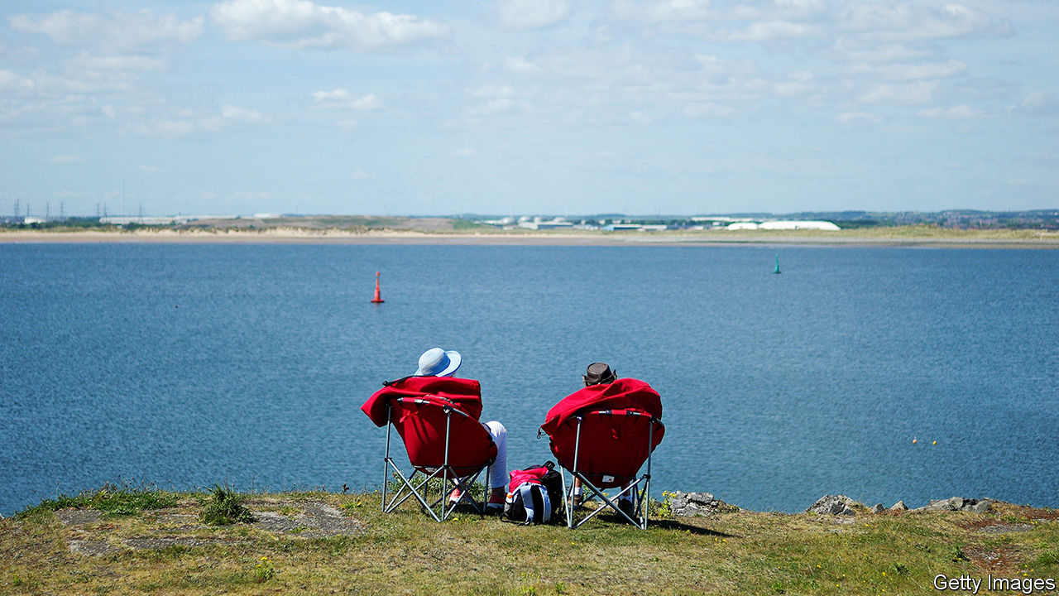

Editor’s note: Some of our covid-19 coverage is free for readers of The Economist Today, our daily [newsletter](https://my.economist.com/user#newsletter). For more stories and our pandemic tracker, see our [hub](https://www.economist.com/news/2020/03/11/the-economists-coverage-of-the-coronavirus)

TOMMY ROWLANDS has spent the past few months flitting between London, Paris, Beirut and Los Angeles. In his head, that is. He has been stuck at home since March, on furlough from his job as a maitre d’ in a London restaurant. That means he has finally had time to devote to the globetrotting novel he had been chipping away at in spare moments for four years. He finished it in seven weeks. After the obligatory acknowledgment of others’ suffering during the pandemic, he confesses: “On the whole, I’ve enjoyed this period.”

When Britons who have worked throughout the covid-19 crisis think of their 9.4m furloughed compatriots, they might picture someone like Mr Rowlands, or perhaps the 25-year-old Yorkshireman who admits it has been “like a three-month garden party”. “I can’t actually believe I’m being paid sometimes,” he says, in a brief pause in his hectic schedule.

But the furlough scheme, under which the Treasury initially paid 80% of workers’ wages up to a £2,500 monthly cap, has drawbacks. First, when an employer furloughs some staff but keeps the rest on their usual hours, some in the former group begin to doubt their worth. “It’s very hard not to feel judged,” says a Londoner who works in marketing and was furloughed before most of his colleagues.

Worse is the prolonged threat of being laid off. The British scheme contrasts to the approach in America, which has increased out-of-work benefits but not paid companies to furlough people. America’s unemployment rose to 15% before falling back to 11%; in Britain, the headline rate is 4%. Unions praised the government for averting mass lay-offs in March, but there are concerns that furloughing is keeping zombie companies alive and paying people whose current positions will not be needed again. As the scheme tapers off before ending in October, redundancy is back on the cards.

For those who expect redundancy, the scheme may be a financial help but a psychological burden. A poll by YouGov in May found that nearly two-thirds of furloughed workers are worried about redundancy, compared with about a quarter of those still at work. Ian Martin, a consultant psychiatrist, reports a spike in anxiety and depression among the furloughed. “It sounds such a gentle, benign arrangement,” he says. “But if you think of it as being suspended from work pending dismissal, it’s a no man’s land of uncertainty.”

Several of Dr Martin’s patients were initially happy to be paid not to work. But, as it became clearer their jobs could be at risk, it began to feel more like “waiting for a verdict”—which, he thinks, may be “scarier than a single-event trauma of redundancy. This lingering uncertainty is incredibly stressful.” Nor have workers likely to be laid off been given incentives to spend this time productively. Government hints of training or reskilling schemes came to nothing, says Mike Hawking of the Joseph Rowntree Foundation, a think-tank.

Millions are waiting to discover their fate, unsure whether to put their feet up or spend their days scrolling through job sites. “Some days I think it’s sunny, I don’t have to work, I can go to the park and read,” says a furloughed Londoner in the music industry. “Other days I think I won’t have a job in the future. How do I keep my career going when my industry might not exist in the same way?” ■

Editor’s note: Some of our covid-19 coverage is free for readers of The Economist Today, our daily [newsletter](https://my.economist.com/user#newsletter). For more stories and our pandemic tracker, see our [hub](https://www.economist.com/news/2020/03/11/the-economists-coverage-of-the-coronavirus)

This article was downloaded by calibre from <https://www.economist.com/britain/2020/07/23/anxiety-levels-rise-among-furloughed-britons>

|  |  |  |  |
| --- | --- | --- | --- |
| Previous | Articles | Sections | Next |

|  |  |  |  |
| --- | --- | --- | --- |
| Previous | Articles | Sections | Next |

#### Housing

# Britain’s fragile property boom

Activity has bounced back but borrowing is getting harder

Jul 23rd 2020 |

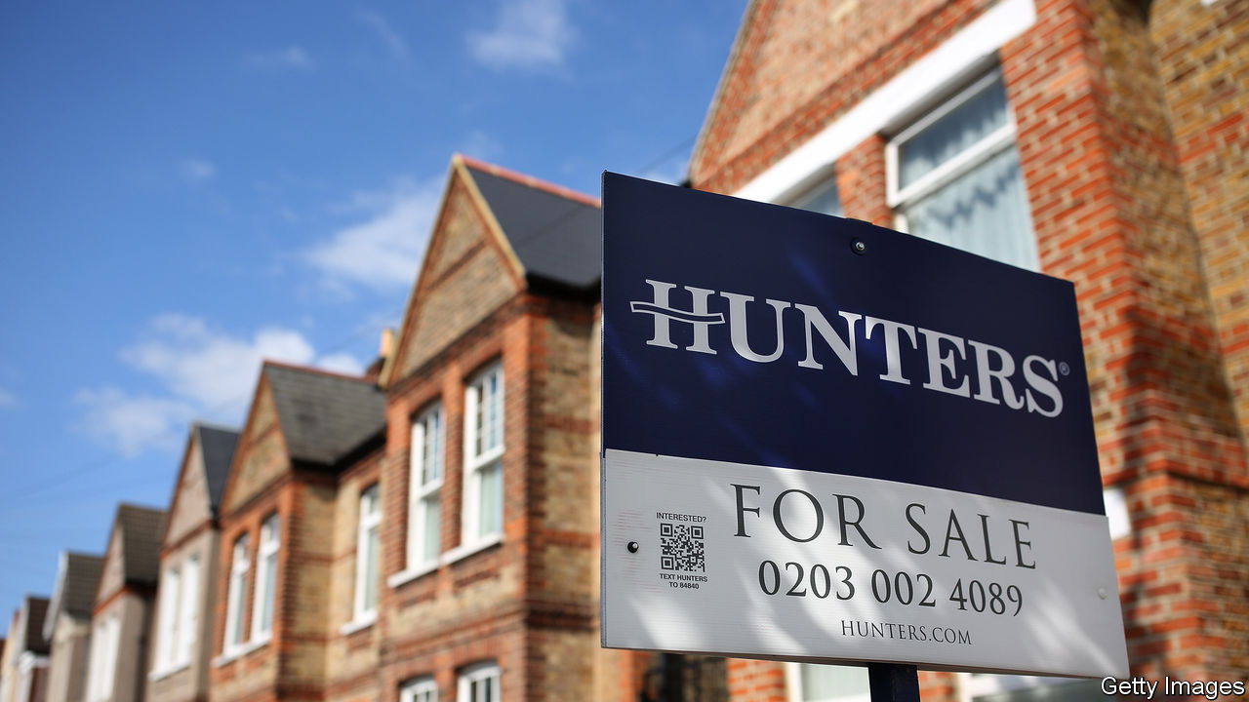

IT TAKES MORE than a global pandemic and the biggest collapse in GDP since the 18th century to slow the British housing market—or at least that is what the latest data from online estate agents suggest. According to Rightmove, the average asking price is now 2.4% above where it was when the lockdown began and buyer inquiries are up by 75% year on year.

What Rightmove dubs “a mini-boom” has taken analysts by surprise. The Office for Budget Responsibility, a fiscal watchdog, expects an 8% fall in prices and a collapse in transactions this year in their latest central scenario, while the big mortgage lenders have been privately bracing for falls of up to 15%. Much of the recent apparent surge in buyer interest may simply be pent-up demand from the market’s eight-week shutdown that ended in mid-May. Transactions in June were still down by around a third on 2019—and that was a tough year for the market, with Brexit uncertainty weighing on activity.

The government is keen for the mini-boom to continue. In his summer statement on July 8th Rishi Sunak, the chancellor, raised the threshold for paying stamp duty, a tax on property transactions, from £125,000 ($159,000) to £500,000 until March 2021. The stamp-duty holiday introduced in 2008 saw a small bounce in sales immediately followed by a second peak just before it expired. Housing moves, which encourage people to buy new fridges and hire builders, can be a useful prop to wider economic activity.

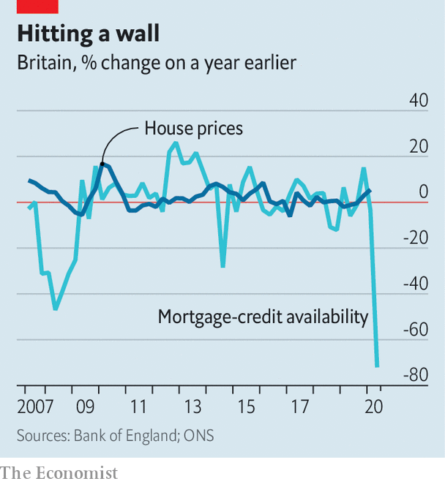

But lenders may prove a drag on the market. Bracing themselves for falling house prices and rising unemployment, banks have tightened mortgage criteria at a record pace (see chart). They expect conditions to ease somewhat in the third quarter of this year but still to be as tight as they were in 2008, at the height of the banking crisis. Moneyfacts, a consumer-finance website, reports that the number of mortgages available with a high loan-to-value (LTV) ratio has collapsed since March.

Consider a couple hoping to buy a house for £220,000, the average price paid by first-time buyers according to Zoopla, a property-price website. The stamp-duty holiday will offer them no benefit as first-time buyers already faced no tax on properties sold for up to £300,000. But the need for deposit of 15-20% compared with 10% before the crisis will mean a higher level of savings are required.

Nationwide, one the country’s largest lenders, announced the return of 90% LTV-ratio loans on July 16th but said they would be subject to “enhanced lending criteria”. In plainer English, higher incomes and better credit ratings will be required. Housing-market analysts do not expect such loans to be widely available. Neal Hudson of BuiltPlace, a consultancy, reckons that although low borrowing costs and forbearance from lenders will support prices in the near term, constrained mortgage availablilty will slow the market overall. He warns that 2021 looks set to be a tougher year for the market than 2020.

Much will depend on what happens to the job market as the government’s furlough scheme tapers off. Rising unemployment, a possible no-deal Brexit and the end of the stamp-duty cut all suggest there will be a difficult start to the new year. The housing market’s immunity to covid-19 is unlikely to be permanent. ■

This article was downloaded by calibre from <https://www.economist.com/britain/2020/07/23/britains-fragile-property-boom>

|  |  |  |  |
| --- | --- | --- | --- |
| Previous | Articles | Sections | Next |

|  |  |  |  |
| --- | --- | --- | --- |
| Previous | Articles | Sections | Next |

#### Britain, the EU and fish

# How fisheries could sink a Brexit trade deal

A tiny industry is political dynamite

Jul 23rd 2020 |

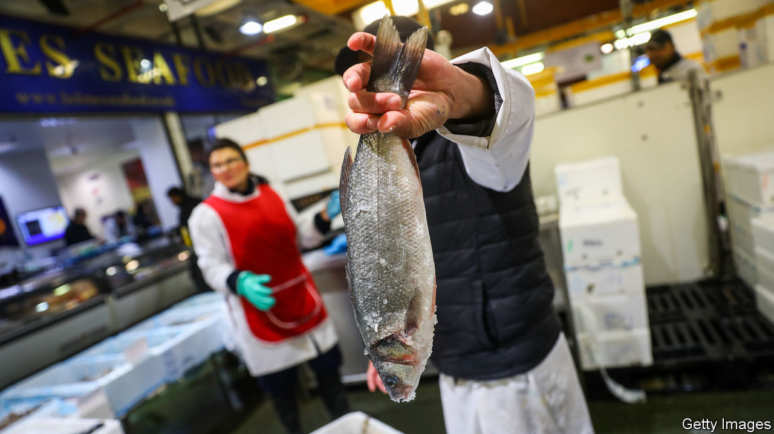

BILLINGSGATE MARKET in east London is busy at 5.30am. Live lobsters and crabs jostle against stalls selling mussels, alongside such exotica as swordfish and tilapia. Social distancing and masks are not in much evidence. Once the world’s biggest fish market, and still the country’s biggest inland one, Billingsgate stands for the history and romance of seafishing in Britain—an industry which, despite accounting for only 0.1% of GDP and barely 12,000 jobs, could yet scupper the chances of a Brexit deal with Brussels.

The desire to take back control of British waters was a powerful force driving Brexit. Brexiteers believe, with justice, that the EU’s common fisheries policy is unfair on British fishermen. For many species, European fishermen have a much larger share of fish quotas in Britain’s coastal waters than do the British themselves. Barrie Deas, chief executive of the National Federation of Fishermen’s Organisations, notes that, for channel cod, Britain has a 9% share against France’s 84%; for Celtic Sea haddock the numbers are 10% and 66%.

The government wants a big increase in British shares based on the location of fish, not historic rights, and annual negotiations like Norway’s. The EU prefers continuing the current system, and says that annual negotiation works with Norway because only seven species are covered and quotas seldom change, whereas with Britain the number is almost 100 and the whole point is to adjust catches. It also insists that, without an agreement on fish, there can be no trade deal. Fishing is now one of the hardest issues in the Brexit talks, which have supposedly intensified—but with big gaps persisting between the two sides.

Because Britain has more coastal water than any EU country, it looks to be in a strong position. Yet some 80% of the fish landed in Britain is exported, mostly to the EU, while 70% of the fish consumed in Britain is imported, largely from the EU. Failure to agree a deal would disrupt two-way trade in a highly perishable product. Iain Spears, who runs a shellfish business in Devon, fears losing access to scallops in the Seine estuary. Britain has neither the capacity to catch all the fish now taken by EU fishermen nor enough patrol boats to police its waters. And the law is messy: many EU firms have bought up British fishing quotas, and they cannot easily or costlessly be deprived of them now.

Furthermore, the most valuable part of the industry is no longer catching but processing, which depends heavily on free trade. Even pro-Brexit Grimsby, where processing is now the main activity, is anxious about lost business if there is no agreement with the EU. James Kane of the Institute of Government, a think-tank, cites a Dutch university study of 2018 which concluded that, without a deal, Britain would lose more from tariffs and non-tariff barriers on fish trade than it would gain from exclusive access to its own waters.

Is there scope for compromise? Britain could agree to multi-year quotas, while the EU could accept that British shares must rise over time. But Brexiteers will cry betrayal the moment Britain agrees to let EU trawlers keep on hoovering up British fish. And feelings on the continent are just as strong. Herring (almost all caught in British waters) are close to the hearts, and stomachs, of the Dutch. The French have fished in British waters for centuries.

Politics makes everything harder. Emmanuel Macron, France’s president, faces a tough re-election battle in early 2022 and will want to placate the country’s fishermen. The British government fears nationalist gains in next year’s election in Scotland, where most fish are caught. But Boris Johnson needs a trade deal, and without agreement on fish, he may find it impossible to land one.■

This article was downloaded by calibre from <https://www.economist.com/britain/2020/07/23/how-fisheries-could-sink-a-brexit-trade-deal>

|  |  |  |  |
| --- | --- | --- | --- |
| Previous | Articles | Sections | Next |

|  |  |  |
| --- | --- | --- |
| Britain | Sections | Special report |

International

Care homes: No place like home

.

|  |  |  |
| --- | --- | --- |
| Britain | Sections | Special report |

|  |  |  |  |
| --- | --- | --- | --- |
|  | Articles | Sections | Next |

#### Who cares?

# The pandemic shows the urgency of reforming care for the elderly

Most people should be helped at home as they age

Jul 25th 2020 | AMSTERDAM, MISSISSAUGA AND TOKYO



Editor’s note: Some of our covid-19 coverage is free for readers of The Economist Today, our daily [newsletter](https://my.economist.com/user#newsletter). For more stories and our pandemic tracker, see our [hub](https://www.economist.com/news/2020/03/11/the-economists-coverage-of-the-coronavirus)

“IT SMELLED LIKE death,” says Stephanie (not her real name) of her first day at Camilla Care Community, a nursing home in Mississauga, a city in Canada. She and other care workers were sent to help out at the 236-bed facility in April as covid-19 ripped through its narrow corridors and crowded wards. Dozens of staff fell ill or refused to work. By mid-July nearly one-third of the residents had died. Outside, on a patch of grass, 69 small white crosses commemorate them.

Across the rich world nearly half of all deaths from covid-19 have happened in care and nursing homes, even though less than 1% of people live in them. In Canada 80% of all the deaths from covid-19 have happened in places such as Camilla (see chart 1). In Britain the pathogen has killed an estimated 5% of all people living in such institutions. The problem is not only that the residents’ age makes them particularly vulnerable, but also that their living arrangements created opportunities for the virus to spread. Countries with fewer care homes have had fewer covid-19 deaths, all else being equal. The number of care-home beds explains 28% of the variation in death rates among European countries and 16% among American states, according to a study by Neil Gandal and colleagues at Tel Aviv University.

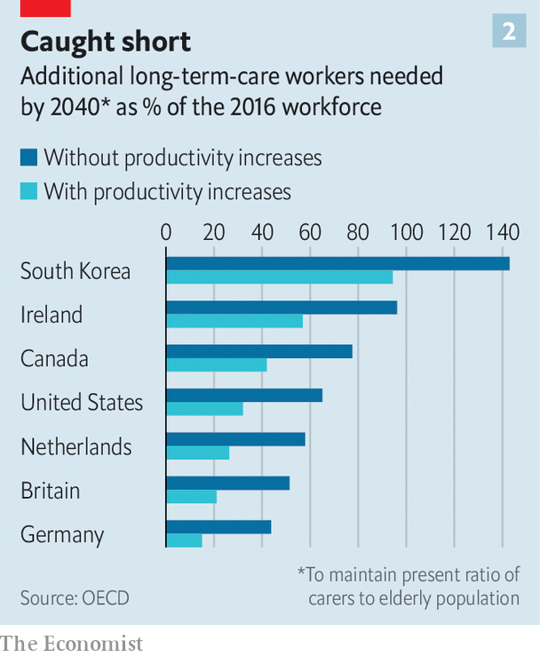

Politicians are under pressure to put more cash into care-home safety, inspections and quality standards. In the short term care homes will need more personal protective equipment (PPE) and better access to testing. But the disaster also offers a chance to reimagine care. In the future, many experts argue, the vast majority of old people should be looked after at home for as long as possible. In all but the most severe cases this is cheaper. It is also what most old people want. Putting them in big institutions is the opposite of what they say they value most: autonomy and independence. And for those who still need it, residential care should be transformed.

Most people will need care as they age. In some countries that will bankrupt them. Some 70% of Americans who reach the age of 65 will eventually need help doing at least two basic daily activities, such as washing or dressing; 48% will receive paid care; 16% will get dementia. The risks are higher for women. For one in ten people who reach the age of 65 in Britain, the cost of care in their remaining years will exceed £100,000 ($127,000), according to a review conducted in 2011. Demand is only growing. In rich countries the share of the population that is over 80 will double by 2050, by which time there will be only two people of working age for every over-65-year-old. Although people’s lives are getting longer, the number of years during which they enjoy good health is not rising as swiftly.

In countries such as Norway and Sweden, care for the elderly is pretty good but costs taxpayers so much that it may not be sustainable as their populations age. In others, such as Britain and America, taxpayer-financed care is intended as a last resort for the poorest and sickest. This usually means a bed in a care home. These institutions have typically received most of the funding that governments set aside for looking after the elderly.

“Let’s be honest,” says David Grabowski of Harvard Medical School. Even before the pandemic “nobody ever wanted to go to a nursing home. This was a crisis on top of a long-standing crisis.” The sector is understaffed. In several countries it is unhelpfully detached from the health system. Care homes were “at the back of the queue during covid, when it came to things like testing,” says Jos Schols at the University of Maastricht. In places such as Hong Kong and Taiwan that experienced the SARS outbreak of 2002-03 care homes had stockpiles of PPE. In other places they were very poorly supplied. People working in British care homes say the pandemic has confirmed their “Cinderella status”. They were about twice as likely to die of covid-19 as workers in hospitals. “Everyone is furious about what happened but too knackered to do anything about it,” says one carer.

All around the world staff at care homes turn over quickly. In Germany nearly a third of long-term-care workers leave their jobs after only one year. In France a fifth of home-care positions were vacant in 2018. That is not surprising given that carers are paid on average 35% less than people who do similar jobs in hospitals, according to the OECD, a club of mostly rich countries. Receiving care from a rotating cast of strangers is bad for everyone, but it is a particular problem for people with dementia. They make up the majority of care-home residents but mostly do not live in institutions that specialise in their condition. At the height of the outbreak in London more than one-quarter of staff in care homes for the elderly could not work, or would not. Officials sent in temporary workers to replace them. That probably spread the virus even further.

## Age is just a number

Many governments spend very little on long-term care. In rich countries it ranges from 0.2% of GDP in Hungary to 3.7% in the Netherlands. Canada spends 1.3%, less than the rich-country average. It has less than half the number of care-home workers per 100 residents as Norway. In America and Britain a frugal monopsony payer (Medicaid and local authorities) typically reimburses less than the cost of residential care. To make up the shortfall, American nursing homes actively recruit patients covered by Medicare, a lavish programme that pays medical costs (but not long-term care costs) for the elderly. They tend to come for short stays to recover after operations such as hip replacements, and bring with them more generous reimbursements. But the pandemic has largely stopped that.

As well as exposing fragile business models, the pandemic has highlighted the tension between keeping old people safe and keeping them happy and well, says Adam Gordon of the University of Nottingham. Regulators encourage nursing homes to focus relentlessly on negative metrics such as falls, bed sores and weight loss. But there is more to quality of life than not falling over. Anne Tumlinson, an expert on ageing, would like to see care homes become less “custodial” and more enthusiastic about “making people happy”.

A better system would make it easier for most people to age at home. Technology could help. The urge to move someone to a care home often starts with concerns for their safety. Care-givers begin to spot unexplained bumps and bruises. Questions about cigarette burns on the duvet are waved away. Pills are not taken. The milk is always off.

Now imagine a home where sensors keep an eye on all of those things. They spot a change in gait, appetite or activity early enough to predict a fall, dehydration or depression. A smart pill dispenser helps with medication. A companion robot provides reassurance, information, brain training and company. Some of the most compelling recent scientific and technological developments aim to help people with dementia. A product produced by Elovee, an American startup, allows them to have simple conversations with a digital avatar styled to look and sound like one of their relatives. The idea is to provide reassurance during moments of anxiety or boredom that occur when their loved ones are not around.

Technology “will never replace the loving attention of a carer,” says Wilco Achterberg of the University of Leiden. But data-crunching could make it easier to work out how to deploy carers more efficiently. Video calling is making it easier for relatives, paid carers and doctors to check in more frequently. Joan Gallimore, a 91-year-old who lives alone in England, says that calling her family using a tablet her home-carers gave her when lockdowns began has been a revelation. She has enjoyed chats with her granddaughters and performances put on by her son-in-law, who is learning to play a ukulele.

Improving conventional ways of providing care at home is essential, too. Buurtzorg, a nursing provider in the Netherlands, champions a model that has been tried out in 25 countries. Its secret is simple, says Jos de Blok, its founder: let nurses do their jobs. Small teams of them are given considerable autonomy to care for a neighbourhood. By stripping away bureaucracy, the model allows nurses to spend more time dispensing help. Because all staff are qualified nurses, their salaries are higher than traditional carers. But because they are better trained they can get as much done despite spending a third less time with each patient.

For some people, particularly the very lonely and those with dementia, home visits are not enough. Day-care centres can help them. Some of those in Switzerland pick people up from their homes, help them get dressed and return them home at the end of the day. In Sweden day care for the elderly is offered by the state, in much the same way as child care is. Chile has only a small formal care sector, but its government has decided to make day care for the elderly a priority.

Day-care services can improve older people’s mental and physical health. They also provide advice and respite for their families. In rich countries more than one in eight people aged over 50 provide care to another person at least once a week. Keeping them from burning out is key to helping people age at home. More support for these carers also helps reduce the risk that their own health will decline, and makes it less likely that they will drop out of the workforce. In America 48% of people who provide help to older adults care for someone with dementia (a quarter of those people have at least one child under the age of 18 to look after as well). Of those who previously had jobs, 18% moved from full- to part-time work when called upon to help. Some 16% took a leave of absence and 9% quit altogether.

Some old people will have to move out of unsuitable homes. But most need not move to an institution, even then. Denmark is a leader in providing alternatives. Its government spends more on non-residential care than the residential sort. Options for ageing Danes include retirement communities and flats built close to but not in care homes. Authorities in some other places are trying to make it easier for families to build annexes that old relatives can move into. Students and some other youngsters in the Netherlands are encouraged to share courtyards or buildings with elderly people who are not part of their family, sometimes in exchange for cheaper rent. The idea is that they will provide them with companionship and occasional help.

Daan Livestro, a consultant at Gupta Strategists, estimates that 25-60% of care given to elderly people in Dutch institutions could be provided at home. In Canada, too, some 40% of residents could go home if given the right support, according to recent research. A study in 2014 in Alabama found that people with similar needs fared about as well in their own houses as those who stayed in care homes. But the group receiving care at home saved $4,500 per year in costs. “Decanting nursing homes” is a growing opportunity, says Zayna Khayat of SE Health, a Canadian care provider.

There will always be people who want or need residential care. In those cases “smaller is often better”, says Dr Grabowski. Research shows that smaller nursing homes use fewer restraints, see fewer infections and have more satisfied residents than larger ones. Small institutions promote closer friendships between residents and closer connections with staff.

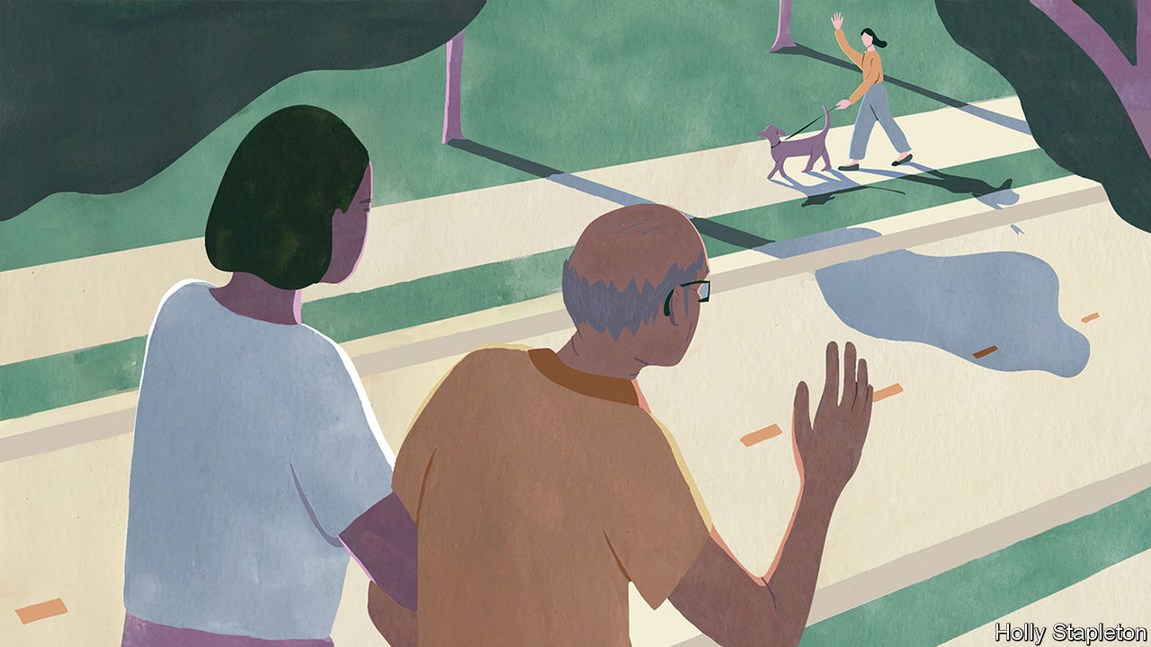

In Tupelo, Mississippi, residents of the Green House wake up to the smell of bacon, cinnamon and fresh coffee. The constant smell of baked goods in the open kitchen is deliberate; declining appetite can be a problem in old age. “I’ve seen people come from traditional nursing homes and they start eating again, they start walking again and they start talking again,” says Steve McAlilly, one of the founders. The Green House consists of ten homes, each with 10-12 housemates. There are no vinyl floors, no dinners on trays and no bingo. “Do you have planned activities in your home?” asks Mr McAlilly. “If it isn’t in a home it isn’t in a Green House.” Bill Thomas, an American geriatrician who founded the Green House movement in 2003, calls himself a “nursing home abolitionist” and says he is guided by two principles: “It is better to live in a house than a warehouse,” and “People should be the boss of their own lives.” Care homes that follow the Green House model now exist in more than 30 American states.

## A room with a view

The Hogeweyk in the Netherlands is sometimes called a “dementia village”. It hosts 169 residents who live in six-bedroom houses. All have advanced dementia. They move around freely on a campus that includes a high street with a pub, a hairdresser and a supermarket. Residents may bring their own furniture and pets. They help with household chores. Twenty-five social clubs organise activities. “Almost nobody wants to be a passive recipient of care,” says Eloy van Hal, its founder. Twenty years ago, when he tore down the conventional nursing home that used to inhabit the same spot, he was warned that “people will fall over.” Instead residents became healthier and more cheerful. “We take far too few risks in life,” he says.

Technology could help improve residential care, even as it reduces the number of people who need it. Sensors placed in nursing homes in Norway and the Netherlands have reduced hospitalisations. Telemedicine is having the same effect in Estonia and Israel.

In southern Tokyo, in a bland conference room on the tenth floor of a grey office tower, a robot glides towards visitors and announces: “The food you ordered has arrived.” The Future Care Lab was set up by Sompo, one of Japan’s largest insurers. It has experimented with labour-saving devices such as a self-cleaning bath and a wheelchair that turns into a bed. It has also invented a pad that when placed under a mattress monitors breathing, heart rate and quality of sleep. A nursing home that tested it last year said that it reduced the time staff had to spend “patrolling” its 54 rooms from seven hours a day to 20 minutes. Residents slept better because staff no longer routinely woke them up.

Improving care will not be cheap. But settling for bad care only stores up costs for later. Research in America links a 10% cut in Medicaid reimbursement to a nearly 10% decline in older people’s ability to do things such as walk and bathe, as well as a 5% increase in persistent pain. Each month the health system in Britain loses about 83,000 hospital days to “bed-blocking” that results when elderly patients who are no longer sick enough to remain in hospital get stuck there because no good care is available outside of it.

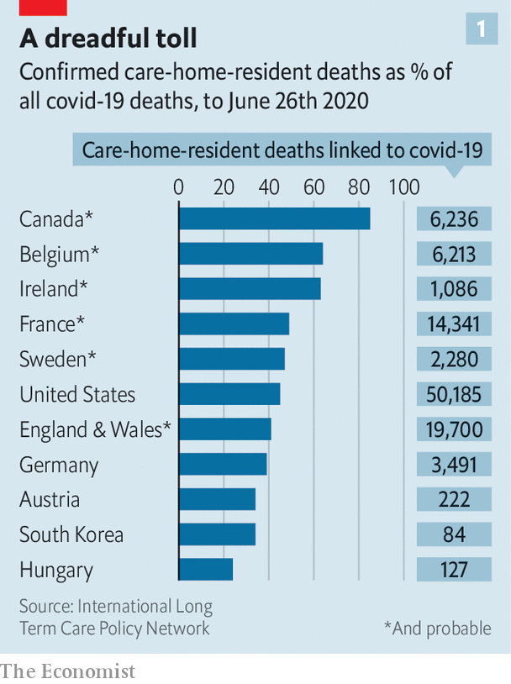

Governments could make more use of personal-care budgets. These are pots of money allocated to someone who needs support. Recipients are entitled to decide for themselves how the cash should be spent. That encourages care providers to dream up ever more personalised services and to keep down costs. Training, recruiting and trying harder to retain carers are also urgent priorities. The number of care workers in rich countries will need to increase by 60% by 2040 just to maintain the present ratio of carers to elderly people, says the OECD (see chart 2). Investments in technology and more efficient use of skilled staff could at best meet half that gap.

Experts are hopeful. “I’ve been preaching this stuff for decades and nobody ever wanted to hear it. Then covid hit and my phone hasn’t stopped ringing,” says Ms Tumlinson. The pandemic is persuading more people that “the mass institutionalisation of older people isn’t such a good idea,” reckons Mr Thomas of the Green House Project. Social care has never enjoyed so much attention, agrees José Luis Fernández of the London School of Economics. But he worries that governments “will struggle to fund new commitments at a time when public finances are under huge pressure.” There have been lots of broken promises in the past.■

Editor’s note: Some of our covid-19 coverage is free for readers of The Economist Today, our daily [newsletter](https://my.economist.com/user#newsletter). For more stories and our pandemic tracker, see our [hub](https://www.economist.com/news/2020/03/11/the-economists-coverage-of-the-coronavirus)

This article was downloaded by calibre from <https://www.economist.com/international/2020/07/25/the-pandemic-shows-the-urgency-of-reforming-care-for-the-elderly>

|  |  |  |  |
| --- | --- | --- | --- |
|  | Articles | Sections | Next |

|  |  |  |
| --- | --- | --- |
| International | Sections | Business |

Special report

The Midwest: An outsized punch

.

Cities: The urban prairie

.

Race and the city: Separate, downtrodden

.

Industry: America’s Mittelstand

.

Universities: From rustbelt to brainbelt

.

Politics: America’s divided middle

.

Nature’s metropolis: Don’t be the next Cahokia

.

|  |  |  |
| --- | --- | --- |
| International | Sections | Business |

|  |  |  |  |
| --- | --- | --- | --- |
|  | Articles | Sections | Next |

#### The Midwest

# A region with outsized punch

America’s Midwest matters out of proportion to its size, says Adam Roberts

Jul 23rd 2020 |

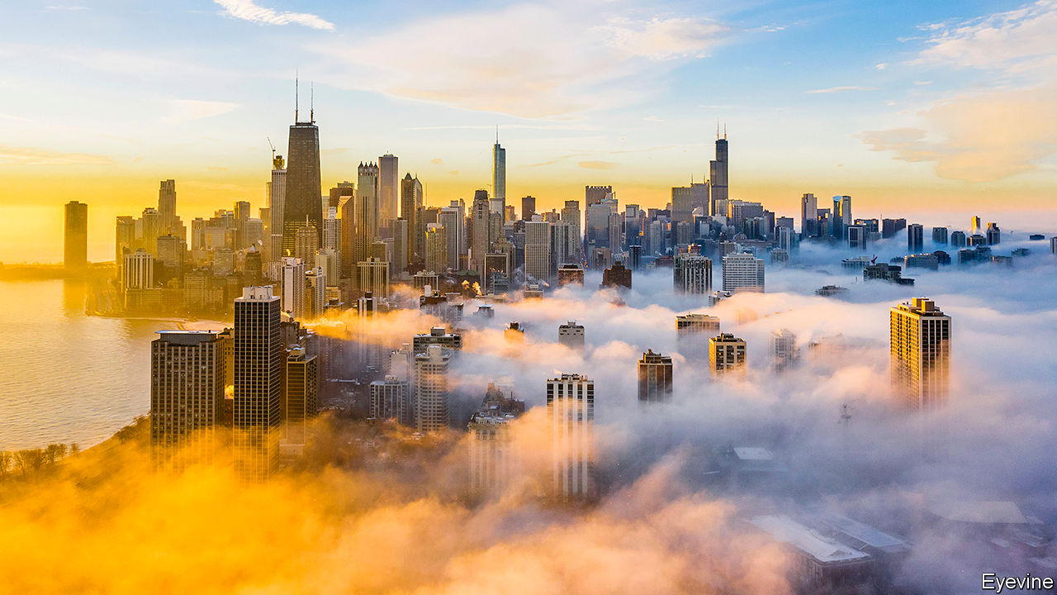

TWICE RECENTLY an eruption in middle America has sent shock waves across the country and the rest of the world. Four years ago Midwestern voters were decisive in putting Donald Trump in the White House, to global consternation. Two months ago, residents of Minneapolis took to the streets after a white policeman had killed George Floyd, an African-American. The resulting protests shut down much of urban America for a spell, then provoked demonstrations and debate on racism everywhere.

Both events were reminders that the Midwest can pack an outsized punch. That is most obvious in politics: the stakes are high in a region in political flux. Unlike much of the coasts and the south, where voters for one or other party have a lock on outcomes, in this region many switch loyalty. If you want to know whether Mr Trump may win another term, a big part of the answer will be found, come November, in battlegrounds like Wisconsin, Michigan and Pennsylvania—three states he unexpectedly won in 2016—and Ohio or Iowa, which he might yet lose.

Second, as the reaction to Mr Floyd’s death showed, the Midwest merits attention because it is exceptionally divided. More than elsewhere, deep racial segregation persists in cities like Milwaukee, Chicago and St. Louis. Protesters’ anger has been focused on ill-trained, violent police and on structural problems. To flourish again, these cities need both economic recovery and reduced racial inequality. Put another way, America will not overcome its profound failures on race until the Midwest does.

Underlying this is a third reason for scrutinising America’s middle: its example for similar regions elsewhere. It grew rich from heavy industry and transport, then declined in the past half-century. A more recent bounce-back of some better-run cities offers lessons for others. Former industrial regions in Europe and Asia can learn from the Midwest.

The Midwest is not the place of rusting cities and reactionary farmers of popular imagination. Its reality is more complex and more interesting. Most Midwesterners wouldn’t know which end of a cow to milk, for they live, by and large, in sprawling metropolitan regions. Many of these cities boast revived downtowns, cultural expansion, diversifying economies, thriving universities. The census this year will show many of them gaining people, although the region overall will grow little. Bigger places like Chicago and Pittsburgh, and smaller ones like Ann Arbor and Madison, have done well of late. Even those with deeper troubles, such as Detroit and Cleveland, have been improving.

In politics, too, there has been cause for cheer. Some towns have become beacons of liberalism (even if that causes unease in rural parts). Illinois legalised marijuana this year and was planning to wipe clean prison records for thousands of people. In Michigan, early this year, lawmakers were seeking ways to shrink its jail population. Two years ago, each of two urban districts in Michigan and Minnesota elected Muslim women to Congress.

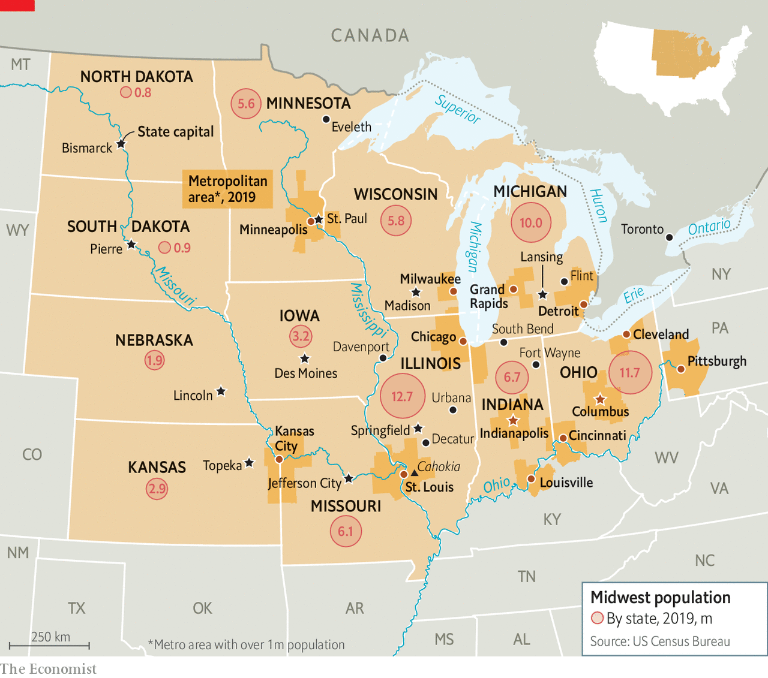

Chicago last year elected as mayor Lori Lightfoot, an African-American, lesbian, ex-prosecutor. At the start of this year another Midwesterner, Pete Buttigieg, a 38-year-old ex-mayor of South Bend, Indiana, was making a serious run to be the Democratic presidential nominee. Few fussed that he is married to a man. Amy Klobuchar, a senator from Minnesota, was offering centrist policies that appealed to many moderates.

This report makes a case that the hope for the region rests on its bigger cities that power the local economy, host successful universities and may again draw skilled immigrants. It is not clear how the turmoil of 2020 will change their prospects, but there are reasons to worry. Mr Trump wants to stop foreign workers and refugees coming. The covid-19 pandemic has already, temporarily, halted inflows. Universities, such as the big ten public ones in the region and many private ones, are unsure how to plan. If cities falter, the Midwest will suffer.

What of the longer term? The Midwest has been a laggard for too long. A report by the Brookings Institution think-tank compared the gains of three broad areas of America in the half-century to 2016. It found economic expansion in the combined coastal zones was a hearty 342%. The “western heartland”, a broad patch west of the Mississippi, grew by 475%. The slowcoach was the “eastern heartland”, the Midwest, which grew by just 187%.

## Where is it?

Something depends on definitions. In 100-odd interviews for this report, at least 100 notions of the Midwest were offered. Flash, who serves the best fried chicken in Decatur, Illinois, says you are in “mid America” when someone says “over and back”, not “to and fro”. Farmers say crops tell the story: if you see cotton, it’s the south; if wheat, the west. Only when gazing on great expanses of corn or soyabean are you in the Midwest.

Values count as much as geography. It’s where you find “a good small big”, says a tech entrepreneur in Cincinnati. Some contrast “Midwestern nice” with “cut-throat” coastal folk. Others talk of the people’s warmth, hospitality, work ethic or fondness for the outdoors. The influence of Nordic and German settlers is obvious in place names and a love of sausages and beer. A prevalence of family-owned, midsized companies reminds some of Germany’s Mittelstand. Others describe a solid sense of duty. An Illinois trader says farm-gear previously owned by locals sells at a premium, as everyone knows middle Americans take better care of their tractors.

This report defines the region in two overlapping ways. It includes a dozen states, spread eastward from the middle of America, below the Great Lakes. Most attention is paid to a core of eight: Illinois, Indiana, Iowa, Michigan, Minnesota, Missouri, Ohio and Wisconsin. The four at the western fringe are Kansas, Nebraska and North and South Dakota. This region of 68m people, one-fifth of all Americans, is as populous as Britain or France.

Its collective gross product is worth nearly $4trn, ranking alongside Germany’s as the world’s fourth-biggest. Big companies call it home. Behemoths, with annual revenues over $100bn, are in health care (UnitedHealth, Cardinal Health), carmaking (Fiat Chrysler, Ford, General Motors) and retail (Kroger, Walgreens). Slightly smaller are retailers like Target and Procter & Gamble, State Farm, an insurer, Caterpillar, a machine maker, and Marathon, in energy. Unlisted giants include Cargill, in commodities, and Koch Industries, a big conglomerate.

A second way to see the Midwest is through its urban areas. Those who plan transport corridors think of “megaregions”, as do investors seeking talent pools, consumers or resources. The Federal Reserve treats cities with a broad hinterland as single labour markets. For example greater Chicago, with some 9.8m people, stretches north from Illinois to Wisconsin and south to Indiana. A focus on cities makes sense. When the British novelist Anthony Trollope toured the area in 1861, he wrote how “in this young world the cities have come first” and marvelled at Milwaukee, Cleveland and Chicago. Such spots—13 metropolitan regions with at least 1m people, from the Twin Cities to Columbus—show the greatest dynamism. Workers in big cities are more productive than those in small places. Counting cities also lets this report include Pittsburgh, just inside Pennsylvania.

These metro areas are not bound together. Rahm Emanuel, an ex-mayor of Chicago, scoffs at suggestions that he is a Midwesterner, saying simply, “I’m from Chicago.” Cities compete for migrants, investors, talent, federal funds and company headquarters. Universities sometimes co-operate. So do states. Seven governors co-ordinated their responses to covid-19. Now and then, as over the Great Lakes, they work out common environmental rules. More visionary folk talk of building a “hyperloop” system, to link places such as Chicago, Columbus and Pittsburgh with high-speed passenger and freight transport in depressurised pipes.

Yet no effective institutional structures unite the region. Richard Longworth, a writer in Chicago, argues that too many levels of government exist. He notes how Chicagoland alone has 1,200 separate official units, mostly elected and with some tax-raising powers, ranging from townships and school districts to city mayors. Hacking these back, not creating more, would make sense.

This report concludes that the Midwest can build on past progress, if its more successful cities can reinforce what they started to get right. They must continue to find ways to grow, to lure people and investors, and to become more equitable and attractive places. In short, the key for the region’s future is urban.■

Dig deeper:  
Sign up and listen to Checks and Balance, our [weekly newsletter](https://www.economist.com/checksandbalance/) and [podcast](https://www.economist.com/podcasts/2020/07/17/checks-and-balance-our-weekly-podcast-on-american-politics) on American politics, and explore our [presidential election forecast](https://projects.economist.com/us-2020-forecast/president)

This article was downloaded by calibre from <https://www.economist.com/special-report/2020/07/23/a-region-with-outsized-punch>

|  |  |  |  |
| --- | --- | --- | --- |
|  | Articles | Sections | Next |

|  |  |  |  |
| --- | --- | --- | --- |
| Previous | Articles | Sections | Next |

#### Cities

# The urban prairie

For the region to prosper, its bigger cities must flourish

Jul 23rd 2020 |

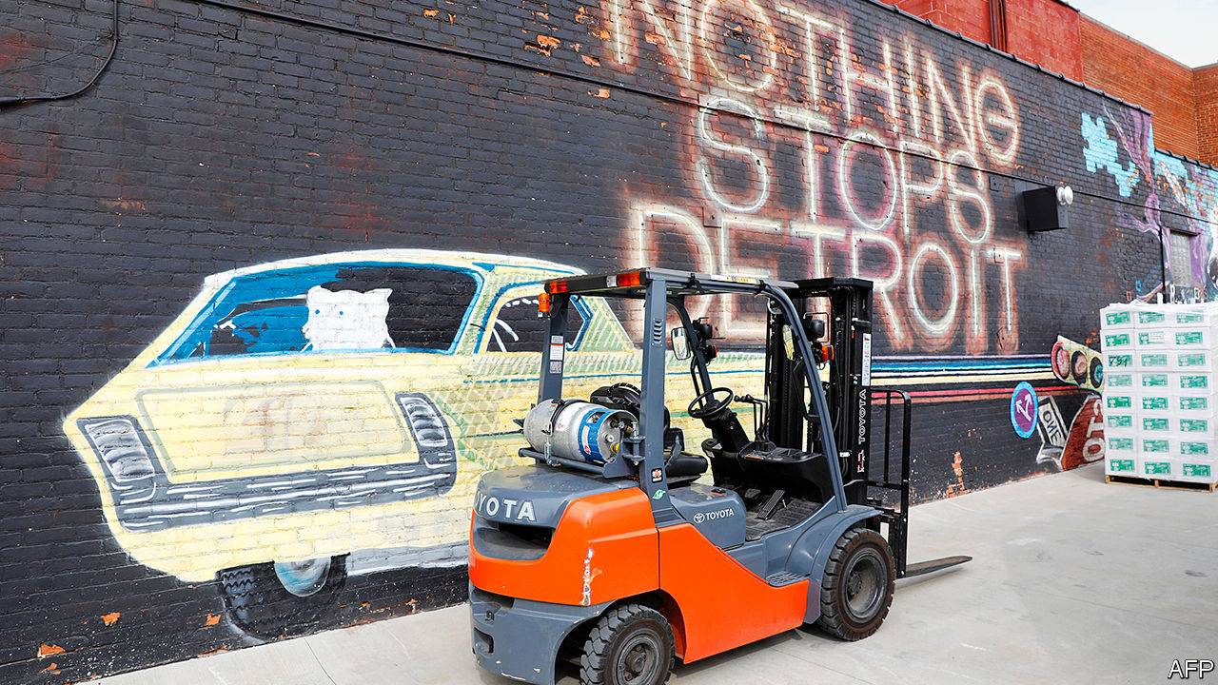

EXPLORE THE Midwest and you spend lots of time between places. Flat expanses are “littered with has-been towns” as Richard Longworth wrote a decade ago. His comment is not much appreciated in places like Assumption, Illinois (population 1,066 and falling). Then again, some Assumption residents express their own prejudice. “People down here want to push Chicago out of Illinois,” says Chris, who sells high-tech farm equipment. The city is too liberal and its voters too dominant. Dan Caulkins, a Republican state representative, sees a “cultural, political, economic divide” pitting Chicago “versus the rest”. Those white-collar Chicagoans “run by one party for generations” might be from a different country. Yet the Midwest’s metro areas are outgrowing states around them. Rural folk may not admit it, but it is urban ones who pay their subsidies.

A report last September by a group of mayors noted that 86% of Americans live in metro areas, producing 91% of national income. The mayors talk of gross metropolitan product (GMP): 38 metro areas, including ten Midwestern ones, have GMPs of $100bn or more. Chicagoland is the Midwest’s biggest. Its $716bn-strong economy is 83% of Illinois’s. The Minneapolis metro area produces $273bn, or 74% of Minnesota’s output. Even troubled Detroit’s metro area, valued at $273bn, makes up over 50% of Michigan’s economy, as St. Louis does of Missouri’s.

Metro areas in the Midwest have had a tough year. Covid-19 struck hard in Cook county, containing Chicago, which saw over 4,500 deaths by July. Wayne county, Detroit, had over 2,700. These were two of the highest death tolls outside New York. But some small-town dwellers railed against lockdowns. In southern Michigan, Illinois and Wisconsin, residents grumbled about fear-mongering city folk. Gun-toting protesters in Michigan entered the state capitol, angry at the lockdown imposed by Gretchen Whitmer, the governor. Conservatives in Wisconsin even got the state’s Supreme Court to overrule its governor, Tony Evers.

The pandemic also spread economic pain. Tourist spots, such as Michigan’s upper peninsula or northern Wisconsin and Minnesota, will see summer revenues slump. But it is cities that will suffer the most. Chicago had expected some 60m visitors this year; it will be lucky to get half. The city predicts a $700m hole in its $11.6bn budget. A University of Illinois study reckons the state will lose the equivalent of 550,000 year-long jobs in 2020, and $76bn in economic activity.

On top of this came the early summer disruption, when hundreds of cities were convulsed by protests against racist policing. Mayors ordered curfews in many cities and the National Guard appeared on the streets. Shops that were tentatively reopening as public-health restrictions eased were boarded up. Some owners of looted places said they would not open again.

The lesson from other big shocks is that they are more likely to accentuate existing trends than to change prospects entirely. The influenza pandemic of 1918 did not stop the rise of America’s cities, including in the Midwest. Big protests in Detroit in 1967 and again after the murder of Martin Luther King in 1968 coincided with (and maybe sped up) the decline of some cities. But those declines were caused by underlying economic trends.

Detroit is a test case. In the past 70 years it has suffered a dramatic slump. Its population peaked at 1.8m in the 1950s, and has since fallen to 670,000. City officials, businesses, community activists and philanthropists claimed it was starting to shine again pre-pandemic. Its town centre appeals to artists and draws tourists for Motown music and trendy restaurants. Suburbanites, craving cultural activity, also flock in. Some companies are even moving headquarters there. Michael Duggan, the mayor, lauds high-rises being built as new sorts of jobs grow, beyond the car industry. Too long dominated by a few huge firms, Detroit is encouraging startups. “Five years ago, you’d step out of your office on a weekday afternoon and the streets were deserted,” says Ray Waters, a businessman. “Today, there are people everywhere, going for dinner, to a show. The city is back.”

Detroit is following a well-trodden path of cities that have scrambled to diversify economies, renovate town centres, stop population loss, draw in youngsters, tackle crime and lure investors. Spend a day with Pete Buttigieg, former mayor of South Bend in Indiana, and he ticks off the usual achievements: a riverfront rehabilitation; the demolition of abandoned houses; improving public finances; luring tech and retail firms to fill old buildings previously given over to manufacturing.

Bruce Katz and Jeremy Nowak, with the Brookings Institution, have scoured the Midwest for examples of such “vanguard cities”, arguing in a recent book that they are gaining clout. Many have added population in the past decade. More people living alone or in households of two drive this, but it also reflects the arrival of young folk to do knowledge-based jobs. Baby boomers who prefer central-city life to sleepy suburbs also count.

Almost nowhere is housing cheap. Renting a home can absorb 30% of incomes. But Midwestern cities are more affordable than coastal ones. Anika Goss-Foster of Detroit Future City, a charity, points out that the housing stock is mostly old—built before 1970—but there is abundant space. Whereas Manhattan has 69,500 residents per square mile, Detroit has just 5,100.

In North End, a scrappy, sparsely occupied district once home to jazz clubs, Diana Ross and Smokey Robinson, redevelopment is under way. Sonya Mays stands in a small house that smells of freshly cut wood and new paint. A property developer, she has plans to construct 1,000 housing units, two-thirds of them in similar, once run-down neighbourhoods. Half will be affordable homes that get support from J.P. Morgan, a bank. If the quality of the housing stock improves, the population will return.

Mr Katz says that, until the pandemic struck, cities in the Midwest were “perfecting this playbook” of selling themselves as more fun than before and more affordable than elsewhere. Companies, too, recognised that it was cheaper to employ staff in cities with lower housing costs. He cites Pittsburgh as an early example of a city that got over the collapse of the steel industry and remade itself as a centre of new technology, robotics, artificial intelligence and more. Tom Murphy, a former mayor, says a tough decision to cut spending, notably on police, created a fund for buying land from former steel mills to be used by other businesses.

## How to be richer

One insight: rather than luring investors with incentives, cities should just create appealing living conditions. A second: cities have more assets than they realise. Public land can be exploited to raise funds for redevelopment and better public transport.

The region bursts with examples. Minneapolis and Madison have done well in health care, helped by the Mayo Clinic and firms like Medtronic, a maker of medical devices with revenues of $31bn and 90,000 staff. John Cranley, the mayor of Cincinnati, says his city has studied and tried to emulate Pittsburgh. Chicago’s success is exceptional: its central population has surged from 18,000 in 1980 to 110,000 today. Columbus, Ohio’s capital, has been gaining an extra 10,000 residents a year, making it one of the fastest-growing cities in America. Its boom, says Kenny McDonald, who leads the One Columbus redevelopment agency, reflects a diversified economy and good location for logistics.

Not everywhere prospers. When states barely add to their population (or, like Illinois, shrink) one city’s gain is another’s loss. Cleveland has lost out to Columbus and Cincinnati. The small tend to be eclipsed by the big. Decatur, Illinois, has slumped over the past decade, after the American headquarters of ADM and Tate & Lyle, two food-processing giants, moved to Chicago.

Aaron Renn, formerly of the Manhattan Institute think-tank, has assessed America’s “stagnating cities” in a report focusing on those that have shed 20% of their population since their peak. He talks of the Midwest coping with a “decline phase”, when “people pool into the places that are still successful”. Bigger urban areas keep growing by slurping up young graduates from smaller ones. Midwestern cities struggle with entrepreneurship. He cites Indiana as an exception that is also prepared to experiment with reform of government. Mr Renn, who lives in Indianapolis, praises a decision in the 1980s to merge the city and nearby county governments. That has lifted the city’s official population and propped up its tax-base. Crucially it binds suburban residents to the city.

Detroit would love to do the same, but it cannot easily annex nearby places because of a century-old state law. It could learn other lessons, such as the unusual readiness of Indianapolis to persuade companies to bid for municipal business, which has helped to repair the city’s finances. Sadly, Indiana’s market-friendly approach is not typical. A report in May by Heartland Forward, a think-tank of the Walton family (who own Walmart), laments that old, big companies do well in the region, but young firms rarely flourish. That is especially true in places that fail to encourage research and innovation. The young firms are likelier to generate new jobs, but regulation chokes small ones and stymies the entrepreneurial-minded. Occupational licensing for businesses such as hairdressers, or telling a bodega that it will need 15 permits to open, saps economies everywhere.■

Dig deeper:  
Sign up and listen to Checks and Balance, our [weekly newsletter](https://www.economist.com/checksandbalance/) and [podcast](https://www.economist.com/podcasts/2020/07/17/checks-and-balance-our-weekly-podcast-on-american-politics) on American politics, and explore our [presidential election forecast](https://projects.economist.com/us-2020-forecast/president)

This article was downloaded by calibre from <https://www.economist.com/special-report/2020/07/23/the-urban-prairie>

|  |  |  |  |
| --- | --- | --- | --- |
| Previous | Articles | Sections | Next |

|  |  |  |  |
| --- | --- | --- | --- |
| Previous | Articles | Sections | Next |

#### Race and the city

# Separate, downtrodden

The region has particular problems with segregation and policing

Jul 23rd 2020 |



TO WALK IN a Midwestern city is to get an education. Outsiders learn of invisible lines that are blindingly clear to locals. Head south from central Chicago on Martin Luther King Drive, and you enter an area that is just getting by. Bronzeville in the mid-20th century was crammed with 110,000 African-Americans; Duke Ellington played there. Today it is gentrifying. After public-housing towers were toppled, people moved into low-rise places.

Farther south, Englewood is depopulating. In one of the two census tracts here, 94% of residents are African-American. Median household income is under $20,000 (one-third of the county average). Less than 10% of residents own their homes, and 75% of children are in poverty. Average life expectancy, at 60 years, is decades less than in richer places. Violence is partly to blame. On May 31st 18 people were murdered in Chicago, its bloodiest day in six decades. Yet Melvin, a barber, won’t blame those in Englewood. “Once you got torn down neighbourhoods, abandoned buildings, drug infested, guns, then you know these kids, they’re vulnerable.” Many homes, shops and churches have been boarded up for years. A Whole Foods supermarket opened in 2016, but is mostly used by commuters who pull in from a motorway.

Chicago can feel almost as segregated as South Africa just after apartheid

The common story of Bronzeville and Englewood is of slow-motion ejection of African-Americans. The mostly white, Hispanic and Asian populations north of Chicago are flourishing. But black residents are flocking out. The black population in the city has shrunk by nearly 290,000 this century. People go to suburbs, to Indiana or, in a “reverse great migration”, back south. The census this year is likely to show, for the first time, more Hispanics than African-Americans in Chicago.

Chicago can feel almost as segregated as South Africa just after apartheid. Only part of the problem is policing. Protests erupted across America this summer after the killing of George Floyd. People were furious because jittery or callous police have long killed black Americans with so few consequences. Minneapolis was pressed to disband its police department. Chicago was convulsed in 2014 when video showed a policeman shooting a teenager, Laquan McDonald, 16 times. The officer’s trial ended with the first murder conviction for an on-duty Chicago policeman in almost half a century. Now its police operate under a “consent decree”, in which the Justice Department oversees reform.

The bigger concerns are inequality and segregation. Carmelo Barbaro, at the University of Chicago, says too many people are born in neighbourhoods that limit their prospects. Historical problems are known: black students kept out of white schools; black people denied mortgages; violent attacks by white residents who corralled African-Americans into a few areas of cities. Formally such restrictions no longer exist. De facto many do.

## History matters

Until a century ago, the Midwest was mainly settled by white immigrants, especially farmers, craftsmen and traders who had come from central and northern Europe. As Isabel Wilkerson has written, the subsequent influx of black southerners coming north to escape Jim Crow was dramatic, disruptive and ill-managed. For six decades after 1915 millions of people flocked to the industrial Midwest. Chicago’s black population rocketed from less than 3% (44,000 people) to more than 33% (or 1m). Northern, Germanic whites were “brittle” in their response, says John Gurda, a historian of Milwaukee. Poorer white people often saw newcomers as gate-crashers competing for jobs and housing.

African-Americans were forced into a few places, creating a housing pattern discernible today. Of the 25 cities with the worst racial segregation in America, 15 are in the Midwest. Myron Orfield of the University of Minnesota Law School says that racial divisions have increased in Minneapolis-St Paul this century. Poverty and race are closely aligned. In Madison, Wisconsin’s capital, 42% of the black population live in poverty, against 10.5% of white residents. Julie Moore Wolfe, mayor of Decatur, Illinois, says decades of white flight and racial sorting has left the town more divided than ever. She foresees more problems because of a “horrific” high-school drop-out rate of over 50% for black boys.

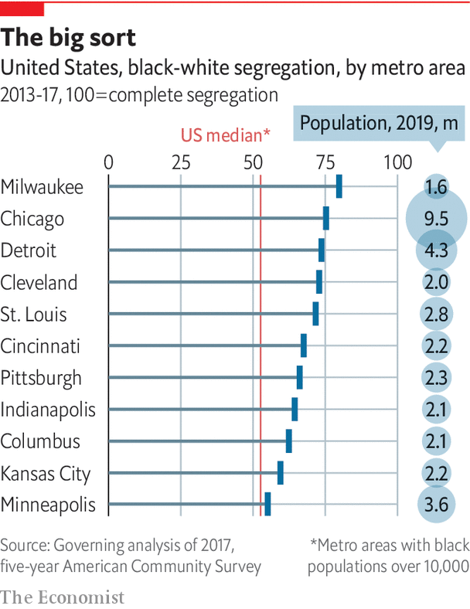

James Loewen has documented how residents in small towns in Illinois, even in the late 20th century, excluded African-Americans. Their method was blunt: signs on roadsides threatened to kill black people present after dark. He began research into “sundown towns” in 1999 and expected to discover ten historical examples in the state. Instead by 2018 he described finding 507. Many remain overwhelmingly white. Activists such as Jamala Rogers and Tef Poe, in St. Louis, Missouri, say nobody should be surprised. And when black people are no longer forcibly excluded, wealthy white folk often go.

After many went to leafy Clayton county beyond St. Louis’s airport, poorer black people moved into Ferguson on the edge of the city. As its fiscal base collapsed, police were ordered to raise revenue from fines for driving offences. They mostly targeted black drivers. These and other local fines brought in 20% of Ferguson’s city budget by 2013, just before a policeman, in 2014, killed Michael Brown, a black teenager, sparking big protests. Don’t just focus on police, says Walter Johnson, author of a history of St. Louis. Look at structures that foster racism, such as how the still white-run city farmed “its poor and working-class black population for revenue”.

The notorious eight-mile line in Detroit divides rich, mostly white, suburbs from the 80%-black city. Detroit’s (white) mayor, Michael Duggan, talks of forming ten commercial corridors to spread the wealth. But success depends on breaching that line. Without public transport, stymied by suburban officials, city residents cannot travel for jobs.

Milwaukee is the most racially segregated of America’s 51 large metro areas. Almost 80% of its black residents would have to move to be distributed similarly to whites. Instead, most have been clumped for decades near the defunct site of a car-parts maker. Some places are vibrant, but most are not. In one area 42% of households are in poverty, six times more than in nearby suburbs. Walk around the north side and you see why so many of the 7m black Midwesterners feel trapped. Chris Arnade, a writer who spent two years documenting “back-row towns”, says desperate people end up seeking salvation through the church, guns or drugs. Mandela Barnes, Wisconsin’s first black lieutenant-governor, said the summer protests call for actions to reduce “systemic inequity and injustice”.

Lori Lightfoot, Chicago’s mayor, says the answer is to tackle poverty, while facing up to “the original sin of slavery” and 400 years of repression. She would like to redirect city spending on the police to stricken neighbourhoods. A paper for the Brookings Institution two years ago by Benjamin Austin, Edward Glaeser and Lawrence Summers, points to the importance of jobs. It noted that many of America’s worst social and economic problems are in the Midwest. In Flint, a mostly black city in Michigan, the male jobless rate was over 35% even when America had near full employment.

Cities that don’t grow, notes Mr Glaeser, can’t change the “housing patterns established in the 1950s to 1970s”. Those that do, like Portland and Seattle in the west, are better at integrating schools and housing. Without growth, gains for one racial group often make another feel it is losing. Yet the Midwest has examples of progress. John Cranley, mayor of Cincinnati, says that in race riots in 2001 “we hit rock bottom”. But his city has managed to cut poverty, improve troubled neighbourhoods and reform the police. Cincinnati is trying to spread entrepreneurial activity by getting more black businesses as suppliers to its biggest companies, Procter & Gamble and Kroger.

Darrin Redus, a local business accelerator, says that 67 black-owned firms now do business worth $1.2bn in annual revenues, employing some 3,500 people. His goal, pre-pandemic, was to double those figures by 2023. Such efforts to spread prosperity are essential for overall urban success, he insists. Others say that only when black residents of cities are helped to accumulate wealth will the economy of the whole city benefit. Mr Barnes is blunter. Not tackling structural problems on race is like ignoring internal bleeding, he says. “You may not see it, but the outcome will be catastrophic if left untreated.”■

Dig deeper:  
Sign up and listen to Checks and Balance, our [weekly newsletter](https://www.economist.com/checksandbalance/) and [podcast](https://www.economist.com/podcasts/2020/07/17/checks-and-balance-our-weekly-podcast-on-american-politics) on American politics, and explore our [presidential election forecast](https://projects.economist.com/us-2020-forecast/president)

This article was downloaded by calibre from <https://www.economist.com/special-report/2020/07/23/separate-downtrodden>

|  |  |  |  |
| --- | --- | --- | --- |
| Previous | Articles | Sections | Next |

|  |  |  |  |
| --- | --- | --- | --- |
| Previous | Articles | Sections | Next |

#### Industry

# America’s Mittelstand

Advanced manufacturing can thrive, as Grand Rapids shows

Jul 23rd 2020 |

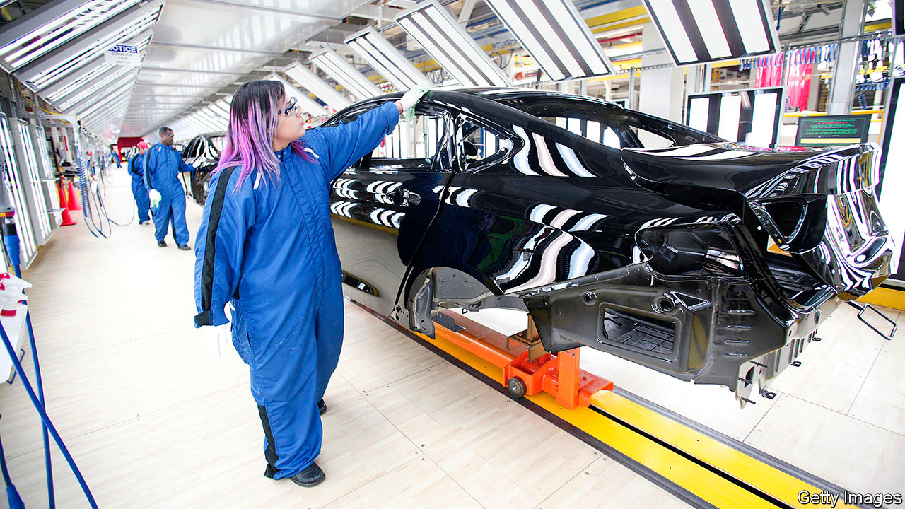

MIDWESTERNERS STILL like to make stuff. Manufacturing may have slid, but they do more of it than other Americans. In Indiana, it makes up 29% of gross state product (and employs 17% of workers). In Michigan it is 19% (and 14% of jobs). In each of the “core” eight states, it is above the national average of 12% of GDP. Companies plug into supply chains for car, aviation and retail industries, or for medical equipment, machine parts and the energy industry. Older-style work, such as furniture-making, persists.

Yet the mass employment of low-skilled workers has largely gone. That hurts those diverted to low-paid work in services. Tony Flora, a union leader in South Bend, asks “How can you provide a middle-class way of life if the jobs are serving omelettes in a restaurant?” Harvard’s Edward Glaeser observes that, as recently as 2000, manufacturing was the largest employer nationally of lower-skilled workers. Now it is one of the smallest.

Paul Krugman, an economist, suggests that rising economic nationalism, confrontation with China and pandemic-induced anxiety over supply chains could nudge some manufacturing back to the Midwest. Sherrod Brown, a senator from Ohio, sees this as a golden opportunity. Any recovery would be centred on those with skills in science, technology, engineering or maths (STEM). Bruce Katz and Jeremy Nowak from Brookings say STEM-related jobs (mostly in manufacturing) are better paid than average, employing 9% of Americans but contributing 17% of GDP.

Training does not have to mean four-year degrees. Instead what is needed are vocational skills that can be taught simultaneously by companies and colleges. Scot McLemore, of Honda, praises the community college in Columbus, Ohio, noting that “there are no more skilled trades, we need multi-craft technicians”, such as the computer savvy. David Harrison, who leads the college, says his 60 trainees study for two days a week in class and work for three at a firm. “Five years ago there was no path for this, now 30 manufacturers are in the programme.” It is an attempt at a German-style apprenticeship scheme.

How can Midwesterners develop more advanced manufacturing? An example of what to avoid is in Mount Pleasant village, in southern Wisconsin. A 20m-square-foot factory complex, planned in the past two years, belongs to Foxconn, a Taiwanese giant. In 2018 Donald Trump, wielding a golden shovel, vowed it would be the “eighth wonder of the world”, employing 13,000 factory workers on high wages. Supposedly Wisconsin’s economy would gain $51bn over 15 years. He talked less about promises to Foxconn of billions of dollars in subsidies.

The project always had a Potemkin air. It was a mystery what Foxconn would make, though television screens were talked of. It was rushed through as the showpiece of a manufacturing renaissance in a swing state. But Tim Bartik, at the Upjohn Institute for Employment Research in Michigan, says it was misconceived. The subsidies were ten times bigger than usual as a share of future wages, suggesting the underlying economics made no sense. Foxconn now talks of innovation and research instead.

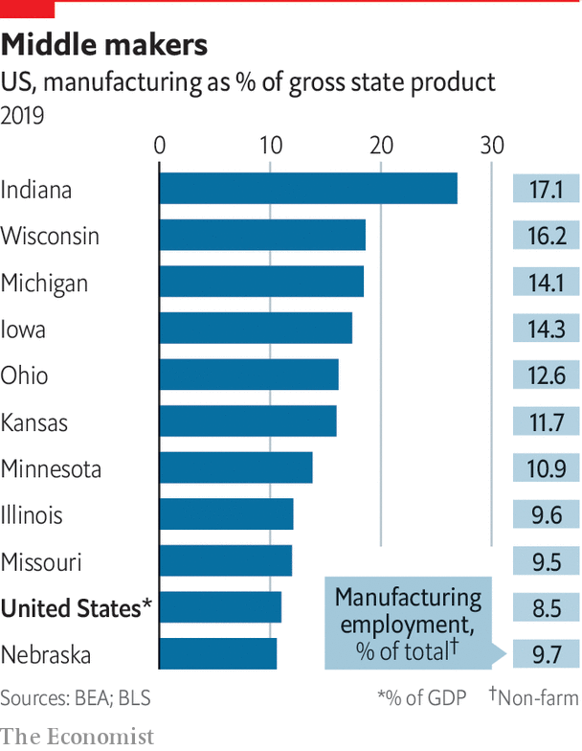

A better example, says Mr Bartik, is Grand Rapids, Michigan, “the most successful intensive manufacturing city in America”. It once made furniture and car parts, but since 1985 has been transformed by a project called “the Right Place”. Change came from the ground up, starting with 13 businesspeople from banks and philanthropy, including the Van Andel and De Vos families, who wanted to make their home more attractive. The early idea was to get existing firms to stay, but later it became to lure newcomers. The burghers first restored the town centre. They built a 12,000-seat arena that hosted big-name performers like Elton John. Hotels, restaurants, coffee bars and other entertainment flourished. Students flocked in. The Van Andels set up the Van Andel Institute, a bioscience cluster. Michigan State University opened a big medical school to train health-care staff. Michigan Tech University set up a branch.

Manufacturers were pressed to modernise. Birgit Klohs, a German transplant who has run the Right Place since 1987, says “We’re still a manufacturing centre, like the Mittelstand. The bulk of our success is in advanced manufacturing, in family-owned, mid-sized firms in their third or fourth generation of ownership, just like in Germany.” She seeks foreign ideas. In the 1980s a Japanese adviser showed car-suppliers Toyota’s lean techniques. She leads forays to Germany to study “Industry 4.0” (high tech in factories) or Israel to see how to work with startups.

As important, foreign investors are urged to come to Grand Rapids. Again, the German connection helps. She says there are 136 foreign companies, including 50 from her former homeland. The city “makes a point of attracting foreign, especially German” firms, she says, “as we saw something in common”. The results are exceptional. The Grand Rapids metro area has more than 1m residents today, up from 740,000 in 2000. New types of manufacturers flourish, such as makers of medical devices and equipment. Ms Klohs’s group lists 79 suppliers of personal protective gear, such as face shields, masks, hand-sanitisers, swabs and more, currently in high demand.

The city is a model for deployment of social capital. Researchers have tried to understand why some collaborative efforts succeed but not others. Part of the answer is that, as with the Mittelstand, many firms in the Midwest are owned by families with a passion for their home towns. Mr Katz says Midwesterners benefit from a “deep commitment to place”. He notes how many institutions with huge endowments there are, including MacArthur in Chicago, Heinz in Pittsburgh, the Cleveland Foundation and the Howard G. Buffett (son of Warren) foundation in Decatur.

One research paper contrasts the fortunes of Allentown in Lehigh Valley, Pennsylvania, with the dim outcomes in Youngstown, Ohio, in the years since the 1970s. In Allentown the main concern, as in Grand Rapids, was to create conditions so firms would stay and grow. In Youngstown (as with Foxconn in Wisconsin) there was a narrower focus on helping a particular industry, in its case steel. The long slog of creating the right eco-system seems more likely to pay off than the short-term effort to pick a winner in a declining business.■

Dig deeper:  
Sign up and listen to Checks and Balance, our [weekly newsletter](https://www.economist.com/checksandbalance/) and [podcast](https://www.economist.com/podcasts/2020/07/17/checks-and-balance-our-weekly-podcast-on-american-politics) on American politics, and explore our [presidential election forecast](https://projects.economist.com/us-2020-forecast/president)

This article was downloaded by calibre from <https://www.economist.com/special-report/2020/07/23/americas-mittelstand>

|  |  |  |  |
| --- | --- | --- | --- |
| Previous | Articles | Sections | Next |

|  |  |  |  |
| --- | --- | --- | --- |
| Previous | Articles | Sections | Next |

#### Universities

# From rustbelt to brainbelt

How higher education can drive prosperity

Jul 23rd 2020 |

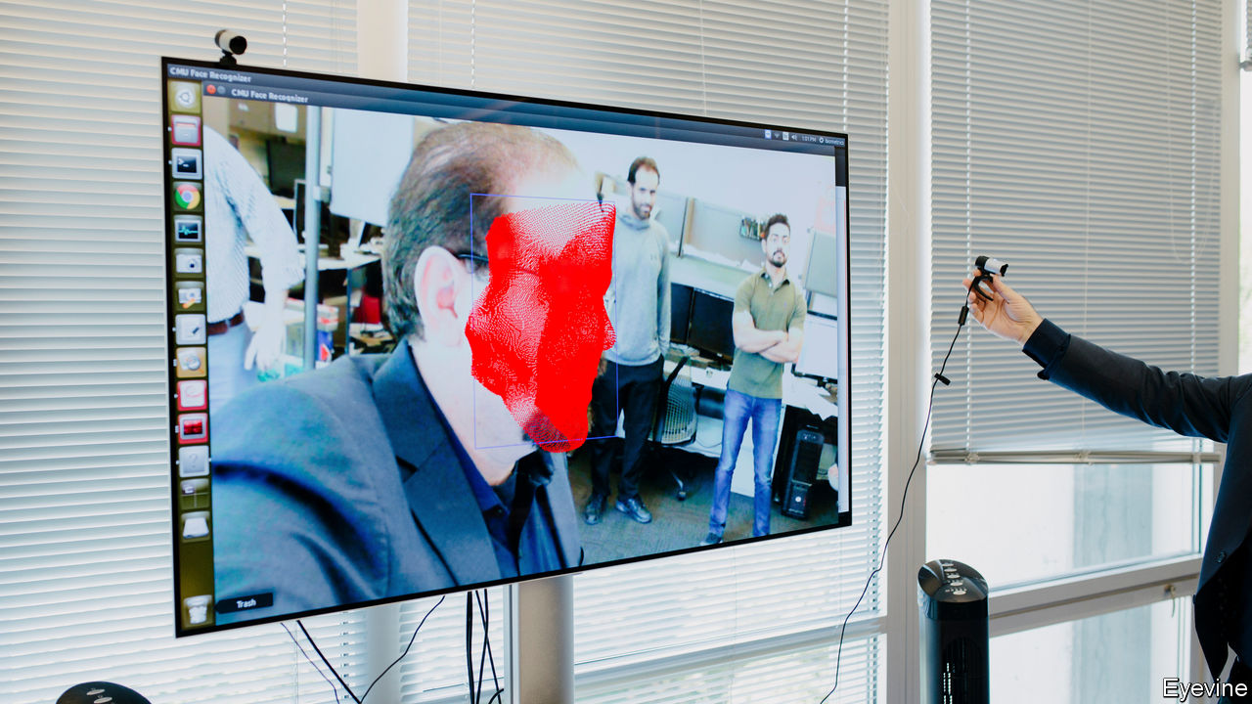

TO BUILD A great city is simple, the politician Daniel Patrick Moynihan once said. First create a university, then wait 200 years. By that logic, the Midwest has decent assets. It is home to lots of excellent universities, and hordes of more modest ones. All influence the cities around them. Those that thrive often have a university at their core; educated places do well long-term. Edward Glaeser of Harvard cites examples. If fewer than 5% of adults had a college degree in a city in 1940 then, 60 years on, no more than 19% did. In cities where more than 5% were graduates in 1940, the later share was up to 29%. Gains made early are felt for generations. He divides the Midwest in two. States in the west, such as Minnesota, Wisconsin, Iowa and Illinois, are better educated than those in the east and have prospered more.

John Austin, at the Chicago Council of Global Affairs, has written a study arguing that the Midwest’s institutional brainpower is exceptional. He says 15 of the world’s 200 top-ranked research universities are there. (In fact, by defining the Midwest expansively, he counts 20.) The “big ten” state universities, which oddly number 14, have 600,000 students, 50,000 faculty and draw annual research funds of $10.6bn, more than the Ivy League and Californian universities combined. The Midwest has 16 of the country’s 50 top-ranked medical schools, five of the 25 best computer-science ones, and 17 of 63 leading research universities. It does not do so well in STEM subjects, claiming just six of 25 top-ranked STEM colleges. Mr Austin tots up 21% of America’s patent filings, by companies and universities in the region. Almost a quarter of National Institutes of Health federal grants for developing drugs and medical technologies go to Midwestern institutions.

They in turn spread prosperity, in three ways. One is to bring in young people, often a city-sized population. Mayors want to revive town centres, so luring youthful consumers is a big plus. As a natural experiment, ask how they suffered when covid-19 sent people home. A resident of Columbus, Ohio, laments how the absence of 30,000 students and staff sapped demand for local businesses. Another example is South Bend, Indiana, where Pete Buttigieg often presents revival as mostly about political leadership. But he concedes that nearby Notre Dame university (where his father taught) mattered. Having 8,500 students beside a city of 100,000, including active ones who volunteer in local schools, is helpful. It was a boon to deploy researchers’ ideas, for example to fit wifi-enabled sensors in sewers to monitor water flow and save money. “We have a Beta City concept, we take intellectual property from the university and apply it,” he says.

Second, universities pool employable talent. Not all graduates hang around their alma mater, but cities that keep them outdo rivals. Rahm Emanuel boasts that, when he stood down as Chicago’s mayor last year, 39% of its adults had four-year degrees, far above the national average. No big city has more, he says, though that rests on defining big. In Minneapolis over 49% of adults have a degree; in Madison 58%. This helps explain why both cities have flourished, especially in medicine and pharmaceuticals, which need educated workers. On average, 32% of Americans (25 or older) have at least a bachelor’s degree. Of 12 states in the broad Midwest only Illinois, Kansas and Minnesota surpass that. The least educated state is Indiana, where barely a quarter have a degree. That is a reminder that early education remains a challenge. In Chicago Mr Emanuel struggled to lift the high-school graduation rate from a dismal 56% in 2012 to a somewhat better 78% last year. He also got more people to take vocational training in community colleges. That matters partly because firms come for Chicago’s supply of educated workers. Every June, he says, 140,000 graduates from across the Midwest flock in to start jobs.

Third, universities can refocus a city’s economy. John Cranley, Cincinnati’s mayor, says “By far the best driver is the co-location of an urban, diverse population near a tier-one research and development institution.” Lori Lightfoot, Chicago’s mayor, calls the University of Chicago “one of our crown jewels”. The university says that in two decades it helped found over 300 companies (including Grubhub, a food-delivery firm), with $1.2bn in funding.

The University of Illinois in Urbana-Champaign (U of I) offers a study in a lost chance to commercialise research. One of its computer-science students, Marc Andreessen, created the world’s first widely used web browser, Mosaic, while studying there in 1992. Sadly for Illinois, he went on to commercial success, co-founding Netscape and more, only after moving to the west coast. Laura Frerichs, head of development at U of I, says her university—with 13,000 engineering students and more mathematics PhDs than anywhere in America—learned from that experience. It has since put up 17 buildings for entrepreneurial students and recent graduates. These contain over 120 small companies, employing 2,200, often partnering with large firms such as State Farm. One student from Iran, whose firm has 35 staff, uses AI to create 3D images for construction companies around the world. Another uses a supercomputer to help cancer patients plan treatment. A third produces “ultra-compact robots” to walk through fields monitoring crops.

The plan is to scale up. The University of Chicago says it expects to become a centre for quantum information engineering, a new form of computing. This year the governor of Illinois, J.B. Pritzker, said he would direct $500m to launch the Discovery Partners Institute (DPI), in southern Chicago, where university research can be commercialised and tech graduates trained. Robert Jones, U of I’s chancellor, likens the plan to Tech Park on Roosevelt Island in New York, saying it will lift Chicago “from being a lower-tier city for innovation to the first tier”.

Another model is Pittsburgh, a once-dying steel city now nicknamed “Roboburgh” for a boom in robotics, artificial intelligence, self-driving cars and biomedical research. Zoom, a video-conferencing firm, recently said it would open a research centre there. Tom Murphy, a former mayor, says the way to understand Pittsburgh’s success is to look at Carnegie Mellon University and its entrepreneurial culture. Bruce Katz and Jeremy Nowak see Pittsburgh as a case study in regeneration driven by a university. They trace much of it to a robotics institute at Carnegie Mellon’s computer-science school, which got attention by working on the Three Mile Island nuclear accident. It inspired a cluster of local tech firms. Rather than choosing which company should flourish, the city and university concentrated on producing lots of graduates, and importing more, a process the authors call “talent sprouting”. In turn, they encouraged entrepreneurial activity.

Can these trends go on? Not every city can bank on a university. And many smaller colleges are threatened by demographic change, lower immigration, the pandemic and, for public ones, looming cuts in funding. But federal authorities, seeking ways to recharge the economy, could adopt an idea of professors at MIT to “jumpstart America” through $100bn of investment in 20 new centres of high-technology, innovation and commercialised research, similar to DPI in Chicago. The idea is that lots of rivals to Silicon Valley could bloom. Of the top 20 candidates in the professors’ list, 13 were around universities in the Midwest. With luck it will take less than 200 years to produce results.■

Dig deeper:  
Sign up and listen to Checks and Balance, our [weekly newsletter](https://www.economist.com/checksandbalance/) and [podcast](https://www.economist.com/podcasts/2020/07/17/checks-and-balance-our-weekly-podcast-on-american-politics) on American politics, and explore our [presidential election forecast](https://projects.economist.com/us-2020-forecast/president)

This article was downloaded by calibre from <https://www.economist.com/special-report/2020/07/23/from-rustbelt-to-brainbelt>

|  |  |  |  |
| --- | --- | --- | --- |
| Previous | Articles | Sections | Next |

|  |  |  |  |
| --- | --- | --- | --- |
| Previous | Articles | Sections | Next |

#### Politics

# America’s divided middle

The Midwest is still the political arena to watch

Jul 23rd 2020 |

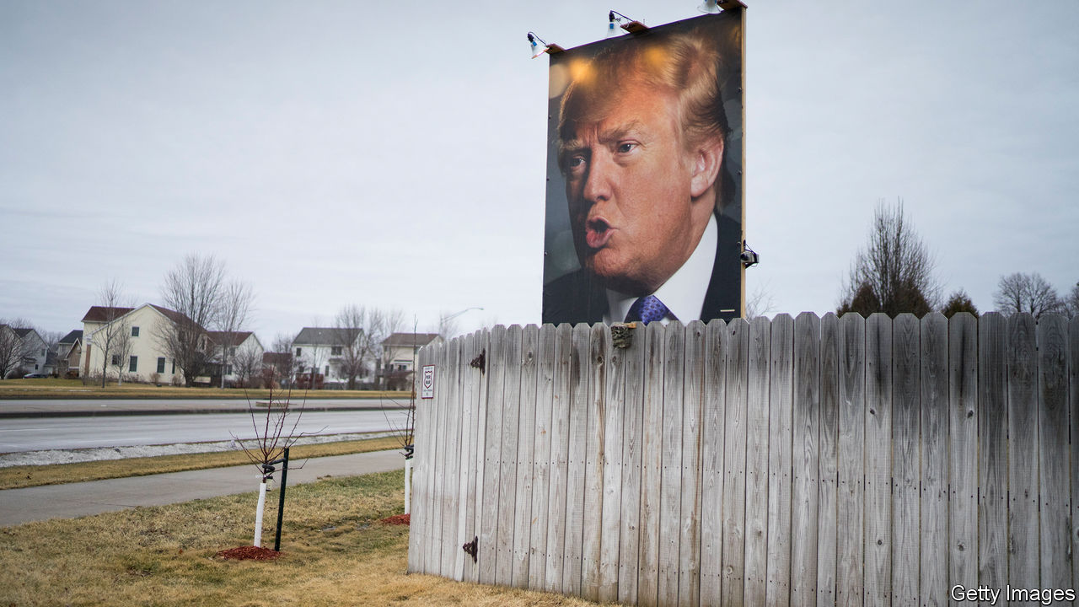

THE BEST explanation of how Donald Trump took the Midwest, and so the White House, came in a book published eight months before he did it. Kathy Cramer at the University of Wisconsin-Madison spent years interviewing small-town voters, such as retired farmers in rural petrol stations chatting over bad coffee. She asked how Wisconsin, a once-placid sort of place, had become bitterly confrontational. Her book, “The Politics of Resentment”, tracked how Scott Walker, the two-term Republican governor who left office in 2019, inspired fury from half the population and adoration from the other half. In every election of the past decade, voters were herded into rival camps. Democrats in populous cities, notably Madison and Milwaukee, were enraged as Republicans weakened unions and cut education funding. Their opponents in small towns in the north, centre and west were more resentful of urban folk and their overly liberal ways.

Small-town folk saw a recall election in 2012 (Mr Walker narrowly survived) as an unfair play by Democrats. The rural and low-paid imagined pampered office workers, especially public officials, living high on the hog in the city. Some conservatives were put off by debates on rights for minorities. Mr Trump’s approach—divisive and focused on firing up his base—fitted in perfectly, as it did in much of the Midwest. He took Wisconsin, Michigan and Pennsylvania on a low turnout. He tapped into the resentment that Ms Cramer found, while spreading cynicism among black voters in Milwaukee. The Democratic nominee, Hillary Clinton, inspired little affection. “She didn’t show up and ask for our vote, the first rule of politics,” grumbles one Midwestern voter. As Dan Kaufman points out in his book “The Fall of Wisconsin”, she blundered tactically, not campaigning (the first candidate to neglect the state since 1972) and spending little on television ads.

## Could it happen again?

Four years on, might the Midwest again put Mr Trump in the White House? Of traditional swing states, Ohio was long the best-known of all. Mr Trump took it by eight points, a large margin, piling up votes from working-class, old manufacturing places along the Mahoning river, while also winning lots of rural votes, such as in 28 counties in the south. Ohio has a record of choosing who occupies the White House. But it has become more Republican. As in Wisconsin, Republicans have in the past two decades managed to take more votes from small-town, suburban and exurban places, no longer bothering with cities. Yet Ohio could switch back in 2020. Sherrod Brown, a senator from the state, says the economic slump and anger over Mr Trump’s handling of racism mean it is likelier than not to flip. As of early July, polls suggest it is a toss-up. But the state’s significance has slipped: Mr Trump could hold it and still handily lose the national contest.

Four years on, might the Midwest again put Mr Trump in the White House?

Other Midwestern places may be more important. Though small, Iowa could be up for grabs. Barack Obama was popular with small-town voters in northern, once-industrial places. That area is notoriously disloyal to both parties. America’s greatest concentration of “pivot counties”, where voters picked Mr Obama as president but switched to Mr Trump, are 50 clustered near the northern stretch of the Mississippi river, in Illinois, Iowa, Minnesota and Wisconsin. Illinois is immovably Democratic, but any of the other three could quite possibly flip.

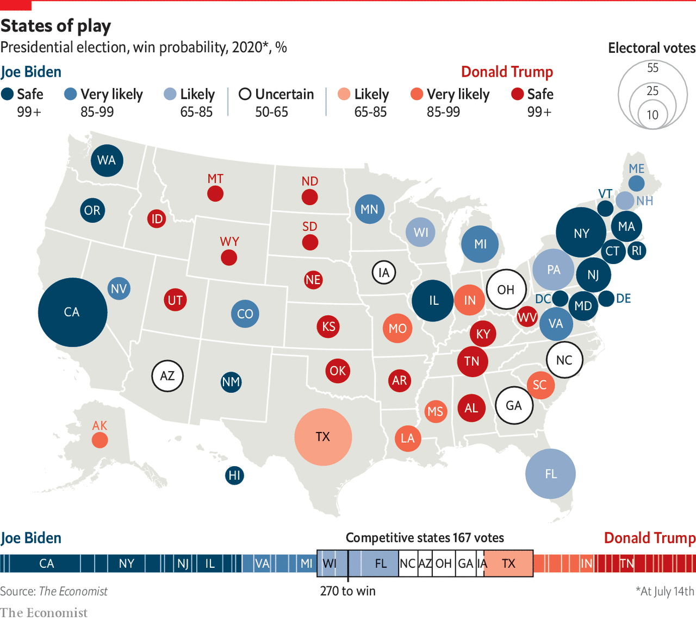

Back when the economy was in good shape, Mr Trump hoped to win Minnesota’s ten electoral-college votes. He lost there in 2016 by just 1.5%, or 45,000 votes, even as he took 78 of its 87 counties. The same rural-urban resentment that Ms Cramer tracked is clear in the state. In once-Democratic strongholds, such as the Iron Range mining district, Republicans have made big gains. Seen from run-down towns like Eveleth, Democrats are out of touch, focusing on the environment and immigration, not on rural, blue-collar interests. And race is undoubtedly also a factor. When Mr Trump attacks non-white Democrats such as Ilhan Omar, a congresswoman of Somali descent from Minneapolis, he hopes it resonates with small-town voters.

Polls suggest that Pennsylvania and Michigan are slipping away from Mr Trump. Partly that is because Joe Biden, as the Democratic nominee, is a powerful asset who appeals more than Mrs Clinton did to rural folk, as well as firing up African-Americans. He did dismally in the Iowa Democratic caucuses, coming a limp fourth, but he will do better with the wider electorate, appealing to independents and even moderate Republicans. He launched his campaign in a union hall in Pittsburgh, where his family has ties. Beth Hansen, a Republican strategist, points out that his father was in the car industry and calls the nominee “pragmatic, low-key, commonsense”. That is gushing praise in the Midwest.

In the 2018 mid-terms, Democrats scooped several suburban congressional seats, and even some exurban ones, that traditionally go Republican. Lauren Underwood, who won a largely rural district in Illinois for the first time, says she did it by focusing on older women voters and health care. If she can hold her seat, the Democrats can expect to retain the House. Democrats also replaced Republicans as governors in Illinois, Kansas, Michigan and Wisconsin. The closest victory was that of Tony Evers, an ex-teacher in Wisconsin, who won even as Republicans kept the state legislature.

In Wisconsin, watch especially the suburbs of Milwaukee, notably the wealthy and mostly white WOW counties—Washington, Ozaukee and Waukesha—where Republicans stack up votes. In recent state elections Republican margins of victory have shrunk, which bodes ill for them. Democrats may be moving in or independents may be turning. Women, particularly those with degrees, are queasy about Mr Trump. His behaviour after the killing of George Floyd put many off. Much Democratic effort will be trained on such places, especially after the Democratic convention is held in Milwaukee in August. Ben Wikler, the head of Wisconsin’s Democrats, says that there is no risk of complacency this time round.

Could this year’s dramatic events help their plans? By early July, all polls put Mr Biden ahead of Mr Trump, suggesting Democrats would make widespread gains in the region. For the Senate, one hopeful—John James, a rare Republican, African-American candidate, in Michigan—briefly looked capable of bringing down a Democratic incumbent, Gary Peters. But later Mr James fell behind in the opinion polls.

Mr Biden may have some leeway. In a tighter race he might have felt obliged to pick a running-mate from the Midwest, just as Mr Trump did with Mike Pence, a former governor of Indiana. Candidates could have included Gretchen Whitmer, governor of Michigan, Tammy Duckworth, a senator from Illinois, or Tammy Baldwin, one from Wisconsin. The region might yet gain its own champion in the White House.■

Dig deeper:  
Sign up and listen to Checks and Balance, our [weekly newsletter](https://www.economist.com/checksandbalance/) and [podcast](https://www.economist.com/podcasts/2020/07/17/checks-and-balance-our-weekly-podcast-on-american-politics) on American politics, and explore our [presidential election forecast](https://projects.economist.com/us-2020-forecast/president)

This article was downloaded by calibre from <https://www.economist.com/special-report/2020/07/23/americas-divided-middle>

|  |  |  |  |
| --- | --- | --- | --- |
| Previous | Articles | Sections | Next |

|  |  |  |  |
| --- | --- | --- | --- |
| Previous | Articles | Sections | Next |

#### Nature’s metropolis

# Don’t be the next Cahokia

Two lessons from a great Midwestern city you’ve never heard of

Jul 23rd 2020 |



WHERE TWO rivers meet is a good spot for a city. For 600 years a sizeable one existed where the Missouri joins the Mississippi. By 1100, at the city’s peak, 20,000 residents may have lived around it, as many as did in London. Today archaeologists call the place Cahokia, after a native American group. These pre-Columbians gave up the city two centuries after it peaked. But you can still explore 80 grass-covered mounds where Cahokia stood. The disappearance of the Midwest’s first great city offers two lessons.

The first concerns the environment, the likeliest cause of Cahokia’s collapse. Deforestation and polluted waterways put strains on nature. Getting enough food was hard. Researchers find evidence of big floods. Such pressures are not so different from those climate scientists warn of today. Predictions in the 1990s of warmer and wetter weather in the Midwest have proved accurate. In 2019 one of the worst floods in six decades drenched the region. Michigan, Minnesota and Wisconsin each had the wettest year on record in 2019. In Wisconsin, four in five of the wettest years have come in the past decade.

Rick Cruse, at Iowa State University, calls climate change a “monster” threat, mostly because of flooding. He suggests 10-12% of Iowa’s soil capacity has been lost, costing farmers $1bn a year. Last year’s deluge inundated cities like Davenport, Iowa. Overall damage was some $6.2bn. Tony Evers, Wisconsin’s governor, complains of “crazy weather happenings” and “100-year floods”. Lauren Underwood, a congresswoman from Illinois, lists this as one of voters’ main concerns. John Urbahns, who promotes development in Fort Wayne, Indiana, describes “weird late-season snowstorms”. The overfull Great Lakes, with one-fifth of the world’s fresh surface water, are eroding beaches, roads, piers and sewers.

West of Iowa, the region could get too little rain in future. But most places will get more. Hotter air carries moisture inland and can suddenly unleash water. Temperature swings can cause rapid snowmelt. In the 115 years to 2016, the Great Lakes area has warmed by 0.9ºC, slightly above the national rate. In the north, especially in winter, change is faster. Two-thirds of Minnesota’s counties have seen average mid-winter temperatures rise by more than 2ºC. In 2018 the National Climate Assessment predicted 30% more spring and summer rain by the century’s end.

Like the residents of Cahokia, presumably, most Midwesterners can see change happening. Polls show that even many Republicans accept that man-made climate change is real. “A day of ten-inch rain makes a believer out of people,” says Mr Cruse. That does not mean many people think it is time to act, for the Midwest is less badly hurt than other regions. Farmers even see some benefit. In Iowa, May 1st was long the unofficial start of planting, but mid-April is now the norm. In South Dakota some are even trying to grow corn. City-dwellers may welcome less bitterly cold winters. Kate Collignon, a consultant, asks if the Midwest might be a haven. If coastal places face worsening tornadoes, hurricanes and forest fires, the American middle may look appealing. But that depends, at least, on cities building better infrastructure—such as big, expensive storm drains, or stronger and higher bridges—to protect themselves. Voters in the region also need to get behind a faster switch to cleaner forms of energy.

The second lesson from Cahokia is demographic. The simplest explanation for its vanishing is that it didn’t import enough people. Modern cities, with low fertility rates, can also dwindle if they do not appeal to newcomers. Of Iowa’s 99 counties, says Art Cullen, a journalist in Storm Lake, 67 have lost population in every census since 1920. Gravity (population 187) could soon implode; Monowi in Nebraska is down to a single resident, Elsie Eiler, who is 84. Even as bigger places do well they rarely attract enough incomers, instead draining the young and the better educated from other parts of the Midwest.

As a whole, the region is stuck with low population growth. Six of the 16 biggest cities in America in 1950 have lost more than half their populations: Buffalo, Cleveland, Detroit, New Orleans, Pittsburgh and St Louis. But even successful places find people with specific skills in short supply. The region needs frequent top-ups of foreign talent. Without immigration, the Midwest’s demographic prospects would be dire. For its universities, health systems, farms and meat-packing plants, immigrants are crucial. In Illinois, for example, 18% of all workers are foreign-born. Among IT workers the rate climbs to 27%. For doctors and surgeons it is 32%. In Michigan and Ohio the numbers are high, too.

The Midwest used to be a more attractive gateway to immigrants. The foreign-born population has crept up, but by less than on the coasts. In 1970, in only one state in the region, Illinois, were more than 5% of residents foreign-born. By the latest census, in 2010, that had climbed to 14% in Illinois, 7% in Minnesota and 6% in Michigan. Those figures are probably higher now. The region was, until recently, exemplary in settling refugees. The mayor of Fort Wayne, Indiana, talks of the many Burmese families there. Dearborn, Michigan, is home to many Arab-Americans. Chicago has all sorts, including Ghanaians, Congolese and Ethiopians. St Cloud and the Twin Cities have many Somalis. Diversity has done wonders for local cuisine and entrepreneurialism, small businesses and livelier town centres.

The biggest threat to the Midwest is that it turns away from others. A misguided national policy under Mr Trump that chokes off inflows of foreigners, while ending the resettlement of refugees, could cost the region dear. The effects of covid-19 in stalling migration will make things worse. Together they threaten to make the Midwest a place that is home to a dwindling, ageing population—on a path not so different from Cahokia’s.

Leaders and voters should instead look for ways to open up. Companies, universities and cities, especially, should be urging national change. They need only look to booming Toronto to see how higher immigration drives growth. The most successful places are the most open. Grand Rapids wins by encouraging foreign investors and ideas. The universities of the Midwest need foreign students and staff, just as big companies seek talent from anywhere. Cities like Chicago, Minneapolis and Pittsburgh consider themselves open, welcoming and diverse. Those are values that have stood the Midwest well. They should do again.■

Dig deeper:  
Sign up and listen to Checks and Balance, our [weekly newsletter](https://www.economist.com/checksandbalance/) and [podcast](https://www.economist.com/podcasts/2020/07/17/checks-and-balance-our-weekly-podcast-on-american-politics) on American politics, and explore our [presidential election forecast](https://projects.economist.com/us-2020-forecast/president)

This article was downloaded by calibre from <https://www.economist.com/special-report/2020/07/23/dont-be-the-next-cahokia>

|  |  |  |  |
| --- | --- | --- | --- |
| Previous | Articles | Sections | Next |

|  |  |  |
| --- | --- | --- |
| Special report | Sections | Finance & economics |

Business

TikTok: Sixty seconds of fame

.

Information technology: In need of a software update

.

Bartleby: Pandemic veterans

.

Corporate profits: Seeing is disbelieving

.

Vaping: Puff piece

.

Mergers and acquisitions: Wakey, wakey

.

Schumpeter: The wannabe Alibaba

.

|  |  |  |
| --- | --- | --- |
| Special report | Sections | Finance & economics |

|  |  |  |  |
| --- | --- | --- | --- |
|  | Articles | Sections | Next |

#### Sixty seconds of fame

# TikTok’s Chinese parent is scrambling to hang onto its hit app

America threatens to ban ByteDance’s most valuable digital property—or seize it

Jul 23rd 2020 |

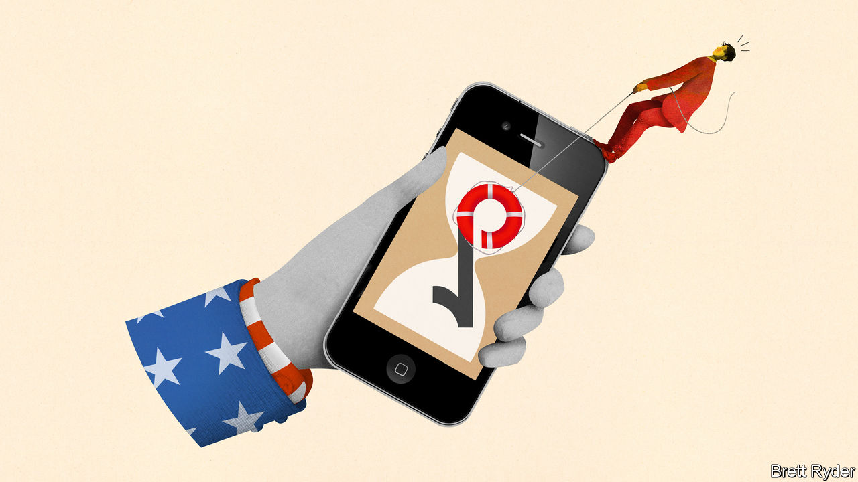

IN MAY BYTEDANCE, the world’s most valuable startup, leapt further ahead of other technology “unicorns”. It was valued at $140bn on the secondary market, up by nearly half from a funding round in the spring. The reason? TikTok, a short-video app that has been downloaded 2bn times. The “last sunny corner” of the internet, as it is known thanks to jolly user-generated content, is China’s first worldwide internet sensation. For ByteDance’s 37-year-old founder, Zhang Yiming, it is part of an ambition to build a global software giant.

Now that ambition is in jeopardy. On June 29th India banned TikTok and 58 other Chinese apps, after deadly clashes between Indian and Chinese soldiers in the Himalayas. The same month ByteDance’s American lawyers told it that President Donald Trump’s administration has concerns over TikTok’s Chinese ownership. America is now threatening to ban the app altogether.

Official unease about TikTok has risen with its popularity. It has an estimated 70m American users, in the same league as Snapchat. In the first quarter it was downloaded 315m times globally, more than any app ever in three months, according to Sensor Tower, a research firm (see chart 1). In America and Britain it rivals YouTube for user attention—and not just among teenagers, who first took to it. “TikTok is a place for everyone now,” says Vanessa Pappas, the app’s general manager for America.

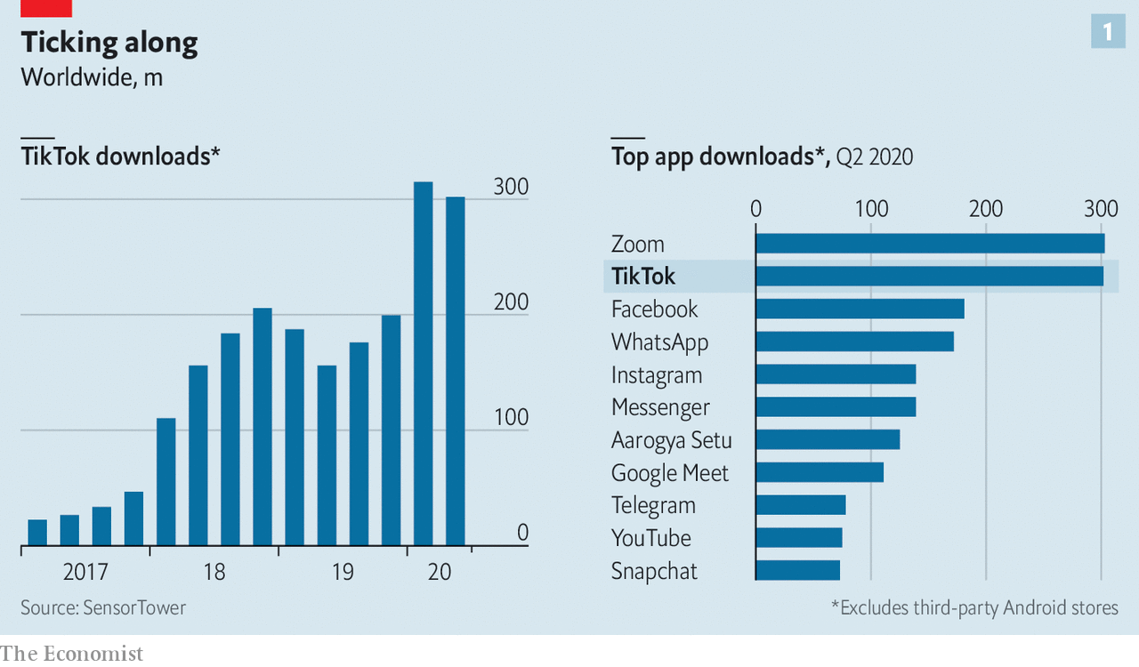

ByteDance keeps its numbers close to its chest but its investors say it is on track to bring in $30bn of revenue in 2020, up from $15bn-20bn in 2019. Net profit could more than double, to $7bn. Most of that comes from its Chinese businesses, Douyin, a version of TikTok, and Toutiao, a news app. TikTok is not yet making money, but ByteDance reckons it may in time eclipse all its Chinese properties put together, by tapping into America’s vast ad market. It has been rolling out tools to advertisers. ByteDance’s mainly American venture-capital backers believe this, plus growth in China, could lift its valuation to $500bn.

To TikTok’s users the idea of Uncle Sam cracking down on videos of baby hedgehogs is as silly as grandpas learning to shuffle. Officials have two concerns. The first is over censorship and propaganda. TikTok has in the past muted discussion of subjects sensitive in China, like Tibet, Tiananmen Square or repression in Xinjiang province. The second worry is that as a Chinese firm, ByteDance is subject to laws that require it to work with China’s authorities.

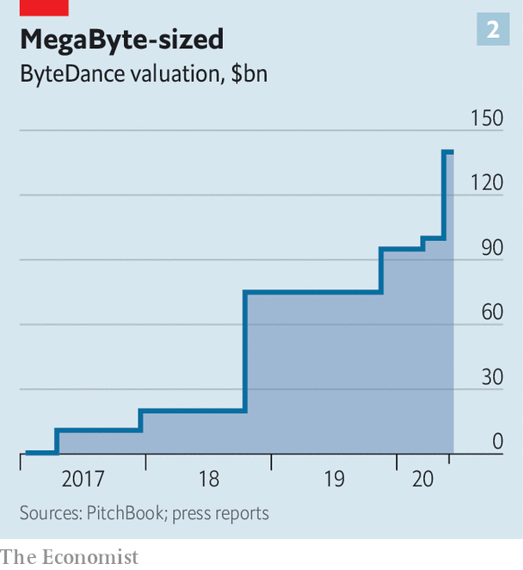

TikTok says that it has never received any formal requests for data from China, and would refuse to hand over information on non-Chinese users. But Alex Stamos, former chief security officer at Facebook who now advises Zoom, a videoconferencing service with operations in China, says that even if TikTok could resist government requests, “the question is what extralegal means exist to get data out”. If Beijing-based engineers have access to TikTok’s servers anywhere in the world, he says, their government could force them to hand over data stored there. TikTok says it collects less data than many social networks, but automatically records users’ GPS location, internet address, and browsing and search history on the app. Users can also opt in to share their contacts.

ByteDance has tried to head off these concerns. As TikTok’s user base exploded in the West, it took steps to Americanise its operations and management. After a covid-related delay its “transparency centre” in Los Angeles, where experts can examine its code, should open this summer. TikTok has hired a high-profile new chief executive, Kevin Mayer, from Disney.

In March ByteDance also came up with a more radical plan. It could take all its non-Chinese businesses, including TikTok, and give them a global headquarters in London, plus a back-office in Ireland (where Europe’s strict data-protection rules are in force). Operationally, the firm would bifurcate into “ByteDance China” and “ByteDance Global”. It talked to the British government about the idea in February.

These discussions stopped once the White House raised the prospect of banning TikTok. Some people involved now reckon the likelihood of such a ban is pretty high. ByteDance’s priority is to avoid this outcome, while hanging on to a meaningful chunk of TikTok’s economic value.

The company’s preferred option is the “ByteDance Global” plan. It is ready to change its capital structure and spin off the global arm, keeping a stake of between 35% and 49%. Mr Zhang would appoint a minority of board members. ByteDance Global could in turn spin out TikTok’s American arm to distance it further from China. Another option on the table is reportedly for ByteDance’s existing investors to buy a majority stake in TikTok, maybe letting ByteDance keep a small shareholding. Whether this would placate the Trump administration is unclear.

What ByteDance fears most is a forced sale of 90-100% of global TikTok to American investors or a tech giant. Larry Kudlow, Mr Trump’s economic adviser, has said he thinks TikTok will become an American firm separate from the Chinese parent. Beijing would probably accept a new European global headquarters for ByteDance, the firm reckons. But handing global TikTok over to Americans would smack of expropriation. “America would get another global tech platform,” notes one person in China involved in the matter.

Letting go of some or all of TikTok would be a financial blow to ByteDance. Without TikTok America its potential value would fall from $500bn to perhaps $300bn, reckons a big investor. Losing TikTok globally would be more painful still. A split could also stunt the future development of the app, whose popularity has been fuelled by ByteDance’s algorithms, honed in developing Douyin and Toutiao.

TikTok’s woes offer others an opening. In India, where 200m users lost access to it overnight, a local rival, Roposo, got 22m sign-ups in 48 hours. In America Facebook is about to launch Instagram “Reels”, a TikTok clone, and YouTube will soon roll out “Shorts”. The White House may yet think twice about banning an app so many Americans are hooked on. Its corporate structure may change. But Ms Pappas is resolute: “TikTok is not going away.” ■

This article was downloaded by calibre from <https://www.economist.com/business/2020/07/23/tiktoks-chinese-parent-is-scrambling-to-hang-onto-its-hit-app>

|  |  |  |  |
| --- | --- | --- | --- |
|  | Articles | Sections | Next |

|  |  |  |  |
| --- | --- | --- | --- |
| Previous | Articles | Sections | Next |

#### In need of a software update

# Indian IT consultancies struggle against technological obsolescence

The subcontinent’s successful tech giants risk being left behind

Jul 23rd 2020 |

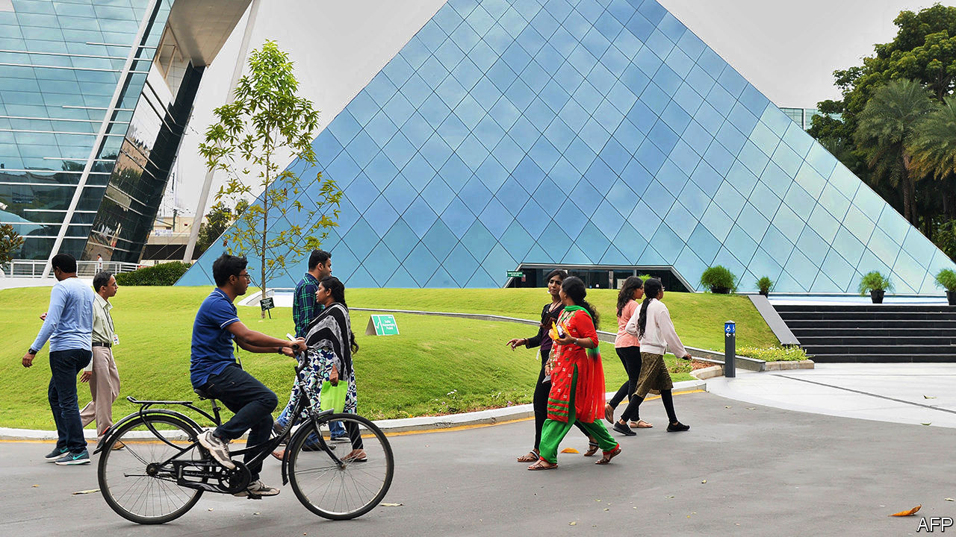

MANY OF THE world’s multinationals claim to be technology companies. In fact, their increasingly digitised operations often rely on a handful of Indian firms. Few people outside their home country have heard of Tata Consultancy Services (TCS), Infosys, Wipro, HCL Technologies or Tech Mahindra, India’s five biggest information technology (IT) consultancies. Yet even when enterprise software to manage marketing, production, inventory and the like comes from Oracle of America or Germany’s SAP, it is often the Indian companies that install and maintain software for clients. They create the ledgers, transaction platforms and risk controls that enable financial firms to operate. They build and run websites. When Rajesh Gopinathan, TCS’s chief executive, noted recently that his firm helps manage the world’s big banks, retailers, manufacturers and telecoms companies, it was not an empty boast.

The IT consultancies have been India Inc’s rare global success story. Except Infosys, which was born as an IT consultancy in 1981, all of the big firms were spun out of their parent conglomerates, beginning with TCS in the 1960s, which was hived off to work out how to optimise electrical output for Tata’s power companies. They won acclaim after patching the “Y2K” bug, which threatened to crash the world’s computer systems flummoxed by the zeroes in the new century’s dates. That brought them to the attention of big Western firms, which realised they could hire talented Indian programmers at a quarter of the going rate in their home markets. Some firms outsourced their entire IT departments.

The upshot has been spectacular growth for India’s IT firms. The big five’s combined market capitalisation surpassed $200bn in 2019. The biggest, TCS, has 285 offices in 46 countries and as many workers as Microsoft, Apple, Alphabet and Facebook put together. The industry which has grown up around TCS and the other IT titans comprises 16,000 companies, employing 4.4m people. The sector’s revenues soared from $8bn in 2000 to $180bn last year, according to NASSCOM, a trade body. That is equivalent to 6% of India’s GDP.

As in the previous downturn after the financial crisis of 2007-09, the coronavirus-induced recession has caused corporate clients to tighten the purse-strings on all manner of expenses, including IT. Sales of the big firms barely grew year on year in the latest quarter, down from an annual growth rate of over 20% throughout the 1990s and 2000s. Lockdowns have put their plush campuses—the Infosys one in Mysore has a bowling alley and a climbing wall, as well as roaming peacocks—mostly out of bounds. Other countries are erecting barriers to foreign employees. America, a crucial market, has suspended visas for skilled temporary workers, 70% of which typically went to Indians.

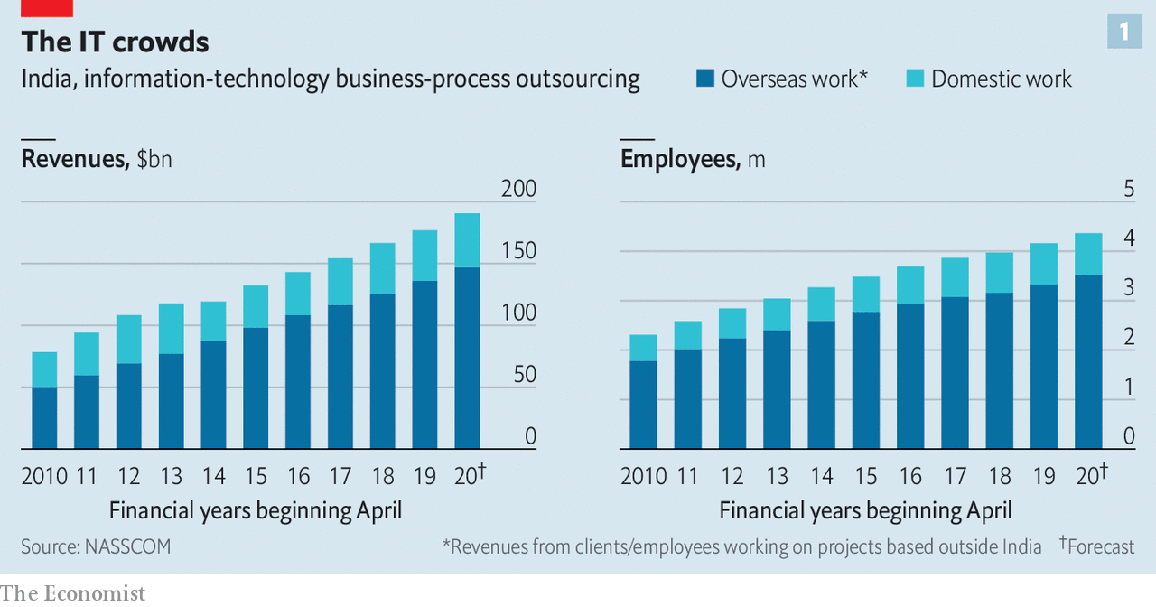

If the pandemic were their only problem, the IT firms would shrug it off. Being technologically adept, they quickly shifted their employees to home-working. Within days, 95% or more of their staff were toiling remotely—quite a feat in a country with patchy broadband and countless bureaucratic obstacles to sudden changes in workplace practices. The impact of having fewer Indians in foreign offices will be mitigated by greater acceptance of videoconferencing and longstanding efforts to recruit workers directly in their foreign markets; Infosys has 17,500 employees in Europe and 22,200 in America.

However, covid-19 hit at a time when growth was already sputtering. The industry’s revenues rose by 6% in 2019, around a quarter of the historic rate. The Indian model has been widely aped by global consulting firms such as Accenture, IBM, Deloitte and EY, all of which now run vast facilities in India and have dispatched employees to work directly with global clients around the world.

For all their tech nous, the Indian giants have also been unable to keep pace with technological change. Corporate software is becoming easier to use, reducing demand for their services. The lucrative legacy business of running mainframes is evaporating. Helping clients shift to the cloud makes money but not nearly as much. Despite some interesting pilot projects—such as Tech Mahindra’s use of artificial intelligence to tell apart 1,645 Indian languages or Infosys’s covid-19 contact-tracing in Rhode Island—the consultancies have not come up with a killer app, let alone powerful platforms like those of America’s big tech firms.

Worse still, multinationals are increasingly reluctant to outsource their IT. Rather than hire the consultants, many are creating subsidiaries in India to do the job in-house—sucking away both custom and workers from the consultancies. Before the pandemic India hosted more than 1,400 of these so-called “captive centres”, employing a total of more than 1m people, according to an analysis by the Ken, an Indian news website; around 70% of them were owned by big American firms. Walmart Labs India, owned by the American supermarket chain, is reportedly on course to double its staff numbers to 7,000 in the next year or two.

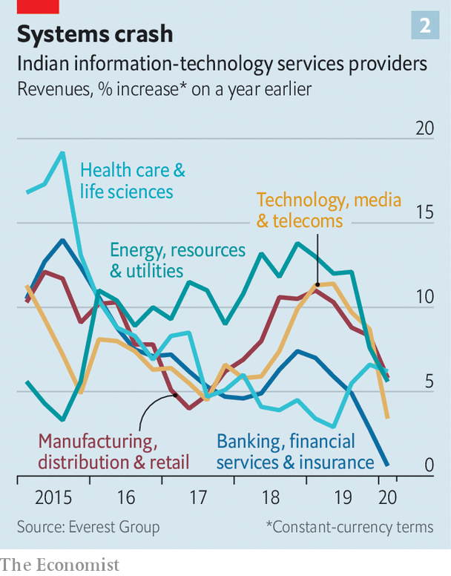

The popularity of such in-house operations has to do with the changing economics of technology. This once required armies of people, so spreading costs among many clients made sense. With falling prices of hardware and software, and more skilled workers around, a captive centre can pay for itself with just 50 employees, says Peter Bendor Samuel of the Everest Group, a research firm. Firms in industries from energy to entertainment are discovering the value of developing their own technology. Their pace of spending with the consultants has slowed (see chart 2).

The Indian IT consultancies are not going away. They retain the ability to solve common problems at a modest cost. This month Infosys signed a new ten-year deal, the biggest in its history, to help Vanguard, a huge American asset manager, keep records and run its website. A new generation of bosses may shake things up. On July 17th HCL’s founder became the last of the industry’s grandees to step aside, leaving his daughter in charge. In May Wipro named Thierry Delaporte, a former executive at Capgemini, a smaller French consultancy, as its CEO. The new guard have their work cut out if the Indian champions, having helped engineer one profound change in the nature of the modern corporation, are not to be left behind by another. ■

This article was downloaded by calibre from <https://www.economist.com/business/2020/07/23/indian-it-consultancies-struggle-against-technological-obsolescence>

|  |  |  |  |
| --- | --- | --- | --- |
| Previous | Articles | Sections | Next |

|  |  |  |  |
| --- | --- | --- | --- |
| Previous | Articles | Sections | Next |

#### Bartleby

# How small businesses have dealt with the crisis

Pandemic veterans

Jul 23rd 2020 |

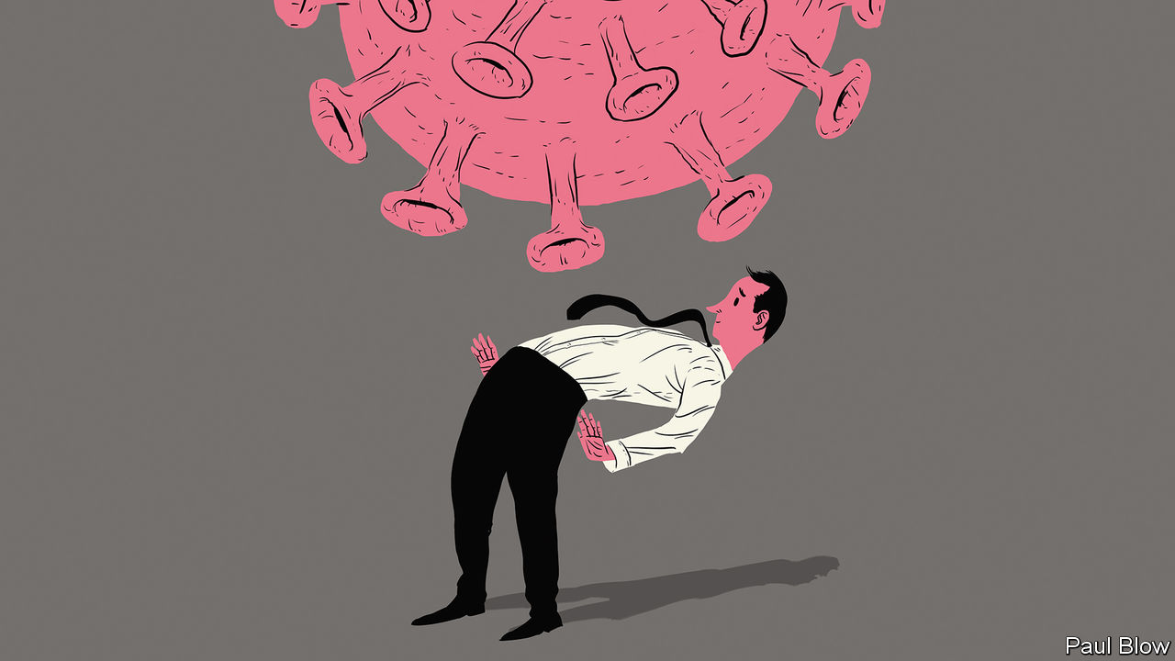

Editor’s note: Some of our covid-19 coverage is free for readers of The Economist Today, our daily [newsletter](https://my.economist.com/user#newsletter). For more stories and our pandemic tracker, see our [hub](https://www.economist.com/news/2020/03/11/the-economists-coverage-of-the-coronavirus)

AS A SPECIAL-OPERATIONS pilot in the American air force, Joe Shamess was used to handling some tricky situations. But the sudden arrival of the coronavirus pandemic this year meant he faced an unexpected challenge. Together with another pilot, Brian Steorts, Mr Shamess had founded Flags of Valor, a company that focused on employing veterans to make products such as flags and gifts for employee-recognition programmes. When the pandemic hit, the company quickly lost two-thirds of its revenue.

Smaller companies like Flags of Valor have been the most vulnerable to the pandemic and its economic turbulence. Most have little in the way of financial reserves and sell a limited range of products. Tom Sullivan, vice-president of small-business policy at the US Chamber of Commerce, points to data showing that 20% of small businesses (those with fewer than 500 employees) in America have closed since the virus hit. Things are worse for black-owned businesses, which often find it more difficult to get bank loans; 40% of such firms have shut.

Government support for American small businesses has been in the form of loans under the Paycheck Protection Programme (PPP). Mr Sullivan says 72% of small firms have received a PPP loan. But, Mr Shamess reports, “even though we were one of the very first applicants, we did not receive funds in the first round.” He feels his bank failed to give the application the attention it deserved.

With the help of a different bank, the company managed to get funds in the second round of PPP loans. But it still took almost a month from the initial application to receipt of the money. Mr Shamess says that the scale of the programme was so great and the time needed to distribute it was so short that it was rather like trying to build a parachute while falling to the ground.

The management therefore had to act without waiting for the feds. The work week went from 40 hours to 20. Some of the firm’s 24 workers were furloughed. The main problem was not manufacturing; the factory was big enough to keep staff socially distanced. It was distribution. Mr Shamess had to close the showroom; trade shows, which brought in a lot of business, were cancelled.

So the firm had to innovate. The showroom is now closed for good and most business is online; one of the firm’s biggest sellers is a newly launched crafts kit for kids, to keep little ones occupied during the long break from school. All of the craftsmen are now back working full time. Still, Mr Shamess says that “we are a different company from four months ago.”

Another firm that has had to transform itself during the pandemic is VetCor, which also happens to employ military veterans but operates in the service sector. Its main business was the restoration of buildings damaged by floods and damp, a common risk in Florida, where it is based. The pandemic forced the company to close one of its offices, lay off some of its 31 workers and apply for a PPP loan (which it received). But Paul Huszar, a former army lieutenant-colonel who runs VetCor, realised the crisis created a business opportunity.

Part of the firm’s work involved dealing with the mould spores associated with damp conditions. The same processes could be used to disinfect buildings to eliminate the coronavirus; the company already had the right chemicals, air scrubbers and personal-protection equipment. This has proved a popular service with restaurants in the area.

VetCor also operates a franchising business, but four conferences where it was due to recruit franchisees were cancelled. So it signed up for a virtual career conference aimed at veterans from Annapolis and West Point (America’s naval and military academies, respectively). Mr Huszar expects several franchisees to sign up as a result.

This flexibility reflects some of the rules Mr Huszar developed when serving in Iraq: don’t be wedded to the plan and recognise when conditions change. And that is one of the advantages of running a small company; it is easier to change direction quickly than at a big firm.

The 20% pandemic closure rate among small businesses in America, bad though it is, could be read as showing that most soldier on. A survey from the National Federation of Independent Business shows that optimism among small firms rose for the second consecutive month in June. This month’s spike in infections might temper it again. But then small-business managers like Messrs Shamess and Huszar will once again adapt. They have the skills to do so.

Editor’s note: Some of our covid-19 coverage is free for readers of The Economist Today, our daily [newsletter](https://my.economist.com/user#newsletter). For more stories and our pandemic tracker, see our [hub](https://www.economist.com/news/2020/03/11/the-economists-coverage-of-the-coronavirus)

This article was downloaded by calibre from <https://www.economist.com/business/2020/07/23/how-small-businesses-have-dealt-with-the-crisis>

|  |  |  |  |
| --- | --- | --- | --- |
| Previous | Articles | Sections | Next |

|  |  |  |  |
| --- | --- | --- | --- |
| Previous | Articles | Sections | Next |

#### Seeing is disbelieving

# America Inc braces for an earnings bloodbath

For investors this earnings season will give the first inkling of just how bad things have got as a result of the pandemic

Jul 23rd 2020 |

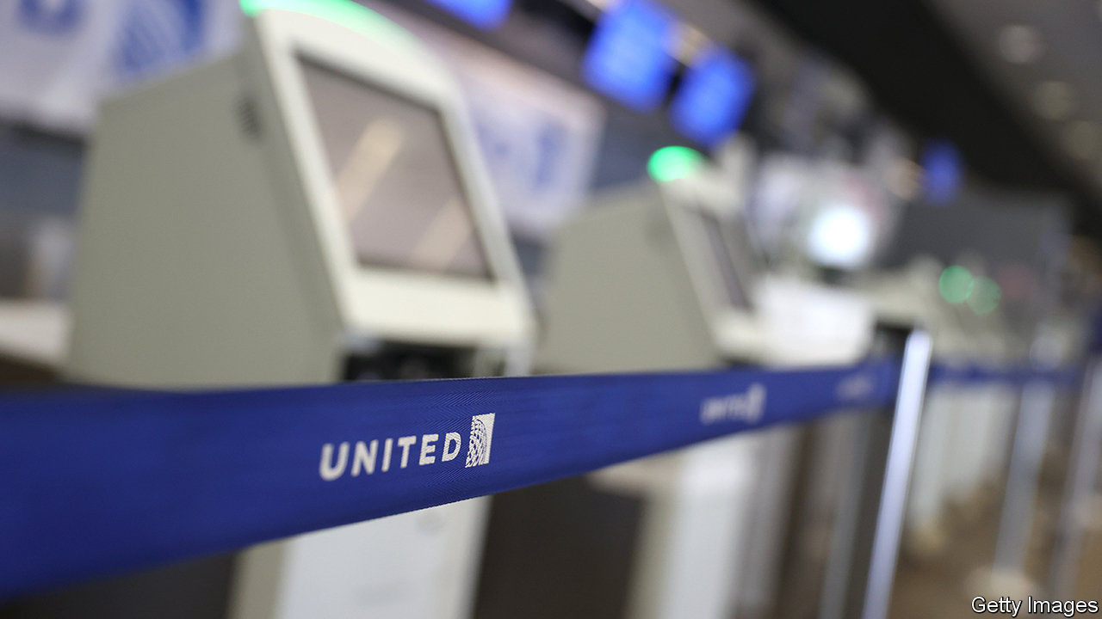

Editor’s note: Some of our covid-19 coverage is free for readers of The Economist Today, our daily [newsletter](https://my.economist.com/user#newsletter). For more stories and our pandemic tracker, see our [hub](https://www.economist.com/news/2020/03/11/the-economists-coverage-of-the-coronavirus)

UNITED AIRLINES bled cash at a rate of $40m a day from April to June. That is the good news. Delta, a rival, clocked $43m a day. It was, United said, “the most difficult financial quarter in its 94-year history”, as lockdowns and travel restrictions led to an 87% fall in revenues. The travel industry has been eviscerated by covid-19. But it is not alone.

As America Inc begins to report its latest quarterly earnings—the first to capture the full extent of the economic coma induced to combat covid-19—companies across all sectors are disclosing hits to the bottom line. On July 21st Coca-Cola said its operating income fell by 34% year on year, as fewer restaurants bought its soft drinks and snacks. Not even big tech was spared. The day before Microsoft unveiled its own (decent) results on July 22nd, LinkedIn, its professional social network, said it would lay off nearly 1,000 workers because of a drought in corporate recruitment. Overall, profits of big American firms in the S&P 500 index are expected to have fallen by 44% in the three months to June, compared with last year, estimates FactSet, a data firm.

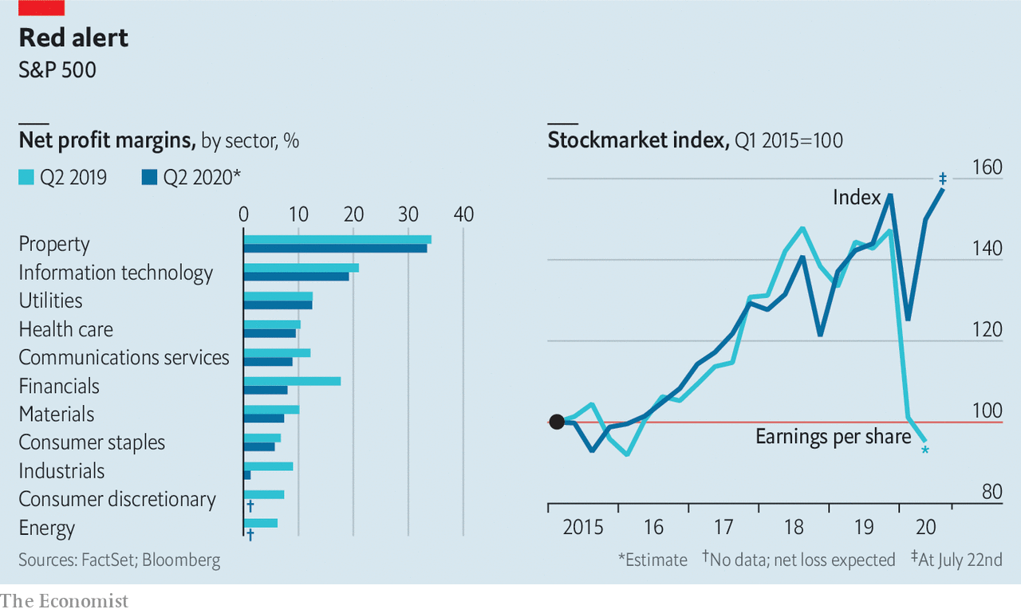

For investors the earnings offer a belated inkling of how bad things are. By May one in two S&P 500 firms declined to issue guidance about their results for the quarter ending in June, citing pandemic uncertainty. Ignorance being bliss, the stockmarket swiftly rebounded from its collapse in March. Now a little knowledge may prove a dangerous thing.

Editor’s note: Some of our covid-19 coverage is free for readers of The Economist Today, our daily [newsletter](https://my.economist.com/user#newsletter). For more stories and our pandemic tracker, see our [hub](https://www.economist.com/news/2020/03/11/the-economists-coverage-of-the-coronavirus)

This article was downloaded by calibre from <https://www.economist.com/business/2020/07/23/america-inc-braces-for-an-earnings-bloodbath>

|  |  |  |  |
| --- | --- | --- | --- |
| Previous | Articles | Sections | Next |

|  |  |  |  |
| --- | --- | --- | --- |
| Previous | Articles | Sections | Next |

#### Puff piece

# A state tobacco monopoly looms over China’s e-cigarette makers

Smoore, the world’s most valuable vaping company, tries to carve out a niche among Chinese smokers

Jul 23rd 2020 |

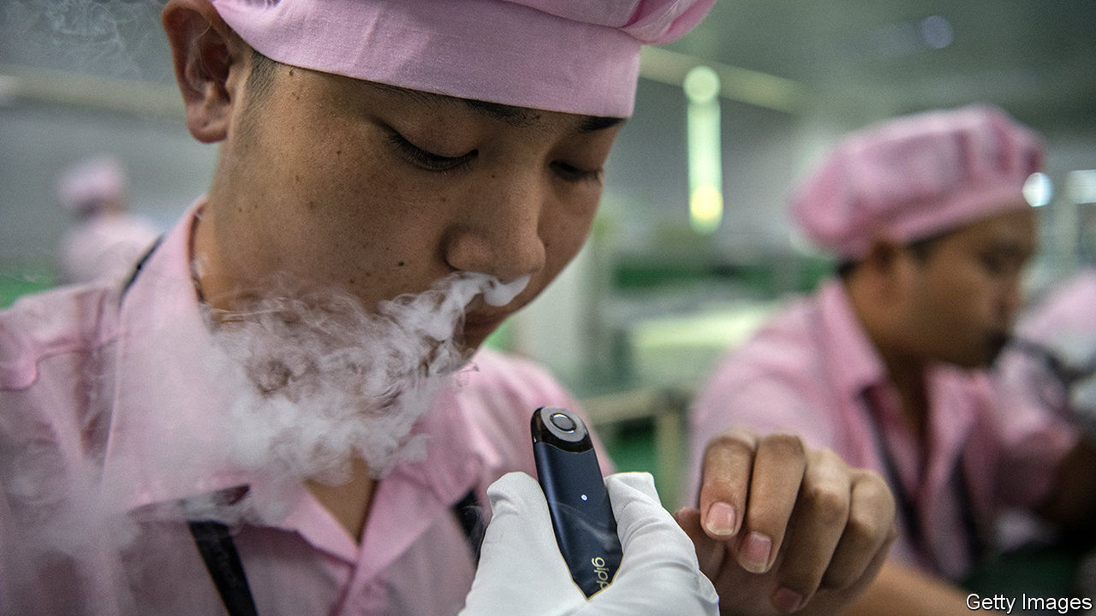

CHINESE LIKE to quip that the electronic cigarette is China’s fifth great invention, after paper, printing, gunpowder and the compass. A Chinese pharmacist hatched the idea in 2003 to wean smokers off tobacco. But it was in America, home to brands like Juul and Blu, that vaping first took off. Although one in four Chinese adults smoke tobacco, sales of e-cigarettes in China amounted to $2.7bn last year, a tenth of those in America, according to Frost and Sullivan, a consultancy.

Investors spy an opportunity. The market value of Smoore, China’s biggest e-cigarette maker, has nearly tripled since its initial public offering in Hong Kong on July 10th. It is now the world’s most valuable vape firm, worth around $24bn, more than the privately held Juul, most recently valued at $13bn. Smoore made a tidy pre-tax profit of 2.6bn yuan ($371m) in 2019, mainly from exporting components to foreign brands. It also hawks branded devices.

Investor optimism derives in large part from the prospect of rapid growth in China, where just 10m people were regular users of e-cigarettes at the end of last year. But dig a little deeper and the outlook darkens. A powerful state-owned cigarette monopoly, China Tobacco, will not cede ground to a rival product without a fight.

Regulators have already intervened on behalf of China Tobacco, which paid 1.2trn yuan in taxes last year, accounting for 6% of government revenues. In November the authorities banned online sales of e-cigarettes (ostensibly to prevent minors from buying them). Now they can be bought only at physical outlets like convenience stores and karaoke bars. In recent months editorials in state-owned newspapers have claimed (falsely) that vaping is more harmful than conventional cigarettes. A spokesman for the Electronic Cigarette Industry Committee of China, a trade body, blames the online ban for a wave of bankruptcies among smaller firms.

Bigger names like Smoore and RELX, both based in Shenzhen, face another problem. China Tobacco has already opened a lab in Shanghai to research e-cigarettes. If it concludes that vaping is here to stay, it too may get in on the action. It boasts a nationwide network of retail stores, and adding a new product to the mix would not be difficult. Cannibalising sales of ciggies may seem sensible if the alternative is losing millions of customers to rivals. ■

This article was downloaded by calibre from <https://www.economist.com/business/2020/07/23/a-state-tobacco-monopoly-looms-over-chinas-e-cigarette-makers>

|  |  |  |  |
| --- | --- | --- | --- |
| Previous | Articles | Sections | Next |

|  |  |  |  |
| --- | --- | --- | --- |
| Previous | Articles | Sections | Next |

#### Wakey, wakey

# Corporate dealmakers emerge from pandemic hibernation

Does a slew of mega-mergers mark the end of an M&A drought?

Jul 23rd 2020 | PARIS



Editor’s note: Some of our covid-19 coverage is free for readers of The Economist Today, our daily [newsletter](https://my.economist.com/user#newsletter). For more stories and our pandemic tracker, see our [hub](https://www.economist.com/news/2020/03/11/the-economists-coverage-of-the-coronavirus)

NOTHING EPITOMISES the animal spirits that drive capitalism as neatly as mega-mergers. As covid-19 spread, companies appeared to be practising the corporate version of social distancing: seldom since the aftermath of the global financial crisis of 2007-09 had takeover activity been so subdued. Now dealmakers are slowly emerging from lockdown.

A spate of deals this month suggests that bankers and lawyers specialising in mergers and acquisitions (M&A) may want to hold off booking summer holidays. On July 20th Chevron announced it would be paying $13bn for Noble Energy, a smaller oil-and-gas rival. A day later Adevinta, a Norwegian company, said it would extend its classified-ads empire by snapping up a unit of eBay worth $9.2bn. A week earlier Analog Devices agreed to pay $19.8bn for Maxim Integrated, another chipmaker.

That is quite a change from the first half of the year. A weak start to 2020 at first looked like a blip in an otherwise bullish M&A cycle going back to 2014 (see chart). By the time covid-19 reached Europe and America in March, the blip had turned into a slump. Barely $500bn-worth of deals were announced in the second quarter, compared with over $1trn a year earlier, according to Refinitiv, a data firm. Mega-deals over $5bn fell even more steeply.

At the height of the crisis, companies were reasonably preserving cash rather than looking for new ways to spend it. Uncertainty over the performance of potential targets made dealmaking risky. Complex M&A transactions—big ones can take more than a year to close—are tricky to pull off over Zoom. Regulators who clear them were also hobbled by the pandemic. Many planned deals fell apart. On March 31st Xerox ditched its $35bn hostile pursuit of HP, a bigger office-systems rival. Boeing shelved a putative acquisition of most of Embraer’s commercial-aviation unit in April, after its own prospects darkened as a result of the pandemic hit to air travel.

But the virus did not snuff out animal spirits entirely. T-Mobile and Sprint, two American mobile operators, merged as planned in April, calculating that the benefits of consolidation outweighed the risks. Just Eat and Grubhub announced a food-delivery tie-up in June. Aon’s planned $30bn purchase of Willis Towers Watson, a smaller insurance broker, is on.

It helped that some sellers discreetly agreed to offer buyers better terms. Lawyers have pored over documents to see whether a global pandemic is sufficient grounds to scupper a takeover, a point which judges will no doubt be required to opine on soon. On July 18th EssilorLuxottica, a Franco-Italian eyewear giant, sued GrandVision, a retailer it had agreed to take over a year ago, arguing it is not being given enough information on recent trading. GrandVision denies this is the case, but its shares are now trading below the price at which it had agreed to be bought out.

A second wave of covid-19 may upset the revival. So could rising protectionism, which hampers cross-border deals. But M&A bankers are bullish about the rest of the year. Firms whose profits have held up are likely to be first to return to dealmaking, says Eamon Brabazon of Bank of America. With good options for parking money scarce, lenders are happy to bankroll takeover bids by strong suitors. Private-equity funds can draw on a record $1.5trn of their investors’ money, according to Preqin, a data provider. They are hunting for bargains. Even grim economic conditions worldwide have a silver lining for the acquirers, if these force struggling targets into a sale whether they like it or not. ■

Editor’s note: Some of our covid-19 coverage is free for readers of The Economist Today, our daily [newsletter](https://my.economist.com/user#newsletter). For more stories and our pandemic tracker, see our [hub](https://www.economist.com/news/2020/03/11/the-economists-coverage-of-the-coronavirus)

This article was downloaded by calibre from <https://www.economist.com/business/2020/07/23/corporate-dealmakers-emerge-from-pandemic-hibernation>

|  |  |  |  |
| --- | --- | --- | --- |
| Previous | Articles | Sections | Next |

|  |  |  |  |
| --- | --- | --- | --- |
| Previous | Articles | Sections | Next |

#### Schumpeter

# MercadoLibre is a wannabe Alibaba

It promises a shake-up to both retail and finance in Latin America

Jul 22nd 2020 |

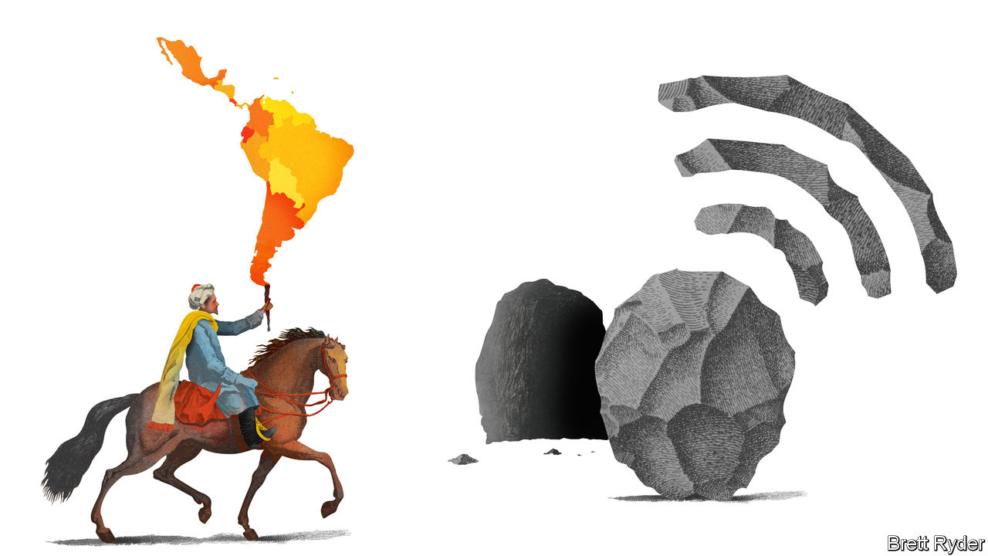

SINCE YOUR columnist first moved to a debt-ridden Latin America in the 1980s, he has seen many aspects of business in the region change for the better. Two have not. The first is the plethora of small businesses, from family-run corner shops and ice-cream parlours to hardware stores, that by and large are as scruffy as they were back then, eke out a meagre existence and remain stubbornly cash-only (even if cashiers still struggle to work out how much change you are due). The second is a visit to a bank, where, it sometimes seems, the only people who get what they need are those with a stocking over their head and an Uzi in their hands.

The two traits reinforce each other. Small businesses fail to modernise because they struggle to tap credit. Oligopolistic banks feel vindicated in not caring a hoot about firms stuck in the past. The resulting lack of dynamism among the small and medium-sized firms that account for more than 99% of enterprises in Latin America is a brake on economic activity. With covid-19 still wracking the region, the vulnerability has become worse. Total or partial lockdowns as well as fear of contagion and a deep recession have put many of the region’s smaller businesses in mortal danger.

Not all, though. To see why, look at MercadoLibre. The pan-Latin American e-commerce and fintech firm’s market value has doubled to $50bn during the pandemic as it has provided online sales and payments lifelines to such vulnerable companies. Since it was founded in 1999 by, among others, Marcos Galperin, an MBA graduate from Stanford University, it has become the region’s biggest tech darling, even though in 2020 revenues are projected to be just $3.2bn and it will lose money for a third year running. Profit, though, is for the future. Meanwhile, it is part of a wave of digital disruption that may propel smaller firms—which make up about 80% of those using its platforms—into the modern era.

Typically, MercadoLibre, which means “free market” in Spanish, has been compared to eBay, the American online marketplace that was an early investor. It is now worth more than its erstwhile mentor. It shares some characteristics with Amazon, with which it competes, especially in Mexico. For instance, like Amazon in its early days, it is prepared to forsake short-term profit for rapid growth. It has also been developing a logistics network. But unlike the American titan, it rarely trades on its own behalf; its e-commerce business earns a fee from transactions between buyers and sellers on its platform. In that way it resembles Alibaba, owner of China’s online emporiums. Its fintech arm, Mercado Pago, is loosely modelled on Alipay, Alibaba’s payments system. Plans announced on July 20th by Alipay’s owner, Ant Group, to issue shares that could value it at $200bn have MercadoLibre’s investors salivating over the prospect of a Latin American equivalent.

What attracts those investors most is the promise of a digital revolution in Latin America. It has been slow to get going. Last year less than 5% of retail sales in the region took place online, compared with 12% in America and 20% in China. Half of all Latin Americans lack a bank account. Fear of credit-card fraud has held back e-commerce, as have logistical nightmares in Brazil, where MercadoLibre generates more than half its revenues. Yet in a mixture of luck and good timing, the firm had invested in logistics just as e-commerce penetration surged into double digits amid the pandemic. Pedro Arnt, its finance chief, says Latin America’s move online has been “fast-forwarded” by three to five years in the past few months. That is true everywhere. But if first-time online shoppers in Latin America make it a habit, MercadoLibre has plenty to gain. According to Barclays, a bank, the value of merchandise traded on MercadoLibre averaged $30 per Latin American last year. The equivalent figure for Amazon in its core markets of America, Europe and Japan was $405.

The potential for payments may be even greater, though this business has had a bumpier ride in the pandemic. Beforehand, MercadoLibre was busily trying to bring offline merchants into its orbit by encouraging them to accept mobile payments via QR codes at bricks-and-mortar outlets. With the closure of restaurants and shops this initiative slowed. But QR adoption as a social-distancing measure may flourish as businesses reopen. Marvin Fong of BTIG, a broker, says a push by Latin American central banks to promote QR-style digital payments could galvanise fintech platforms in Latin America, such as Mercado Pago.

## The Amazon delta

Mr Arnt admits it would be foolish to savour these “once-in-a-generation” opportunities and ignore the competitive threats. The biggest is Amazon, against which his firm has waged a costly battle in Mexico. So far Amazon has paid more attention to e-commerce opportunities in India than in Central and South America, but that could change. The second threat is that covid-19 convinces big physical retailers of the urgency to build online networks. He calls this the “empire strikes back” scenario. The third is in payments, whether in the form of competition from regional fintech startups or from WhatsApp (linked, perhaps, with the e-commerce ambitions of Facebook, its owner). MercadoLibre executives must have breathed a sigh of relief last year when they received a $750m investment from PayPal, a potential rival, to help them expand their company’s digital payments.

But MercadoLibre also has some built-in advantages. Its e-commerce success has given it enough brand recognition to support a region-wide payments business. Its small and medium-sized business customers rely on it for e-commerce, payments and, increasingly, credit; that helps entrench their loyalty. And its Latin American heritage means it understands not just the countries’ commonalities, but also their differences. Locals say it is a collegiate company that the brightest people in the region want to work for—more so than Amazon. If it inspires them to create their own businesses to sell via its platform, so much the better.■

This article was downloaded by calibre from <https://www.economist.com/business/2020/07/22/mercadolibre-is-a-wannabe-alibaba>

|  |  |  |  |
| --- | --- | --- | --- |
| Previous | Articles | Sections | Next |

|  |  |  |
| --- | --- | --- |
| Business | Sections | Science & ... |

Finance & economics

Shadow banking: Putting the capital into capitalism

.

Metals: Shining brightly

.

Much Ant-icipated: Ant Group goes to market

.

Digital currencies: Bips and bytes

.

Buttonwood: Snake in the grass

.

Free exchange: Real-time danger

.

|  |  |  |
| --- | --- | --- |
| Business | Sections | Science & ... |

|  |  |  |  |
| --- | --- | --- | --- |
|  | Articles | Sections | Next |

#### Putting the capital into capitalism

# Banks lose out to capital markets when it comes to credit provision

That explains the Fed’s response to the latest economic crisis

Jul 25th 2020 | NEW YORK

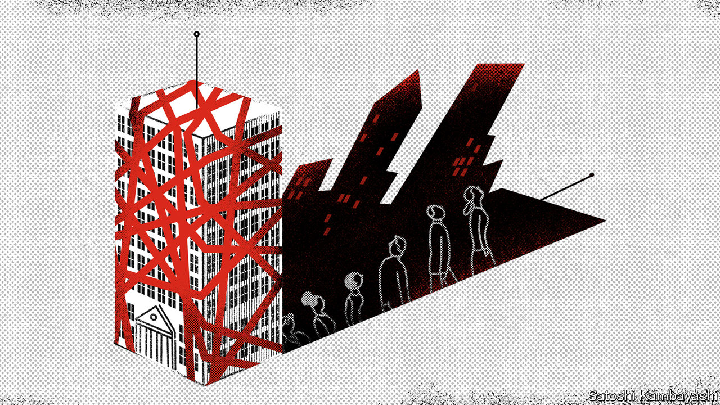

IN RENAISSANCE ITALY the first modern bankers realised that they could get away with keeping only some of the gold that was deposited with them on hand, and lending out the rest. In most countries banks have dominated lending to households and firms ever since. America has long been different, though. Yes, banks have played a big role in economic development: John Pierpont Morgan was the muscle behind the railways rolled out from coast to coast during the 1880s and a century later Citibank was helping America Inc expand abroad as globalisation took off. But capital markets have played a mighty role, too. Today that is truer than ever, which in turn helps explain the stunning scope of the Federal Reserve’s response to the latest economic crisis.

How banks are defined in America has changed over time. Between 1933 and 1999 commercial banks were legally required to be separated from investment banks, a quintet of which dominated America’s capital markets and were regulated differently. But all these firms had elements in common. They held only a fraction of their assets as reserves and they borrowed short-term to make long-term loans or hold long-term securities. That exposed them to runs. Economic history is littered with the tombstones of banks that were felled when markets for illiquid securities seized up, or depositors rushed to withdraw their funds.

Most of these crises inflicted severe economic pain, not least the subprime fiasco of 2007-09. After it the phrase “too big to fail” entered the modern lexicon—and the popular perception of leviathans pulling the strings of the world’s biggest economy took hold.

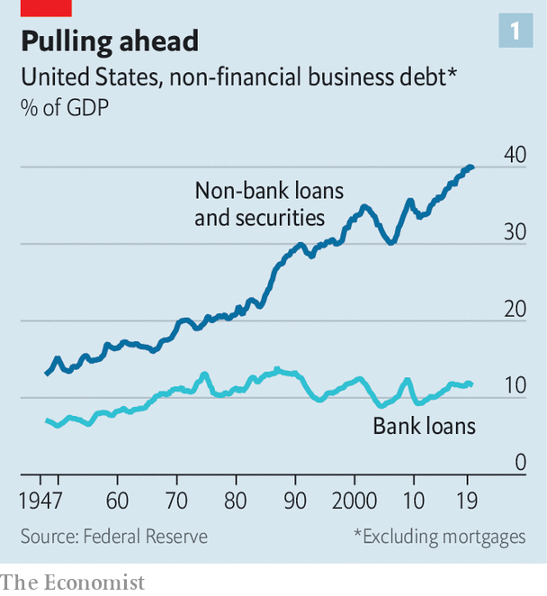

This portrait of utterly dominant and dangerous banks exaggerated their importance and today looks out of date. Banks have become safer—including the investment banks, most of which are now part of big banking conglomerates. And they are being upstaged by a new wave of innovation in capital markets that has changed securitisation and debt issuance and led to more direct lending by other financial firms. As a result banks’ corporate lending as a share of GDP, for example, has stagnated at about 12%, even as they have rebuilt their strength and America Inc has indulged in a borrowing boom (see chart 1).

Banks’ stagnation and their risk aversion has had consequences for how central banks respond to crises. In 2007-09 the Federal Reserve had to intervene in capital markets, but went to much greater lengths to prop up commercial and investment banks. Earlier this year, however, banks went relatively unscathed as capital markets seized up. Rather than acting as a lender of last resort to banks, the Fed became marketmaker of last resort, intervening in credit markets with a total size of about $23.5trn. The scale of the Fed’s intervention surpasses any other in its history.

You can trace the gradual rise of America’s capital markets to the 1940s and 1950s, when the pots of money raised by financiers such as mutual-fund managers began to swell. The 1980s brought about a rush of debt issuance, especially of junk bonds, by companies. And there was a boom in household debt winding up in capital markets—and therefore in the hands of investors—via the new financial technology of securitisation, or bundling loans into bonds and selling them. Eventually securitisation helped cause the crash of 2007-09.

The crisis showed that banks remained at the centre of the financial system, acting as dealers and speculators. Subsequent rule changes have nudged them from the limelight. Legislation, including the Dodd-Frank Act in America in 2010, and national and international regulation, such as the Basel framework, have together required banks to fund themselves with more capital, and encouraged them to take less risk. As a result, banks in America have nearly $2trn worth of core capital on their balance-sheets, almost double the amount they did in 2007. That is a meaty 12% of risk-adjusted assets. And crucially, banks’ assets are less troublesome. The risk weight that supervisors attach to them—a measure of how racy the underlying loans and securities are—has dropped from 70% to less than 60% (these figures adjust for changes in the regulators’ definition of risk over that time).

Many of these rules have been aimed at taming the investment-banking activities that sit inside huge firms such as Bank of America and JPMorgan Chase. As all types of banks have faced tighter regulation, the last two big standalone investment banks, Goldman Sachs and Morgan Stanley, have evolved to look like banking conglomerates, too. Both have spread into sedate areas that attract more deposits, such as wealth management and retail banking.

Regulation has blunted banks’ competitive advantage. The fact that they were vertically integrated—they tended to issue loans, monitor and collect those loans, and hold the associated risk on their balance-sheets—once gave them an edge over investors and funds seeking to profit from just one slice of a transaction. It made up for the fact that they were slow to embrace technology. But bankers now talk of their balance-sheets as a “scarce” resource.

As banks have grown risk-averse, non-banks, often tech-savvy, are stepping up. “When you regulate the banks and you leave the rest of the financial system more lightly regulated, there will be regulatory arbitrage,” says Richard Berner of New York University. “But technology has also facilitated a shift because, particularly in the past decade, it has promoted the growth of payments and of bank-like activities outside the banking system.”

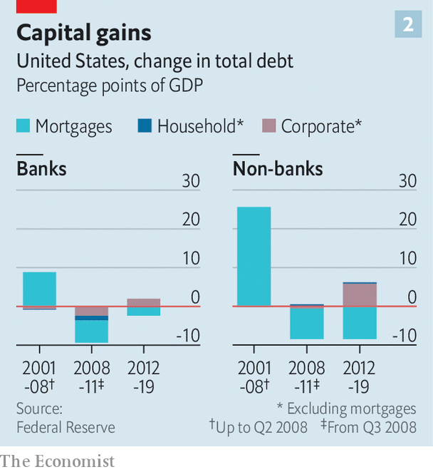

You can gauge this by looking at how the stock of lending by banks and non-banks has slowly changed. America has deleveraged since the financial crisis (see chart 2). That was almost wholly driven by the decline in mortgage debt, held by both banks and non-banks. Corporate debt, though, has reached an all-time high, and the bulk of activity has still been facilitated by shadow banks. Of the stock of debt that companies have added since 2012, that lent by banks has increased by just 2 percentage points of GDP. The stock that the non-bank sector holds has risen by 6 percentage points. Even though banks are now flush with capital and liquidity it is the capital markets that have financed the bulk of the increase in corporate debt.

A notable shift has taken place in the rest of the world, where capital markets have historically played a smaller role. Since the crisis these have expanded. In 2007 global non-bank financial assets stood at $100trn, equivalent to 172% of GDP and 46% of total financial assets, according to the Financial Stability Board (FSB), a grouping of regulators. Now these assets, at $183trn, constitute 212% of GDP, or 49% of the world’s financial assets.

What counts as a shadow bank? In America banks are now easy to define: they take retail deposits and are regulated by the Fed. They can park cash in accounts with the central bank, and borrow directly from it in times of stress. The term shadow banking, meanwhile, could apply to a range of financial institutions and activities. It includes long-established institutions like pension, insurance, private-equity and hedge funds, as well as newer ones, like exchange-traded fixed-income funds, which provide a vehicle for savers to deposit cash that is then invested in government and corporate bonds.

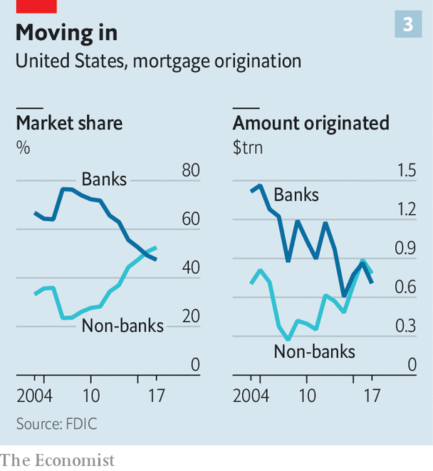

Separating the activities of the “real” banks from shadow firms is harder. Some non-banks, such as private-credit lending arms, make loans just as banks do. And just as they did before the financial crisis, banks issue shadow instruments that are allocated in capital markets, such as mortgage-backed securities or bundled corporate loans. Banks also lend to shadow banks. This has been one area where bank lending has grown relative to GDP, and it now makes up 5% of loan books.

## What we do in the shadows

Untangling these complex interlinkages is tricky. But to get an idea of how the financial landscape is changing in America, simply look across the range of typical bank activities, from the bread-and-butter work of lending to households and firms, to advisory services and market-making.

Start with mortgages. In 2007 almost 80% of mortgages were created by banks; a decade later, more than half were originated by non-banks. Big hitters include Quicken Loans, a Michigan-based online lender, and LoanDepot, a broker in California. Both were early to online-only mortgage lending and have invested heavily in slick websites and responsive call centres. Quicken, which is preparing to list on the stockmarket, became the largest originator of home loans in America in 2018.

Lending to mid-sized firms is also drawing in new types of institutions. The shift is mirrored by trends in the private-equity (PE) industry over the past decade or so. PE used to fund its takeover bids using bank loans or junk bonds. Most credit funds at PE shops were in their infancy before the 2007-09 crisis. Today at least a fifth of funds under management at five of the largest PE firms—Apollo, Ares, Blackstone, Carlyle and KKR—are invested in credit assets. At Apollo some $221bn of the $260bn the firm has raised since 2010 is for credit investment. The private-credit industry as a whole has amassed $812bn-worth of credit assets that it manages. To give a sense of scale, that is equivalent to 14% of outstanding corporate bonds.

Shadow banks are also muscling into businesses that used to be the sole preserve of the giant investment banks. That includes advisory services on mergers and acquisitions—where newish boutique firms like Evercore and Financial Technology Partners have blossomed alongside established names like Lazard—to even trading stocks and bonds. Banks were once the dominant traders of equities and fixed income. But market structure has evolved, says Paul Hamill of Citadel Securities, a broker-dealer set up by Ken Griffin, founder of Citadel, a hedge fund.

The firm is one of the largest equity traders in America. (When Slack, a corporate-messaging service, went public last year it listed directly via Citadel Securities.) Jane Street Capital, another non-bank trading firm, has also found success intermediating equity markets.

Citadel Securities has expanded into trading fixed income too, in part thanks to regulations that pushed securities like interest-rate swaps onto central clearing platforms, making competition easier. Mr Hamill says there are a few big institutions that conduct full-scale Treasury trading; all are large banks, except for Citadel Securities. The firm may apply to become a primary dealer—ie, an institution that can buy bonds from the government and trade directly with the Fed. This would make it the second non-bank to earn the privilege: Amherst Pierpont, a smaller broker-dealer, was designated a primary dealer in 2019.

That banks have a fight on their hands is clear. They are less profitable in a world where they must hold low-yielding safe assets and carry huge safety buffers. According to Michael Spellacy of Accenture, a consultancy, banks earn half of the roughly $1trn in annual revenues that all global firms make by intermediating capital markets. But of the $100bn in economic profits, which take into account the cost of capital and other expenses, they capture just 10%.

For borrowers and investors, the continuing clout of capital markets and the emergence of innovative new firms has meant more competition in the financial system. Prospective homebuyers can choose the lender that offers the best services. Mid-sized firms struggling to access bank loans can turn to a wealth of newly minted private-credit funds instead.

What does the shift mean for risk in the system? The role that banks play in maturity transformation means that they are always exposed to runs, jeopardising the provision of credit to businesses and households. Whether the evolution of the financial system is risky depends on how bank-like shadow banking is.

TheFSB has tried to identify the financial firms most susceptible to sudden, bank-like liquidity or solvency panics, and which pose a systemic risk to the economy. Pension funds and insurance firms are excluded as they match their long-term liabilities with long-term assets. Worldwide the exercise identified $51trn (or 59% of GDP) in “narrow” shadow investments, almost three-quarters of which are held in instruments “with features that make them susceptible to runs”. This slice has grown rapidly, from $28trn in 2010 (or 42% of GDP). At the end of 2018, America’s share of the risky bucket stood at $15.3trn. Its commercial banks, with assets of $15.6trn, were only just bigger.

The riskiest types of shadow banks, says the FSB, include fixed-income funds and money-market funds, which are large in America; companies that make loans and might be dependent on short-term funding, such as retail-mortgage or consumer-credit providers; broker-dealers, which trade securities; and entities that do securitisation-based credit intermediation, such as creating collateralised-loan obligations that bundle corporate loans which are then sold to investors. Tellingly, it was many of these markets that seized up in March and April.

With a growing number of capital-markets functions and a great deal of credit-provision to firms sitting outside the banking system, policymakers have once again found their customary tools do not work as well as they might like. In the financial crisis, both banks and non-banks were caught up in the panic. This time there has been no concern that banks might fail. Even in the worst case dreamt up by the Fed for this year’s stress tests, core capital ratios fell from an average of 12% across the 33 biggest banks in America to a still-chunky 9.9%.

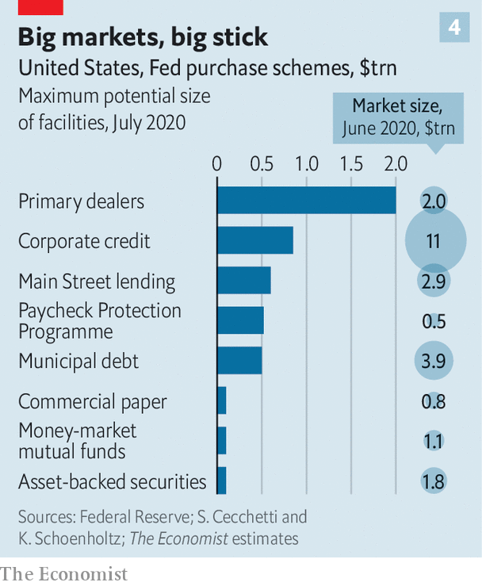

Rather than acting as a lender of last resort to the banking system, therefore, the Fed has been forced to act as a marketmaker of last resort. The crisis of 2007-09 was an audition for this role, with some experimental interventions. Now the Fed has intruded into a bewildering array of financial markets (see chart 4). It stepped in to calm the Treasury market, and to revive the corporate-bond market, which had ceased functioning, by promising to buy bonds. It has provided funding to the repo market—where Treasuries are swapped overnight for cash—as it did in September 2019, when the market sputtered. It is providing liquidity to money-market mutual funds, which take cash from individuals and park it in very short-term investments like Treasury bills, in the hope that investors can be paid promptly when exiting such funds. And it has bought up mortgage-backed securities—the ultimate output of retail-mortgage providers.

## The cold light of day

The Fed was able to soothe investors through the power of its announcements; it has so far lent only $100bn through its schemes. But Stephen Cecchetti and Kermit Schoenholtz, two scholars, have calculated the scale of each of the implicit guarantees. Adapting their figures, we estimate that the Fed has promised to lend, or to buy instruments, to the tune of more than $4trn in credit markets with a total outstanding value of $23.5trn. That is backed by a $215bn guarantee from the Treasury, potentially exposing the Fed to losses.

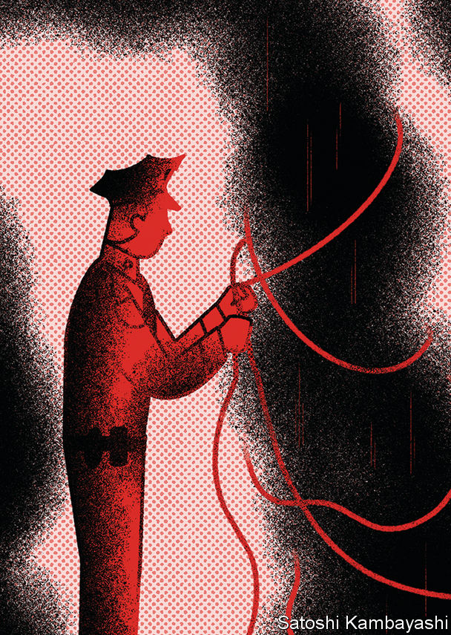

The sheer breadth of the intervention takes the Fed into new territory. As the Bank for International Settlements, a club of central bankers, noted in its recent annual report, the consequences of bailing out capital markets on such a scale could linger. “The broad and forceful provision of liquidity has stemmed market dysfunction, but it has also shored up asset prices across a wide risk spectrum. This could affect the future market pricing of risk.”

Banks’ stagnation may be no bad thing: credit provision has grown more competitive, and is probably becoming less reliant on a handful of large risky institutions. But when banks malfunction, regulators at least know where to look. When so much activity takes place in the shadows, they risk fumbling in the dark. ■

This article was downloaded by calibre from <https://www.economist.com/finance-and-economics/2020/07/25/banks-lose-out-to-capital-markets-when-it-comes-to-credit-provision>

|  |  |  |  |
| --- | --- | --- | --- |
|  | Articles | Sections | Next |

|  |  |  |  |
| --- | --- | --- | --- |
| Previous | Articles | Sections | Next |

#### Shining brightly

# Unusually, copper and gold prices are rising in tandem

An uncertain and uneven recovery explains their skyward leap

Jul 23rd 2020 | NEW YORK



THERE IS, SUPPOSEDLY, a neat choreography to copper and gold prices. When one rises, the other tends to fall. In an economic downturn, for instance, gold climbs as investors seek a haven. Copper prices dip as manufacturing and construction slow. But these are unusual times, and gold and copper are moving in unusual ways. Rather than continue their customary do-si-do, they are leaping upwards together.

The price of copper surpassed $6,000 a tonne in June, up about 30% since the depths of March. Gold this month topped $1,800 an ounce, approaching a record reached in 2011. Many analysts reckon it may exceed $2,000 this year or next. As the world continues to reel from covid-19, the economic outlook is uncertain and the recovery uneven from one country to the next. For those betting on gold and copper, this has proved a winning formula.

Gold started its recent climb from an already lofty perch. The ascent began at the end of 2018, as a trade war between America and China clouded the prospects for economic growth. Sinking interest rates in America lowered the yield on ten-yearinflation-indexed Treasury bonds, making gold shine brighter. From November 2018 to late 2019 the price of the yellow metal jumped by about 25%, to $1,515.

Now covid-19 is propelling gold to even more vertiginous heights. Investors are scrambling for security, fearing a prolonged downturn as the virus continues to ravage giant economies such as America and Brazil. Gold-backed exchange-traded funds attracted $40bn in the first half of the year, a record. The dollar has weakened, making it cheaper for holders of other currencies to buy gold. Rates remain low. Jerome Powell, the chairman of the Federal Reserve, said in June that he was not even “thinking about thinking about” raising them. China, hit first by the virus, is recovering first, too, offering further upside. It is gold’s biggest retail market, and more shopping there would lift prices higher.

Copper’s rise this year may be even more striking. Its price sank by more than a quarter from January to mid-March when covid-19 spread across China, which accounts for about half of the red metal’s consumption. Now, however, efforts to stimulate China’s economy are spurring investment. In June a tracker of sector-level demand for copper in China used by Citigroup, a bank, rose by 5.5% on the year, its biggest jump in over two years.

As China invests to recover from the pandemic, though, the Americas are still grappling with it, explains Jeff Currie of Goldman Sachs, a bank. Because copper production is concentrated in South America, that has constrained supply. Some mines in Peru, shut because of the virus, are only slowly resuming production, points out Susan Bates of Morgan Stanley, another bank. In Chile, where mines have been operating with reduced staff, the deferral of needed maintenance may restrict supply in the months to come. And miners may strike, further threatening output.

It is unclear how long copper prices can be sustained by investment in one place and infection in another. The metal’s traditional engine—strong global economic growth—is sputtering. Continued infections in America or a resurgence of the virus elsewhere could further depress demand for appliances, cars and other copper-dependent goods.

That said, on July 21st European leaders agreed to new stimulus; and demand for copper may rise as countries outside China invest in electric grids and solar farms veined with the metal. Gold’s rally may be even more persistent, argues Mr Currie, supported by factors that linger through the 2020s: high debt levels that weigh on the dollar, and low interest rates. The journey skyward may not be over yet. ■

This article was downloaded by calibre from <https://www.economist.com/finance-and-economics/2020/07/23/unusually-copper-and-gold-prices-are-rising-in-tandem>

|  |  |  |  |
| --- | --- | --- | --- |
| Previous | Articles | Sections | Next |

|  |  |  |  |
| --- | --- | --- | --- |
| Previous | Articles | Sections | Next |

#### Swarming to market

# Ant Group announces plans to list in Shanghai and Hong Kong

It becomes the latest in a trail of listings

Jul 23rd 2020 |



ON JULY 20TH Ant Group, the financial-services arm of Alibaba, an e-commerce giant, announced its plans to list on the star market, the Shanghai stockmarket’s technology-focused board, and in Hong Kong. The offering could be huge—the firm was valued at $150bn in 2018. Ant would become the latest in a trail of listings on both venues this year, where the number of ipos has rivalled those on America’s Nasdaq.■

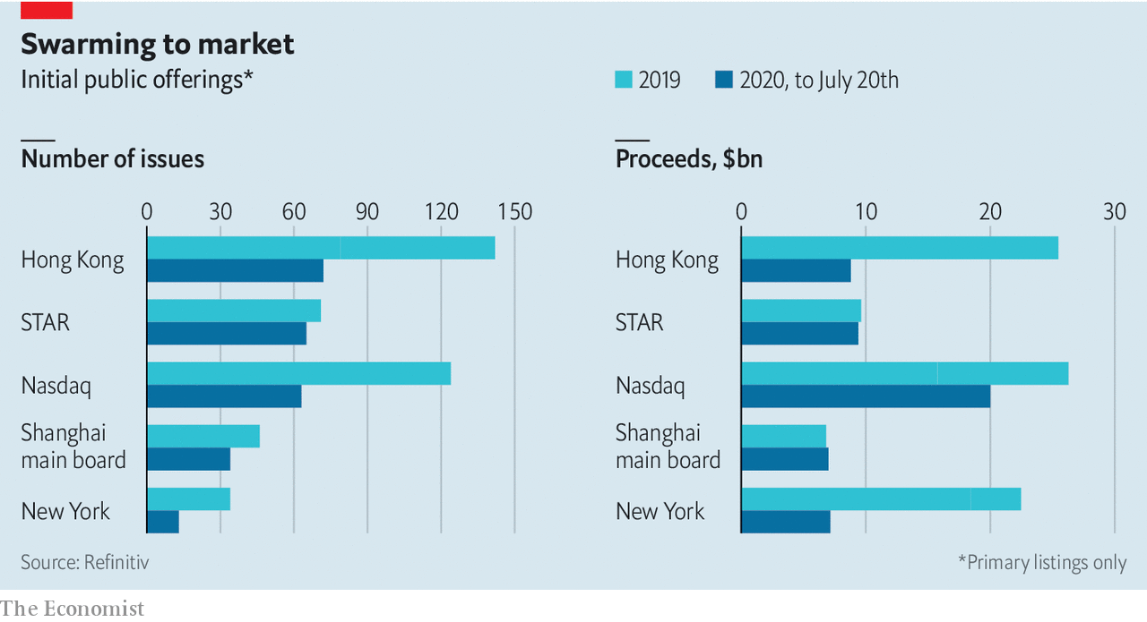

This article was downloaded by calibre from <https://www.economist.com/finance-and-economics/2020/07/23/ant-group-announces-plans-to-list-in-shanghai-and-hong-kong>

|  |  |  |  |
| --- | --- | --- | --- |
| Previous | Articles | Sections | Next |

|  |  |  |  |
| --- | --- | --- | --- |
| Previous | Articles | Sections | Next |

#### Bips and bytes

# A shift from paper to virtual cash will empower central banks

Officially issued digital currencies could help usher in negative interest rates

Jul 23rd 2020 | SHANGHAI



AMERICA’S FEDERAL RESERVE recognised the disruptive potential of electronic money long ago. “This is a service which it is expected will be more and more availed of as the ease and economy of using it are understood,” its New York arm declared in a report. The year was 1917, and the Fed had just started allowing banks to transfer funds by telegram free of any interest charge. More than a century on, central banks are grappling with another technological revolution: the rise of mobile payments and the turn away from cash.

Just as in the early 20th century, when central banks created telegraph transfer networks, they are now coming to the view that they must design their own digital-payment networks in order to retain control of their monetary systems. One idea gaining favour is to issue a so-called central-bank digital currency (CBDC), which would exist only as electrons on a computer chip, rather than a coin or bill. Roughly 80% of central banks are doing some kind of CBDC work, from research to trials, according to one survey. Although still early, it is a trend that could give rise to tantalising new possibilities for monetary policy.

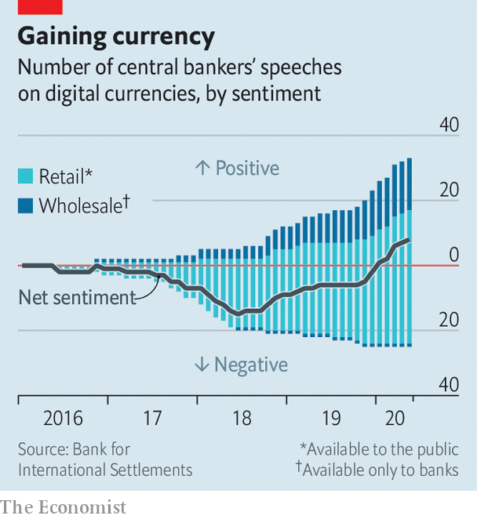

Most central bankers were sceptical about CBDCs at first, but in recent months their views have turned more positive, according to an analysis of their speeches by the Bank for International Settlements (BIS), a club of central banks (see chart). Partly, that is because they are now more familiar with the concept. China has already put the digital yuan into use on a limited test basis, and Sweden is close to that with the e-krona. The coronavirus pandemic has added to the urgency as more people shop online or pay with contactless cards or phones rather than cash.

The primary motivation for issuing a CBDC is likely to be defensive. The gradual demise of cash poses two basic risks. First, online-payment systems could fail, suffering outages or hacks. To safeguard the integrity of their currencies, central banks hope to offer fail-safe digital alternatives.

The second risk is that private-sector systems are too successful, with more people switching to payment platforms offered by big tech firms such as Facebook or Tencent. Many central banks began taking this risk more seriously when Facebook unveiled its plans for a digital currency in 2019. As Hyun Song Shin, head of research at the BIS, has put it, a shift towards such currencies would be like moving the economy from a town-square market—where all vendors happily accept cash—to competition between full-service department stores. Once popular enough, the department stores could stop you from shopping elsewhere and might also introduce new fees. Regulators could require private payment platforms to interconnect, but a well-designed CBDC would help ensure that this happens, by forming a digital bridge between different systems.

European central bankers are most exercised by the effects of a privately run digital currency on competition and the consumer interest. The Fed seems farther away from considering the idea, in part because Americans are keener on cash.

CBDCs also give central banks more control. They could allow for transactions to be easily tracked, perhaps making them more alluring to China’s authorities. In the West, where surveys show that the public cares more about privacy, CBDCs may need to ensure anonymity, without circumventing anti-money-laundering checks.

Where things get really interesting from a theoretical perspective are the implications for monetary policy. This is particularly the case if the new currencies are “retail” CBDCS, made available for use by the public. (A less exciting option would be to issue “wholesale” CBDCs exclusively to commercial banks, much as they already get funds from the central bank, albeit underpinned by whizzier technology.)

CBDCs may make it easier to implement negative interest rates. Unlike old-fashioned cash, digital fiat can be programmed. For now, rates cannot go too negative, because savers can always demand cash, which by definition offers an interest rate of zero. But if digital cash is programmed to have a negative interest rate, people would have fewer fallbacks and central banks more flexibility.

Central bankers might also be tempted by the potential for targeted interventions—much to the horror of those already worried about the clout of unelected monetary officials. Rather than lending to commercial banks, central banks would be able to top up individual currency accounts. During a downturn, they could transfer funds to those with low balances. After a natural disaster, they could direct support to affected areas. And they could offer consumption rebates depending on how and where the money is spent.

Yet these newfound powers would have drawbacks. For the CBDC to be a conduit for negative rates, countries would probably need to have eliminated cash, otherwise people could still opt for physical over virtual money. Moreover, if the CBDC does have a deeply negative interest rate, people might lose confidence in it. Savers could demand another currency or a different asset, such as gold. As for targeted interventions, there is a danger in programming too many special features into digital currencies. They would start to resemble securities with specific purposes, undermining the fungibility that has been a feature of money since the days of cowrie shells.

Central banks would also have to pay heed to new vulnerabilities. In the event of a panic, savers could convert their bank deposits into their CBDC accounts, adding to stresses on the financial system. Even without a panic, strong demand for CBDCs could chip away at banks’ deposit bases, making them more reliant on wholesale funding, which is often more costly and less stable. Some economists argue that limits on withdrawals and on issuance might help avoid some of these effects.

In any case, the policy ramifications are the stuff of monetary fiction for now. A more practical concern is whether central banks can succeed in building sturdy, easy-to-use CBDCs. The past few months have brought several examples of failures in public technology, from overwhelmed unemployment websites in America to an abandoned coronavirus-tracing app in Britain. No government wants to see its currency crash, even if only virtually. ■

This article was downloaded by calibre from <https://www.economist.com/finance-and-economics/2020/07/23/a-shift-from-paper-to-virtual-cash-will-empower-central-banks>

|  |  |  |  |
| --- | --- | --- | --- |
| Previous | Articles | Sections | Next |

|  |  |  |  |
| --- | --- | --- | --- |
| Previous | Articles | Sections | Next |

#### Buttonwood

# Chapter 11 is no longer a haven for deadbeat debtors

These days secured creditors are in control

Jul 23rd 2020 |

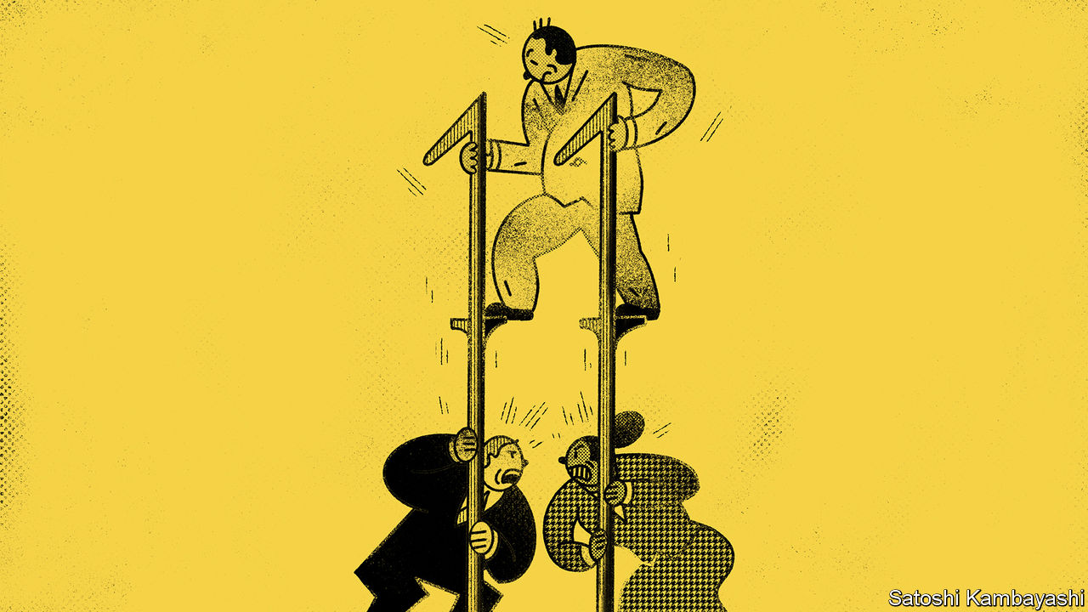

IN THE EARLY 1980s Houston lived through a real-estate frenzy. Then the oil price crashed. Humble Place, a 30-acre tract divided into land parcels, was one of many unfinished projects. The developer filed for Chapter 11 bankruptcy. By the start of the 1990s, his creditors were still unpaid. A court heard that his recovery plan amounted to “mowing the grass and waiting for the market to turn”.

Such cases shaped a particular view of Chapter 11, the bit of America’s bankruptcy code directed at preserving businesses rather than winding them up. It was widely seen as a way to enrich lawyers and a means for debtors to frustrate creditors endlessly. The growing caseload in the wake of the covid-19 recession is likely to give new life to critics of Chapter 11. There are serial users. NorthEast Gas Generation, of Texas, recently joined the “Chapter 33” club. It has filed three times in six years.

A perennial bugbear is that Chapter 11 keeps the debtor in possession of the business. If unpaid debts do not spell the sack for management, say critics, then where is its incentive to be prudent? Yet a system that leans towards keeping a firm alive helps preserve its value. Bankruptcy is no longer creditor versus debtor, if it ever was. It is—as it should be—a wrangle between creditors. And these days it is secured bondholders who appear to be in control of the process.

Why involve the courts at all? In the case of a single debtor and a single creditor, there is not much to adjudicate. A property firm owes $2m to a bank. It defaults. The bank seizes the assets. Case closed. Things become messier when there are lots of competing claims on a troubled company. There is then an incentive for creditors to rush to get their money out while they can, which can undermine the business and destroy value for other creditors. Bankruptcy allows for a stay on legal action while the parties sort out what happens to the business and decide who gets what.

The first goal of a bankruptcy process is to maximise the proceeds. For a business that is bleeding cash, the best option may be liquidation: selling off buildings, equipment, patents and other assets. But a lot of the value of an enterprise is tied up in intangible assets, such as the skills of its workforce or its relationships with suppliers and customers. So getting the most value often means selling the business as a going concern, or finding other ways for it to continue. The second goal is to preserve the priority of claims so that senior creditors are paid first and common-equity holders paid last. This is vital to the working of capital markets. Securities should be priced according to their risks.

A third goal may be ensuring that a firm’s managers pay a penalty for its going bankrupt. But that may clash with the first goal. Managers who know a business are probably best placed to preserve its value.

A big sticking point is working out just how much value is in the business. Take Broke N Hungry, a hypothetical casual-dining chain, which has filed for Chapter 11. It has two creditors, Narcissus Capital, which owns $100m of senior debt and CovLite Capital, which owns $100m of junior debt. The liquidation value of Broke N Hungry’s assets is $100m. But there is uncertainty about its value as a going concern. There is a 50-50 chance that a vaccine for covid-19 is found. If it is found, Broke N Hungry is worth $200m; if not, the business is worth $50m. The expected value of it is thus $125m. The right decision is to keep it going. But Narcissus will not see it that way. In a liquidation it is sure to get its money back. If the business carries on, it gains nothing extra if things go well and loses $50m if things go badly. So it will favour liquidation, denying CovLite the chance to get its money back.

Reality is trickier still. The uncertainty is greater and there are many different classes of debt. But today senior creditors seem to be getting the upper hand. Perhaps that is because more and more of them are savvy distressed-debt specialists, often from the world of private equity. They buy up the secured debt of troubled firms with the aim of becoming owners. They offer a financing package to tide the business over. And they make a bid to buy out other creditors.

Do the unsecured bondholders get a raw deal? “Put it this way”, deadpans a law professor, “everybody wants to be a senior secured creditor.” The power in Chapter 11 ebbs and flows. The shift might even be traced back to the Humble Place case. An appeals-court judge eventually ruled against the debtor. The case notes do not record whether a lawnmower was one of the seized assets.

This article was downloaded by calibre from <https://www.economist.com/finance-and-economics/2020/07/23/chapter-11-is-no-longer-a-haven-for-deadbeat-debtors>

|  |  |  |  |
| --- | --- | --- | --- |
| Previous | Articles | Sections | Next |

|  |  |  |  |
| --- | --- | --- | --- |
| Previous | Articles | Sections | Next |

#### Free exchange

# Why real-time economic data need to be treated with caution

The measures are not a proxy for overall economic activity

Jul 23rd 2020 |



THE GLOBAL downturn of 2020 is probably the most quantified on record. Economists, firms and statisticians seeking to gauge the depth of the collapse in economic activity and the pace of the recovery have seized upon a new dashboard of previously obscure indicators. Investors eagerly await the release of mobility statistics from tech companies such as Apple or Google, or restaurant-booking data from OpenTable, in a manner once reserved for official inflation and unemployment estimates. Central bankers pepper their speeches with novel barometers of consumer spending. Investment-bank analysts and journalists tout hot new measures of economic activity in the way that hipsters discuss the latest bands. Those who prefer to wait for official measures are regarded as being like fans of U2, a sanctimonious Irish rock group: stuck behind the curve as the rest of the world has moved on.

The main attraction of real-time data to policymakers and investors alike is timeliness. Whereas official, so-called hard data, such as inflation, employment or output measures, tend to be released with a lag of several weeks, or even months, real-time data, as the name suggests, can offer a window on today’s economic conditions. The depth of the downturns induced by covid-19 has put a premium on swift intelligence. The case for hard data has always been their quality, but this has suffered greatly during the pandemic. Compilers of official labour-market figures have struggled to account for furlough schemes and the like, and have plastered their releases with warnings about unusually high levels of uncertainty. Filling in statisticians’ forms has probably fallen to the bottom of firms’ to-do lists, reducing the accuracy of official output measures.

In some countries with dodgy official statistics, economists have no choice but to rely on alternative indicators (see [article](https://www.economist.com/middle-east-and-africa/2020/07/25/why-tanzanias-statistics-look-fishy)). In the rich world, though, official figures are still the benchmark for high-quality economic information. The methodologies used to construct them are, in the main, transparent and they have track records dating back decades, over the course of several economic cycles. The same cannot be said about many of the indicators that are currently in vogue.

Take, for example, the mobility data from Apple and Google that have drawn so much attention in financial markets. The tech firms should be commended for making the figures available so quickly, and at a level of granularity that allows for a detailed look at travel patterns. But the numbers need to be treated as what they are—a measure of mobility—and not a proxy for overall economic activity. They may reveal that more people are returning to workplaces, but not whether they were previously working from home or out of the labour force altogether. Nor can they show whether commuters are spending more or less on their coffees and sandwiches. Both Apple and Google present their figures relative to a pre-pandemic benchmark of travel in January. That made sense in February and March. Now, however, it could mislead. The latest mobility reports show that visits to non-food retail stores in some European countries are above those in January. But spending habits often have a seasonal pattern, which needs to be taken into account. Oxford Economics, a consultancy, cautions that consumer spending in Europe is usually 5-15% higher in July than in January.

You might think that figures on debit- and credit-card transactions provide a better estimate of household spending. In June Andy Haldane, the Bank of England’s chief economist, pointed to a bounce-back in one such measure as evidence that Britain’s recovery from the depths of lockdown was “so far, so V”. But even here the signal is blurred. With many businesses keen to avoid cash transactions to prevent the spread of infection, card spending may be inflated by a substitution away from physical money. Even in countries where contactless payment is common, cash was still more likely to be used in small-value transactions before the pandemic. Adjusting for this shift is especially tricky.

Real-time indicators with a narrower focus, such as measures of seated diners in restaurants or job vacancies posted on recruitment websites, probably provide an accurate gauge of activity in smaller pockets of the economy. But these are of limited use to policymakers trying to see the big picture. Part of the problem is that, as most of the data are collected by smartphones and consumer-facing websites, most real-time measures shine a light on consumers’ spending. But, though household spending is the single largest component of GDP, it is the smaller, more volatile components that tend to drive the business cycle. Companies’ capital spending is trickier to measure in real time than restaurant visits—but much more important to overall economic performance.

## No better than the real thing

The value of real-time measures will be tested once the swings in economic activity approach a more normal magnitude. Mobility figures for March and April did predict the scale of the collapse in GDP, but that could have been estimated just as easily by stepping outside and looking around (at least in the places where that sort of thing was allowed during lockdown). Forecasters in rich countries are more used to quibbling over whether economies will grow at an annual rate of 2% or 3% than whether output will shrink by 20% or 30% in a quarter. Real-time measures have disappointed before. Immediately after Britain’s vote to leave the European Union in 2016, for instance, the indicators then watched by economists pointed to a sharp slowdown. It never came.

Real-time data, when used with care, have been a helpful supplement to official measures so far this year. With any luck the best of the new indicators will help official statisticians improve the quality and timeliness of their own figures. But, much like U2, the official measures have been around for a long time thanks to their tried and tested formula—and they are likely to stick around for a long time to come. ■

This article was downloaded by calibre from <https://www.economist.com/finance-and-economics/2020/07/23/why-real-time-economic-data-need-to-be-treated-with-caution>

|  |  |  |  |
| --- | --- | --- | --- |
| Previous | Articles | Sections | Next |

|  |  |  |
| --- | --- | --- |
| Finance & economics | Sections | Books & arts |

Science & technology

Astrobiology: Life on Mars: the search continues

.

Covid-19: The bat signal

.

|  |  |  |
| --- | --- | --- |
| Finance & economics | Sections | Books & arts |

|  |  |  |  |
| --- | --- | --- | --- |
|  | Articles | Sections | Next |

#### Astrobiology

# Is there life on Mars?

A new generation of spacecraft may soon find out

Jul 21st 2020 |



AROUND 3.5BN years ago conditions on Earth and Mars were similar. Both had thick atmospheres and liquid water on their surfaces. Both, in other words, had the conditions required to sustain life. And on one of those planets life was, indeed, sustained. Precisely when biology began on Earth remains obscure. But by 3.5bn years ago, a billion years after the solar system formed, it was well established there and has since evolved into the lush abundance of complex forms seen today. Mars, meanwhile, became a freezing desert.

The question nevertheless remains: given that the conditions needed for life to emerge on Earth also seem to have pertained for a time on Mars, might life have evolved there, too? And, if it did, might it still survive in some form, even if only in vanishingly rare amounts?

To answer that question means visiting the place—if not with people then at least with robots. And now is a good time to do so, for Earth and Mars are aligned in a way that means the journey takes less than seven months. On July 20th, therefore, the first of a caravan of craft planning to take advantage of this alignment set off. That was when Al Amal, meaning “hope”, rose from Japan’s spaceport on Tanegashima, off the southern tip of Kyushu. Al Amal is an orbiter intended to study Mars’s weather, and also look at how the Martian atmosphere is leaking into space. Its lift-off adds the United Arab Emirates (UAE) to the list of countries that have dispatched probes towards extraterrestrial bodies.

Al Amal was followed, on July 23rd, by Tianwen-1 (“heavenly questions”), a Chinese mission consisting of an orbiter, a lander and a rover that took off from Wenchang Space Launch Centre, on Hainan. The lander’s provisional target is Utopia Planitia, a large impact basin where an American craft, Viking 2, touched down in 1976. Chinese officials have so far declined to release much detail about Tianwen-1’s scientific aims, but what is known of them suggests that it will study the distribution of ice on Mars and examine how the planet’s habitability has changed over time.

Lack of publicity has not been an issue for the third member of the flotilla. On July 30th NASA, America’s space agency, hopes to launch Perseverance, a one-tonne, six-wheeled rover, from the country’s principal spaceport at Cape Canaveral, in Florida. It will have cost $2.4bn to build and dispatch, and will absorb another $300m in operating costs during its mission. It will be the most sophisticated vehicle yet sent by America to the Martian surface.

## Once upon a time...

Perseverance is aimed at a 45km-wide crater called Jezero that was, 3.5bn years ago, home to a lake. The rover’s main goal is to look for signs of ancient life. But it is also the opening gambit in a decade-long plan to bring Martian rocks to Earth. Jezero itself sits on the inner rim of Isidis Planitia, another large impact basin, which was excavated 3.9bn years ago. One source of the water which formed the lake that once lay within it seems to have been a river leading to a well-preserved delta. The layers of sediment in this feature (colour-coded in the picture on the previous page according to their mineral composition) are prime targets in the search for Martian biology.

On Earth, some of the oldest evidence for life comes in the form of stromatolites. These stratified structures form in shallow water when colonies of microbes grow layer upon layer, trapping sediment as they do so. The most ancient examples are thought to be those found in Greenland in 2016, which have been dated to 3.7bn years before the present day. If there was sufficient time for stromatolite-forming organisms to evolve on Earth by this date then there is no obvious reason why they might not also have evolved on Mars.

Spotting stromatolite-like layers in rocks will not, though, be enough on its own. Researchers will also need to consider the textures of the rocks concerned and the distribution within them of potentially telltale minerals and organic molecules. Confusingly, in chemistry-speak, an organic molecule is not necessarily of biological origin. The term just means that it is built around carbon atoms, so organic molecules can also originate inorganically, as it were. The biological nature of an organic molecule has thus to be justified by other evidence. As Kathryn Stack Morgan, a geologist who is the Perseverance mission’s deputy project scientist, observes, “This is exactly the type of thing that we do here on Earth to make a case for biosignatures in our own rock record, and for the very first time using our instruments we can do that on the surface of Mars.”

## Rocks and hard places

Perseverance carries two instruments in particular that are intended to examine the surfaces of rocks which the rover encounters. Both will look for pertinent minerals and organic molecules. SHERLOC, situated at the end of the rover’s robotic arm, will shine a laser onto tiny grains in rocks it comes across. By analysing the spectrum of the light that is scattered back, this instrument will be able to identify molecules in the grains under scrutiny. WATSON, a camera, will then take close-ups of rocks that SHERLOC deems worthy of further study.

Mapping SHERLOC’s chemical analyses onto WATSON’s high-resolution images will show how different mineral layers are arranged and textured. That will be a big improvement over the instruments on board NASA’s current operational Mars rover, Curiosity, which arrived in 2012. These are capable only of grinding up rocks to work out whether or not organic molecules are present in the bulk material. If there are stromatolites (or even fossils of more complex creatures) Perseverance will be able to see them, both chemically and optically.

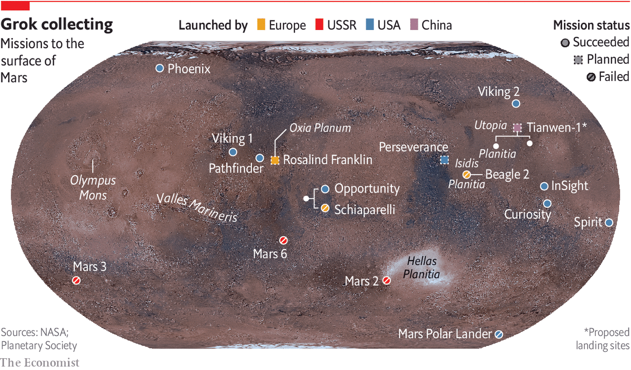

As did Curiosity, Perseverance will rely on an autopilot to guide it through the atmosphere to the planet’s surface, after arriving at a velocity, relative to its target, of 19,500km per hour. “We refer to it as the seven minutes of terror,” says Matt Wallace, an engineer who is the mission’s deputy project manager. The rover’s autonomy will then carry over to its everyday operations. Because of the time it takes radio waves to travel from Earth to Mars, Perseverance will receive instructions only once a day. On the ground on Mars it will need to find and avoid awkwardly placed rocks, and also more serious hazards, such as cliffs, by processing, in real time, pictures coming from its 23 cameras. This autonomy, NASA is confident, will permit the new rover to cross the Martian surface routinely and safely at a speed of around 150 metres per hour, double that at which Curiosity is usually allowed to travel.

As well as eyes, Perseverance has ears. A pair of microphones on board will permit people to hear the winds of Mars for the first time. They will also be able listen to the whirr of the rover’s gears, the crunch of its wheels as it moves across the regolith (the crushed rock that passes for soil on Mars) and the percussive sounds of the drill at the end of its arm as it chips out samples of rocks to study.

Not all of those samples will be discarded after investigation. Some will be packed for eventual dispatch to Earth by a project called the Mars Sample Return mission. This is a collaboration between NASA and the European Space Agency, ESA, that involves launching five separate spacecraft over the course of a decade. Perseverance is the first, and its collaboration-related job is to seal samples of Martian rock that its operators think worthy of further investigation into one of around 30 titanium tubes which it carries. As the illustration overleaf presages, it will leave these on the surface to be picked up by an ESA-designed “fetch rover” that could arrive as early as 2028. Once collected, the tubes will be brought back to Earth by a system of relay craft, and their contents analysed.

Perhaps most intriguingly of all, Perseverance will also carry a 1.8kg helicopter, called Ingenuity. If this manages to fly in Mars’s thin atmosphere (which has about 1% of the density of Earth’s at the surface), it will represent the first controlled flight, beyond the landing and lift-off of a spacecraft, to take place on another heavenly body. And if that happens, it will pave the way for more sophisticated drones on future missions to act as scouts.

## Every contact leaves a trace

The life-seeking instruments on Perseverance are more advanced than anything that has come before them, but this was not the original plan for the next phase, after Curiosity, of NASA’s attempt to find life on Mars. In February 2012, while Curiosity was still making its way there, Barack Obama’s administration slashed NASA’s planet-exploration budget by a fifth. At the time, American scientists had been developing a programme called ExoMars, in collaboration with ESA. This was to involve an orbiter and several rovers being launched from 2016 onwards, with a combination of tools intended to look for signs of life.

Mr Obama’s cuts killed American involvement in ExoMars and, by the time Curiosity reached Mars in August 2012, NASA had no plans to send any future rovers. The overwhelmingly positive public reaction to Curiosity’s nail-biting landing, however, helped persuade the agency’s chiefs to reconsider their priorities and put together a scaled-back version of previous plans that required no increase in the budget. The result, the mission now known as Perseverance, was announced a few months later.

Meanwhile, ESA had kept its part of the ExoMars programme alive, turning to Russia for help with launching and hardware. In 2016 the agency delivered the first part of the programme, the Trace Gas Orbiter. Its goal is to measure the precise concentrations in Mars’s atmosphere of substances, including methane, water vapour, nitrogen oxides and acetylene, that each form less than 1% of the atmosphere’s total volume but which might be signs of biology.

Methane is of particular interest since its presence varies with both time and location on the planet’s surface. Methane does not live long in the Martian atmosphere, suggesting there is an active source of the gas. On Earth, living things emit methane as they digest nutrients. But purely geological processes can also liberate the stuff.

The next step in ESA’s ExoMars programme is a rover, called Rosalind Franklin. This was also scheduled for launch in the current window. However, a combination of technical delays and the effect of covid-19, which has meant the team of engineers involved could not easily travel to complete the manufacture and testing of the rover, has pushed the lift-off date back to the next favourable alignment, in 2022.

When Rosalind Franklin eventually does arrive on Mars (2023, if this timetable is adhered to), the craft will crawl over an area called Oxia Planum. This has clays that date back around 4bn years, which will make it the oldest site yet explored on Mars. Since clay minerals require water to form, there are high hopes that Oxia Planum may once have been a life-friendly region.

Rosalind Franklin’s scientific payload will be capable of much more sophisticated analyses than Perseverance’s. In particular, the Mars Organic Molecule Analyser (MOMA) will be able to extract organic molecules from rocks and regolith more effectively than before.

Previous attempts to study organic molecules on Mars have been plagued by the presence of chemicals called perchlorates. These were first seen in 2008, by NASA’s Phoenix lander, and were confirmed by Curiosity half a decade later. Those missions baked their Martian samples in ovens, to release the organics. That also released chlorine and oxygen from the perchlorates, and these oxidised most of the organic molecules present. MOMA will circumvent this problem by using an ultraviolet laser that will knock organic molecules off rock samples so fast that any perchlorates present will not have time to decompose.

Rosalind Franklin’s most important tool, however, will be a drill that can collect samples from two metres below the surface. This is crucial for recovering material in which organic molecules can be found in a good state of preservation. The thin Martian atmosphere is easily penetrated by ionising radiation from space. This slams into the surface and even travels a little way beneath it. As Jorge Vago, ExoMars’s lead scientist, observes, “Over many millions of years, this ionising radiation acts like gazillion little knives slowly cutting away the functional groups of the organic molecules you would like to hopefully discover.” Use a drill to go deep enough, though, and material it collects will have been protected from radiation by several metres of rock. ESA’s modelling suggests that samples from 1.5 metres down would be scientifically interesting. The deepest any mission has so far sampled under the surface of Mars is a few centimetres.



Stony ground or bountiful regolith?

The jackpot of this treasure hunt would be to find things like sugars, phospholipids (constituents of the membranes of cells), nucleotides (the “letters” of genetic material) or amino acids (the building blocks of proteins) that are characteristic of life on Earth. But consolation prizes might be available in the form of less direct signals of biology within the chemistry—traces of the actions of enzymes, for example. As Dr Vago observes, the way fatty acids are synthesised biologically on Earth means that they usually have an even number of carbon atoms, although there is nothing in their underlying chemistry which favours that in abiotic syntheses. Finding a pattern like this, or something equally chemically striking, in Martian organic molecules would be encouraging to those who hope that Mars has or once had life.

## Many hands

The UAE’s launch of Al Amal shows how even a small country can join the space race if it is determined enough. No one, however, expects it to become a serious space power. China, though, with half a dozen visits to the Moon under its belt, already is one. Nor is Tianwen-1 the first Chinese attempt to join the Mars club. In 2011 a craft called Yinghuo-1 (“firefly”) attempted to hitch a ride with Phobos-Grunt, a Russian probe. Unfortunately, the rocket intended to propel the combined mission on its way malfunctioned, and it never left Earth orbit. This time, China is going it alone.

One thing which is known is that the mission will host around a dozen scientific instruments, including cameras, chemistry sets, magnetometers and radars. Officials from the China National Space Administration say the plan is to make detailed surveys of the surface. A ground-penetrating radar, for example, will measure the thickness and composition of layers within the regolith and identify any ice within 100 metres of the surface.

It will be a sophisticated spacecraft, if details revealed about the landing system are accurate. Zhang Rongqiao, the chief designer, told Chinese television-viewers in 2019 that the lander would separate from the craft’s main body at an altitude of 70 metres and hover until it found a safe landing spot. Cameras and laser scanners will help this lander avoid obstacles as it makes its way to the surface.

Tianwen-1’s lander does not look capable, from its instrument list, of quite the sorts of sophisticated biology-detecting activity planned for Perseverance and, after it, Rosalind Franklin. But even if that is the case, those other two vehicles, combined with the forthcoming ESA and NASA Mars sample-return mission, do now offer a realistic possibility of answering the question of whether there is, or was, life anywhere other than on Earth. A failure to find it would be a disappointment, although the search would no doubt go on, both on Mars and elsewhere. But an answer in the affirmative, even were that life only bacterial and extinct, would surely transform humanity’s view of itself as profoundly as did the discoveries of Nicolaus Copernicus and Charles Darwin.■

This article was downloaded by calibre from <https://www.economist.com/science-and-technology/2020/07/21/is-there-life-on-mars>

|  |  |  |  |
| --- | --- | --- | --- |
|  | Articles | Sections | Next |

|  |  |  |  |
| --- | --- | --- | --- |
| Previous | Articles | Sections | Next |

#### Bat signal

# The hunt for the origins of SARS-CoV-2 will look beyond China

The virus may have been born in South-East Asia

Jul 22nd 2020 |



Editor’s note: Some of our covid-19 coverage is free for readers of The Economist Today, our daily [newsletter](https://my.economist.com/user#newsletter). For more stories and our pandemic tracker, see our [hub](https://www.economist.com/news/2020/03/11/the-economists-coverage-of-the-coronavirus)

ONE OF THE great questions of the past six months is where SARS-CoV-2, the virus that causes covid-19, came from. It is thought the answer involves bats, because they harbour a variety of SARS-like viruses. Yunnan, one of China’s southernmost provinces, has drawn the attention of virus hunters, as the closest-known relatives of SARS-CoV-2 are found there. But some think the origins of the virus are not to be found in China at all, but rather just across the border in Myanmar, Laos or Vietnam.

This is the hunch of Peter Daszak, head of EcoHealth Alliance, an organisation which researches animals that harbour diseases that move into people. Since the outbreak, in 2003, of the original SARS (now known as SARS-CoV), scientists have paid close attention to coronaviruses. Dr Daszak says that around 16,000 bats have been sampled and around 100 new SARS-like viruses discovered. In particular, some bats found in China are now known to harbour coronaviruses that seem pre-adapted to infect people. The chiropteran hosts of these viruses have versions of a protein called ACE2 that closely resemble the equivalent in people. This molecule is used by SARS-like viruses as a point of entry into a cell.

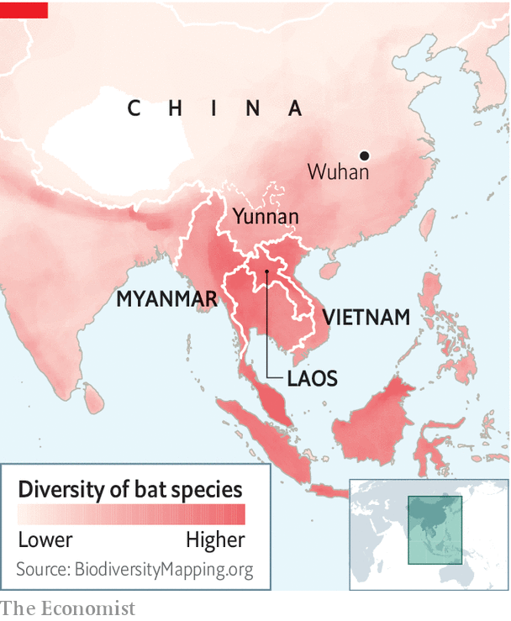

That such virological diversity has so far been found only in China is because few people have looked at bats in countries on the other side of the border. Yet these places are likely to be an evolutionary hotspot for coronaviruses—one that mirrors bat diversity (see map). The horseshoe bats in Yunnan which harbour close relatives of SARS-CoV-2 are found across the region. Other countries are thus likely to have bats with similar viral building blocks. Dr Daszak believes it is “quite likely that bats in Myanmar, Laos and Vietnam carry similar SARS-related coronaviruses, maybe a huge diversity of them, and that some of them could be close to SARS-CoV-2”.

None of this, though, explains how a virus whose ancestor may be found in South-East Asian bats went on to start a pandemic from central China. China’s government has agreed that a mission led by the World Health Organisation (WHO) can visit later this year to help answer this question. There is particular interest in how much sampling has been conducted to look for the missing link in places like the wildlife market in Wuhan (the first known centre of the outbreak) and more generally in farmers, traders and possible intermediate or host species.

Jeremy Farrar, the head of the Wellcome Trust, a large medical-research charity, and a former professor of tropical medicine, says his guess is that either SARS-CoV-2 or something similar to it has been circulating in people in parts of South-East Asia and southern China, probably for many years, and that intermediate hosts have not yet been identified. Dr Farrar spent 18 years working in Vietnam as the head of an Oxford University research unit. He says people go searching for bats for food and sell them in markets in what is a sophisticated trade that can end up in big cities like Wuhan. Bats are able to carry a huge diversity of viruses without getting sick, and are also more mobile than people realise. As he puts it, bats “congregate in huge colonies, and poo everywhere. And then other mammals live off that poo and then act as a mixing vessel for these sorts of viruses.”

Support for the idea that something resembling SARS-CoV-2 might have been circulating in the region before the pandemic began also comes from another intriguing observation: the low incidence of covid-19 in South-East Asia, particularly in Vietnam. John Bell, a professor of medicine at the University of Oxford, says everyone thought there would be a flood of cases in Vietnam because the country is right across the border from China. Yet Vietnam has reported only 300 in a population of 100m, and no deaths. The country did not have a great lockdown either, he adds. Nobody could work out what was going on.

One explanation, he suggests, is that Vietnam’s population is not as immunologically “naive” as has been assumed. The circulation of other SARS-like viruses could have conferred a generalised immunity to such pathogens. So, if a new one emerged in the region, it was able to take hold in the human population only when it travelled all the way to central China—where people did not have this natural resistance.

This would tie in with the idea that infection with one coronavirus can provide protection against others, and that even in countries away from the evolutionary cauldron of South-East Asia part of the population may have some protection against the current pandemic. In particular, there are suggestions that protection might be conferred mainly via part of the immune system called T-cells (which work by killing virus-infected cells) rather than via antibodies (which work by gumming up pathogens). If that is the case, then serological studies which look at antibodies may be underestimating natural immunity.

Sunetra Gupta, an epidemiologist at Oxford, argues that natural immunity to covid-19 is conferred by infections with seasonal coronaviruses. If correct, this has implications for the level of vaccination needed to reach herd immunity. It is widely assumed that over 50% of people need to be vaccinated to prevent a resurgence of SARS-CoV-2. In a preprint released on July 15th Dr Gupta says this figure could be much lower if a significant part of the population is already resistant to infection.

As for the mystery of the origin of covid-19, more answers will come when the WHO mission takes place, perhaps in August. The critical steps that led a South-East Asian bat virus to start a pandemic could have happened inside or outside of China—whether in wild-animal markets or farms, or in traders or hunters. The virus may have jumped directly from bats into people, or come via an intermediate species. The story is waiting to be told. ■

Editor’s note: Some of our covid-19 coverage is free for readers of The Economist Today, our daily [newsletter](https://my.economist.com/user#newsletter). For more stories and our pandemic tracker, see our [hub](https://www.economist.com/news/2020/03/11/the-economists-coverage-of-the-coronavirus)

This article was downloaded by calibre from <https://www.economist.com/science-and-technology/2020/07/22/the-hunt-for-the-origins-of-sars-cov-2-will-look-beyond-china>

|  |  |  |  |
| --- | --- | --- | --- |
| Previous | Articles | Sections | Next |

|  |  |  |
| --- | --- | --- |
| Science & ... | Sections | Economic & ... |

Books & arts

Inside Tibet: Fear and loathing on the plateau

.

Bullfighting: The cape and the masks

.

Rock’n’roll fiction: The band played on

.

Home Entertainment: There’s always a catch

.

Johnson: The shadowland

.

|  |  |  |
| --- | --- | --- |
| Science & ... | Sections | Economic & ... |

|  |  |  |  |
| --- | --- | --- | --- |
|  | Articles | Sections | Next |

#### Inside Tibet

# Two books penetrate the mystery and evoke the tragedy of Tibet

Barbara Demick and Benno Weiner lift the veil on China’s remote, turbulent fringe

Jul 23rd 2020 |



Eat the Buddha: Life and Death in a Tibetan Town. By Barbara Demick. Random House; 352 pages; $28. Granta; £18.99.

The Chinese Revolution on the Tibetan Frontier. By Benno Weiner. Cornell University Press; 312 pages; $45 and £37.

IF ALL CHINA’S Tibetan-inhabited territory were combined into a single country, it would be among the dozen or so largest in the world by land area, albeit with a population about the size of tiny Hong Kong’s. So vast is the Tibetan plateau that a plane flying directly from Lhasa, its cultural capital, to Beijing about 2,500km away completes nearly half of its journey before leaving the airspace above the Tibetan-populated zone.

This scale matters. It is challenging enough to understand the lives of Tibetans, given that more than half of the area they inhabit forms the Tibet Autonomous Region (TAR), to which China rarely admits foreign journalists. Then there is the tyranny of distance—the difficulty of reaching scattered Tibetan communities across the plateau’s high-altitude grasslands. The parts outside the TAR are administered by four other provinces, which do admit journalists. But a long journey can reach a fruitless end at police roadblocks erected near trouble spots. That hypothetical Tibetan country would be by far the least accessible of the world’s giants.

Barbara Demick, a former Beijing correspondent of the Los Angeles Times, has therefore achieved something remarkable with her portrait of a small Tibetan town, Ngaba (also called Aba), in Sichuan province. It is close to the edge of the plateau, near that halfway point along the plane’s flight path. Yet its proximity to China’s ethnic-Han interior does not make it anyeasier to visit than Lhasa.

The authorities see to that—because, ever since an explosion of unrest across the plateau in 2008, Ngaba has been a centre of Tibetan discontent. It was the scene of some of the most violent action by Chinese security forces that year. In “Eat the Buddha”, Ms Demick says dozens of protesters in Ngaba were shot dead. Of more than 150 Tibetans who have since set themselves on fire in protest against Chinese rule, about one-third have come from Ngaba or its surroundings.

Ms Demick managed to make three visits to Ngaba, using a floppy hat and face mask to obscure her features (this was before covid-19, when masks were worn to protect against pollution). Her investigations of the lives of selected residents were aided by interviews in less-restricted parts of the plateau and among Tibetan exiles. The resulting account is gripping.

Ngaba (pictured) is a little-known town that got its first traffic light in 2013. Ms Demick illuminates it as no other writer has. Through her subjects’ eyes, she describes its turbulent development from the early days of the Communist Party’s control of the plateau in the 1950s to the unrest of 2008 and its horrific aftermath as Chinese forces tried to crush all opposition.

For weeks after that upheaval, the authorities blockaded Kirti monastery, the town’s religious centre, in what appeared to be an attempt to starve the 3,000 monks inside into submission. Eventually they moved in, arrested 600 of them and locked them into spaces so crowded that nobody could sit or lie down. The monks had to urinate and defecate where they stood, Ms Demick recounts. They were forced to make statements, sometimes on camera, disavowing support for the Dalai Lama, Tibet’s exiled spiritual leader. Even now, Ms Demick says, “The level of fear among Tibetans is comparable to what I’ve seen in North Korea.” (An earlier book of hers explored horrors there.)

It is striking that an area of Tibet so close to the relatively prosperous ethnic-Han hinterland should be so seething with resentment of Chinese rule. If there has been any spillover effect of that wealth, it clearly has not helped win over Tibetans there. A Tibetan construction worker in Ngaba tells Ms Demick that most of the businesses and shops are these days owned by Han Chinese.

## When history rhymes

In “The Chinese Revolution on the Tibetan Frontier”, Benno Weiner, an academic, focuses on the early phase of the party’s efforts to integrate another bit of the Tibetan fringe into the Communist state. His work draws on official archives from Zeku, a county in Qinghai province. It is a drier account than Ms Demick’s, but provides valuable detail on how the party tackled the problem of establishing control in an area culturally, linguistically, economically and politically so different from the interior.

Again, proximity to the Han hinterland did not appear to help. In the 1950s that part of the plateau was in revolt before an uprising in distant Lhasa that resulted in the Dalai Lama’s flight to India. Many thousands of Tibetans in Qinghai were killed during the suppression of the rebellion there in 1958. That violence “has not been forgotten” in the region, Mr Weiner writes.

The confrontations of the late 1950s followed a period during which Tibetans had been allowed to maintain their pre-Communist way of life, with the old elites largely still in place. It was when the party lost patience and began to treat those elites as class enemies and collectivise agriculture that widespread unrest erupted. Readers of Mr Weiner’s book might reflect on how aspects of his story are now being repeated in Hong Kong. Another place on China’s fringe is discovering what happens when the party loses patience with a pre-Communist order that it once tolerated.

At least in Hong Kong the world is watching. By contrast, seldom is the veil lifted from Tibet—which makes Ms Demick’s and Mr Weiner’s chronicles all the more worth reading. ■

This article was downloaded by calibre from <https://www.economist.com/books-and-arts/2020/07/23/two-books-penetrate-the-mystery-and-evoke-the-tragedy-of-tibet>

|  |  |  |  |
| --- | --- | --- | --- |
|  | Articles | Sections | Next |

|  |  |  |  |
| --- | --- | --- | --- |
| Previous | Articles | Sections | Next |

#### The cape and the masks

# Bullfighting in the era of covid-19

Gore and pageantry on the sand, social distancing in the stands

Jul 22nd 2020 | ÁVILA



Editor’s note: Some of our covid-19 coverage is free for readers of The Economist Today, our daily [newsletter](https://my.economist.com/user#newsletter). For more stories and our pandemic tracker, see our [hub](https://www.economist.com/news/2020/03/11/the-economists-coverage-of-the-coronavirus)

IN HIS STRIKING lime-green costume, Octavio Chacón, a journeyman matador, enticed a bull to charge around him, alternately drawing it forward by the left horn and the right. Several beasts showed remarkable strength to shrug off mounted picadors, remaining on their feet and winning applause even as death in the sand approached. Meanwhile in the stands, security teams ensured that a distance of one and a half metres was maintained between all spectators. Loudspeakers broadcast frequent reminders that, following an edict from the regional government of Castile and León, masks were compulsory.

Live entertainment of all kinds is struggling to adapt to covid-19, not only because of the financial blows it has dealt. The electricity of performance risks being defused by the hygiene measures now required to host even diminished audiences. Amid the gore and pageantry of the first bullfights in Spain of the covid era, held in Ávila on July 18th and 19th, the contradiction between drama and health precautions was especially stark. “At least the toilets here have sinks,” reflected one enthusiast. “Salamanca has a much prettier ring but there is nowhere to wash your hands.”

Bullfighting was already struggling before the pandemic, as ticket sales and subsidies dwindled and audiences aged. The virus had seemed an even bigger threat to its future than the perennial campaigns by animal-rights activists. The trouble isn’t only that the largely elderly fans sit cheek by jowl to enjoy the bloody spectacle. The upkeep of fighting bulls is expensive—and in the absence of corridas, the slaughterhouse is a more cost-efficient option than the bullring. The bullfighting season runs from March to October; as the first four months of this year’s were lost, breeders cut costs by replacing their bulls’ diet of fodder with grass. Some animals have lost weight. Some matadors have put it on.

The crowd in Ávila was keen to see the bulls’ return and clamoured for the liberal award of trophies (matadors can be awarded one or both of a bull’s ears and, exceptionally, its tail). But there were sombre notes amid the excitement. Social-distancing rules meant the arena’s capacity was reduced from just over 8,000 to 2,000. Even then, in these nervy times some tickets went unsold. Death may be matadors’ stock-in-trade, but it can ambush even them—some relatives of Alberto López Simón, the weekend’s star turn, are among Spain’s almost 30,000 coronavirus fatalities. The event began with a minute’s silence in their honour; it was followed by the national anthem and cries of “Viva España”, politically charged gestures against the backdrop of separatist claims in Catalonia, which banned bullfighting in 2010.

If the opening was muted, so were the climaxes. The audience was told that the tradition of showering triumphant matadors with flowers (or other tokens of appreciation, such as chickens) was prohibited. Police intervened when one bullfighter, Finito de Córdoba, threw cash at a loudmouth who felt short-changed by his kill. Combining classical moves with crowd-pleasing tricks, Mr López Simón gave the best-received performance. But new rules forbade his colleagues from carrying him away on their shoulders, and he had to make do with a victory lap of the ring. ■

Editor’s note: Some of our covid-19 coverage is free for readers of The Economist Today, our daily [newsletter](https://my.economist.com/user#newsletter). For more stories and our pandemic tracker, see our [hub](https://www.economist.com/news/2020/03/11/the-economists-coverage-of-the-coronavirus)

This article was downloaded by calibre from <https://www.economist.com/books-and-arts/2020/07/22/bullfighting-in-the-era-of-covid-19>

|  |  |  |  |
| --- | --- | --- | --- |
| Previous | Articles | Sections | Next |

|  |  |  |  |
| --- | --- | --- | --- |
| Previous | Articles | Sections | Next |

#### Rock’n’roll fiction

# David Mitchell’s new novel is the story of a rock band

In “Utopia Avenue” he turns down the high jinks and puts the emphasis on characterisation

Jul 23rd 2020 |

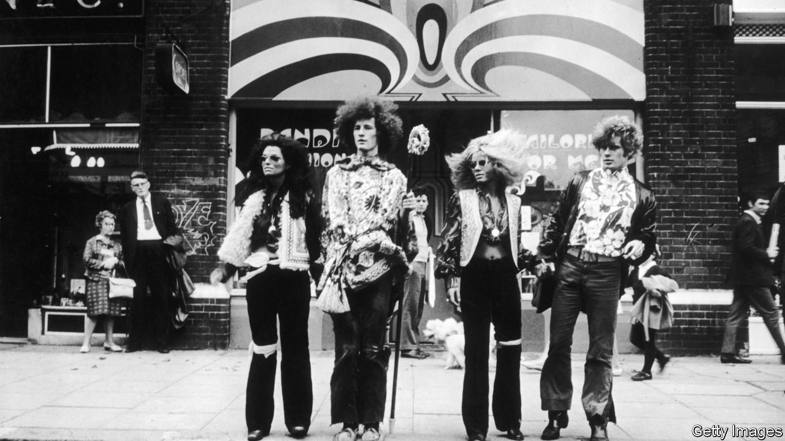

Utopia Avenue. By David Mitchell. Random House; 592 pages; $30. Sceptre; £20.

USING DIVERSE voices and styles, and telling several stories together, David Mitchell’s finest novels conjure up multiple worlds, both real and fantastical. Each of their chapters transports readers to a different time or place and revolves around a new theme or idea. These sections are discrete enough to resemble stand-alone stories, but recurring motifs or reappearing characters provide unity. For all the singular events and far-reaching chaos they encompass, these are books about interconnected lives and shared fates.

His kaleidoscopic and polyphonic novels showcase their author’s capacious imagination. The globe-spanning miniature dramas that make up his debut, “Ghostwritten” (published in 1999), chart the wayward progress of, among others, a pair of jazz aficionados, a nuclear physicist, a member of a doomsday cult and a disembodied, transmigrating soul. Bigger and bolder, “The Bone Clocks” (2014) follows a character from 1984 to a post-apocalyptic future, by way of a cosmic conflict between immortal beings. Mr Mitchell’s most ambitious work, “Cloud Atlas” (2004), is also his best. Intricately structured and deftly plotted, its contrasting ingredients—thriller, history, farce, dystopia, science fiction—make a potent blend.

His ninth novel is, for the most part, a more conventional affair. “Utopia Avenue” tells the story of a fictitious British rock band of that name which experiences fame, triumph and tragedy in the late 1960s. The book lacks the formal daring and dizzying inventiveness of its predecessors. This time, though, Mr Mitchell places a stronger emphasis on characterisation. By rotating the narrative between the players’ perspectives, he ensures that each emerges as a fleshed-out human being as well as a member of the collective.

The group forms in Soho (“The saucy twinkle in Mother London’s eye”) in 1967. It consists of Dean Moss, a blues bassist, folk singer and keyboardist Elf Holloway, virtuoso guitarist Jasper de Zoet and Peter “Griff” Griffin, a jazz drummer. They harness their influences and pool their talents to create a winningly eclectic sound. Aided by their enterprising manager, LevonFrankland, they secure a record deal, play gigs, appear on television and gradually make a name for themselves in “the autumn of the Summer of Love”.

But their journey to the top has downs as well as ups. They encounter shady promoters and snarky critics. They weather erratic sales and dented self-confidence. Jasper goes AWOL in New York; in Rome, Dean faces imprisonment. Eventually the band wins critical acclaim and commercial success on both sides of the Atlantic. Can anything derail this rollercoaster career?

“Utopia Avenue” itself is not a fast ride. Some scenes go on too long, others take unnecessary tangents. Nevertheless it is a consistently absorbing book, which skilfully conveys the excitement and mayhem of the era, and the hopes and dreams of those swept up in it. Elf’s sections sketch a voyage of self-discovery, during which she recognises her abilities, moves on from a sponger boyfriend and embraces her true sexuality. Dean’s story is a cautionary tale rich with lurid scandals, comic misadventures and family feuds. Jasper develops into the novel’s most complex character. A former patient of a Dutch psychiatric clinic, he wrestles with “emotional dyslexia” and a fear of mirrors. But when he is plagued by persistent knocking from “the squatter in his skull”, both his sanity and the band’s future are threatened.

The later sections told from Jasper’s perspective are filled with what one figure in “The Bone Clocks” termed “magickery-pokery”. Mr Mitchell overdid his mind-bending flights of fancy in that book; in this one there is method in his madness. There are entertaining cameos from famous faces, notably David Bowie, Francis Bacon and Janis Joplin. As ever, characters from the author’s earlier stories pop up and pass through this one, often in intriguing new guises. A lot of fun is had along the way, by both Mr Mitchell and the reader. ■

This article was downloaded by calibre from <https://www.economist.com/books-and-arts/2020/07/23/david-mitchells-new-novel-is-the-story-of-a-rock-band>

|  |  |  |  |
| --- | --- | --- | --- |
| Previous | Articles | Sections | Next |

|  |  |  |  |
| --- | --- | --- | --- |
| Previous | Articles | Sections | Next |

#### Home Entertainment

# “Catch-22” and the caprices of bureaucracy

Joseph Heller’s comic war novel resonates anew during the pandemic

Jul 23rd 2020 |



AT THE BEGINNING of “Catch-22” Captain Yossarian vows “to live forever or die in the attempt”. Though the odds are stacked against him, he tirelessly resists anyone and everything that wants to kill him. This broad category includes the German army, his own commanders with their dangerous missions and even the cells in his body, because “every one was a potential traitor and foe”.

Set mainly in an American air-force base towards the end of the second world war, Joseph Heller’s story seemed unlike other war novels when it was published in 1961. Rather than hailing martial bravery, it lambasted the era’s violence and paranoia, as well as bungling bureaucrats and capricious rules of a kind that are freshly recognisable today. Early reviewers called the book “repetitive and monotonous”, but younger readers appreciated Heller’s extravagantly constructed jokes, in which the punchline may come hundreds of pages after the set-up. Above all they identified with the authority-questioning Yossarian, the closest thing “Catch-22” has to a hero.

Later adapted for film and television, the novel follows the captain and around 70 other characters in a bafflingly non-linear plot. Some of them are megalomaniacs, others amoral profiteers; the enlisted men are variously jaded, idealistic and suicidal. Some die, come back, and die all over again. Events slide into each other, loosening the reader’s grasp on time, much as the languor of lockdown can seem to. Incidents are revisited from alternative points of view, first played for laughs and later depicted as tragedies. (Heller made an enormous handwritten plan for the book to keep track of the timeline.)

The phrase “Catch-22” has since entered the language, making the novel vaguely familiar even to those who have never read it. In the story, air-force regulation “Catch-22” says that insane servicemen cannot be excused combat duty, because trying to get out of it implies concern for their safety—meaning they must be sane after all. But the phrase quickly became shorthand for any predicament from which escape is impossible because of an inherent contradiction. Everyone encounters these: an entry-level job advert that stipulates “experience required”; being unable to find a lost pair of glasses because you cannot see. Some of the dilemmas of the pandemic—public-health measures that are meant to save lives, but might end up blighting them—have a Catch-22 feel.

“Yossarian lives”, a slogan that was plastered on subway carriages in New York in the 1960s, may have been a bit of a spoiler, but it captures the consolation that the novel ultimately offers. Today the captain and his friends are offbeat guides to a risky, maddening and rule-bound life. And Heller’s inimitable comic voice is a reminder that humour and humanity might just see you through. ■

This article was downloaded by calibre from <https://www.economist.com/books-and-arts/2020/07/23/catch-22-and-the-caprices-of-bureaucracy>

|  |  |  |  |
| --- | --- | --- | --- |
| Previous | Articles | Sections | Next |

|  |  |  |  |
| --- | --- | --- | --- |
| Previous | Articles | Sections | Next |

#### Johnson

# The shadowlands of language

“Irregardless” is part of a penumbra of unorthodox English words

Jul 23rd 2020 |

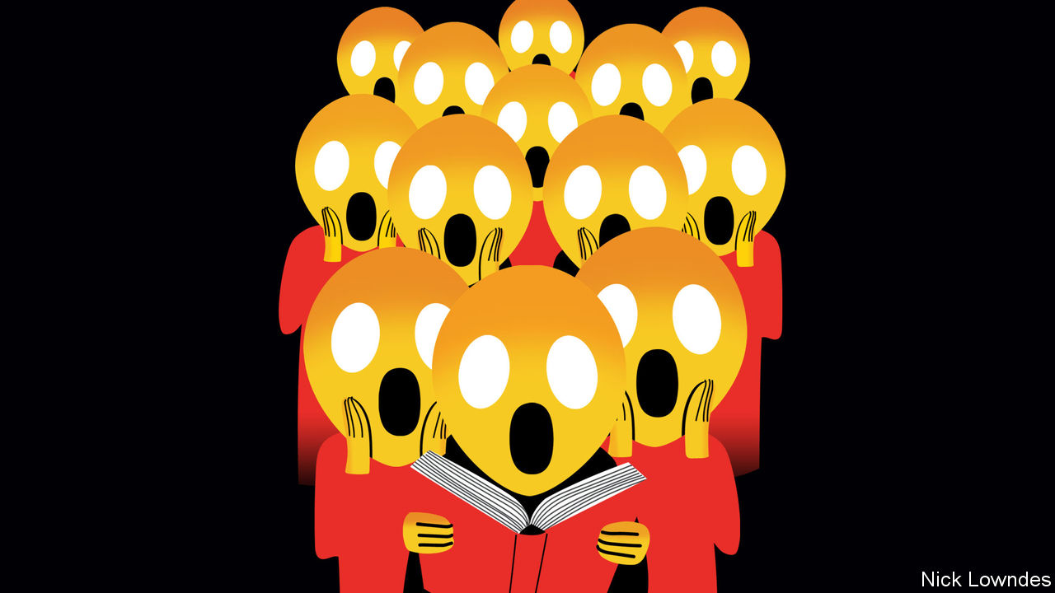

WHAT, THE actor Jamie Lee Curtis recently asked on Twitter, could make 2020 even more dismal? Her somewhat surprising answer: “Merriam-Webster just officially recognised ‘irregardless’ as a word.” A horrified emoji followed; 27,000 people signalled agreement with a “Like”. Many others tweeted independently about their dismay.

The premise of these gripes was mistaken. Merriam-Webster hadn’t “just” recognised irregardless. It appeared in Webster’s controversial Third New International Dictionary of 1961, which also included words such as ain’t and heighth, to the distress of many. It even made it into Webster’s Second in 1934, which many linguistic conservatives cherish to this day as a totem from an earlier, more sensible age. Irregardless also turns up in the American Heritage Dictionary, which was explicitly created as a traditionalist response to Webster’s Third, as well as in the capacious Oxford English Dictionary.

What is it about irregardless that gets some people quite so worked up? The case against it is straightforward. It has two negative affixes, one at the beginning (ir-) and one at the end (-less), making it malformed, those two negatives possibly even suggesting a positive. It probably began as an unintentional mash-up of irrespective and regardless.

Does that mean it is not a word, though? Who would determine that, and how? All the words in this sentence, English-speakers would agree, are words. They can be found in dictionaries, and people know how to use them. And everyone would concur that an unpronounceable, random string of characters like qtt3pf is not a word. What about klorf? Harder to tell. (It’s not a word: Johnson just made it up. But unlike qtt3pf, it is pronounceable, and could be.)

How about hangry? Meh? Real words? Slang? Half-words? It turns out that besides all the unambiguous English words, many others constitute a kind of penumbra of the language. These include dialect (such as Yorkshire’s nowt, for “nothing”), terms from foreign languages being used increasingly in English (such as Arabic’s hijab), proper nouns that have become ordinary words (to Google), relatively new arrivals (woke), and others. Some dictionaries set out to make a mark by incorporating as many of these as they can—and their publishers try to drum up interest by putting out press releases touting the new entries. After all, weight aside, the most helpful dictionary is the one with the most words, not the fewest.

The case for admitting irregardless is not that it is lovely, or useful. It is simply that people occasionally say it. Lexicographers don’t decide who gets into the club; they register who’s already in, based on whether a word is in circulation. Irregardless has a fixed form (spelling and pronunciation) as well as a clear meaning: it’s an adverb, used in the same way as regardless. But lexicographers are not unmindful of the standing of irregardless among the literati, so all the dictionaries mentioned here mark it as “nonstandard”, or suchlike.

Still, irregardless isn’t nonstandard in the way that, say, ain’t is. Ain’t is extremely common, found in fiction, jocular standard speech and many dialects. Irregardless is much more of a fringe phenomenon. It hardly ever makes it into edited writing. Data from Google Books shows it to be only around1/1,000th as common as regardless (and of its few instances in print, some are in meta-discussions of the word’s impropriety). The Corpus of Contemporary American English, another big database representing a wide swathe of language from different genres, finds it frequently in blog comments and unscripted television, but hardly anywhere else.

In other words, there is a better case against irregardless than the fact that it is malformed. (After all, many words are malformed: television combines Greek and Latin roots. Flammable arose from a misunderstanding of inflammable, which means “capable of being inflamed” but was misinterpreted as “not flammable”.) The real problem is that it has never quite found a secure place in the English language. It may be said now and then by people who either do not think of it as an error or do not mind, but the fact that it virtually never appears in edited prose—except when discussed as a solecism—suggests that it may never settle in.

A word it is, but maybe another sense needs to be added to those dictionaries: “irregardless: a word that distinguishes people who do not care much about English usage from those who care terribly—and want the world to know it.”

This article was downloaded by calibre from <https://www.economist.com/books-and-arts/2020/07/23/the-shadowlands-of-language>

|  |  |  |  |
| --- | --- | --- | --- |
| Previous | Articles | Sections | Next |

|  |  |  |
| --- | --- | --- |
| Books & arts | Sections | Graphic detail |

Economic & financial indicators

Economic data, commodities and markets

.

|  |  |  |
| --- | --- | --- |
| Books & arts | Sections | Graphic detail |

|  |  |  |  |
| --- | --- | --- | --- |
|  | Articles | Sections | Next |

# Economic data, commodities and markets

Jul 23rd 2020 |

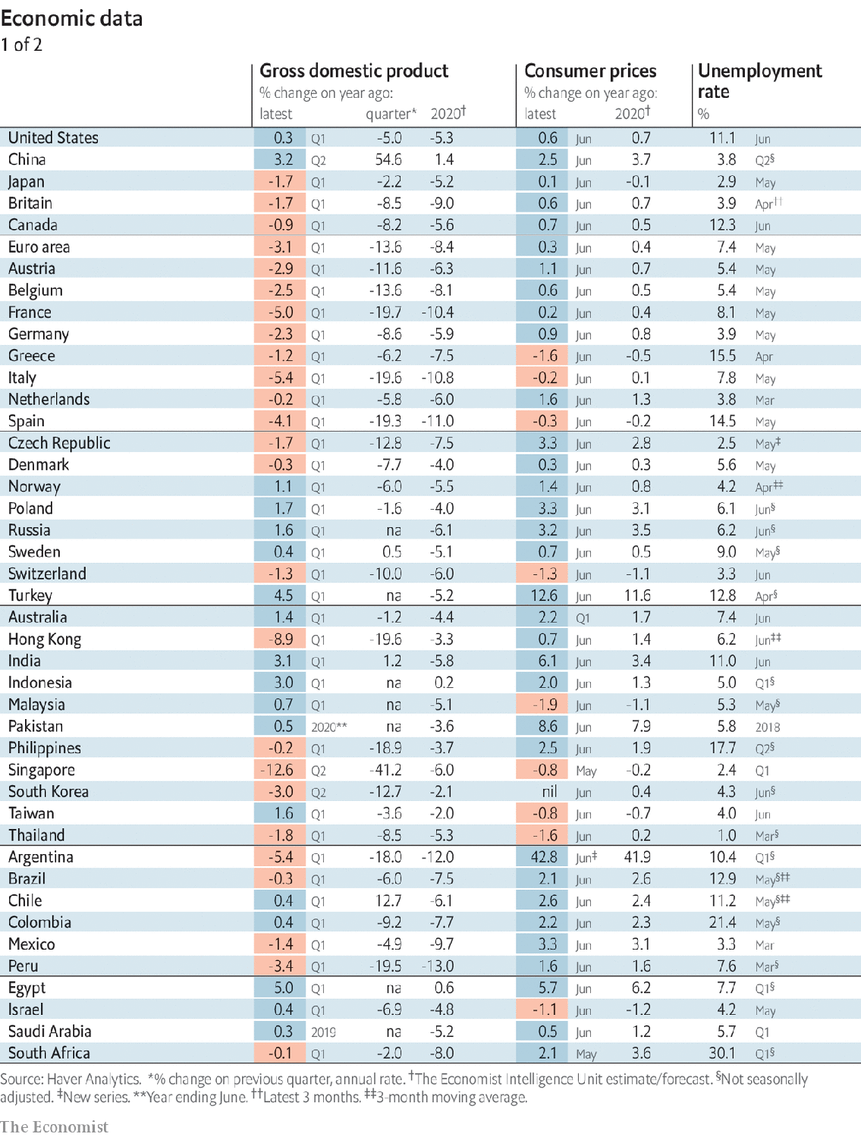

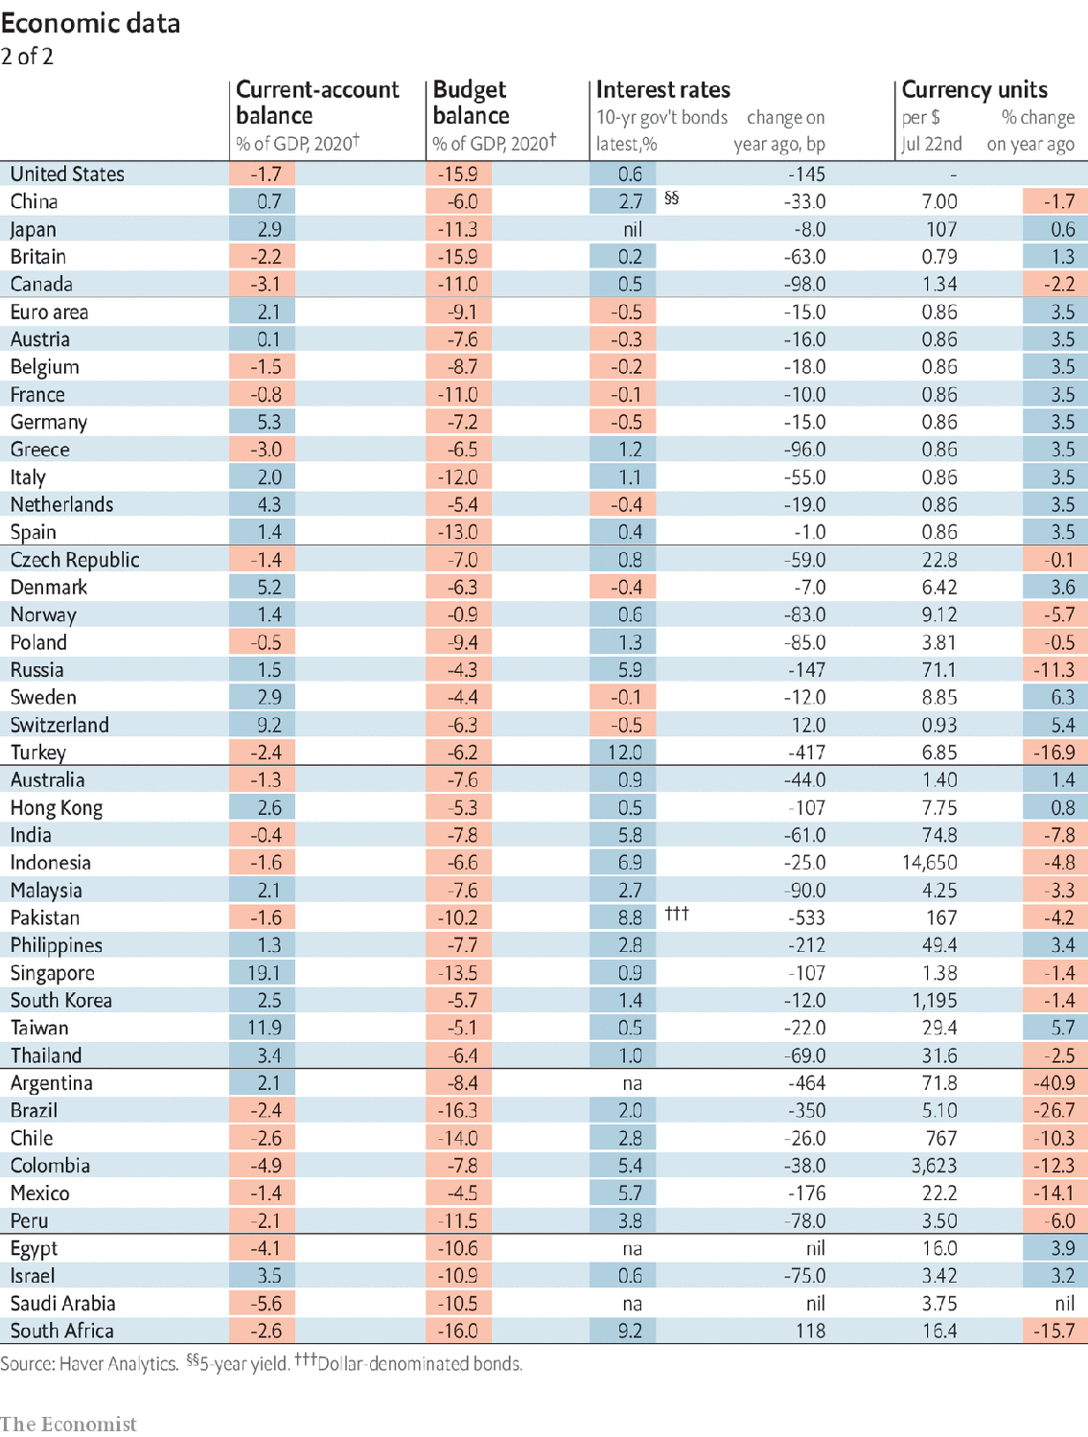

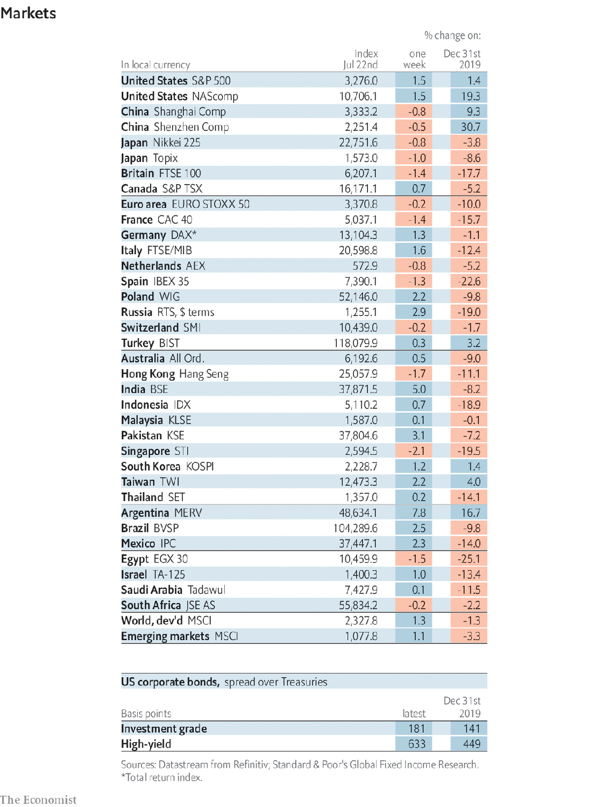

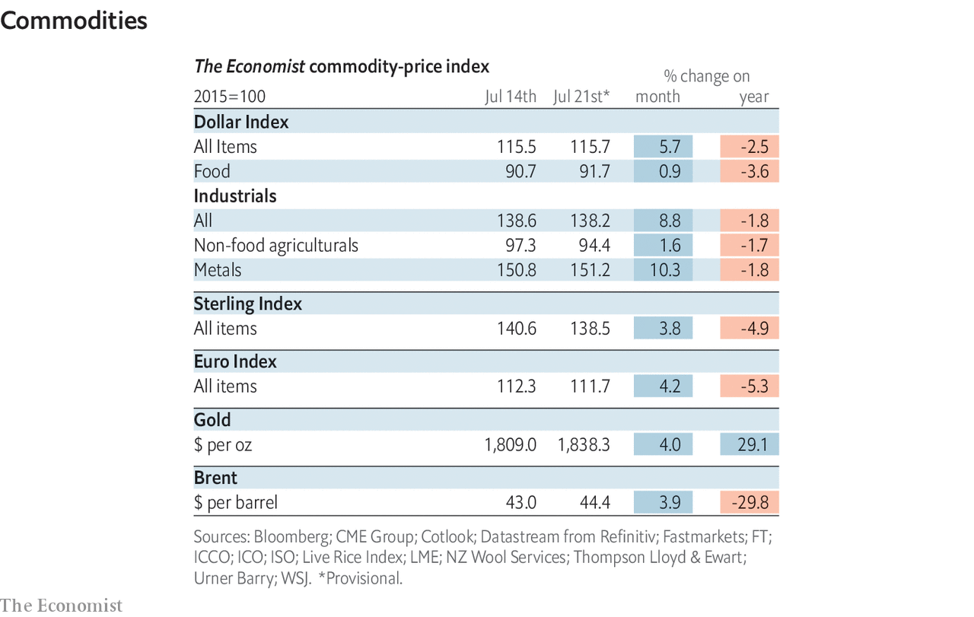

This article was downloaded by calibre from <https://www.economist.com/economic-and-financial-indicators/2020/07/23/economic-data-commodities-and-markets>

|  |  |  |  |
| --- | --- | --- | --- |
|  | Articles | Sections | Next |

|  |  |  |
| --- | --- | --- |
| Economic & ... | Sections | Obituary |

Graphic detail

Covid-19 and football: Home comforts

.

|  |  |  |
| --- | --- | --- |
| Economic & ... | Sections | Obituary |

|  |  |  |  |
| --- | --- | --- | --- |
|  | Articles | Sections | Next |

#### Home comforts

# Empty stadiums have shrunk football teams’ home advantage

Officiating bias disappears without fans, but clubs still play better at home

Jul 25th 2020 |

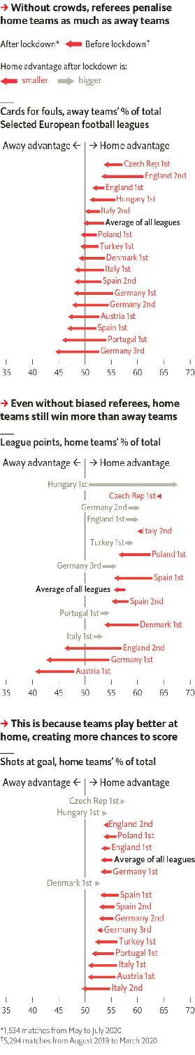

LOCKDOWNS WERE particularly frustrating for football devotees, who had no live matches to watch while stuck at home. But the fans most pleased by the sport’s return may be statisticians. For them, empty stadiums are not a cheerless last resort, but rather a chance to tackle a great quandary: why do travelling teams tend to lose?

Most studies have blamed referees for trying to placate fans. In one experiment, officials were shown recorded games and asked how they would have ruled. They were kinder to home sides when they could hear baying fans than when the sound was muted. Some analyses of live matches have found more bias with denser crowds. Before this summer, few competitive fixtures were played without fans. One study from this May found just 160 cases since 2002. In this small sample, the home team’s edge vanished. Referees gave similar numbers of cards for fouls to both sides, and visitors won almost as often as hosts did.

This finding could easily be skewed by a few clumsy tackles or flukey goals. But the pandemic has made a larger study possible. At our request 21st Club, a consultancy, has analysed 1,534 matches played without fans this year, spanning dozens of leagues.

Sure enough, officials no longer appear biased. Although the pattern varies widely by league, the total share of cards received by home teams has risen from 46% before lockdowns to 50% afterwards.

However, the lack of help from referees has merely reduced home sides’ advantage, rather than eliminating it. Football leagues give teams three points for a win, one for a draw and none for a loss. With crowds watching, home teams gained 58% of points; without them, hosts have still earned 56%. In other words, three-quarters of home overperformance remains intact.

So why have teams fared better at home, even without biased officials? Since May, hosts have taken 53% of shots at goal—less than the 55% they took in full stadiums, but enough to give them an edge.

The cause of this gap remains mysterious. In American sports, visitors have to endure long trips between games. But travel times within European countries rarely exceed a few hours. A more plausible reason is that coaches still use conservative line-ups and strategies when playing away, even though hostile officials no longer undermine their best players’ efforts. If that is a factor, managers who excoriate referees ought to consider their own failings, too. ■

Sources: 21st Club

This article was downloaded by calibre from <https://www.economist.com/graphic-detail/2020/07/25/empty-stadiums-have-shrunk-football-teams-home-advantage>

|  |  |  |  |
| --- | --- | --- | --- |
|  | Articles | Sections | Next |

|  |  |  |
| --- | --- | --- |
| Graphic detail | Sections |  |

Obituary

John Lewis: A country’s conscience

.

|  |  |  |
| --- | --- | --- |
| Graphic detail | Sections |  |

|  |  |  |  |
| --- | --- | --- | --- |
|  | Articles | Sections | Next |

#### A country’s conscience

# John Lewis died on July 17th

The congressman and civil-rights activist was 80

Jul 20th 2020 |

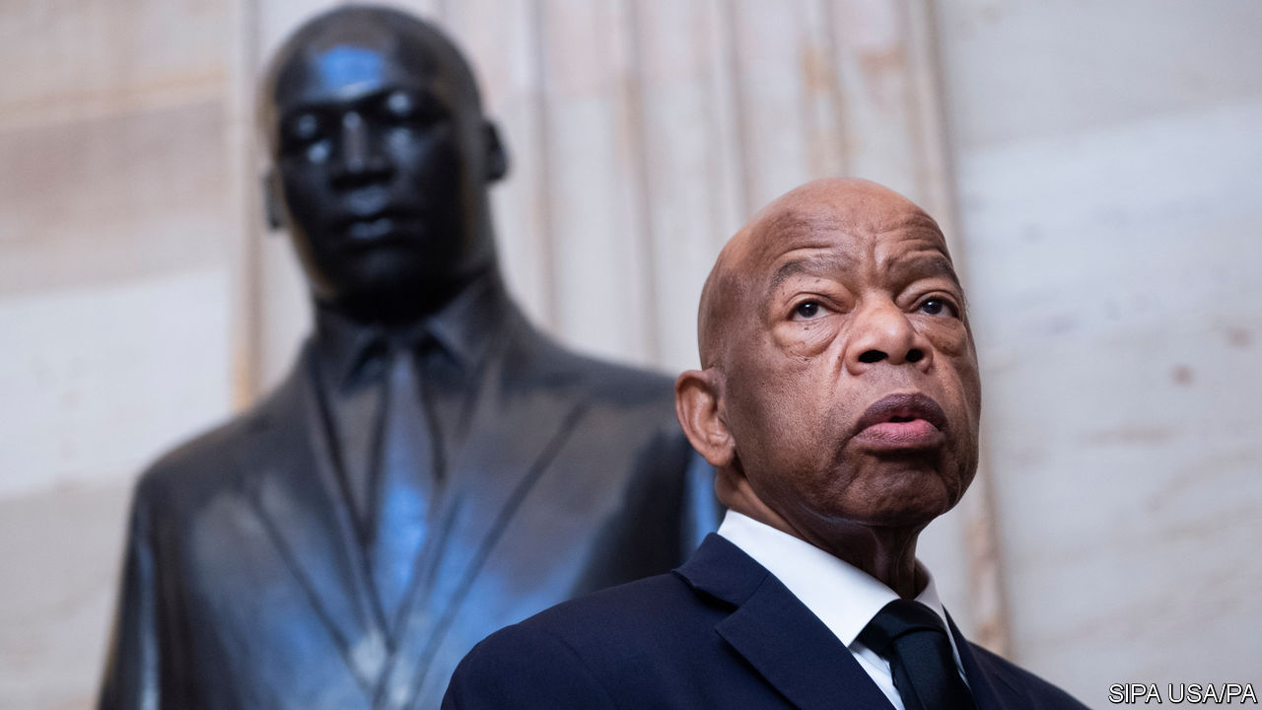

JOHN LEWIS had a ritual that saw him through the early 1960s. After being released from jail, he would head back to wherever he was staying—usually a local family’s house—take a long shower, put on jeans and a fresh shirt, find a little restaurant where he could order a burger and a cold soda, drop a quarter in the jukebox and play Curtis Mayfield or Aretha. He would sit down and, as he wrote in his memoir, “let that music wash over me, just wash right through me. I don’t know if I’ve ever felt anything so sweet.”

If it seems like the ritual of a man at the end of a hard day’s work, that is because it often was. Civil-rights activists across the south faced arrest, usually on flimsy charges such as disorderly conduct and disturbing the peace. It was all a part of what he called getting into “good trouble” for acting and speaking out against injustice. He never lost that habit. He was arrested for the 45th time in 2013, his 26th year in Congress, at a rally for immigration reform.

Raised in a small house in Pike County, Alabama, without running water or electricity, he had put himself on an activist’s path early. He applied for a library card at 16. He was denied, of course—libraries, like everything else in Alabama then, were segregated—but he drafted a petition arguing that the library should open its doors to black Alabamans whose taxes helped pay for it.

He had recently heard a sermon on the radio by a young Baptist minister from Atlanta named Martin Luther King junior, who urged listeners to concern themselves not just with God’s Kingdom, but with racial injustice here on Earth. He also wanted to be a preacher—when he was a boy, he had preached to his family’s chickens—and King was the first one he heard use the Gospel to ask how American Christians could believe in both brotherhood and segregation. King could not accept it, and neither could he. What he and King fought for was both radical, given America’s racial history, but also nothing more than an insistence that America live up to its stated ideals of liberty and justice for all.

His activism did not sit well with his parents, who were ashamed when he was jailed. They urged him to “get out of this movement, just get out of that mess.” He was not a gifted orator like King, nor was he urbane like Julian Bond—a co-founder of the Student Nonviolent Co-ordinating Committee (SNCC) and the upper-crust son of a college president whom in 1986 he defeated in the race for the Atlanta congressional seat that he would hold until he died. Small, broadly built and somewhat shy, he was a participant, a doer, an organiser. In person, he was serious and warm, committed to his views but a first-rate listener.

Some of the better-educated members of the movement quietly teased him for his country accent. But as Kelly Miller Smith, who taught him the art of preaching at American Baptist College noted, every word from him might as well be carved in granite, and carried its own truth. His sense of purpose did not waver, even as others retreated from activism, shell-shocked by what they had seen and endured, or lost patience with the slow pace of change and the requirement that they receive blows without giving any back.

But his non-violence was not soft or conciliatory; it was adamantine, confrontational. His first Freedom Ride was in 1961, a bus trip south in which black and white riders sat next to each other and used the “wrong” restrooms and water fountains, provoking beatings, sympathy and attention in order to get the federal government to enforce its ban on segregated facilities at bus and railway stations. Before they left, some of his fellow Riders wrote wills. A poor student of 21, he had nothing to leave anyone.

He defied Bobby Kennedy, then the attorney-general, and Roy Wilkins, the head of the National Association for the Advancement of Coloured People, who urged the Riders not to continue into Mississippi. Two years later, Kennedy conceded that “the young people of SNCC have educated me.” At the March on Washington in 1963—where, at just 23, he was by far the youngest speaker, and the most strident—he vowed to “splinter the segregated South into a thousand pieces and put them back together in the image of God and democracy.”

The night he was nearly beaten to death leading marchers across the Edmund Pettus Bridge in Selma, Alabama—March 7th 1965—he chastised Lyndon Johnson for sending federal troops to Vietnam and Congo but not Alabama. He had been drawn to Selma in part because of the repeated assaults on C.T. Vivian—a minister and veteran activist who was to die on the same day he did—while trying to register black voters. Johnson annonced the next day that he was sending troops and signed the Voting Rights Act into law five months later. But after Selma, as he wrote, “the road of non-violence had essentially run out,” and the civil-rights movement began to fracture.

## The beloved community

He settled in Atlanta, where he was elected to the city council, and then to Congress. He sought votes from every constituency, blue- and white-collar, Jewish and gay. He never stopped believing in King’s Beloved Community, centred on radical love and justice, never stopped making good trouble. In 1996, almost 20 years before the Supreme Court ruled that gay-marriage bans violate the constitution, he gave a stirring speech on the House floor calling marriage “a basic human right” that should not be denied people just because they happen to be gay.

Alone among March on Washington speakers, he lived long enough to see America elect a black president. At lunch after the inauguration in 2009, he approached the new president with a commemorative photograph and asked for an autograph. Barack Obama wrote, “Because of you, John”, and signed his name.

He spoke forcefully in favour of Donald Trump’s impeachment. His last appearance was with Muriel Bowser, the seventh African-American mayor of Washington, DC, standing on the newly painted Black Lives Matter plaza in front of the White House—a reminder of how far America had come, and how far it still has left to go.■

This article was downloaded by calibre from <https://www.economist.com/obituary/2020/07/20/john-lewis-died-on-july-17th>

|  |  |  |  |
| --- | --- | --- | --- |
|  | Articles | Sections | Next |